AI Assistant Coding
LAB ASSIGNMENT-3.2

2303A52475
Shivayamini
Batch-38
Question
Lab 3: Prompt Engineering – Improving Prompts and Context Management
Lab Objectives:
● To understand how prompt structure and wording influence AI-generated code.
● To explore how context (like comments and function names) helps AI generate
relevant output.
● To evaluate the quality and accuracy of code based on prompt clarity.
● To develop effective prompting strategies for AI-assisted programming.
Lab Outcomes (LOs):
After completing this lab, students will be able to:
● Generate Python code using Google Gemini in Google Colab.
● Analyze the effectiveness of code explanations and suggestions by Gemini.
● Set up and use Cursor AI for AI-powered coding assistance.
● Evaluate and refactor code using Cursor AI features.
● Compare AI tool behavior and code quality across different platforms.
Task Description-1
• Progressive Prompting for Calculator Design: Ask the AI to design a simple calculator
program by initially providing only the function name. Gradually enhance the prompt by
adding comments and usage examples.
Expected Output-1
• Comparison showing improvement in AI-generated calculator logic and structure.
PROMPT:
design a simple calculator that can perform addition, subtraction, multiplication, and division operations. The calculator should take two numbers and an operator as input from the user and display the result.
CODE:
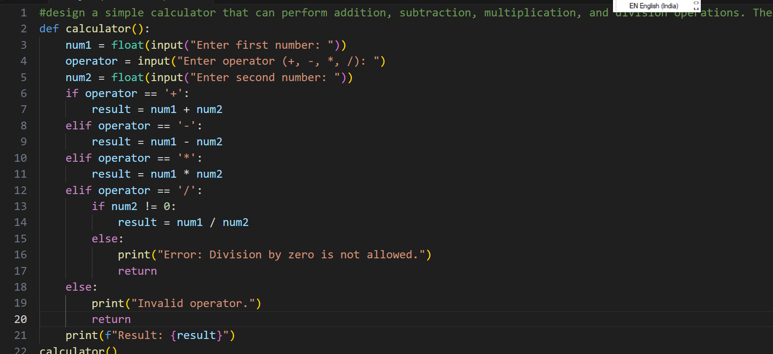
OUTCOME:
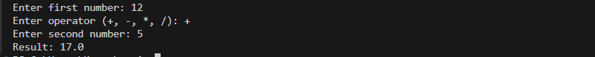
PROMPT:
design a simple calculator that can perform addition, subtraction, multiplication, and division operations. The calculator should take two numbers and an operator as input from the user and display the result and add comment lines and example usages
CODE:
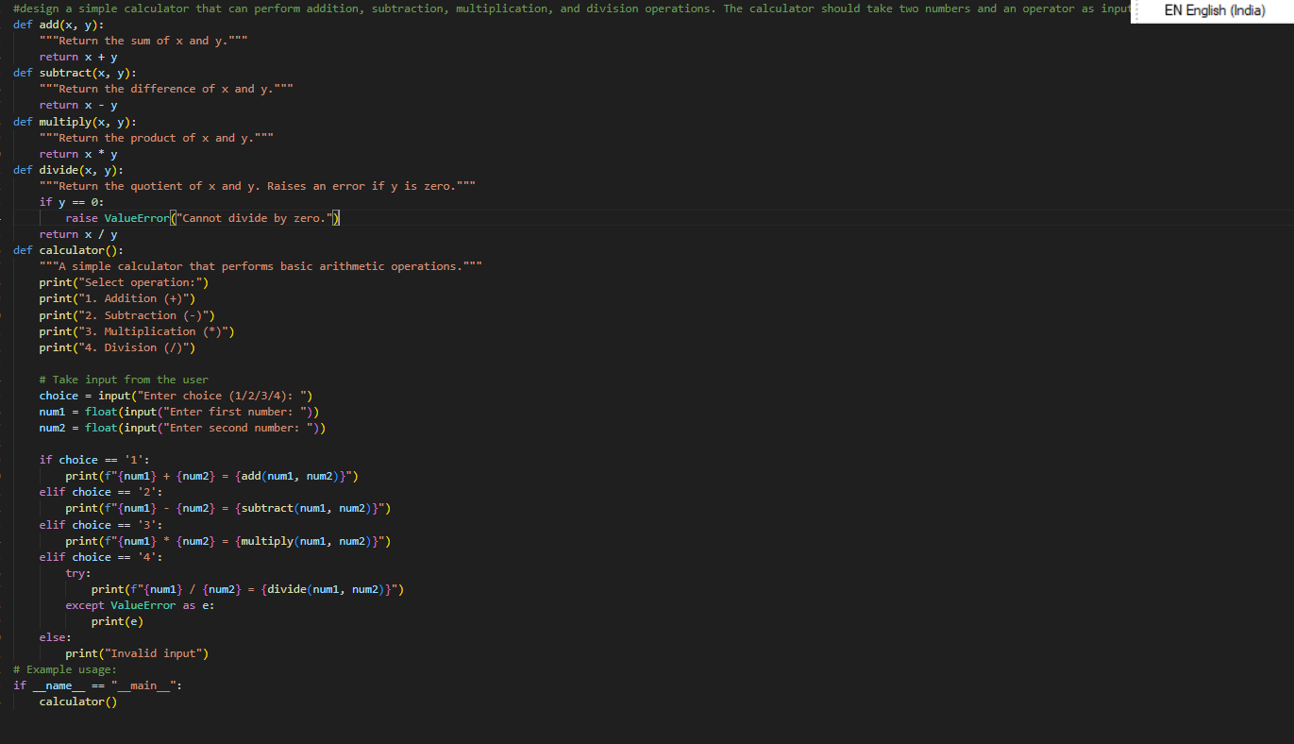
OUTPUT:
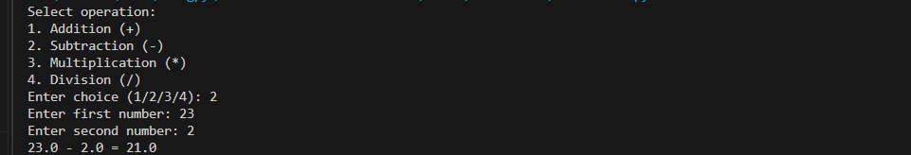
Explanation:
First, a basic prompt was given to create a simple calculator. The code worked but did not have comments or examples, so it was not easy to understand.
Then, the prompt was improved by asking for comments and example usage. Because of this, the generated code became clearer, well-documented, and easier to use.
This shows that improving the prompt helps in getting better and more understandable code.
Task Description-2
• Refining Prompts for Sorting Logic: Start with a vague prompt for sorting student marks,
then refine it to clearly specify sorting order and constraints.
Expected Output-2
• AI-generated sorting function evolves from ambiguous logic to an accurate and efficient
implementation.
PROMPT:
write a program to sort the student marks
CODE:
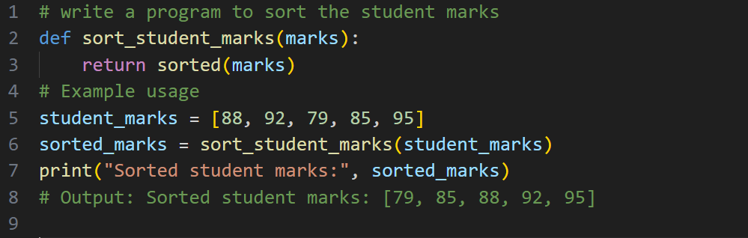
OUTPUT:
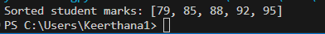
PROMPT:
write a program to sort the student marks in ascending order and by using constraints by user input
CODE:
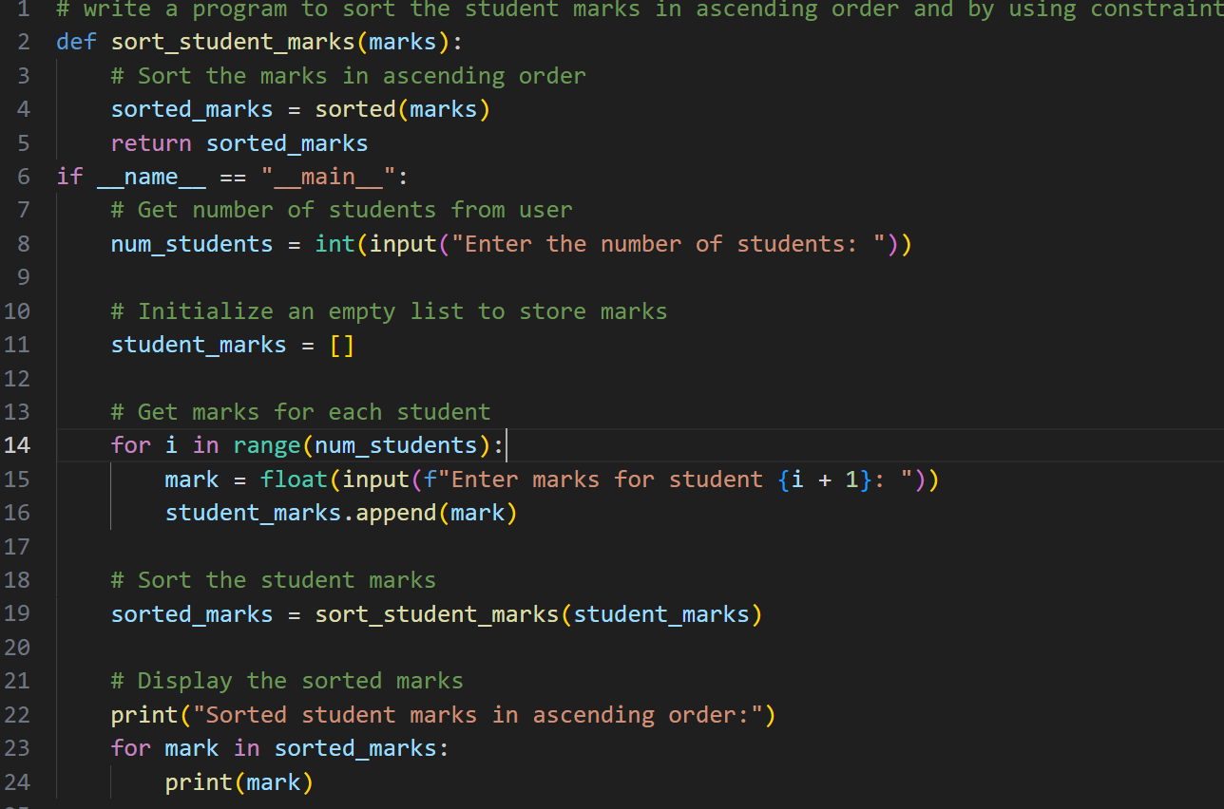
OUTPUT:
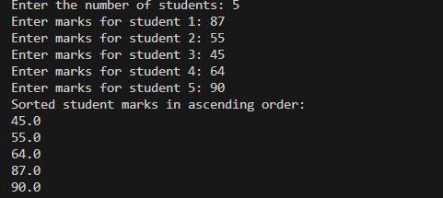
EXPLANATION:
First, a general prompt was given to sort student marks. Since it did not mention the sorting order or any conditions, the output was basic and unclear.
Then, the prompt was refined by specifying ascending order and user input constraints. This helped the AI generate a more accurate and well-defined sorting program.
Task Description-3
• Few-Shot Prompting for Prime Number Validation: Provide multiple input-output
examples for a function that checks whether a number is prime. Observe how few-shot
prompting improves correctness.
Expected Output-3
• Improved prime-checking function with better edge-case handling.
PROMPT:
Write a program to check whether a number is prime or not
CODE:
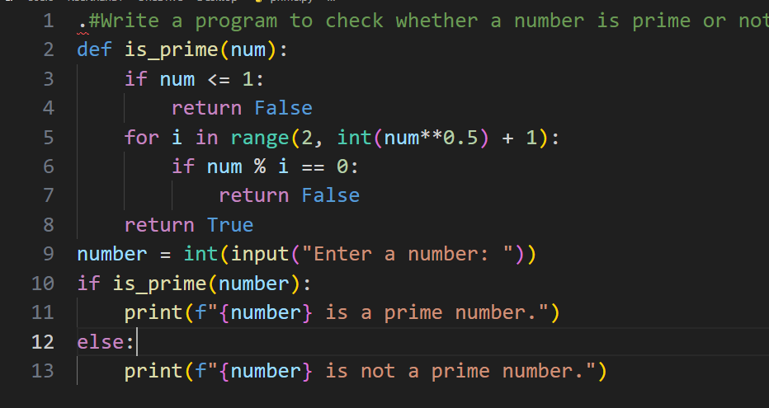
OUTPUT:
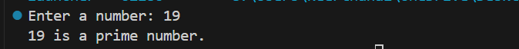
PROMPT:
Write a program to check whether a number is prime.
Input: 2
Output: Prime

CODE:
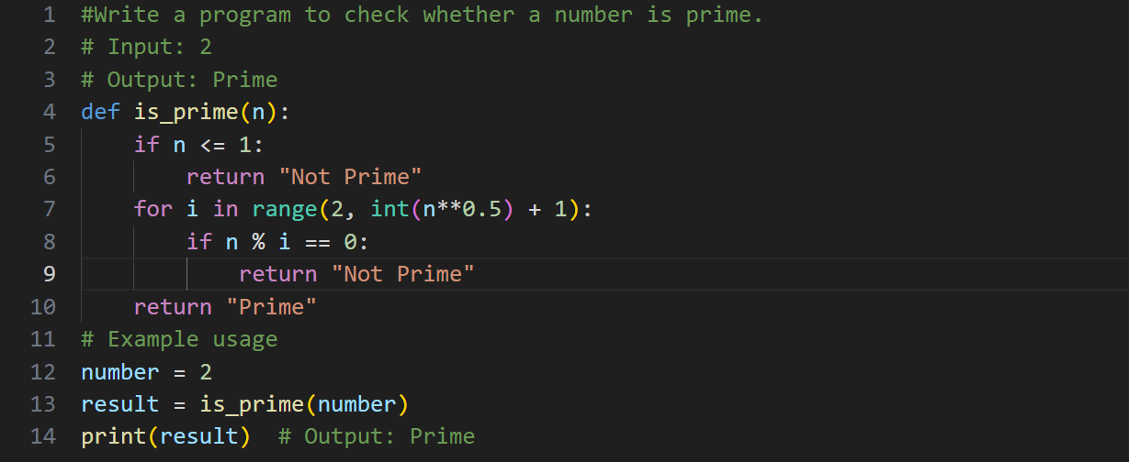
OUTPUT:
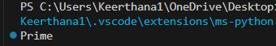
EXPLANATION:
The program checks whether a given number is a prime number.
It takes a number as input and tests if it can be divided by any number other than 1 and itself.
For the input 2, it has no other divisors, so the program prints Prime.
Task Description-4
• Prompt-Guided UI Design for Student Grading System: Create a user interface for a
student grading system that calculates total marks, percentage, and grade based on user
input.
Expected Output-4
• Well-structured UI code with accurate calculations and clear output display.
PROMPT:
Create a user interface for a student grading system that calculates total marks, percentage, and grade based on user input.
CODE:
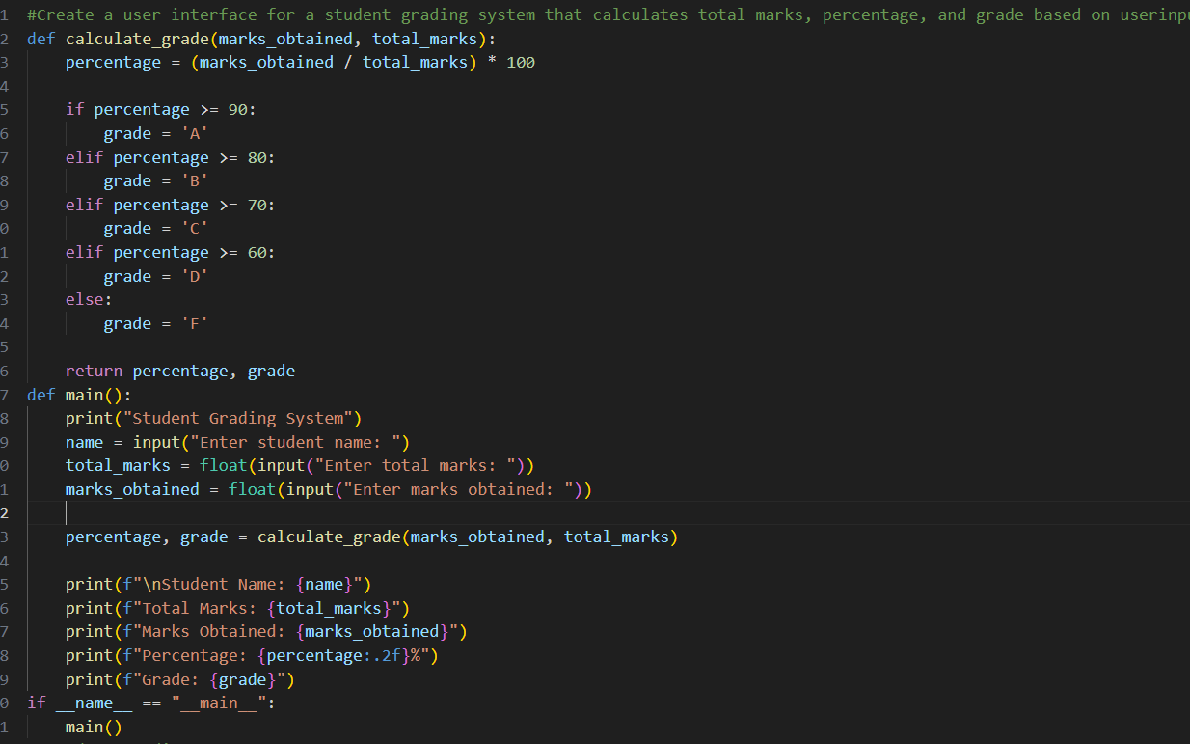
OUTPUT:
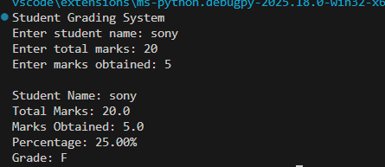
EXPLANATION:
The prompt generated a student grading system that takes user input, calculates percentage, assigns a grade, and displays the result clearly.
Task Description-5
• Analyzing Prompt Specificity in Unit Conversion Functions: Improving a Unit
Conversion Function (Kilometers to Miles and Miles to Kilometers) Using Clear
Instructions.
Expected Output-5
• Analysis of code quality and accuracy differences across multiple prompt variations.
PROMPT:
Write a program to convert kilometers to miles and miles to kilometers.
CODE:
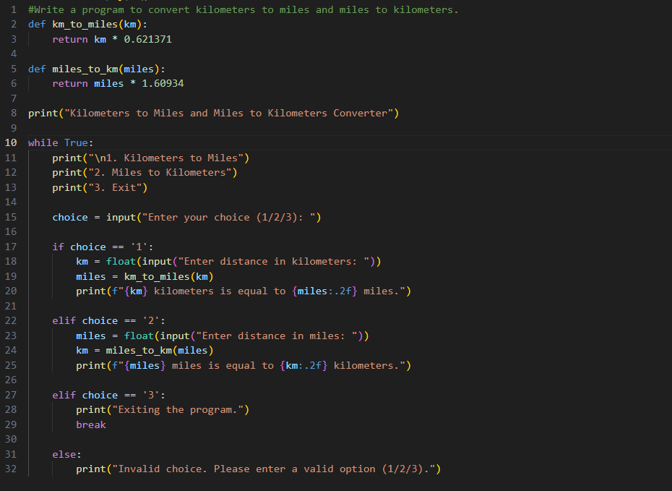
OUTPUT:
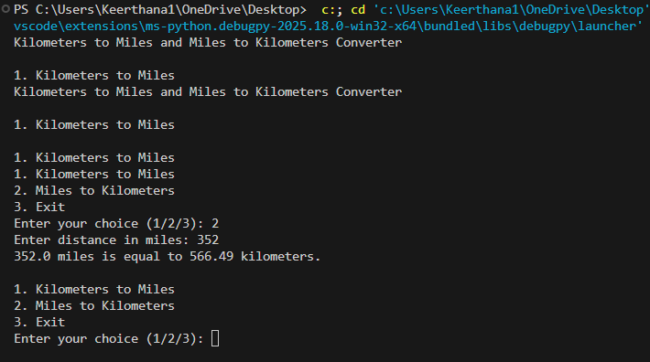
EXPLANATION:
The program converts kilometers to miles and miles to kilometers using user input and displays accurate results through a menu-driven interface.

