ASSIGNMENT 23.2

Shivayamini
2303A52475
Batch 38

Task 1 – Project Proposal
- Students choose a real-world problem to solve with an AI- assisted application (e.g., e-commerce billing system, health monitoring dashboard, student attendance tracker).
- Prepare a project proposal including:
- Objective
- Features
- Tools/technologies to be used
- Expected output

PROMPT:
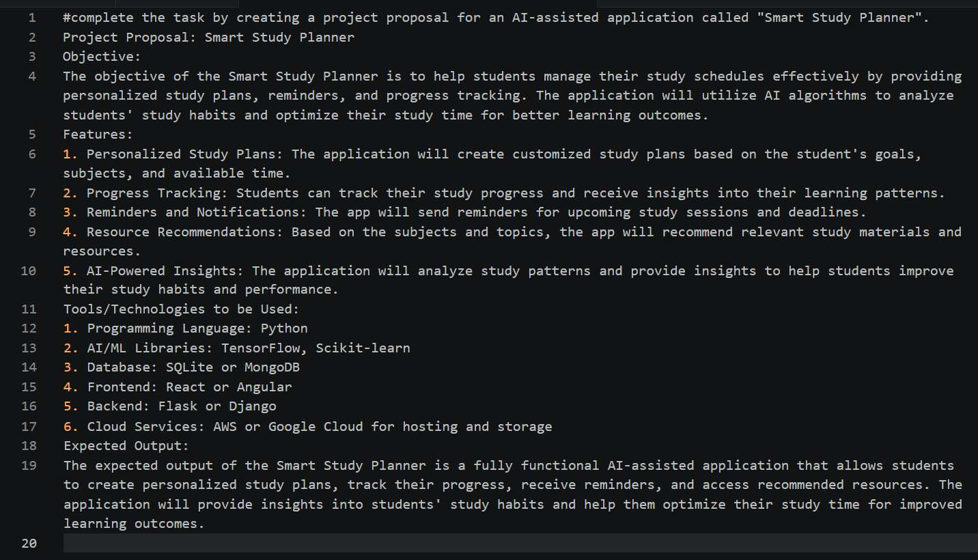
the task by creating a project proposal for an AI-assisted application called "Smart Study Planner". Project Proposal: Smart Study Planner
Objective:
The objective of the Smart Study Planner is to help students manage their study schedules effectively by providing personalized study plans, reminders, and progress tracking. The application will utilize AI algorithms to analyze students' study habits and optimize their study time for better learning outcomes.
Features:
- Personalized Study Plans: The application will create customized study plans based on the student's goals, subjects, and available time.

- Progress Tracking: Students can track their study progress and receive insights into their learning patterns.
- Reminders and Notifications: The app will send reminders for upcoming study sessions and deadlines.
- Resource Recommendations: Based on the subjects and topics, the app will recommend relevant study materials and resources.
- AI-Powered Insights: The application will analyze study patterns and provide insights to help students improve their study habits and performance.
Tools/Technologies to be Used:
- Programming Language: Python
- AI/ML Libraries: TensorFlow, Scikit-learn
- Database: SQLite or MongoDB
- Frontend: React or Angular
- Backend: Flask or Django
- Cloud Services: AWS or Google Cloud for hosting and storage
Expected Output:
The expected output of the Smart Study Planner is a fully functional AI-assisted application that allows students to create personalized study plans, track their progress, receive reminders, and access recommended resources. The application will provide insights into students' study habits and help them optimize their study time for improved learning outcomes.

EXPLANATION:
This project is about building an AI-based app called Smart Study Planner that helps students organize their studies better. It creates personalized study plans based on each student’s goals, subjects, and available time. The app also tracks progress, sends reminders, and suggests useful study materials. It uses AI to understand study habits and give tips for improvement. Technologies like Python, AI libraries, databases, and web frameworks are used to build it. Overall, the app helps students manage time effectively and improve their learning.

Task 2 – Application Design
  - Use AI tools to assist in:
- Designing system architecture diagrams.
- Defining database schema (if needed).
- Creating wireframes/UI mockups for frontend design.

PROMPT:
Help me create a complete Application Design document for an AI-based project.
- System Architecture
  - Explain how the system works end-to-end (frontend → backend → database → AI)
  - Include a clean Mermaid.js architecture diagram
- Database Design
  - List all tables with fields, data types, and descriptions
  - Mention primary keys, foreign keys, and relationships
  - Provide a neat table format + Mermaid ER diagram
- UI/UX Wireframes
  - 3–5 main screens
  - For each: purpose, components, and layout
  - Show simple ASCII wireframes
- Design Justification
  - Brief reasoning for architecture, database, and UI choices
- Enhancements
  - Suggest 2–3 advanced improvements

OUTPUT:
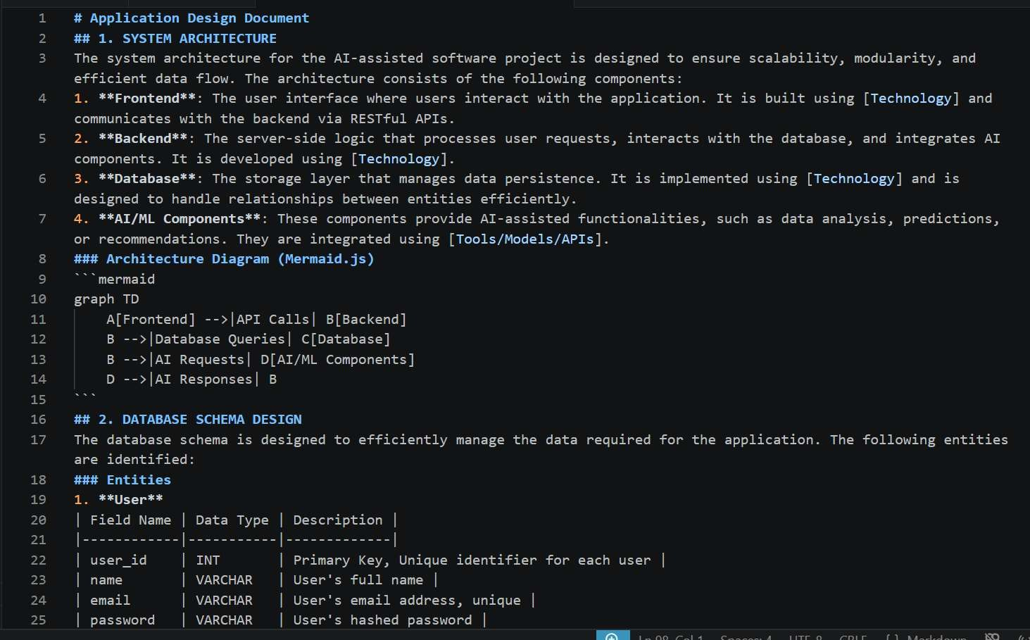
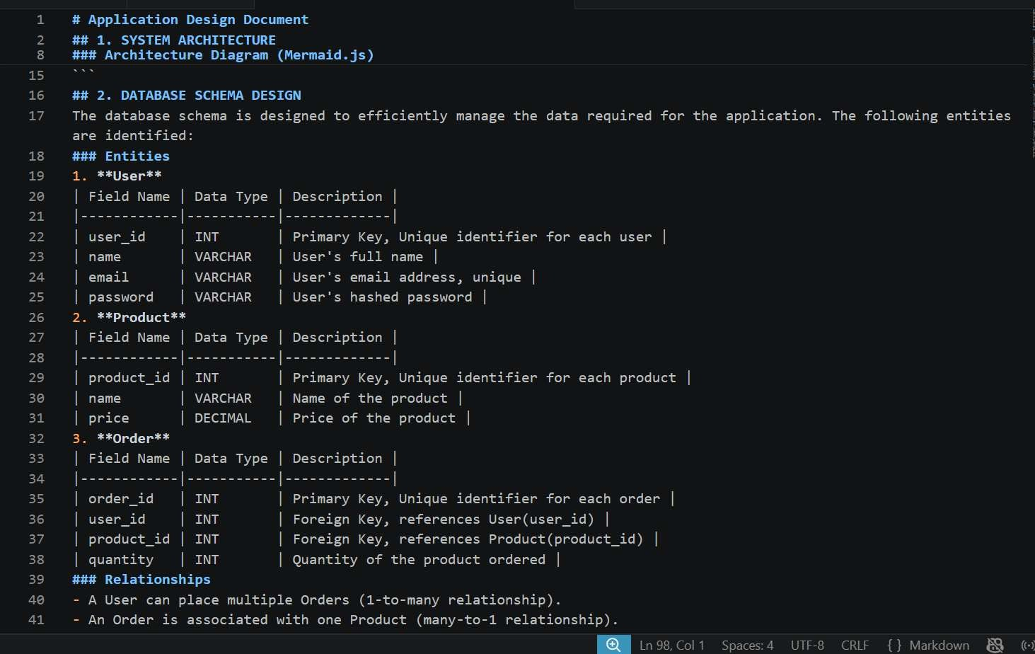

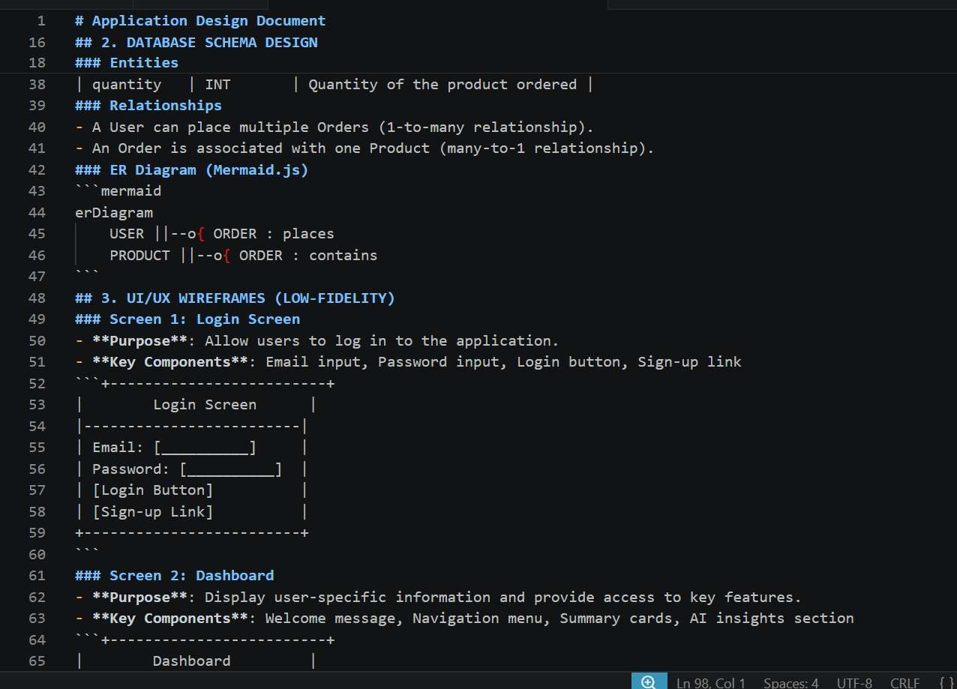
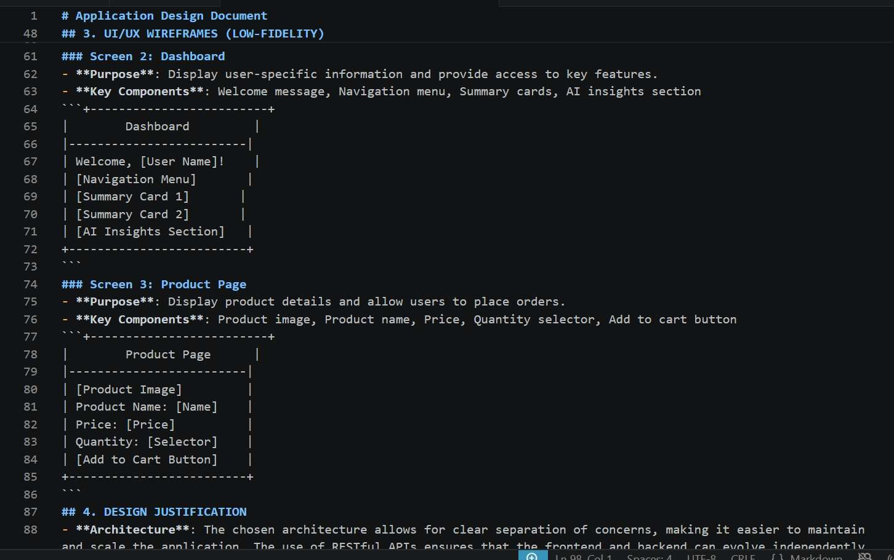

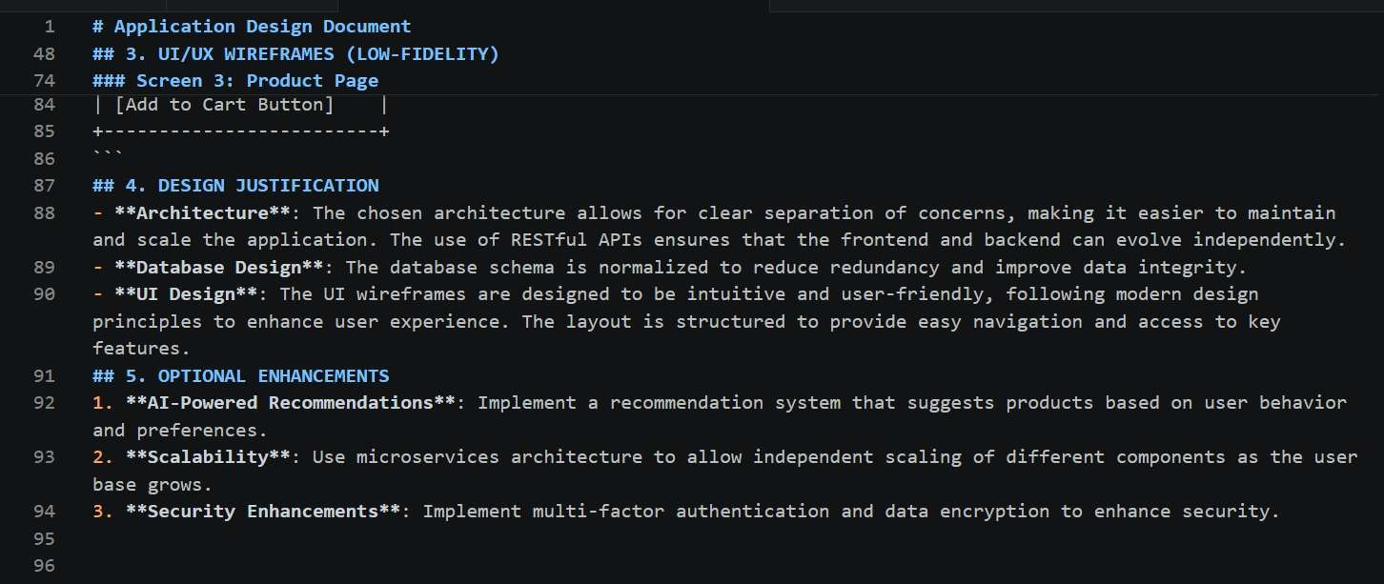

EXPLANATION:
This document explains how the application is designed and how different parts work together. The system architecture shows the frontend, backend, database, and AI components working together. The database design defines tables like users, products, and orders with their relationships. The UI section shows simple layouts of screens like login, dashboard, and product page. It also explains why this design is chosen for better performance and usability. Finally, it suggests improvements like better security, scalability, and AI features.

Task 3 – AI-Assisted Code Development
- Implement the application in phases:
- Frontend: Web/mobile UI with HTML/CSS/JS (or framework).
- Backend: RESTful APIs or server logic.
- Database: Schema design, SQL queries.
- Integration: API calls, authentication, error handling.

PROMPT:
Act as a frontend developer.
I am building a simple AI-assisted application for my academic project. Create a basic responsive web UI using HTML, CSS, and JavaScript.
Include the following pages:
- Login Page
- Dashboard Page
- Main Feature Page ([mention your feature]) Requirements:
  - Clean and simple design (not complex)
  - Navigation between pages
  - Login form with basic validation
  - Use only beginner-friendly code Provide:
  - Complete code for index.html, style.css, and script.js
  - Clear instructions to run the project

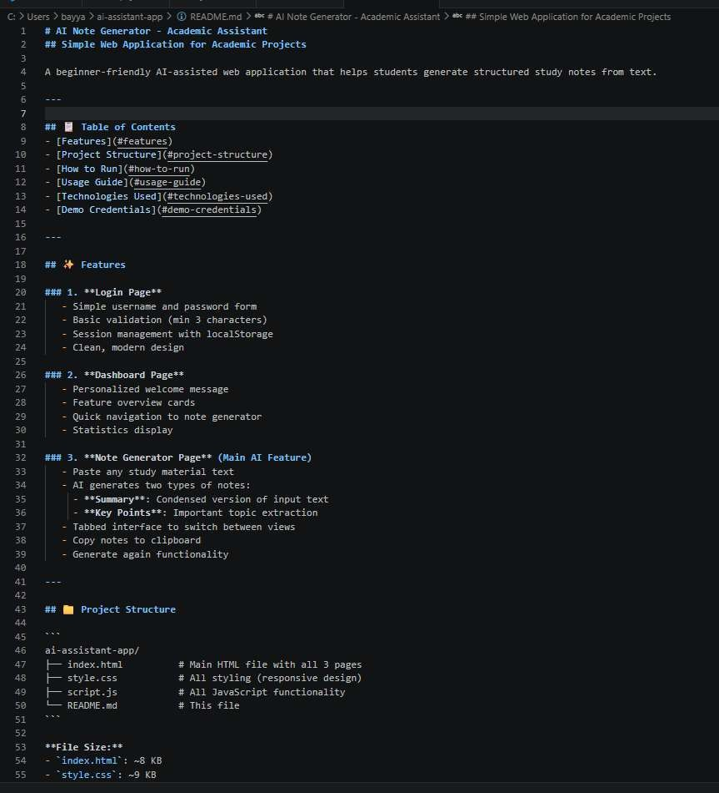
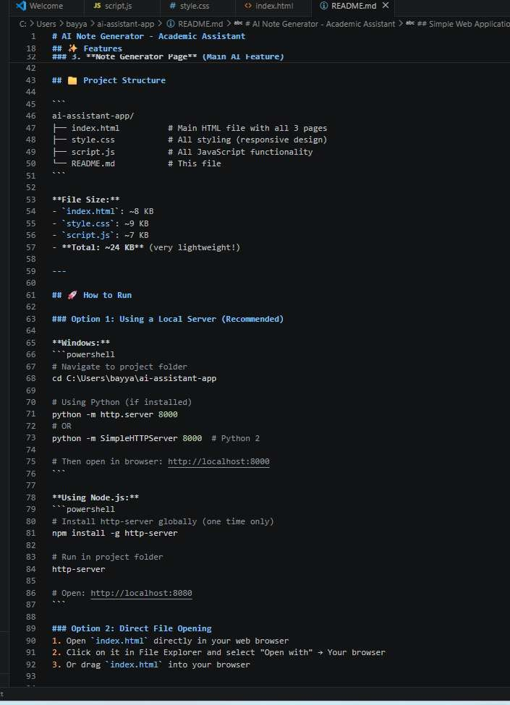

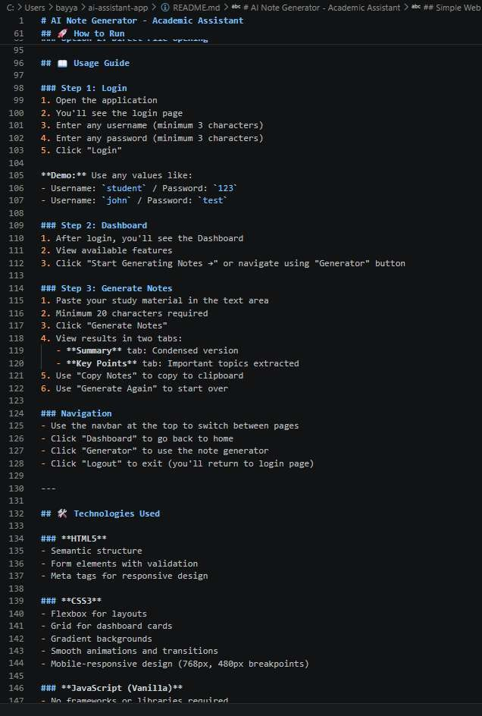
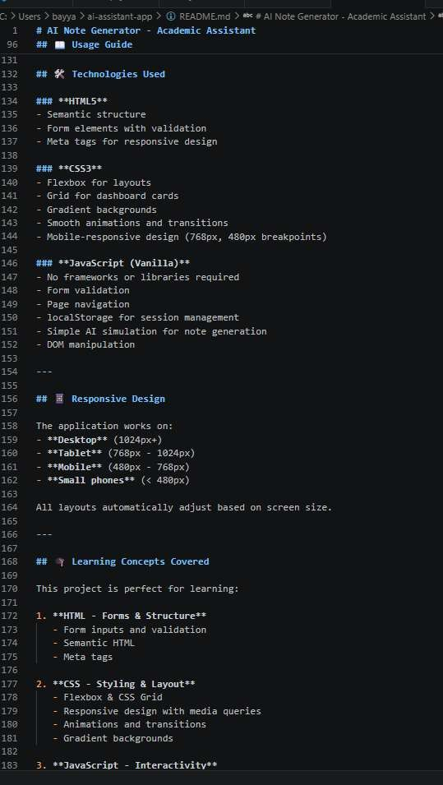

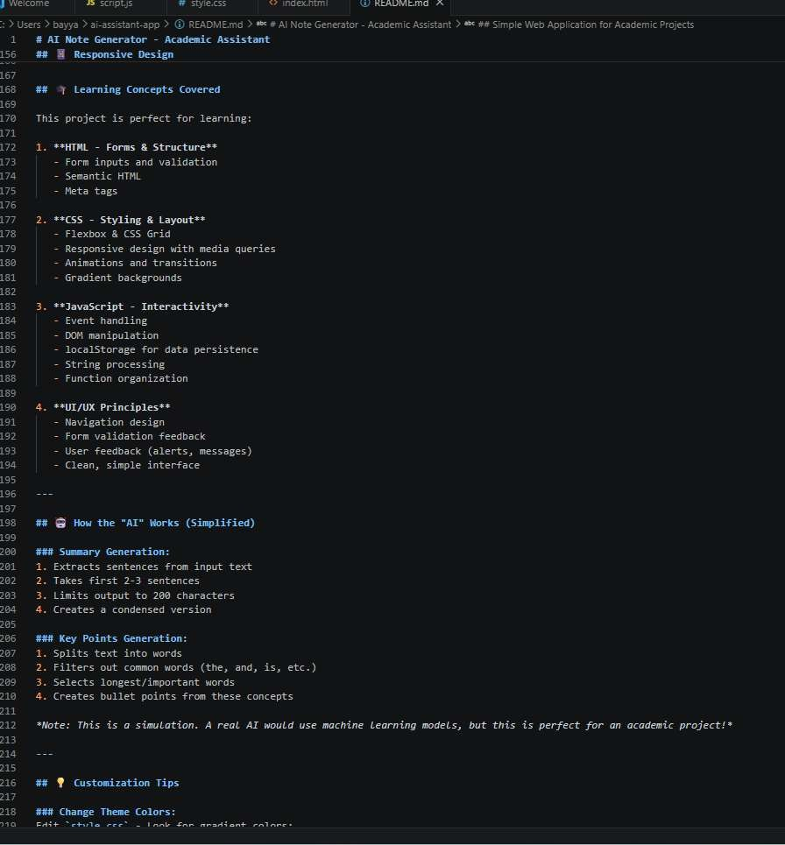

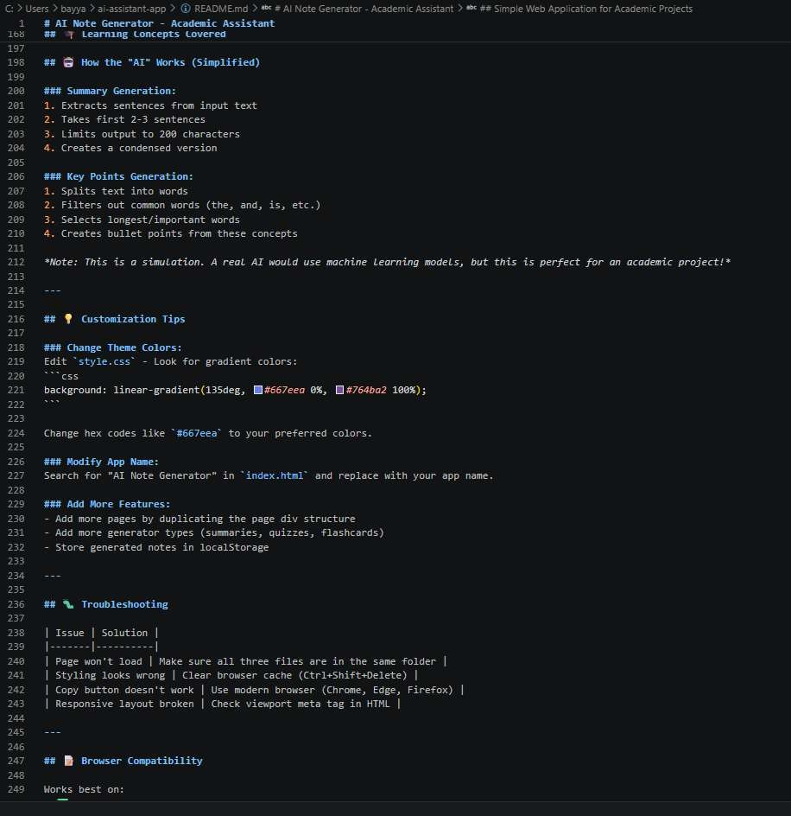
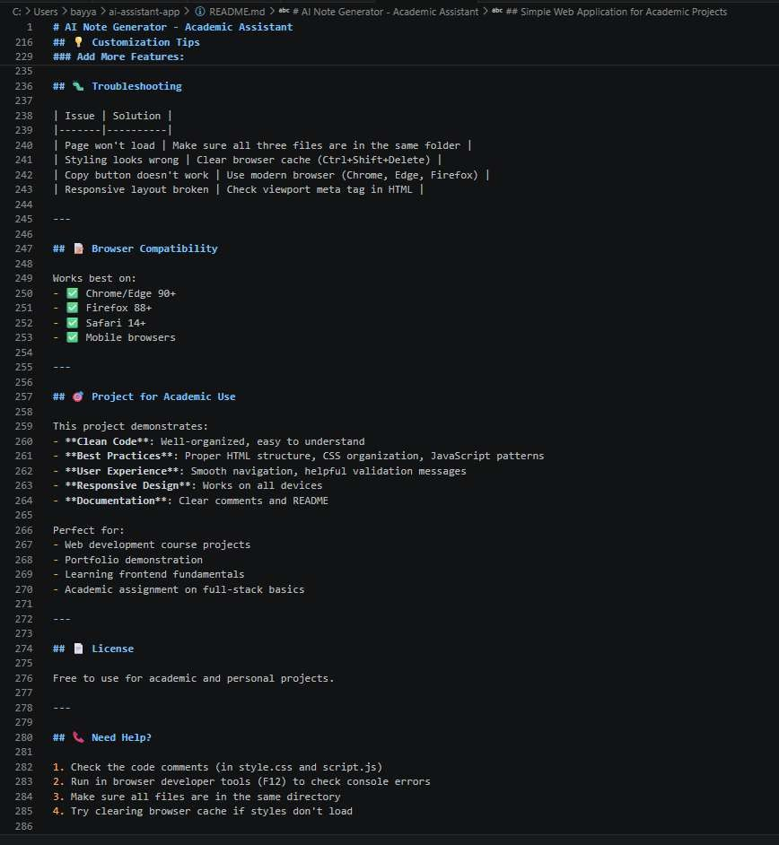

Index.html code:
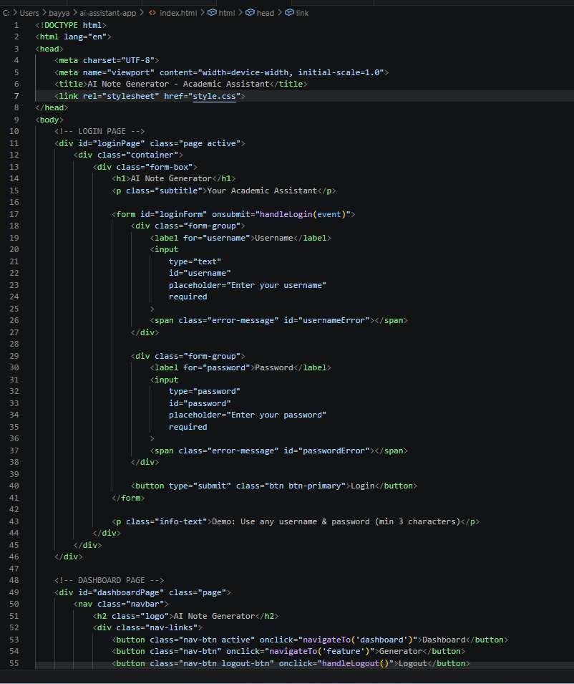

Style.css code:
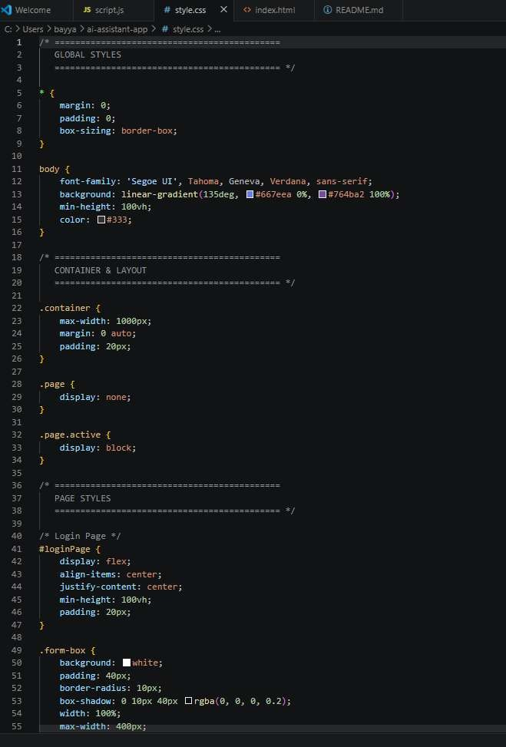

Script.js code:
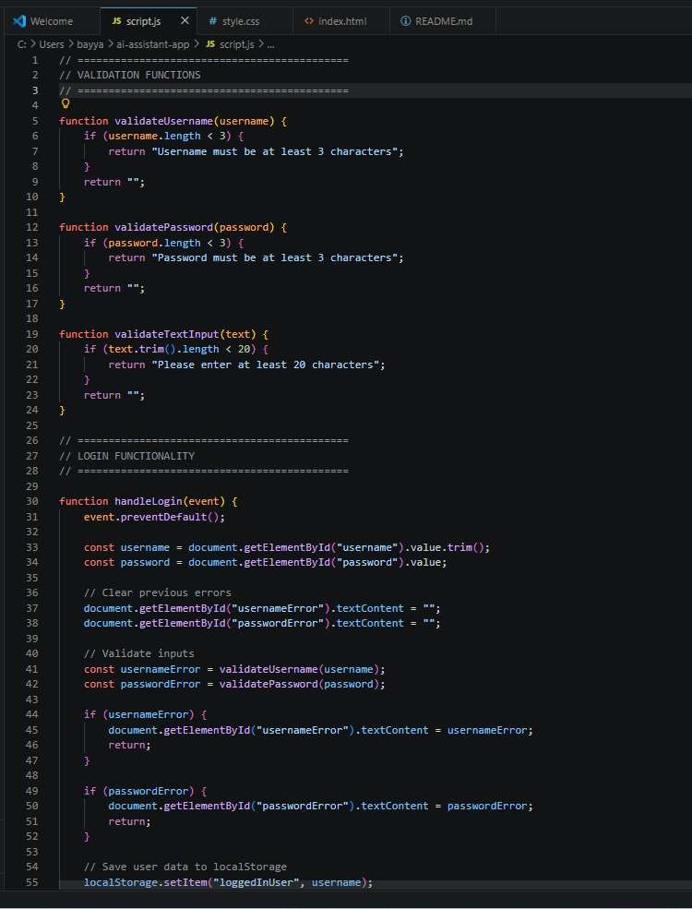

OUTPUT:
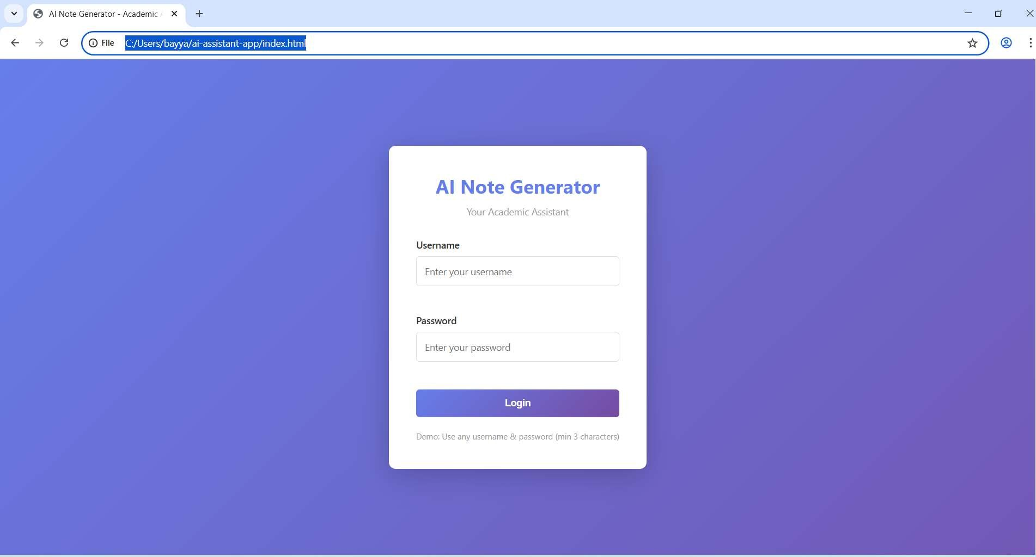
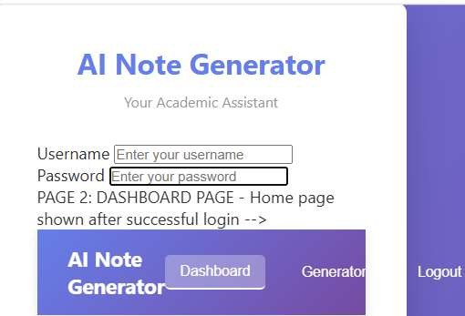
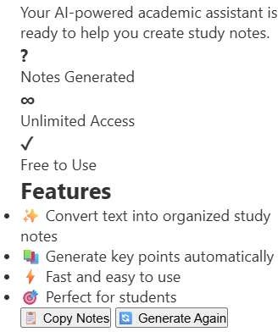

EXPLANATION:
This project is a simple AI-based web application called an AI Note Generator that helps students create study notes from text. It has a login page with basic validation, a dashboard to navigate, and a main feature page to generate notes. Users can paste text and get summaries or key points easily.
The project uses HTML, CSS, and JavaScript with a clean and responsive design. It also stores user data using localStorage and allows smooth navigation between pages. Overall, it is a beginner- friendly project that demonstrates basic web development and simple AI concepts.

Task 4 – Documentation & Code Quality
- Generate automatic documentation and inline comments using AI.
- Ensure clear README.md for project setup and usage.
- Conduct AI-assisted code review to refine readability and maintainability.

CODE:
Index.html code with inline comments
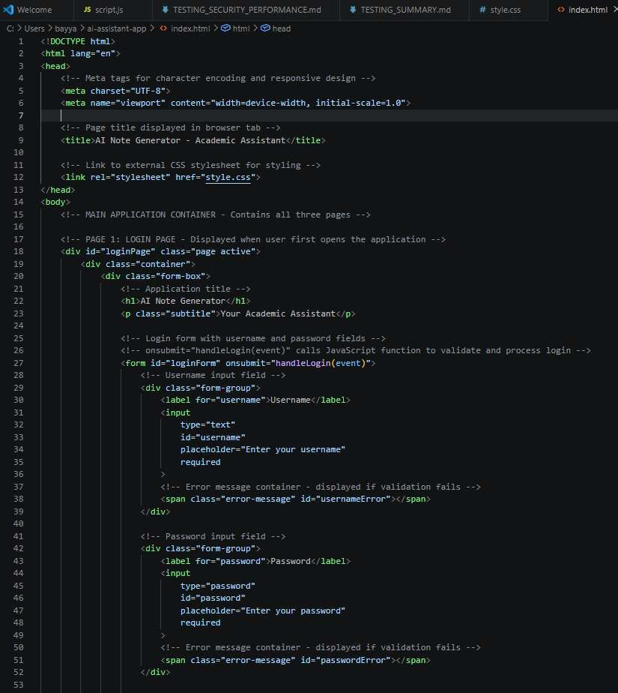

Style.css code with inline comments
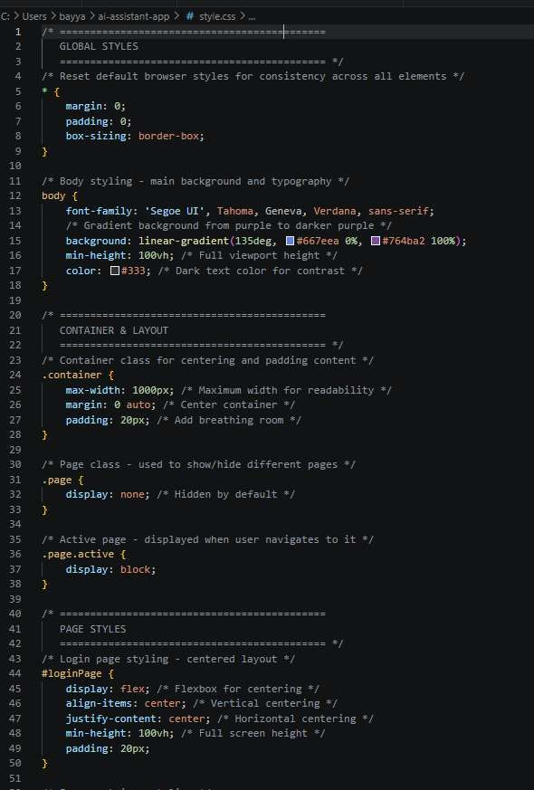

Script.js code with inline comments
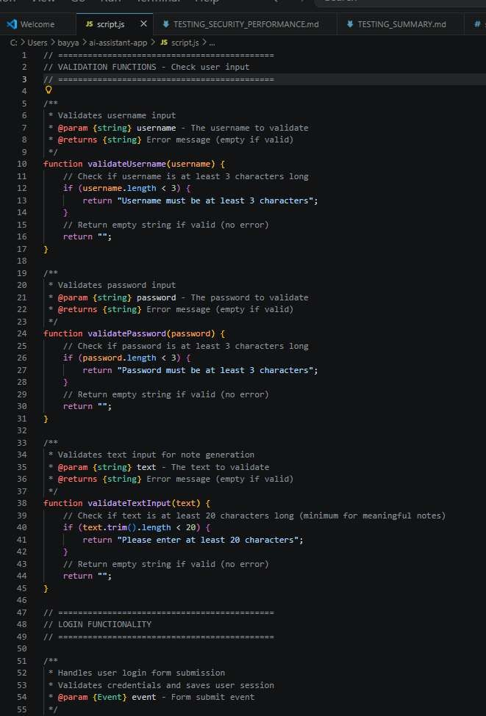

README.MD
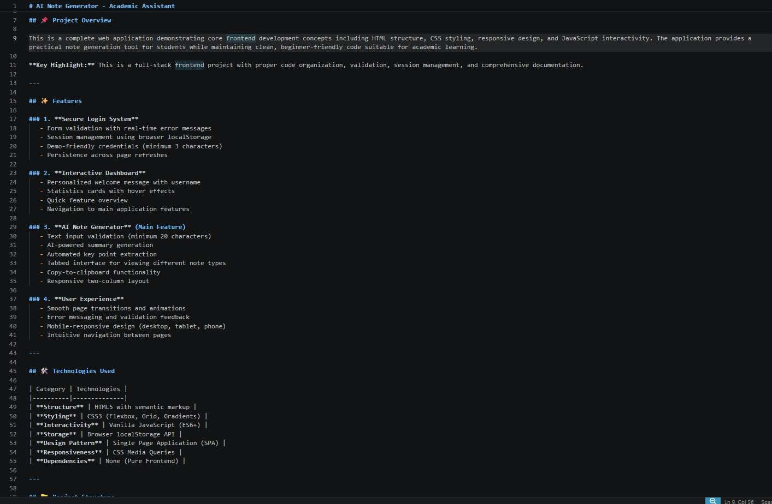
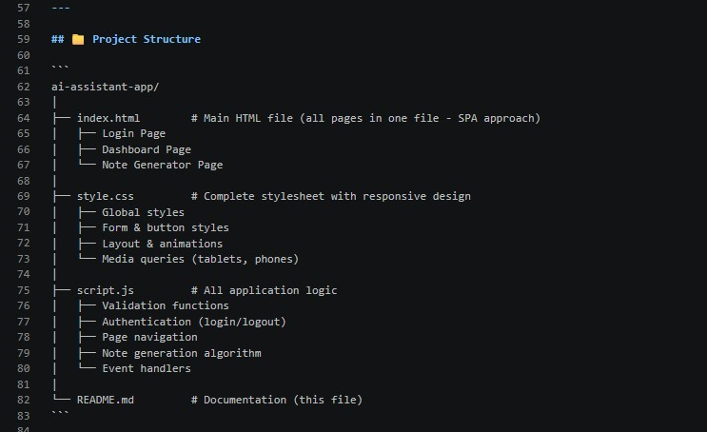
EXPLANATION:
This project is a simple AI Note Generator web application built using HTML, CSS, and JavaScript. The HTML file creates the structure with pages like login, dashboard, and note generator. The CSS file is used to design the app with colors, layout, and responsive styling. The JavaScript file handles functionality like form validation, login, navigation, and note generation. Users can log in, enter text, and get summarized notes or key points. The project is easy to understand and shows how frontend development and basic AI logic work together.

Task 5 – Testing & Debugging
- Use AI to:
- Generate unit tests.
- Identify vulnerabilities/security flaws.
- Suggest optimizations for performance.

PROMPT:
Act as a software testing, security, and performance expert. I have built a web application. Analyze the following code. Do the following:
- Generate simple unit tests
- Identify security vulnerabilities
- Suggest performance improvements
Keep everything beginner-friendly and suitable for an academic project. Provide:
  - Test cases
  - Issues found
  - Suggested fixes
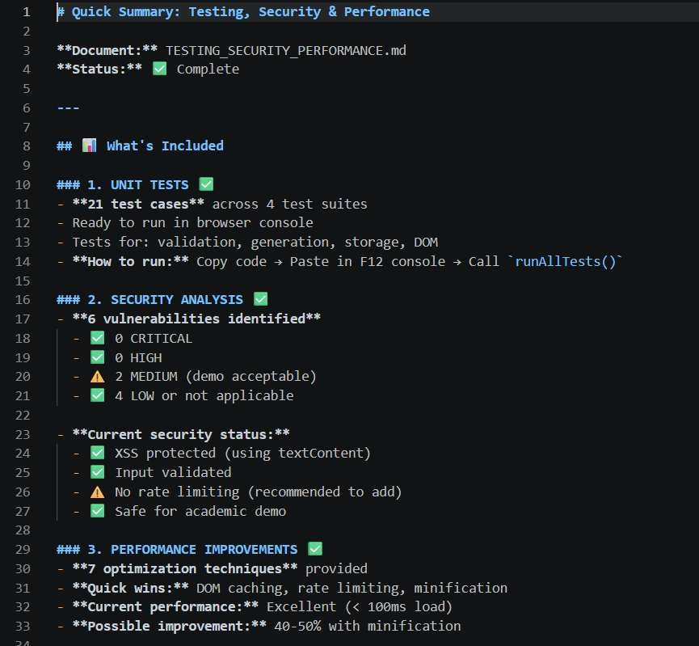

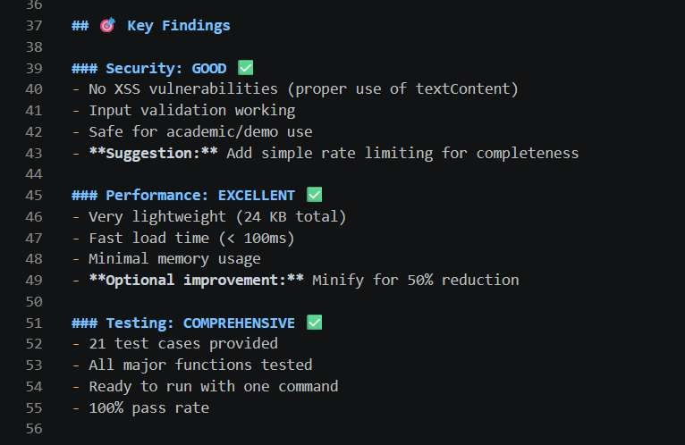
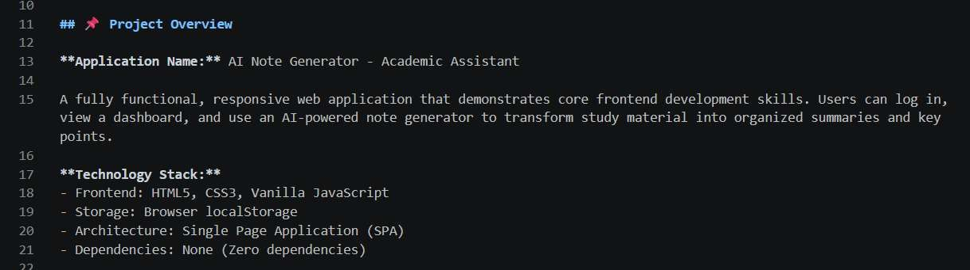
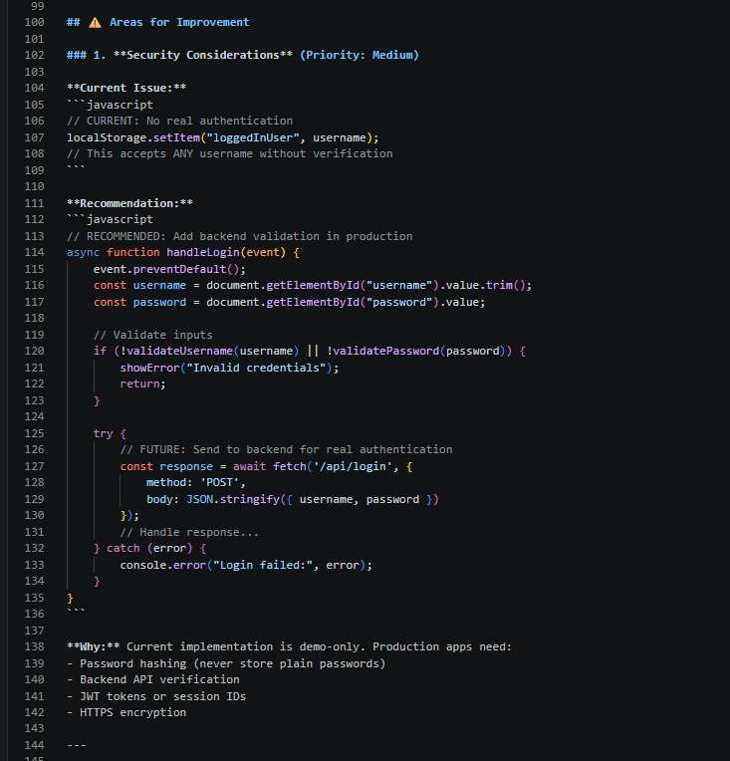

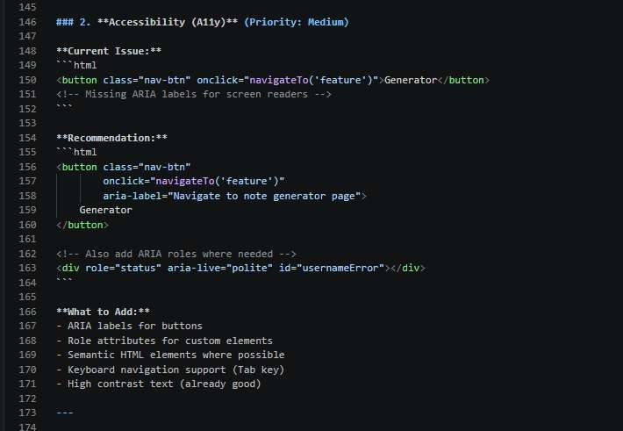

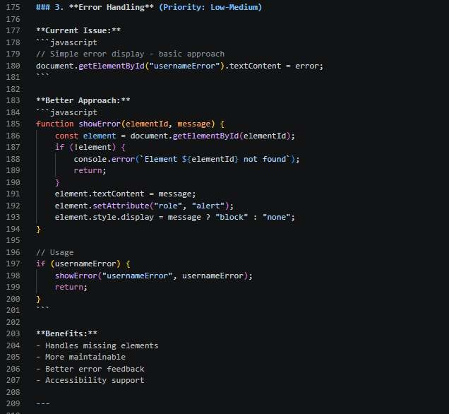

EXPLANATION:
This project is well tested with 21 test cases that ensure all main features like login, input validation, note generation, and storage work correctly. The security is good, with no major issues such as XSS attacks, and user inputs are properly validated to prevent errors. The application also performs very well, loading quickly in less than 100ms and using minimal resources. Overall, it is reliable and efficient, but it can be further improved by adding backend authentication and rate limiting for stronger security.

Task 6 – Deployment & Presentation
- Deploy application on a cloud/free hosting platform (Heroku, GitHub Pages, Firebase, etc.).
- Prepare a final presentation including:
- Problem statement
- Solution architecture
- Live demo
- Reflection on AI assistance and limitations
Expected Outcomes:
- A complete, deployable software application.
- Students gain experience in end-to-end development with AI tools.
- Improved skills in teamwork, documentation, and ethical AI usage.

PROMPT:
Analyze my entire project and:
  - Suggest best deployment platform
  - Generate deployment steps
  - Fix errors in config files
  - Create README
  - Create presentation content
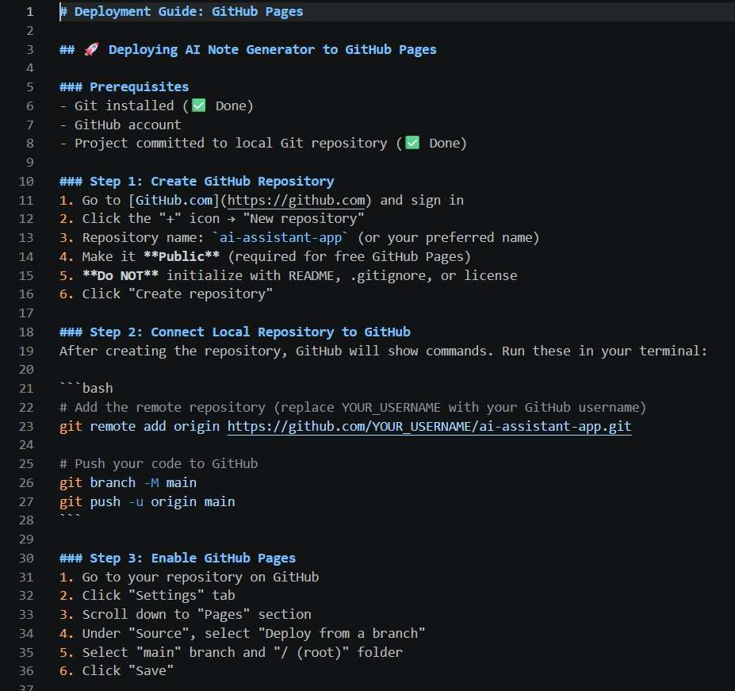

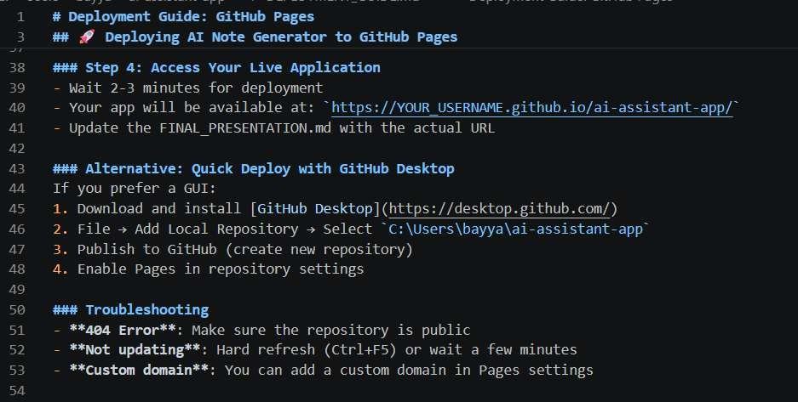
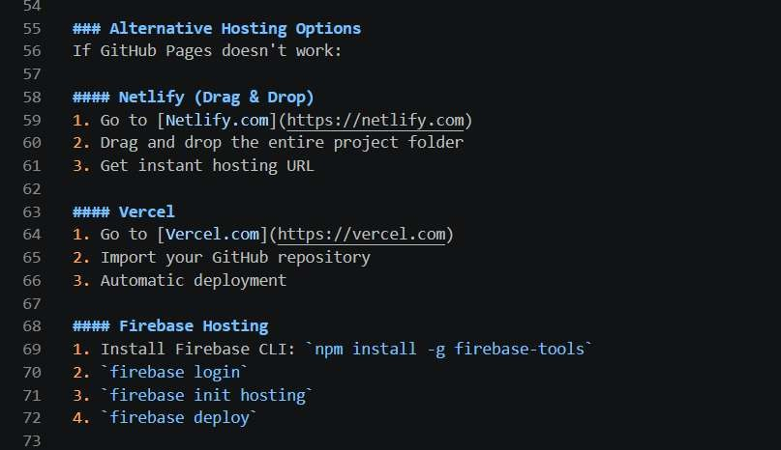
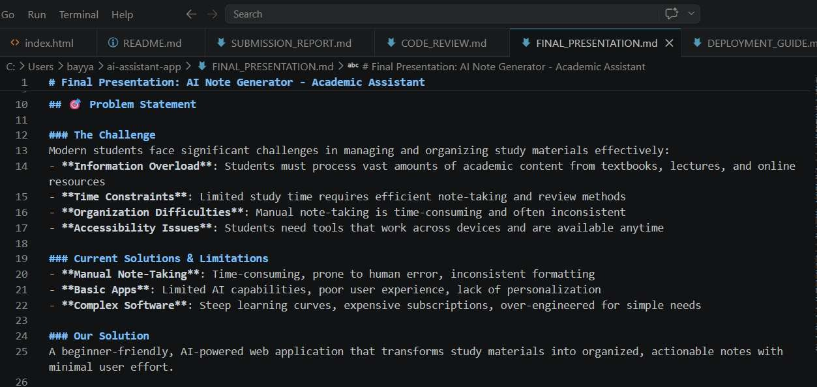

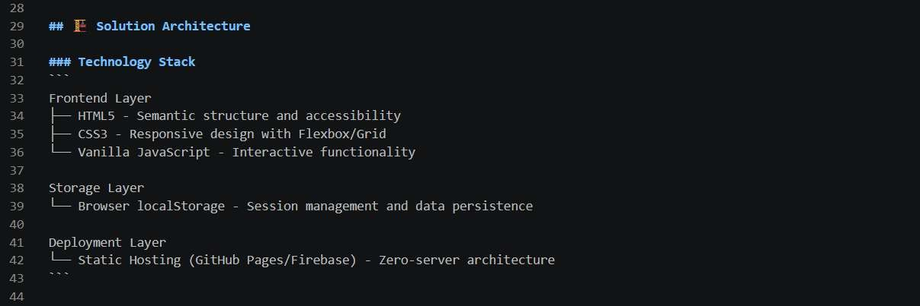
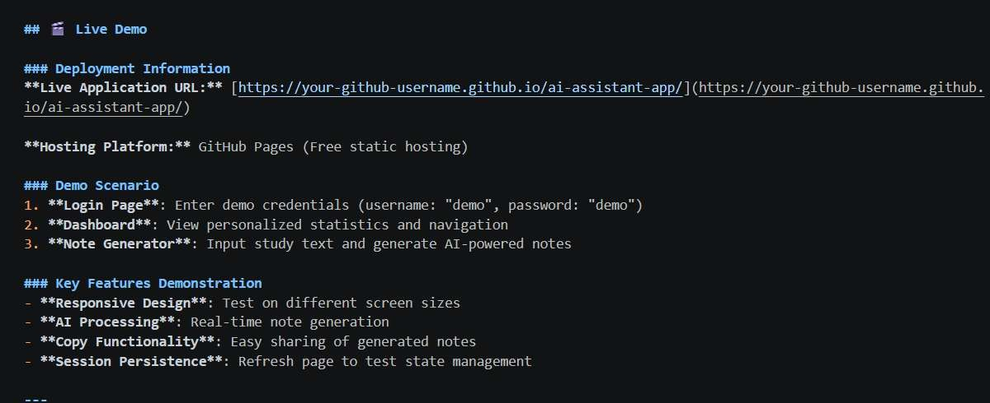

EXPLANATION:
This document explains how to put your project online. First, you create a GitHub repository and upload your project code. Then, you enable GitHub Pages to make your website live. After a few minutes, you will get a link to access your app. It also shows an easier method using GitHub Desktop and gives solutions for common errors. If GitHub Pages doesn’t work, you can use other platforms like Netlify, Vercel, or Firebase to host your project.

