AI ASSISTED CODING
Assignment -13.2
Name : Shivayamini
Hall ticket No : 2303A52475
Batch-38

Lab 13: Code Refactoring – Improving Legacy Code with AI
Suggestions
Lab Objectives:
• Identify code smells and inefficiencies in legacy Python scripts.
• Use AI-assisted coding tools to refactor for readability,
maintainability, and performance.
• Apply modern Python best practices while ensuring output
correctness.
Task Description -1 (Refactoring – Eliminating Repetitive Logic)
• Task: Use AI-assisted coding techniques to restructure a Python
program that performs repeated calculations, transforming it into
a reusable and maintainable design.
Instructions:
• Ask AI to locate repeated computations within the program.
• Encapsulate repeated logic into reusable functions.
• Verify that program output remains unchanged after refactoring.
• Add proper docstrings to all defined functions.
Sample Code:
length = 8
width = 4
print("Area:", length * width)
print("Perimeter:", 2 * (length + width))
length = 12
width = 6
print("Area:", length * width)
print("Perimeter:", 2 * (length + width))
Expected Output:
A refactored Python script that uses a single reusable function to
compute area and perimeter without repeating code.
Prompt:
by using the following code provided restructure a Python
program that performs repeated calculations, transforming it into
a reusable and maintainable design

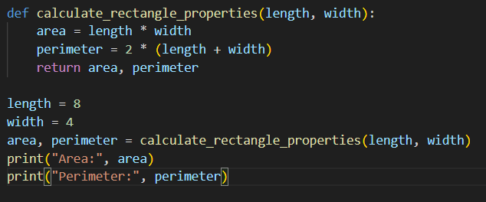

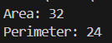

Explanation:
The code defines a function calculate_rectangle_properties(length, width) to compute the area and perimeter of a rectangle. Inside the function, the area is calculated using length × width and the perimeter using 2 × (length + width), and both values are returned. The function is then called with length = 8 and width = 4, and the returned values are stored in area and perimeter. Finally, the program prints the results in the terminal as Area: 32 and Perimeter: 24.

Task Description -2 (Refactoring – Modularizing Inline
Calculations)
• Task: Use AI to refactor a Python script by extracting repeated
inline calculations into reusable and well-documented functions.
Instructions:
• Identify repeated calculation patterns in the code.
• Convert them into reusable functions.
• Ensure readability and proper documentation.
Sample Code:
amount = 1000
discount = amount * 0.10
final_amount = amount - discount
print("Final Amount:", final_amount)
amount = 2000
discount = amount * 0.10
final_amount = amount - discount
print("Final Amount:", final_amount)
Expected Output:
A modular Python program that uses a reusable function to compute
final amounts for different inputs.
Prompt:
by using the following code provided refactor a Python script by extracting repeated
inline calculations into reusable and well-documented functions.
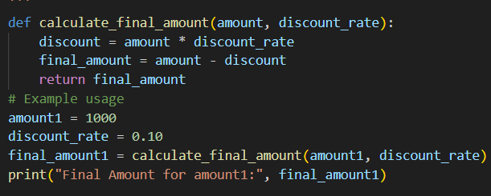
Output:

Explanation:
The code defines a function calculate_final_amount(amount, discount_rate) to calculate the final price after applying a discount. Inside the function, the discount is calculated using amount × discount_rate, and the final amount is obtained by subtracting the discount from the original amount. The function returns the final amount, which is stored in final_amount1 when called with amount1 = 1000 and discount_rate = 0.10. The program then prints the result, producing the output Final Amount for amount1: 900.0.

Task Description -3 (Refactoring – Improving Loop and
Conditional Performance)
• Task: Apply AI-based suggestions to enhance the performance of
Python code that relies on nested loops and repeated conditional
checks.
Instructions:
• Use AI to recommend more efficient data structures or logic
simplifications.
• Replace inefficient constructs while preserving program behavior.
• Compare execution efficiency before and after refactoring.
Sample Code:
students = ["Anil", "Bhavya", "Charan", "Divya"]
check_list = ["Charan", "Esha", "Bhavya"]
for name in check_list:
exists = False
for student in students:
if name == student:
exists = True
if exists:
print(name, "found")
else:
print(name, "not found")
Expected Output:
An optimized Python program that performs faster lookups using
efficient logic, along with execution performance comparison.
Prompt:
by using the following code provided enhance the performance of
Python code that relies on nested loops and repeated conditional checks
by the following instructions:
1)recommend more efficient data structures or logic simplifications
2)Replace inefficient constructs while preserving program behavior.
3)Compare execution efficiency before and after refactoring.
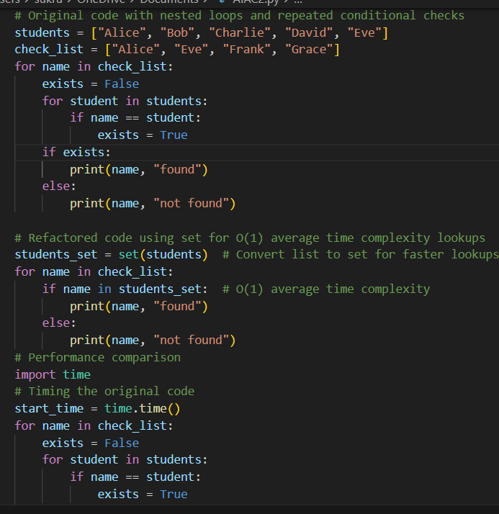

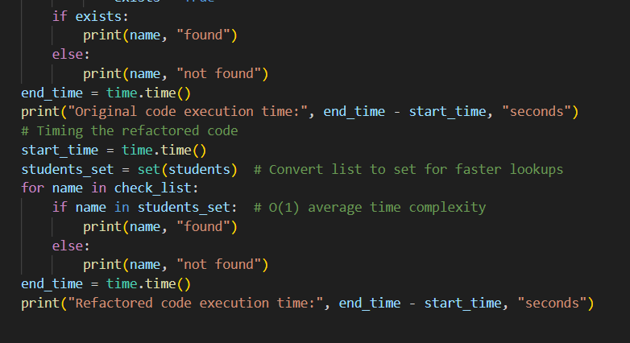
Output:
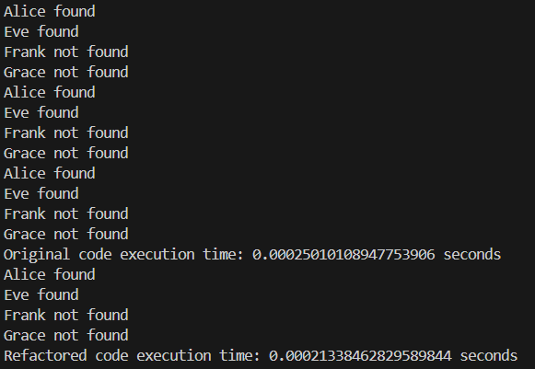
Explanation:
The program checks whether names in check_list exist in the students list. In the original code, nested loops are used to compare each name with every student and print whether it is found or not found. The refactored version improves efficiency by converting the list into a set and using the in operator for faster lookup with O(1) average time complexity. The output shows which names are found (Alice, Eve) and not found (Frank, Grace), and also displays the execution time of both the original and refactored code, where the refactored code runs slightly faster.
Task Description -4 (Refactoring – Replacing Hardcoded Values
with Constants)
• Task: Utilize AI assistance to improve maintainability by
replacing hardcoded numerical values with named constants.
Instructions:
• Detect hardcoded numeric values used directly in expressions.
• Define descriptive constants at the beginning of the program.
• Update calculations to use these constants without changing
results.
Sample Code:
print("Simple Interest:", (1000 * 2 * 5) / 100)
print("Simple Interest:", (2000 * 2 * 5) / 100)
Expected Output:
A revised Python program using constants such as RATE and TIME for
clearer and maintainable calculations..
Prompt:
by using the following code provided enhance the performance of
Python code that relies on nested loops and repeated conditional checks
by the following instructions:
• Detect hardcoded numeric values used directly in expressions.
• Define descriptive constants at the beginning of the program.
• Update calculations to use these constants without changing
Prompt:
by using the following code provided improve maintainability by
replacing hardcoded numerical values with named constants.
by the following instructions:
• Detect hardcoded numeric values used directly in expressions.
• Define descriptive constants at the beginning of the program.
• Update calculations to use these constants without changing

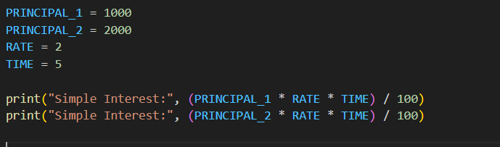
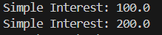
Explanation:
This Python program calculates simple interest for two principal amounts using the formula $(P×R×T)/100$. The values for principal, rate, and time are defined as constants at the beginning of the program instead of using numbers directly. This makes the code easier to read and maintain. The program then performs the calculation and prints the simple interest for both principal values.

Task Description -5 (Re factoring – Enhancing Variable Naming
and Code Clarity)
• Task: Apply AI tools to improve code readability by renaming
unclear variables and adding meaningful comments..
Instructions:
• Replace non-descriptive variable names with meaningful
identifiers.
• Add inline comments where the logic may be unclear.
• Ensure program output remains the same.
Sample Code:
x = 50
y = 30
z = x + y
print(z)
Expected Output:
A Python program with clear variable names and explanatory comments
that improve readability without altering functionality.
Note: Report should be submitted a word document for all tasks in a
single document with prompts, comments & code explanation, and
output and if required, screenshots

Prompt:
use the following code to improve code readability by renaming
unclear variables and adding meaningful comments..
Instructions:
• Replace non-descriptive variable names with meaningful
identifiers.
• Add inline comments where the logic may be unclear.
• Ensure program output remains the same.

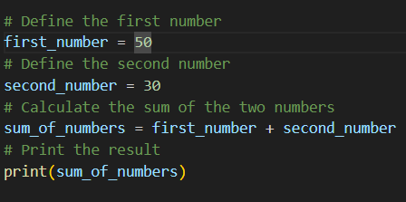
Output:

Explanation:
This Python program adds two numbers and prints their sum. The variables first_number and second_number store the values 50 and 30. The program then calculates the sum using sum_of_numbers = first_number + second_number. Meaningful variable names and comments are used to make the code easy to read and understand. Finally, the result is printed, showing the sum of the two numbers as 80.

