AI Assistant Coding
Assignment – 15.2
Name : Shivayamini
Hall ticket No: 2303A52475
Batch – 38
Lab 15 – Backend API Development: Creating RESTful services
with AI
Lab Objectives:
• Understand the fundamentals of RESTful API design.
• Use AI-assisted coding tools to generate backend services.
• Implement CRUD (Create, Read, Update, Delete) operations.
• Document endpoints with comments and auto-generated
Week8 -
Tuesday
documentation.
Task Descriptor-1: (Setup Fast API Backend )
Instructions:
• Install Fas tAPI and Uvicorn.
• Use AI to generate a basic FastAPI application with one endpoint
Sample Code:
from fastapi import FastAPI
app = FastAPI()
@app.get("/")
def read_root():
return {"message": "Welcome to AI-powered FastAPI"}
Expected Output:
Running the server and accessing:
http://127.0.0.1:8000/
Response:
{"message": "Welcome to AI-powered FastAPI"}
Prompt : Generate a simple FastAPI backend application in Python for a lab on RESTful API development. The API should include a basic GET endpoint “/” that returns the message "Welcome to AI-powered FastAPI" in JSON format. Also include instructions to run the server using Uvicorn and access it at http://127.0.0.1:8000/. Add clear comments explaining the code for beginners.
Code :
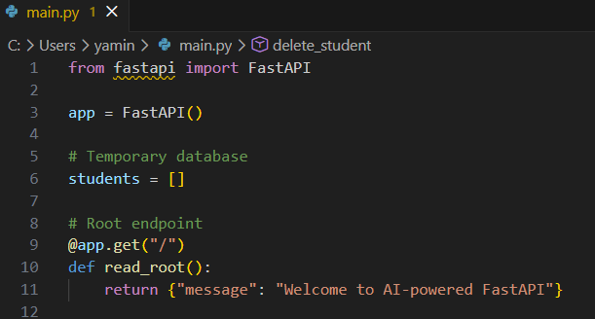
Terminal Commands ( we can run them in the command prompt too)! :
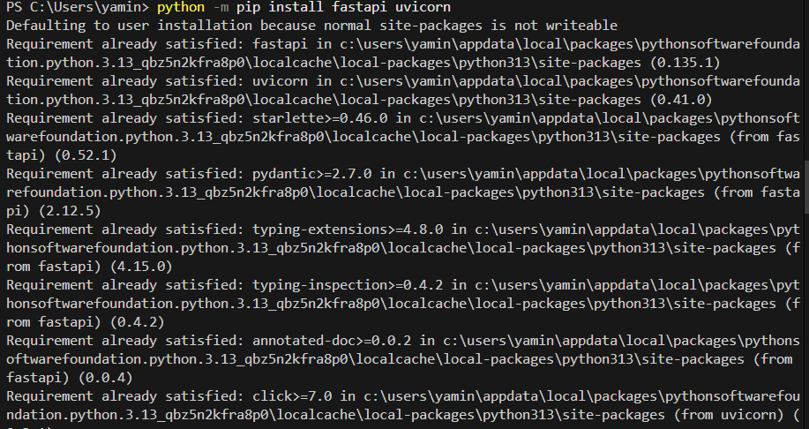
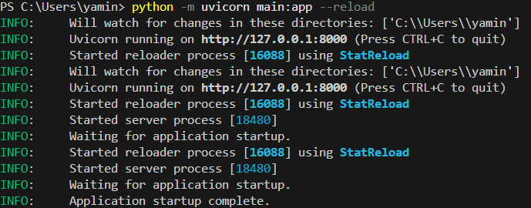

Output: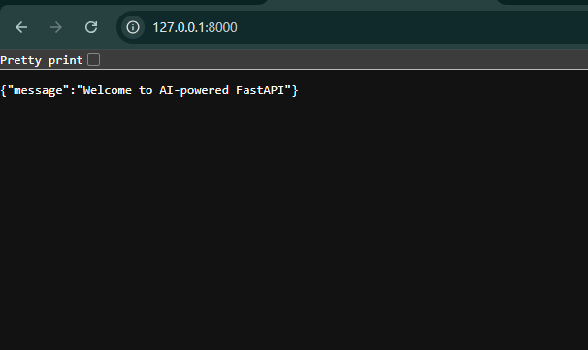
Explaination : Task 1 is about setting up a basic FastAPI backend application. In this task, FastAPI and Uvicorn are installed to create and run a RESTful API server. A simple FastAPI app is created with a GET endpoint “/” that returns a welcome message in JSON format. The server is started using Uvicorn, allowing the API to run locally at http://127.0.0.1:8000. When the root URL is accessed in a browser, it displays the message “Welcome to AI-powered FastAPI.” This task helps understand the basic setup and structure of a backend API.

Task Descriptor- 2: (API – Create and Read Items)
Instructions:
• Implement endpoints to add and retrieve products.
• Use a Python list as temporary storage.
Sample Code:
items = []
@app.get("/items")
def get_items():
return items
@app.post("/items")
def add_item(item: dict):
items.append(item)
return {"message": "Item created", "item": item}
Expected Output:
GET /items → []
POST /items with {"name":"Pen","price":20}
→ {"message":"Item created","item":{"name":"Pen","price":20}}

Prompt: Generate a simple FastAPI backend API in Python to create and read items. Use a Python list as temporary storage to store products. Implement two endpoints: GET /items to retrieve all items and POST /items to add a new item with name and price. Include beginner-friendly comments and return JSON responses.
Code :
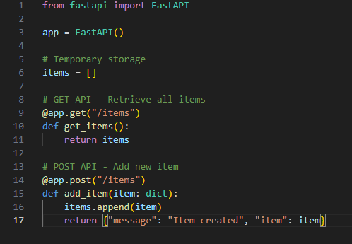

Output:
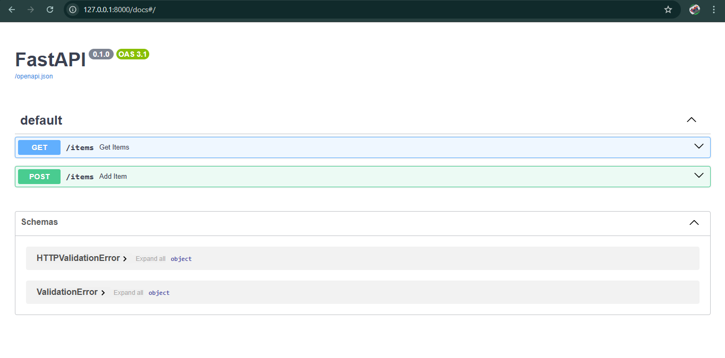
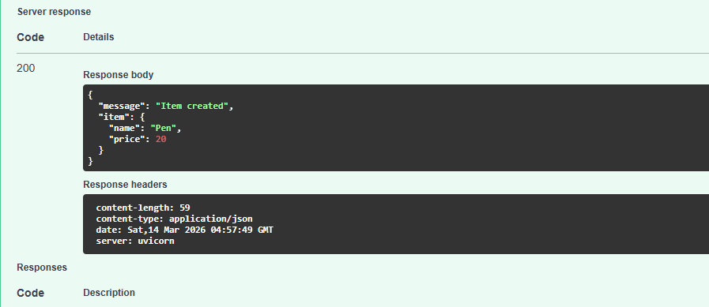

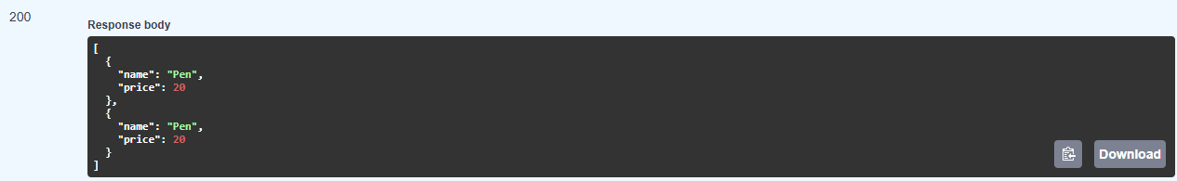
Explaination : Task 2 is on implementing Create and Read operations in a FastAPI application. A Python list called items is used as temporary storage to store product data. The GET /items endpoint retrieves and returns all the items stored in the list. The POST /items endpoint allows users to add a new item by sending its details, such as name and price, in JSON format. When a new item is added, it is appended to the list and a confirmation message is returned. This task demonstrates how REST APIs handle data creation and retrieval.

Task Descriptor- 3: (Update Existing Item)
Instructions:
• Use AI to generate an endpoint to update an item using its index.
Sample Code:
@app.put("/items/{index}")
def update_item(index: int, item: dict):
if index >= len(items):
return {"error": "Item not found"}
items[index] = item
return {"message": "Item updated", "item": item}
Expected Output:
PUT /items/0 with {"name":"Pencil","price":10}
→ {"message":"Item updated","item":{"name":"Pencil","price":10}}

Prompt: Generate a FastAPI endpoint in Python to update an existing item using its index in a list. Use a Python list called items as temporary storage. Implement a PUT /items/{index} endpoint that checks whether the index exists and updates the item. Return a JSON response with a success message or an error if the item is not found.
Code :
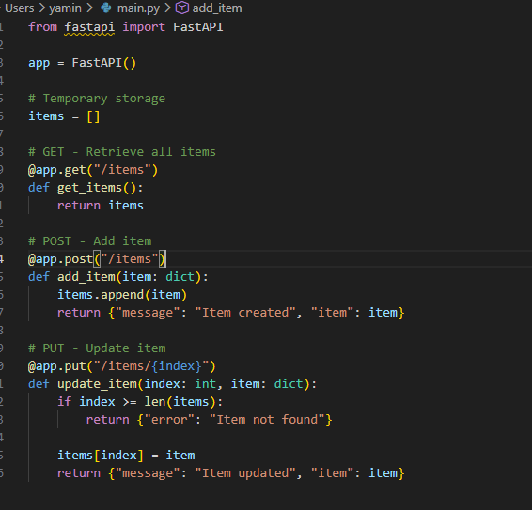
Output :
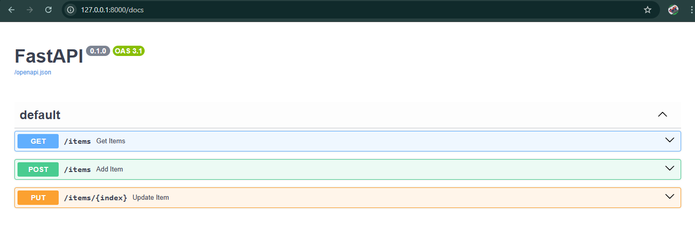
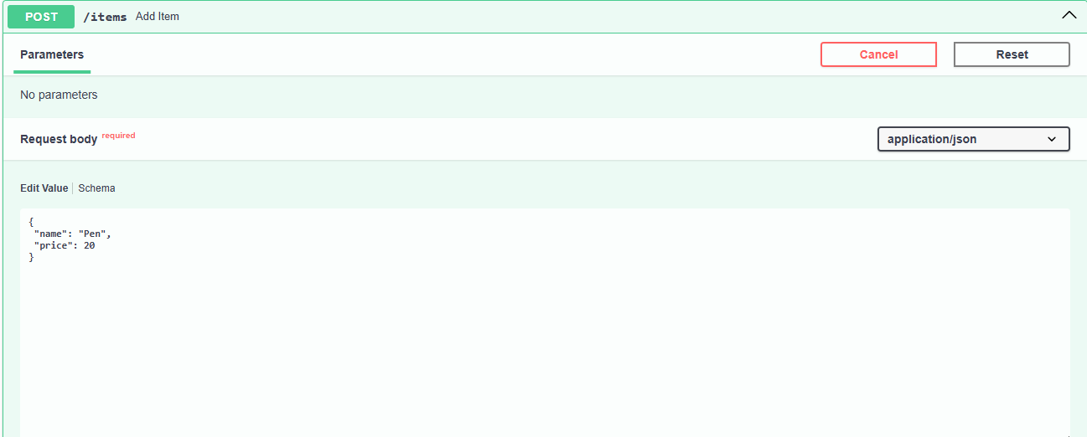
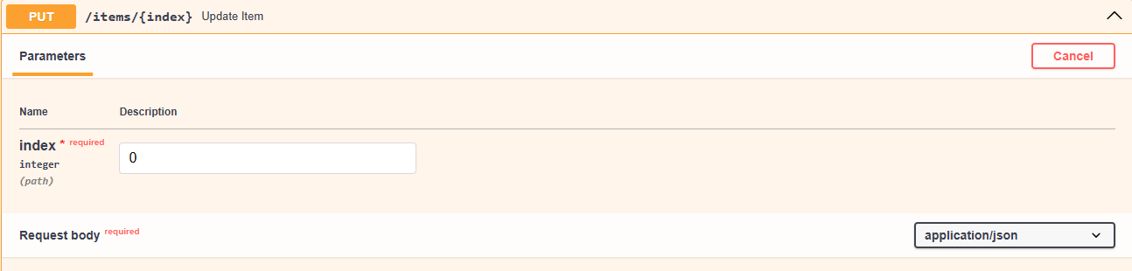
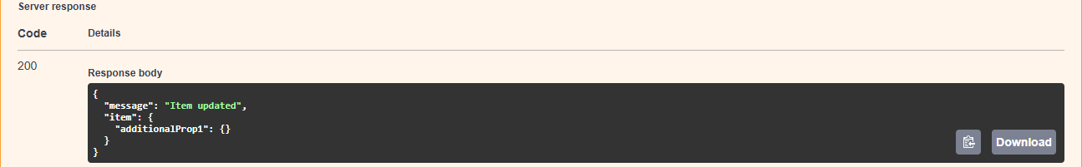

Explaination : In Task 3, we implement an Update operation in the FastAPI application. The endpoint PUT /items/{index} is used to modify an existing item stored in the items list. The user provides the index of the item and the new item data in the request body. The program first checks whether the given index exists in the list; if not, it returns an error message. If the index is valid, the item at that position is replaced with the new data and a confirmation message is returned. This demonstrates how REST APIs can update existing resources.
Task Descriptor- 4: (Delete Item)
Instructions:
• Implement deletion of an item by index.
Sample Code:
@app.delete("/items/{index}")
def delete_item(index: int):
if index >= len(items):
return {"error": "Item not found"}
removed = items.pop(index)
return {"message": "Item removed", "item": removed}
Expected Output:
DELETE /items/0
→ {"message":"Item removed","item":{"name":"Pencil","price":10}}

Prompt : Generate a FastAPI endpoint in Python to delete an item from a list using its index. Use a Python list named items as temporary storage. Implement a DELETE /items/{index} endpoint that checks whether the index exists before removing the item. If the index is valid, remove the item using pop() and return a confirmation message. If not, return an error message saying "Item not found".
Code :
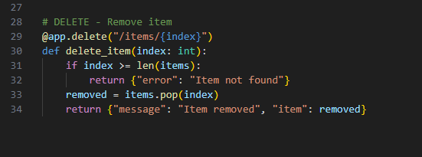

Output :
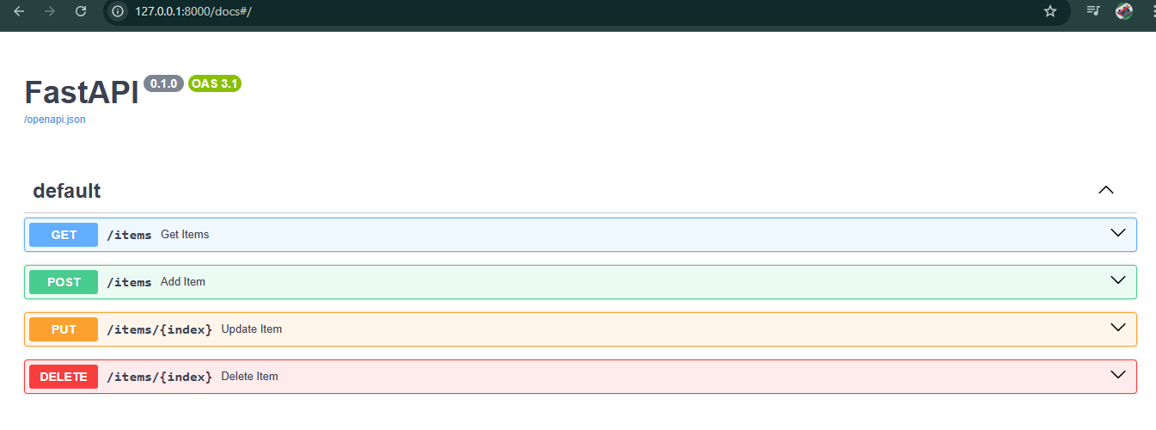
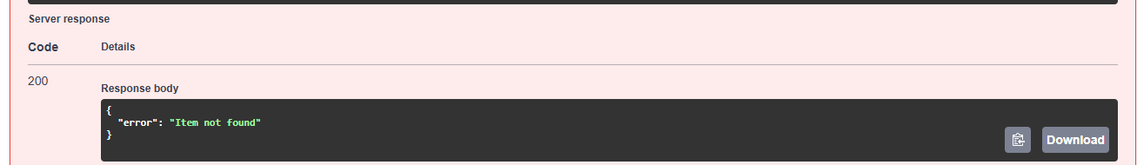

Explaination : Task Descriptor-4 implements the Delete operation in the FastAPI application. The endpoint DELETE /items/{index} is used to remove an item from the items list based on its index. The program first checks whether the given index exists in the list to avoid errors. If the index is invalid, the API returns an “Item not found” message. If the index is valid, the item is removed using the pop() method and the deleted item is returned in the response. This task completes the CRUD operations (Create, Read, Update, Delete) in the REST API.

Task Descriptor -5: (Add Auto-Generated Documentation)
Instructions:
• Use AI to add inline comments and docstrings for all endpoints.
• Optionally, integrate Swagger / Flask-RESTX to auto-generate
API documentation.
Sample Code:
@app.route('/items', methods=['GET'])
def get_items():
"""
GET /items
Returns a list of all items in the store.
Prompt : Generate a FastAPI application in Python with CRUD endpoints for items. Add clear inline comments and docstrings for each endpoint explaining its purpose, parameters, and responses. Ensure the documentation appears automatically in Swagger UI using FastAPI’s built-in documentation system. The endpoints should include GET, POST, PUT, and DELETE operations for managing items.
Code :
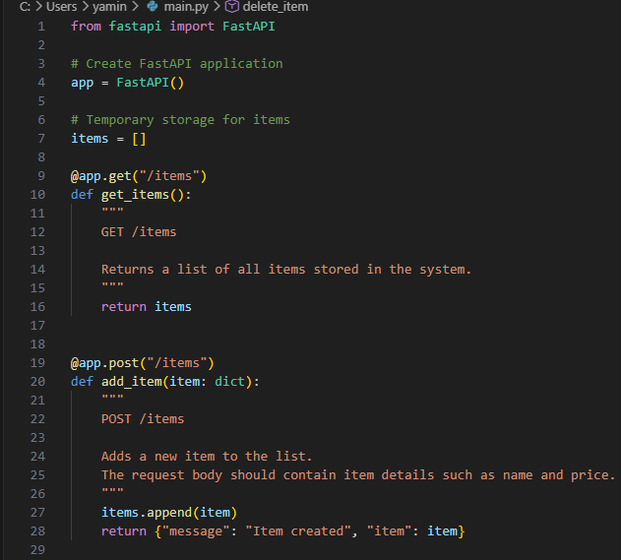
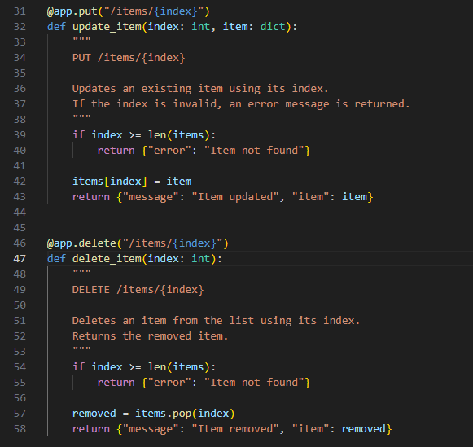

Output :
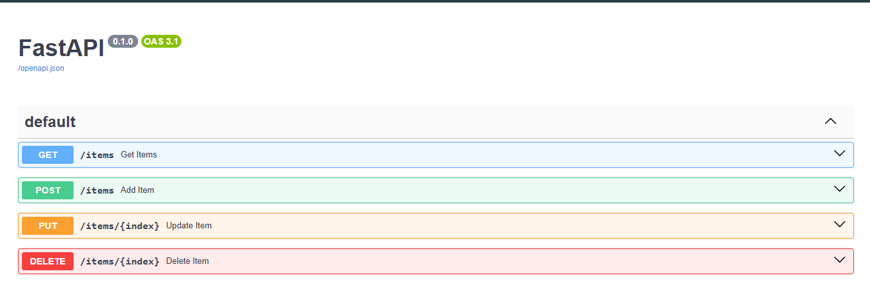
Explaination : Task Descriptor-5 focuses on adding documentation to API endpoints. Inline comments and docstrings are written inside the code to describe what each API does, its parameters, and responses. FastAPI automatically reads these docstrings and generates interactive API documentation using Swagger UI. This documentation appears at /docs and allows developers to understand and test the APIs easily. It improves readability, usability, and maintenance of the backend service.

