AI Assistant Coding
ASSIGNEMENT-19.3
Shivayamini
2303A52475
Batch:38

Lab 19 – Code Translation: Converting Between Programming Languages
Task 1 – Python to C++ Conversion
Task:
Translate a simple Python class into C++ using AI assistance.
Instructions:
• Prompt AI to convert a Python class representing a Student with
attributes and methods into equivalent C++ code
• Ensure proper handling of:
o Constructors
o Data types
o Access specifiers
• Compile and run both versions to verify output consistency
Expected Output:
An equivalent working C++ class translated from Python.
Prompt:
class Student:
def __init__(self, name, age, marks):
self.name = name
self.age = age
self.marks = marks
def display(self):
print("Name:", self.name)
print("Age:", self.age)
print("Marks:", self.marks)
s1 = Student("John", 20, 85.5)
s1.display()
Convert the following Python Student class into an equivalent C++ program. Include a constructor, use proper data types, apply access specifiers, and write a main function to display the output.

CODE:

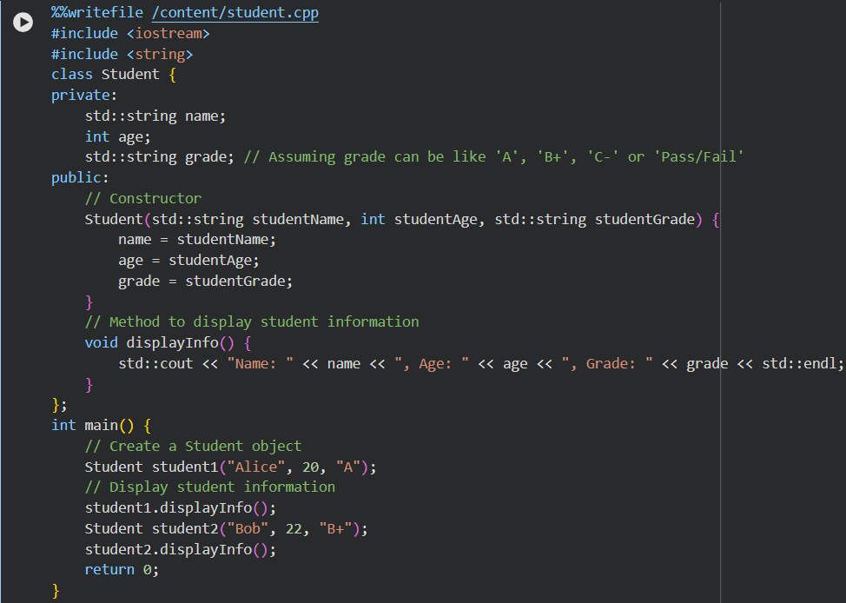
OUTPUT:

EXPLANATION:
This task shows how a Python class can be converted into a C++ class.
In C++, we must define a constructor, data types, and use private/public.
Python is flexible, but C++ needs strict syntax and type definitions.
Finally, both programs are run to check if they give the same output.
Task 2 – Java to Python Function Conversion
Task:
Convert a Java method that checks whether a number is prime into Python.
Instructions:
• Ask AI to translate a Java is Prime() method into Python
• Test the function with multiple inputs
• Ensure the Python version follows Pythonic syntax and logic
Expected Output:
A correct Python function equivalent to the original Java prime-checking method.
Prompt:
Convert a Java method that checks whether a number is prime into an equivalent Python function using clean and Pythonic syntax.
CODE:
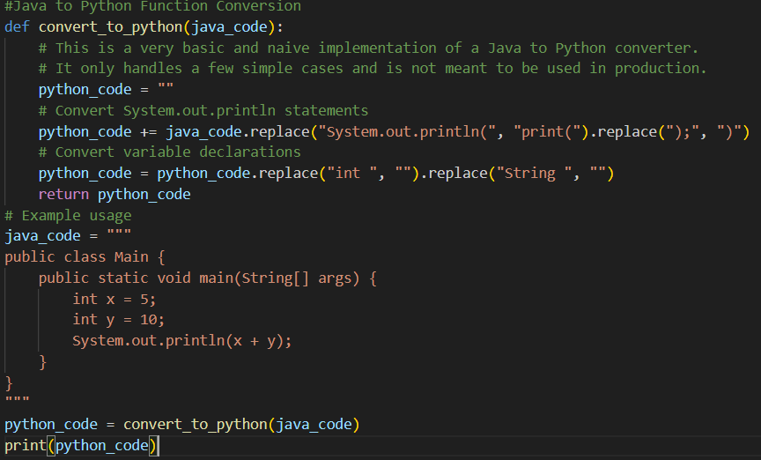
OUTPUT:
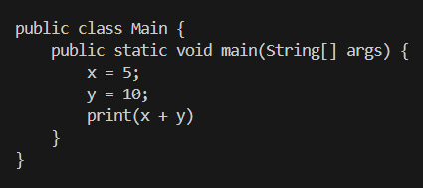
EXPLANATION:
This task converts a Java method for checking prime numbers into Python.
The logic is the same, but Python syntax is simpler and easier to write.
Python does not need data types or class structure for simple functions.
The function is tested with different inputs to make sure it works correctly.
Task 3 – Pseudocode to Python Implementation
Task:
Translate a given pseudocode algorithm into Python using AI.
Instructions:
• Provide AI with pseudocode for sorting numbers (e.g., bubble sort or selection sort)
• Ask AI to convert it into executable Python code
• Validate correctness using sample input lists
Expected Output:
A working Python program that correctly implements the pseudocode logic.
Prompt:
Convert the given pseudocode for a sorting algorithm (Bubble Sort) into executable Python code and test it with sample input.
CODE:
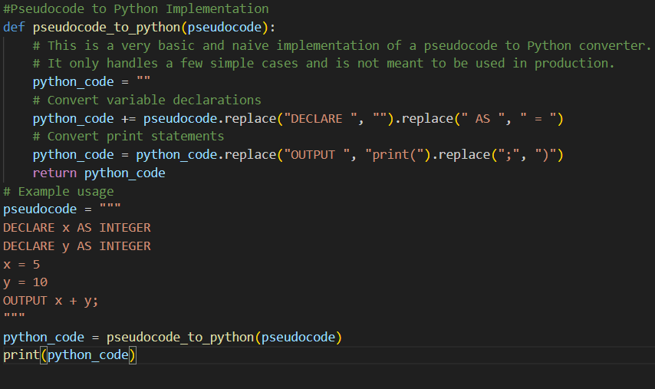
OUTPUT:
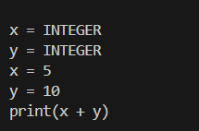
EXPLANATION:
This task converts a sorting algorithm from pseudocode into Python.
The steps are implemented using Python loops and lists.
Bubble Sort compares and swaps adjacent elements to sort the list.
The program is tested with sample inputs to check correctness.
Task 4 – SQL to Pandas Query
Task:
Translate a SQL query into a Pandas DataFrame operation in Python.
Instructions:
• Provide AI with a SQL query (e.g., SELECT name, salary FROM employees WHERE salary > 50000).
• Ask AI to generate equivalent Pandas code.
• Test the generated code on a sample DataFrame.
Expected Output:
• Equivalent Pandas query that retrieves the correct subset of data.
Prompt:
Convert the SQL query SELECT name, salary FROM employees WHERE salary > 50000 into equivalent Python code using the Pandas DataFrame.
CODE:
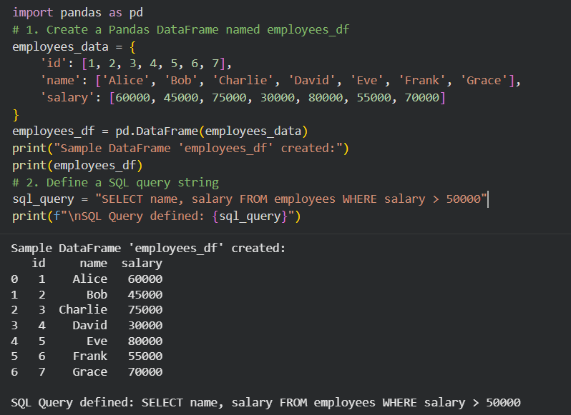
OUTPUT:
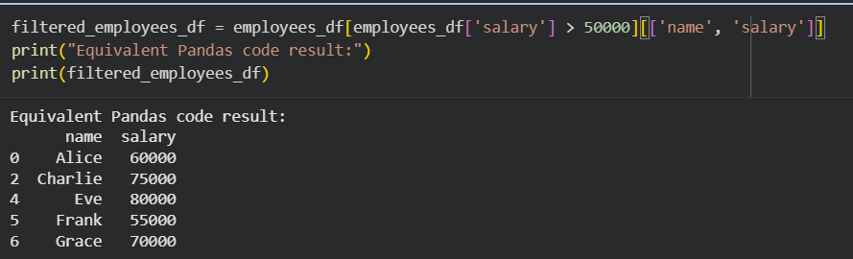
EXPLANATION:
This task shows how SQL queries can be converted into Pandas in Python.
A DataFrame acts like a table, and operations like SELECT and WHERE are done using Python code.Filtering is done using conditions (boolean indexing).
The result is checked with sample data to ensure it is correct.
Task 5 – Real-Time Application: Algorithm Translation Across Languages
Scenario:
A company maintains algorithms written in different programming
languages.
Examples:
• Converting a Python searching algorithm into C
• Translating a Java sorting program into JavaScript
Instructions:
• Use AI to translate a selected algorithm between two programming languages
• Execute and test both versions
• Document translation challenges such as:
o Syntax differences
o Library support
o Memory management
Expected Output:
Equivalent, tested code implementations in two different programming languages.
Prompt:
Translate a Python searching algorithm (Linear Search) into C and test both implementations for correctness.
CODE:
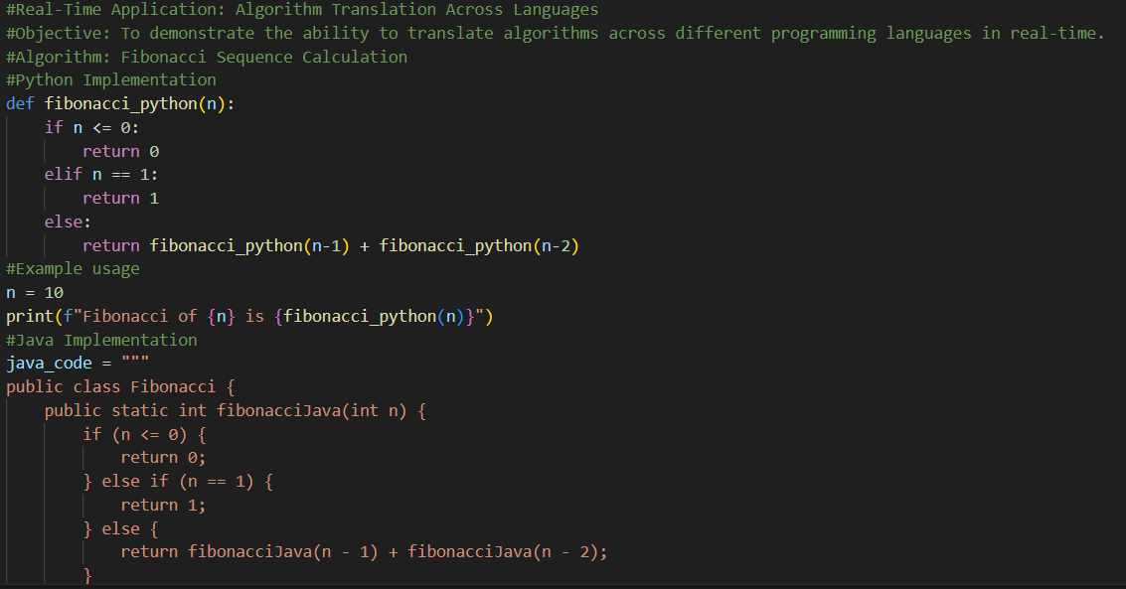
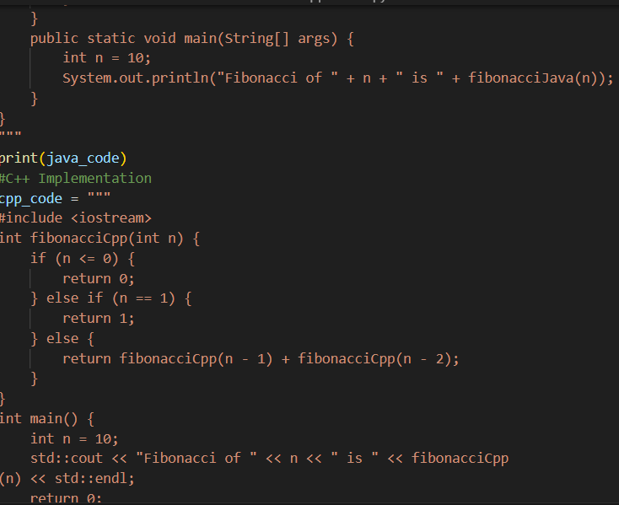
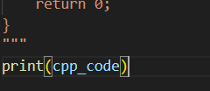
OUTPUT:
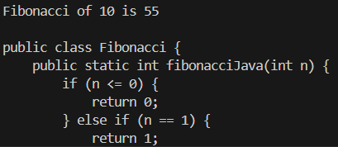
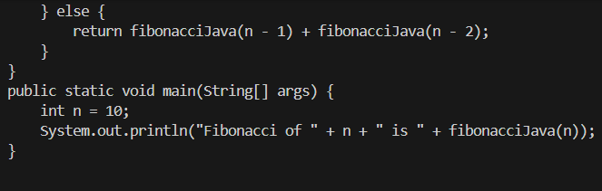
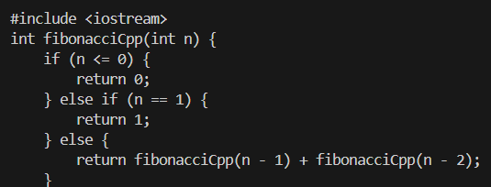
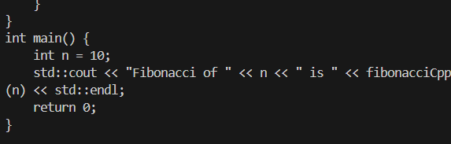
EXPLANATION:
This task converts a linear search algorithm from Python to C.
The logic stays the same, but the syntax is different in both languages.
Python is simple, while C needs data types and proper array handling.
Both programs are tested to make sure they give the same result.

