JAVA DEVELOPMENT 2
YAMINI KUNAPAREDDY (500234808)
Assignment_Report.docx

Code of exception handling for the Calculator.
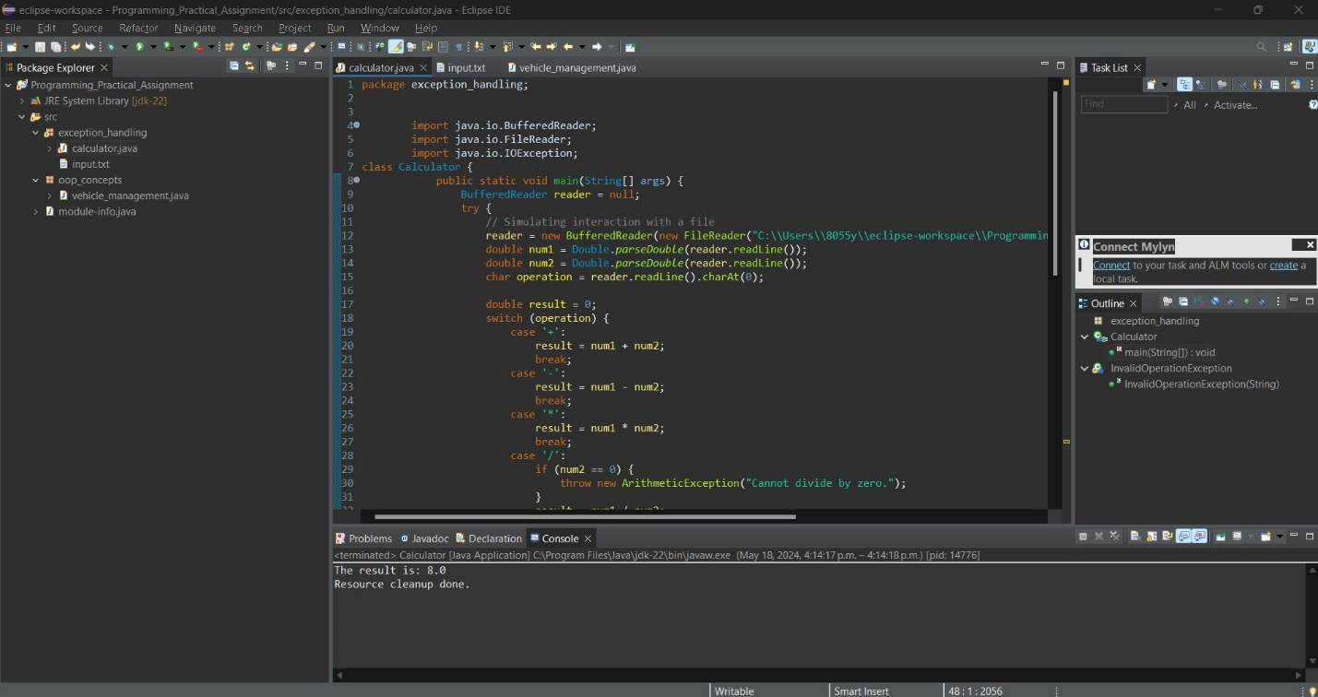

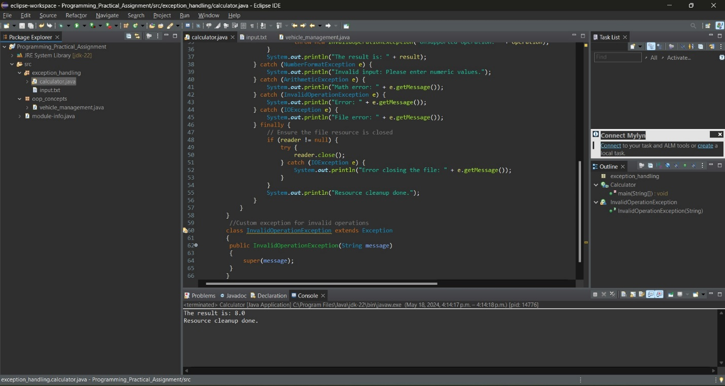

This is the text file where we give input for the calculation.
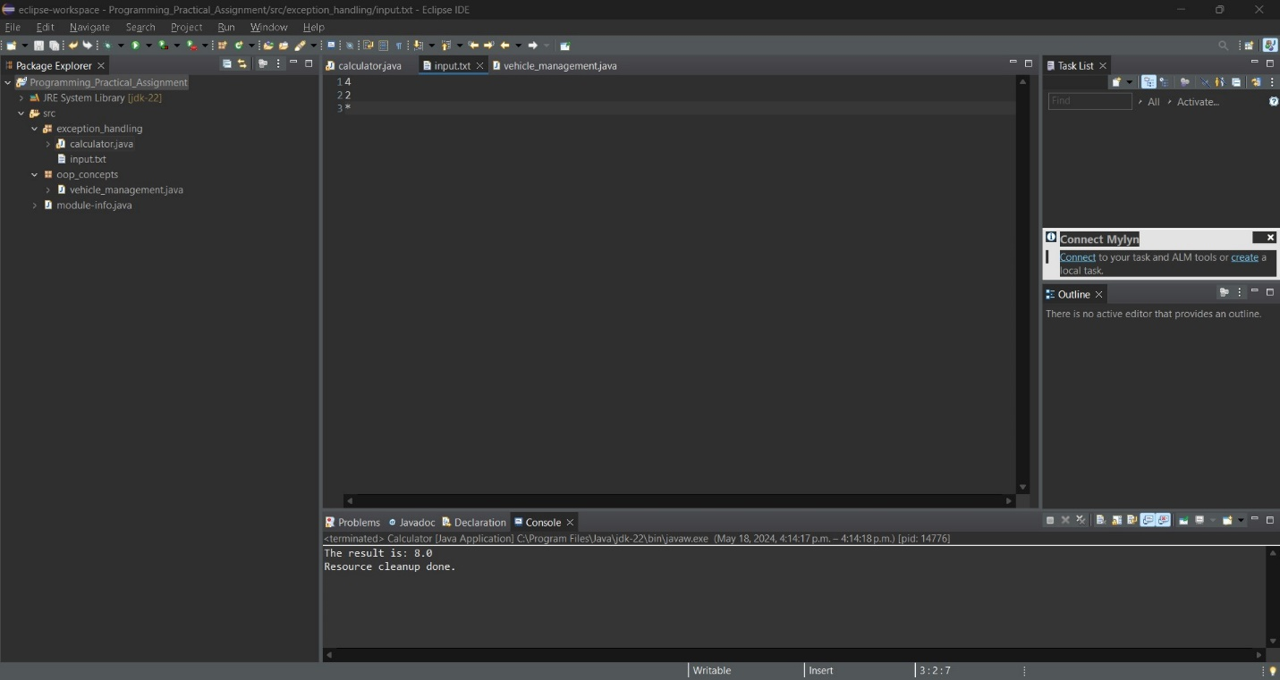
Out put for the code after giving the input in txt file.
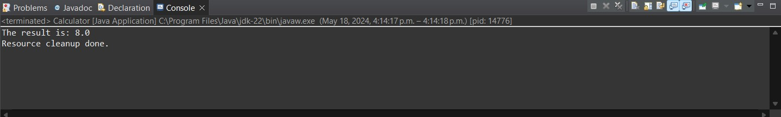

This is exception giving alphabet and zero and displaying error as please enter numeric file.
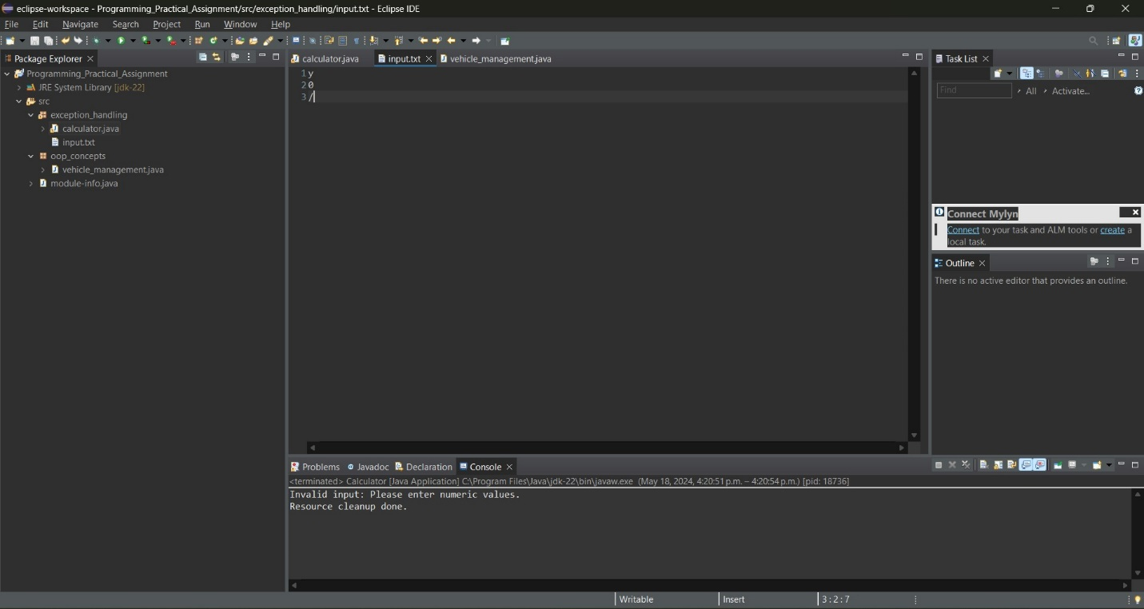

Code of oops concept for the vehicle management system.
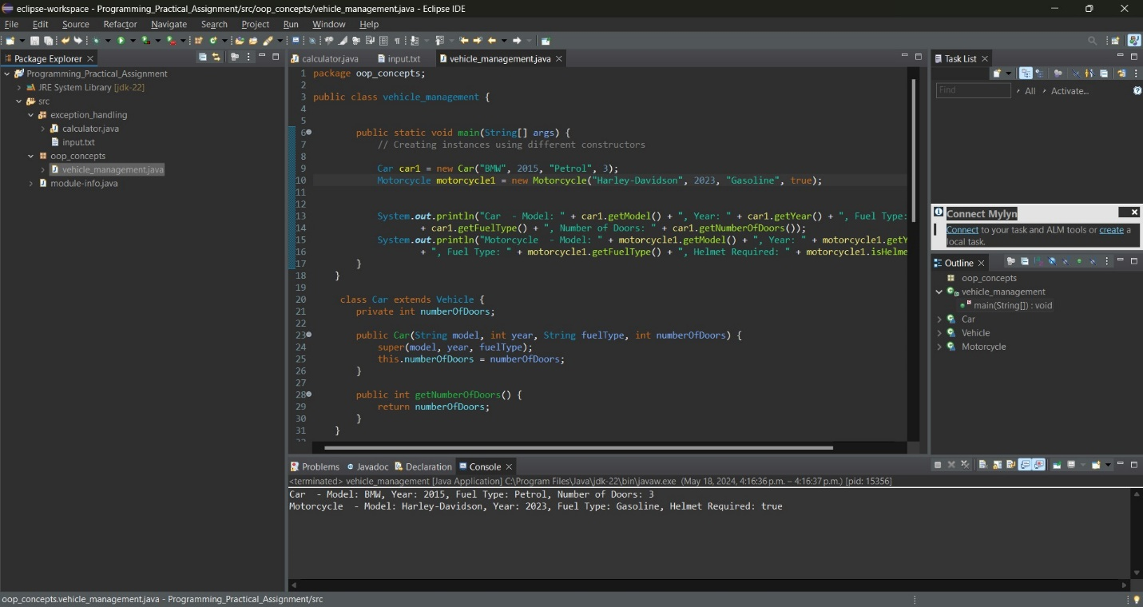
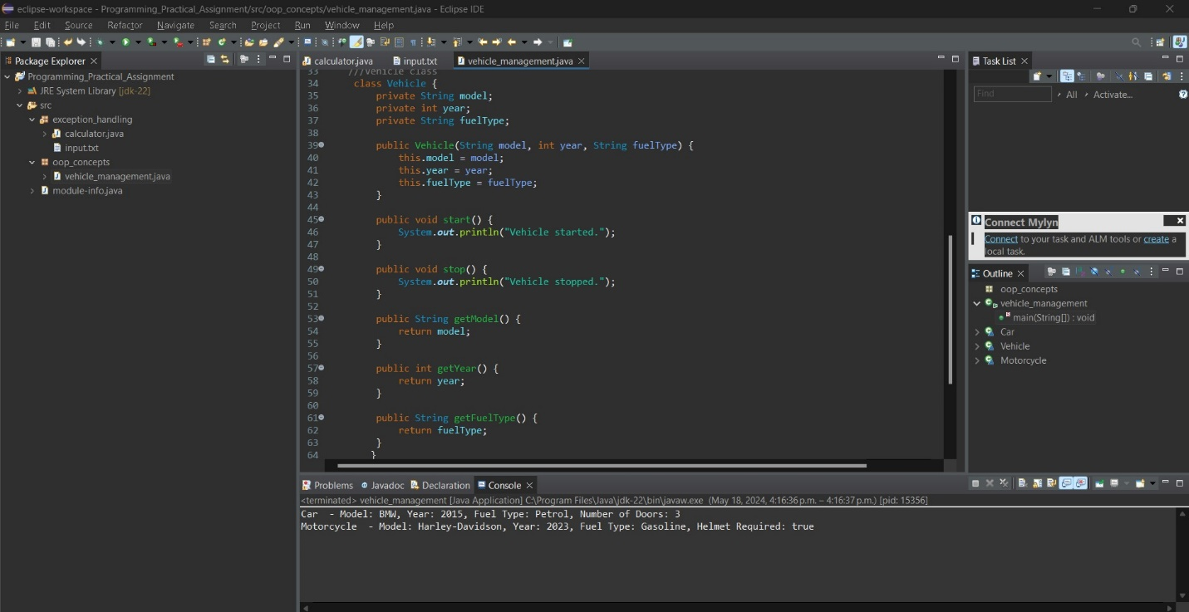

Out put:
