**Data:**

The data used for this analysis contains information on 4,000 passengers who belong to an airline’s frequent flier program. For each passenger, the data include information on their mileage history and on different ways they accrued or spent miles in the last year.

**Business Problem:**

**Objective:** Target potential customers interested on the company’s products/services and identify clusters to target for frequent flier program.

**Constraints:** Flying patterns, earning and use of frequent flyer rewards.

|  |
| --- |
| **Data Dictionary:** |

|  |  |  |  |
| --- | --- | --- | --- |
| **Name of Feature** | **Description** | **Type** | **Relevance** |
| ID# | Unique ID | Quantity, Normal | Irrelevant |
| Balance | Number of miles eligible for award travel | Quantity, Ratio | Relevant |
| Qual_miles | Number of miles counted as qualifying for Topflight status | Quantity, Ratio | Relevant |
| cc1_miles | Number of earned miles with airline freq. flyer credit card in the past 12 months | Quantity, Ordinal | Relevant |
| cc2_miles | Number of earned miles with Rewards credit card in the past 12 months | Quantity, Ordinal | Relevant |
| cc3_miles | Number of earned miles with Small Business credit card in the past 12 months | Quantity, Ordinal | Relevant |
| Bonus_miles | Number of miles earned from non-flight bonus transactions in the past 12 months | Quantity, Interval | Relevant |
| Bonus_trans | Number of non-flight bonus transactions in the past 12 months | Quantity, Interval | Relevant |
| Flight_miles_12mo | Number of flight miles in the past 12 months | Quantity, Interval | Relevant |
| Flight_trans_12 | Number of flight transactions in the past 12 months | Quantity, Interval | Relevant |
| Days_since_enroll | Number of days since Enroll date | Quantity, Interval | Relevant |
| Award? | Dummy variable for last award.(0=null, 1= not null) | Quantity, Binary | Irrelevant |

**Dendrogram:**

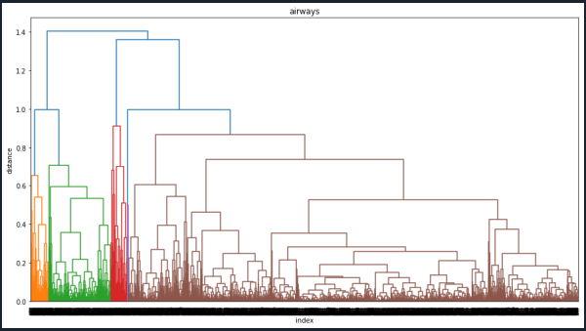

**Clusters:**

