2CE339

Analysis and Design of Algorithm

Innovative Assignment

Course Coordinator : Sapan H Mankad

February 10, 2014

Topic Name : Triangulation

Group : 11bce078, 12bce153, 12bce157

Triangulation

Triangulation means partition a polygon P into non-overlapping triangles using diagonals only. Triangulation of a polygon is the set of chords that divide the polygon into triangles such that no two chords intersect except possibly at a vertex. Let v0, v1, …, vn-1 be the vertices of a convex polygon with n vertices(i.e. n-gon). This polygon can be divided into n-2 triangles by a set of n-3 non-crossing chords. This set of n-3 non-crossing chords is called a triangulation of the n-gon.

The optimal polygon triangulation problem for a convex polygon is an optimization problem to find a triangulation with minimum total weight. It is known that this problem can be solved using the dynamic programming technique in O(n3) time using a work space of size O(n2).

A triangulation of a polygon is a set of T chords of the polygon that divide the polygon into disjoint triangles. In the set T of chords is maximal: every chord not in T intersects some chord in T. The sides of triangles produced by the triangulation are either chords in the triangulation or sides of the polygon.

The number of triangulation is depends on the choice of triangulation. Triangulation reduce the complex shape to collection of simpler shapes. Triangulation are usually not unique.

The application of triangulation visibility, robotics, mesh generation, location etc..

Every simple polygon admits a triangulation. Every triangulation of n-gon has exactlyn-2 triangles.

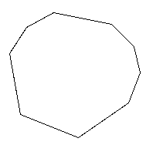 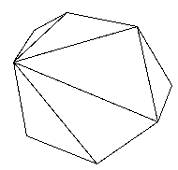

Fig. Convex Polygon Fig. Triangulation of the Polygon