

**Instructor:** Francis Bello

**Course:** CSD3354, Winter 2022

**Assignment:** 2 (palindrome web app)

**Total points:** 30

A palindrome is a word, phrase, sentence or number that reads the same backward or forward.

E.g.: “ASP.Net MVC” 🡺“CVM teN.PSA”

You are to create an MVC web app that will perform a palindrome on the input text on the browser.

|  |  |
| --- | --- |
| **Student name** | Yamini Rathod |
| **Student number** | C0796390 |

**HomeController.cs**

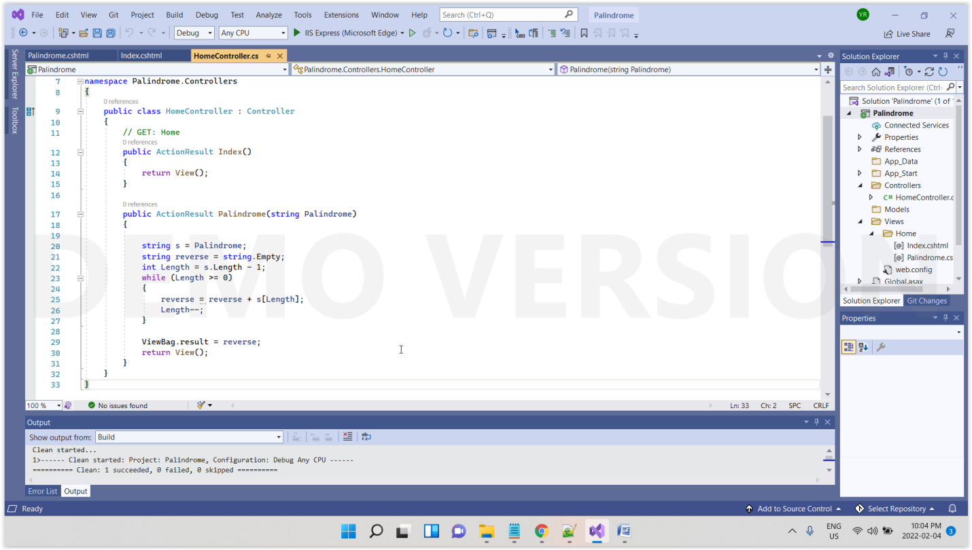

**Index.cshtml**

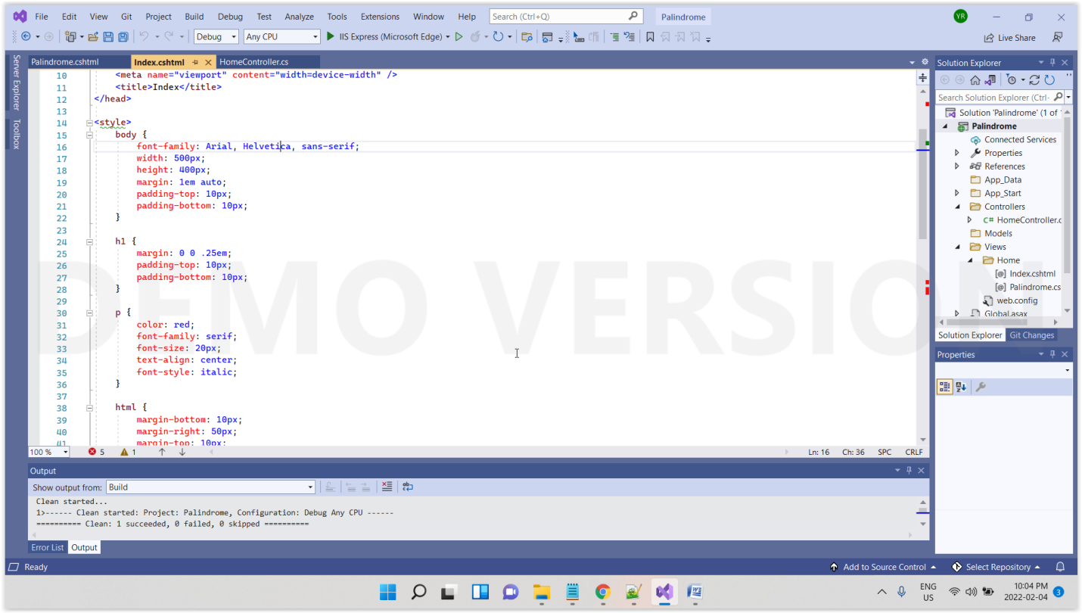

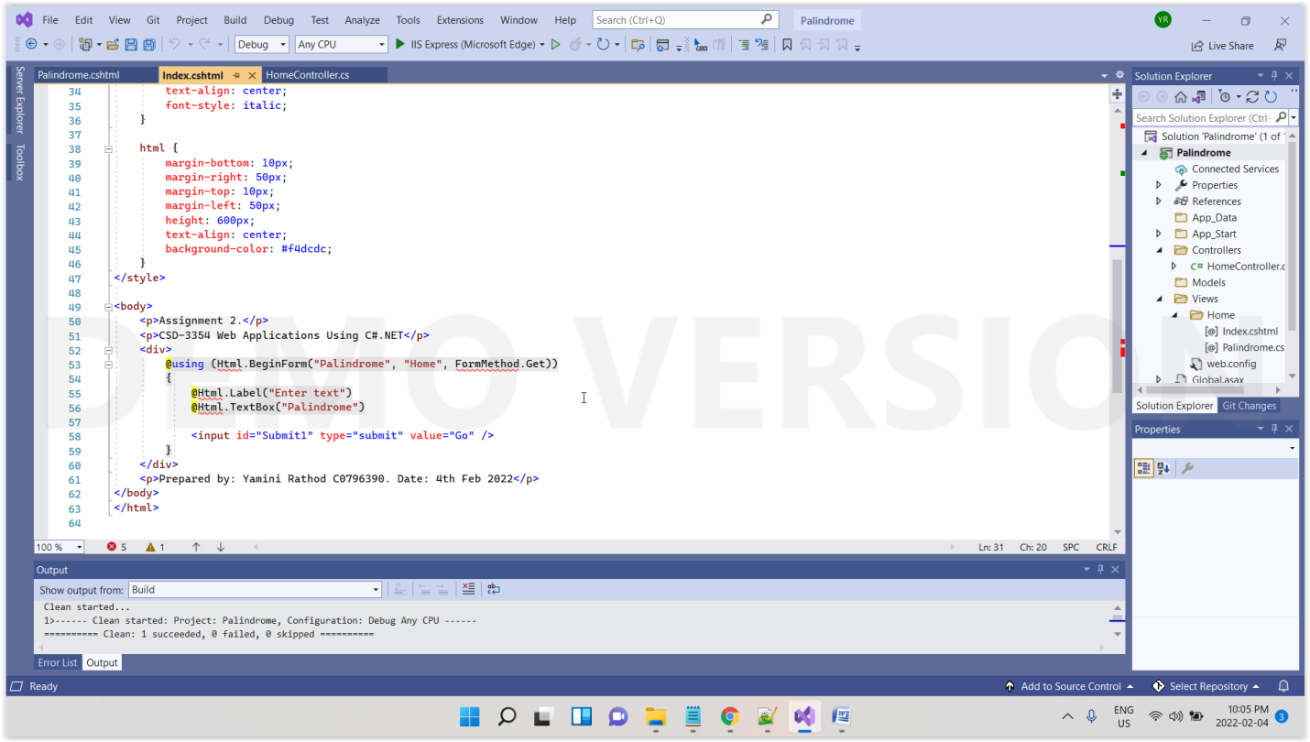

**Palindrome.cshtml**

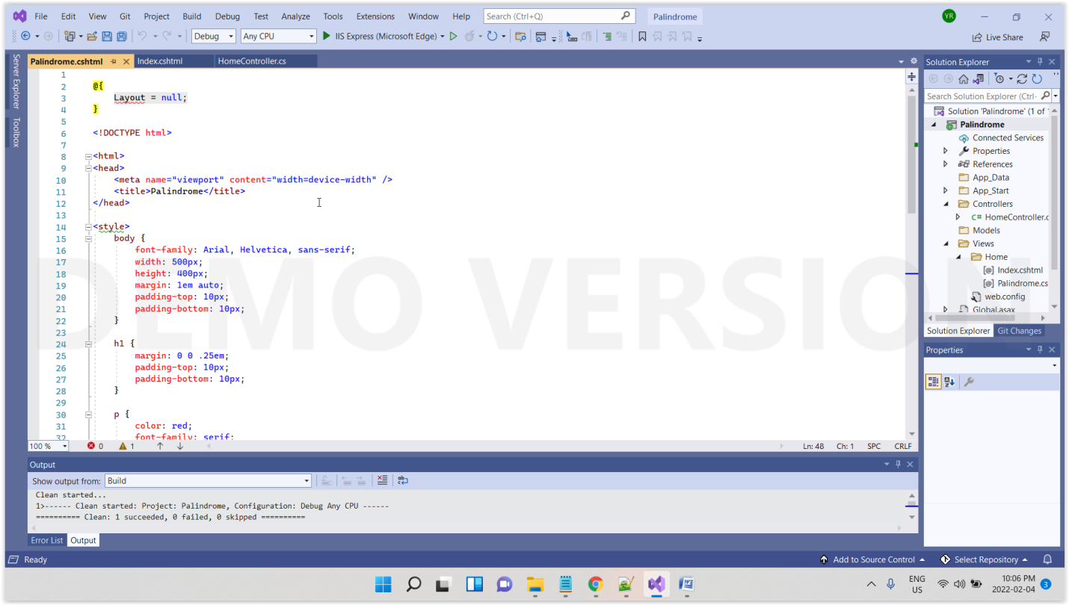

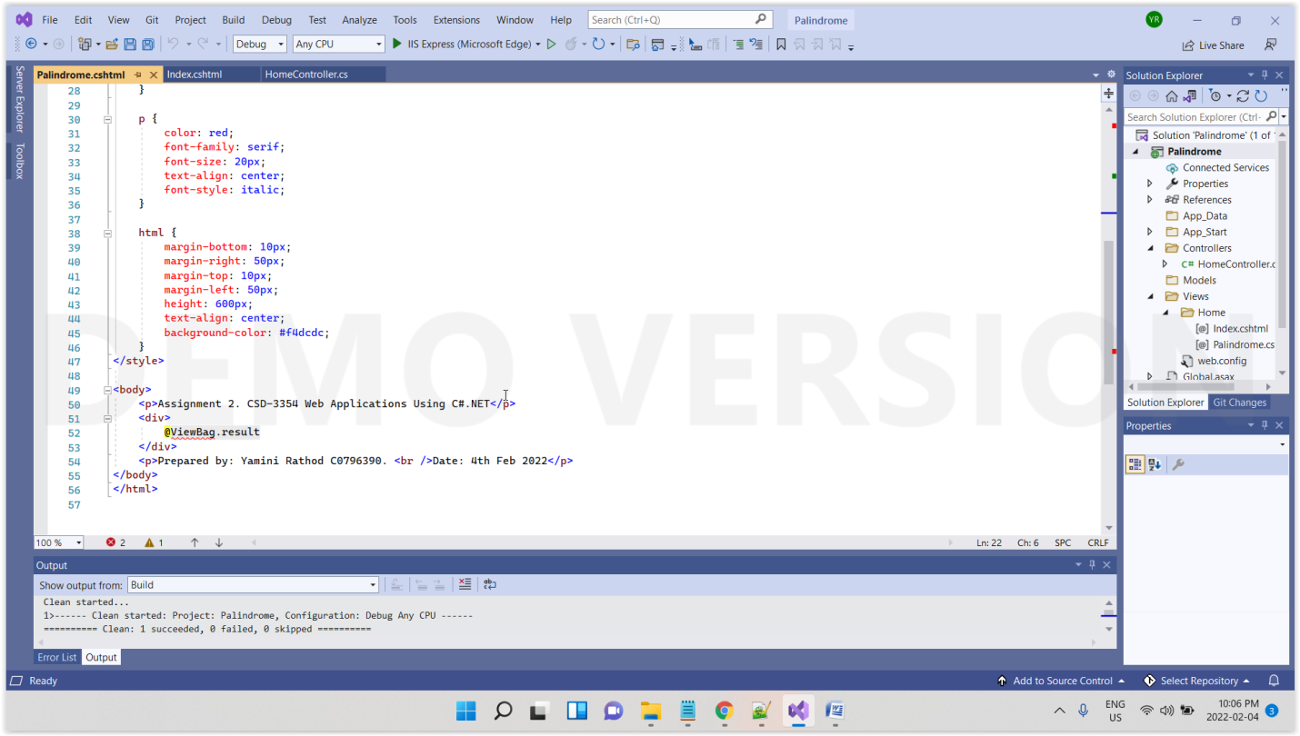

**Output**

