# Major Project

**Framework for Interactive Content Generation**

**And Publishing**

**System Requirement Specification**

**Team Members**

Siddharth Ayer (12BCE175)

Yamini Rathod (11BCE078)

**Project Guide**

Dr. Madhuri Bhavsar,

Associate Professor, CSE, IT, NU

Contents

1. Introduction 4

1.1 Methodology 4

1.1.1 Rational Unified Process 4

1.1.2 Purpose 5

1.1.3 Scope 5

1.2 Definitions, Acronyms and Abbreviations 5

1.3 Tools Used 5

1.3.1 Application Architecture: PHP 5

1.3.2 Web server – WAMP 5

1.3.3 Development tool –RAD 5

1.3.4 Database platform – MySQL 6

1.4 References 6

1.5 Technologies to be used 6

1.6 Overview 6

1.6.1 Existing System 6

1.6.2 Proposed System 6

1.6.3 Our plan 6

2. Overall description 7

2.1 Product perspective 7

2.2 Software Interface 7

2.2.1 Client on Internet 7

2.2.2 Web Server 7

2.2.3 Data Base Server 7

2.2.4 Development End 7

2.3 Hardware Interface 8

2.3.1 Minimum requirements 8

2.3.2 Recommended requirements 8

2.4 Communication Interface 8

2.5 Constraints 8

2.6 Use Case Model Survey 9

2.6.1 Administrator 9

2.6.2 Approver 9

2.6.3 Reviewer 9

2.6.4 Sales Executive 9

2.6.5 Publisher 10

2.6.6 Manger 10

2.7 Architecture Diagram 11

2.8 Database Design 12

3. Specific Requirements 13

3.1 Use case reports 13

3.1.1 Administrator 13

3.1.2 Approver 14

3.1.3 Reviewer 15

3.1.4 Manager 16

3.1.5 Publisher 17

3.1.6 Sales Executive 18

3.2 Activity Diagrams 19

3.2.1 Generalized Object insertion diagram 19

3.2.2 Generalized Object editing diagram 20

3.2.3 Generalized Object Deleting diagram 21

21

3.2.4 Generalized user login Diagram 22

3.2.5 Content publishing diagram 23

3.2.6 Content Approval diagram 24

3.2.7 Content Review diagram 25

3.2.8 Content push staging diagram 26

3.3 Sequence Diagrams 27

3.3.1 User login sequence diagram 27

3.3.2 Add object sequence diagram 28

3.3.3 Edit Object sequence diagram 29

3.3.4 Delete Object sequence diagram 30

3.3.5 Publishing Sequence Diagram 31

3.4 Class Diagram 32

3.5 CRC Index Cards 34

# Introduction

## Methodology

### Rational Unified Process

This software engineering process has three branches from all of the generic process models that a standard software engineering project would requires or is entitled to, it also supports regular revisions and it also provides guidelines of “standard practices” in system analysis and design.

This model is best described by following three perspectives:

**Static |** this shows the set of actions that are carried out over development period

**Dynamic |** this shows an overview of phases that covers major aspects of development

**Practice |** these are guidelines that provides the bases of standards that should be followed

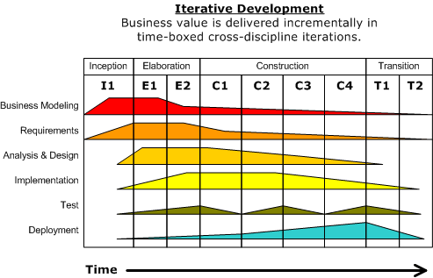

Figure 1Phasese of RUP

**Inception |** the objective of this phase is to provide the outline to the organization for the system. This includes identification of all the factors and entities that will be the part of communication system either to the system or from the system.Collection of this information will help create the business case for the proposed system.

**Elaboration |** this phase mainly encloses the entities related to the bases of understanding the problem, its domain, the framework of architecture and the project plan and most importantly the stakeholder and risk associated with each of them.

**Construction |**although previous phase may include the activities related to establishing the grounding framework of this project, this phase is actually dedicated to the overall system design, implementation and testing. Parts of the system may be developed in small sized units and finally are coupled together during this phase.

**Transition |**thislast phase is concerned with deploying the system to the customer base from the testing and development environment.

### Purpose

This framework is provided as an intelligent web application to the users who could access it from the wide range of heterogeneous products and environments, and will provides the means of generating the content that they wish to publish and then finally push the generated content to the standard publishing portal that will showcase the outcome of the generated content.

The unique feature of our system is that we will support content interaction, which will increase the utility value of the same content which would otherwise represent the same content but will be less productive.

And hence the framework would relieve the user from using different standard technologies for content generation and other standard technologies to publish same content.

### Scope

The scope for this project is limited only by the imagination of the organization that uses this. This system can support and publish all kind of media regardless of dependencies that content requires.Though for sake of this major project, a few domains that could utilize this system are as follows,

Educational and training institutes can generate content that is highly interactive and are highly complicated with ease.

Publishing houses can focus onto content generation rather that dealing with complex technologies that can convert this content to publishable form and then actually publishes it on standard platform.

## Definitions, Acronyms and Abbreviations

## Tools Used

### Application Architecture: PHP

**PHP** is a [server-side scripting](http://en.wikipedia.org/wiki/Server-side_scripting) language designed for [web development](http://en.wikipedia.org/wiki/Web_development) but also used as a [general-purpose programming language](http://en.wikipedia.org/wiki/General-purpose_programming_language). PHP code can be simply mixed with [HTML](http://en.wikipedia.org/wiki/HTML) code, or it can be used in combination with various [templating engines](http://en.wikipedia.org/wiki/Web_template_system) and [web frameworks](http://en.wikipedia.org/wiki/Web_framework). PHP code is usually processed by a PHP [interpreter](http://en.wikipedia.org/wiki/Interpreter_%28computing%29), which is usually implemented as a web server's native [module](http://en.wikipedia.org/wiki/Plugin_%28computing%29) or a [Common Gateway Interface](http://en.wikipedia.org/wiki/Common_Gateway_Interface) (CGI) executable.

After the PHP code is interpreted and executed, the web server sends resulting output to its client, usually in form of a part of the generated web page; for example, PHP code can generate a web page's HTML code, an image, or some other data. PHP has also evolved to include a [command-line interface](http://en.wikipedia.org/wiki/Command-line_interface) (CLI) capability and can be used in [standalone](http://en.wikipedia.org/wiki/Computer_software)[graphical applications](http://en.wikipedia.org/wiki/Graphical_user_interface).

### Web server – WAMP

**WAMP** is an [acronym](http://en.wikipedia.org/wiki/Acronym) for an archetypal model of web service [solution stacks](http://en.wikipedia.org/wiki/Solution_stack), originally consisting of largely interchangeable components: Windows, the [Apache HTTP Server](http://en.wikipedia.org/wiki/Apache_HTTP_Server), the [MySQL](http://en.wikipedia.org/wiki/MySQL)[relational database management system](http://en.wikipedia.org/wiki/Relational_database_management_system), and the [PHP](http://en.wikipedia.org/wiki/PHP) programming language. As a solution stack, LAMP is suitable for building [dynamic web sites](http://en.wikipedia.org/wiki/Dynamic_web_page) and [web applications](http://en.wikipedia.org/wiki/Web_application).

### Development tool –RAD

**Jetbrains PhPStorm** is an IDE that can support the development of php application by providing code hinting debugging, database visualization and many more.

### Database platform – MySQL

**MySQL** the world's second mostwidely usedopen-source [relational database management system](http://en.wikipedia.org/wiki/Relational_database_management_system) (RDBMS).

## References

Wikipedia - [*www.wikipedia.com*](http://www.wikipedia.com)

## Technologies to be used

* + Php: Server side scripting
  + Bootstrap: Responsive website deign
  + JQuery: Sophisticated JavaScript library
  + MySQL: Relational database system
  + PhPStorm: Rapid application developer

## Overview

### Existing System

No existing system are available, as this the inception of this kind of system.

### Proposed System

This project an apparent solution to the problems faced by the organizations in generating and publishing content. The solution is to provide the coupling facility between the tools of generating and publishing, which in turn proposes the new challenges that are related to cross domain functionality, and are by nature hard to accomplish or at least not achievable without complex and sophisticated solutions. The solution is to provide the framework that does the publishing and generation for us. And this solution can be converted into the need if implemented properly. This solution is focused on creating online framework that provides the means of generating interactive content and mechanism to publish the content over the heterogeneous platforms ranging from formal desktop environments to mobile application.

This means that the publishing party would provide the source content as input and views that are compatible with the multiple platforms and environments will be available as output.This solution is made from the ground up with the latest technology available and hence it keeps the door for the expansion and extension open. And hence it is more preferable and economical

Also the published content is compatible with the majority of the platforms ranging from desktop systems to the Sandboxed Mobile Application environment. Also the system is capable of publishing content that target device can cache offline. And hence eliminate the need of the continuous communication with our server.

The system is accessible from the web enabled device and would have group of users each with different access rights and set of primitive action and responsibility. And according to the criterion set by us, users will be able to access the content. This provision of the content access will be subject to the service agreement which can be decided, and are subject to change or replace.

The system can be extended to publish the content in multiple languages depending on the region of their deployment. This enables us in acquiring the variety of consumer from wide demographic regions.

### Our plan | Release the proposed system at the completion of major project under semester 8.

# Overall description

## Product perspective

**Browser**

**Http Server (WAMP)**

**Web Service Client**

**MySQL**

**Cloud Data Storage**

**Web Service Engine**

**(Apache)**

**Content Generation Engine**

**Content Publishing Engine**

## Software Interface

### Client on Internet |

Web Browser, Operating System (any)

### Web Server

WAMP, Operating System (Windows)

### Data Base Server

MySQL, Operating System (windows)

### Development End

RAD (PHP, HTML, XML, AJAX, JQuery), MYSQL, OS (Windows),WAMP (Web Server)

## Hardware Interface

### Minimum requirements

|  |  |  |  |
| --- | --- | --- | --- |
| **Client Side** | | | |
|  | Processor | Ram | Disk Space |
| **Internet explorer 8** | Intel Pentium III or AMD -  800 MHz | 128 MB | 100 MB |

|  |  |  |  |
| --- | --- | --- | --- |
| **Server Side** | | | |
|  | Processor | Ram | Disk Space |
| **RAD** | Intel Pentium III or AMD -  800 MHz | 1 GB | 3.5 GB |
| **MySQL** | Intel Pentium III or AMD -  800 MHz | 256 MB | 150 MB |

### Recommended requirements

|  |  |  |  |
| --- | --- | --- | --- |
| **Client Side** | | | |
|  | Processor | Ram | Disk Space |
| **RAD** | All Intel or AMD - 1 GHZ | 256 MB | 100 MB |

|  |  |  |  |
| --- | --- | --- | --- |
| **Server Side** | | | |
|  | Processor | Ram | Disk Space |
| **Internet explorer 8** | All Intel or AMD - 2 GHZ | 2 GB | 3.5 GB |
| **MySQL** | All Intel or AMD - 2 GHZ | 512 MB | 500 MB |

## Communication Interface

* Client (customer) on Internet will be using HTTP/HTTPS protocol.
* Client (system user) on Internet will be using HTTP/HTTPS protocol

## Constraints

* GUI is only in English.
* Login and password is used for the identification of users.
* Only registered users will be authorized to use the services.
* Limited to HTTP/HTTPS.

## Use Case Model Survey



### Administrator

A super user with superior privileges that affects the whole system including the users of the system. It can manage users, generate reports and also sets the scope of the user’s actions using page management.

### Approver

This user would approve/ reject the content published by publisher.

### Reviewer

This user would review the decision taken by the approver for final release.

### Sales Executive

This user would generate and associate valid subscription plan with the publisher content and would also assign the service agreement on using the published content.

### Publisher

This user is responsible for generation of the content using the system tools and content templates. It would also manage the assets that published content would use. It would manage the sponsors and publishers associated with each generated content.

### Manger

This user is responsible for managing the content types and templates that publisher would require and consume. This user is also responsible for managing the asset types that system supports.

## Architecture Diagram

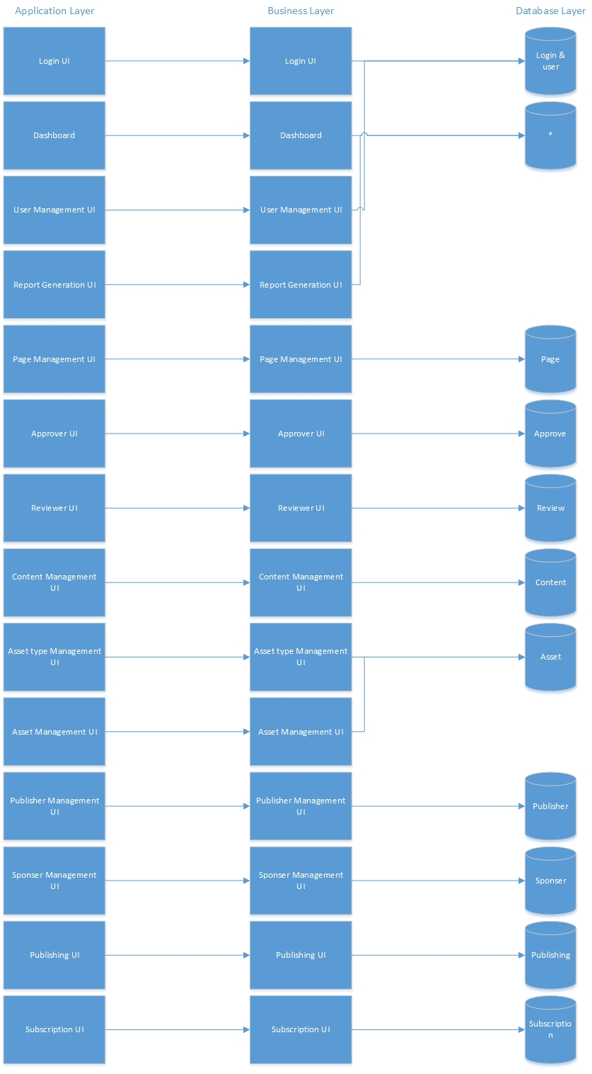

## Database Design

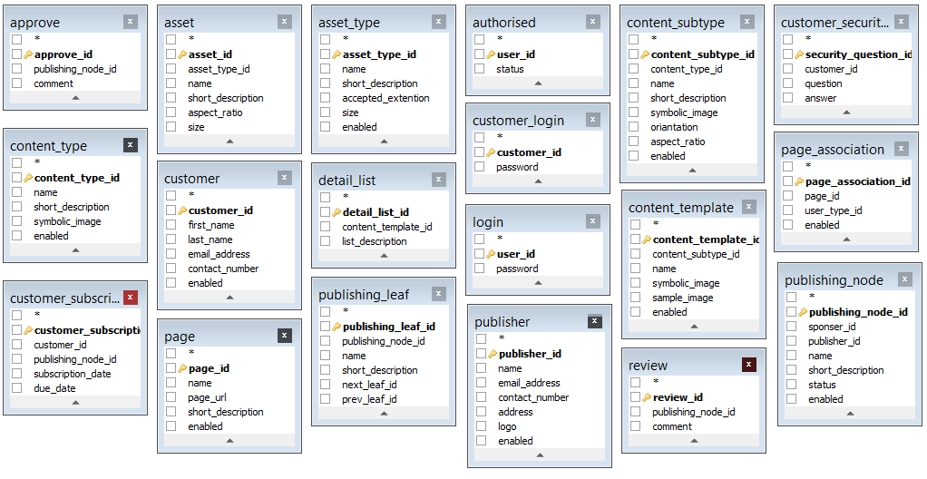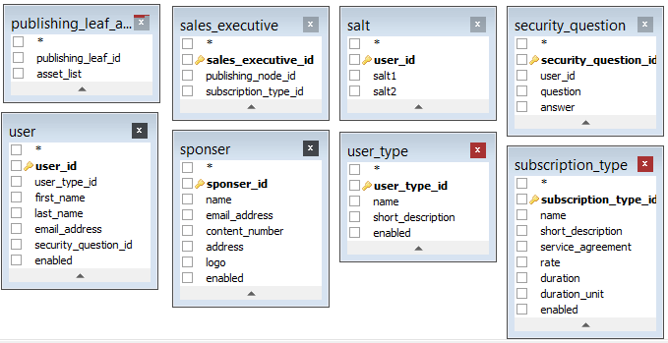

# Specific Requirements

## Use case reports

### Administrator



### Approver



### Reviewer



### Manager



### Publisher



### Sales Executive



## Activity Diagrams

### Generalized Object insertion diagram

## 

### Generalized Object editing diagram

## 

### Generalized Object Deleting diagram

## object deletion

### loginGeneralized user login Diagram

### Content publishing diagram

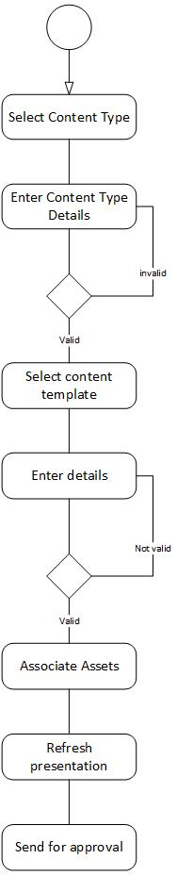

### Content Approval diagram

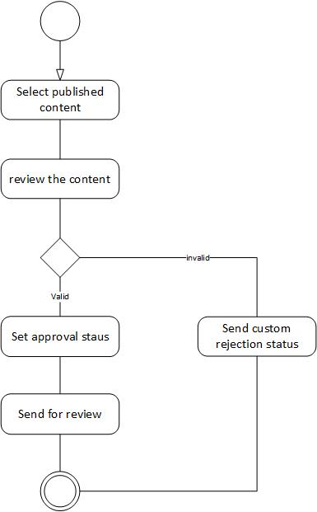

### Content Review diagram

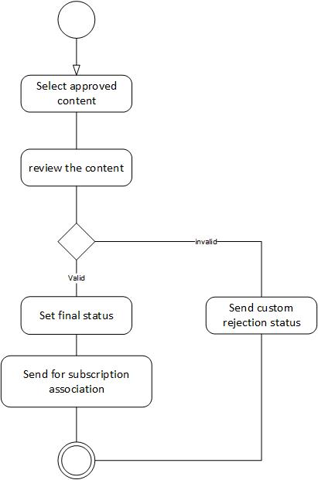

### Content push staging diagram

### salesExecutive

## Sequence Diagrams

### User login sequence diagramuserLoginSequence

### Add object sequence diagram

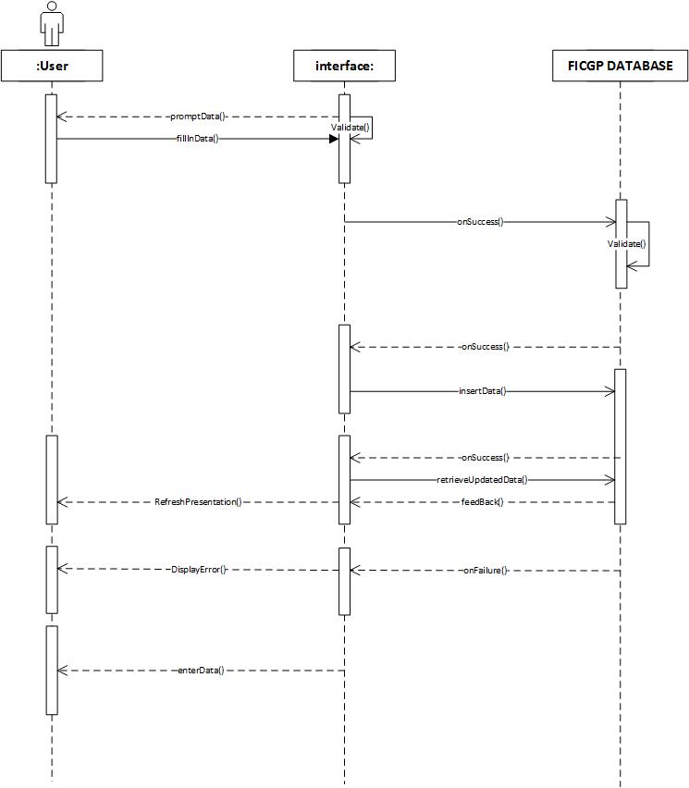

### Edit Object sequence diagram

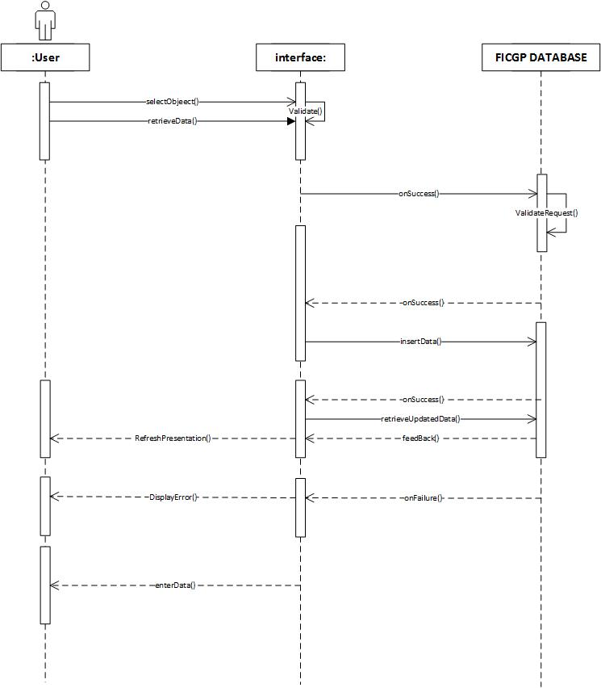

### Delete Object sequence diagram

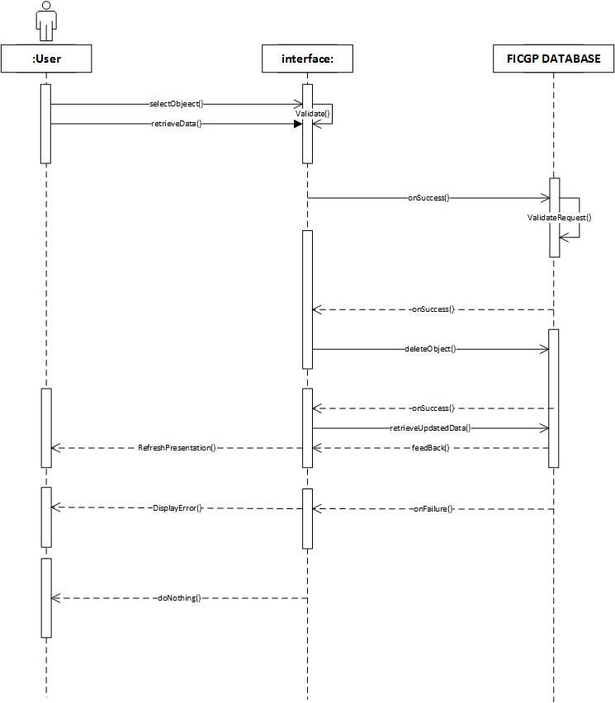

### Publishing Sequence Diagram

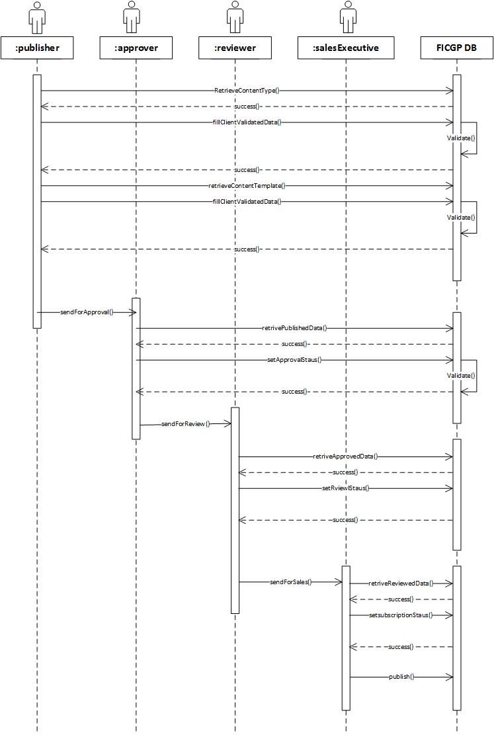

## Class Diagram

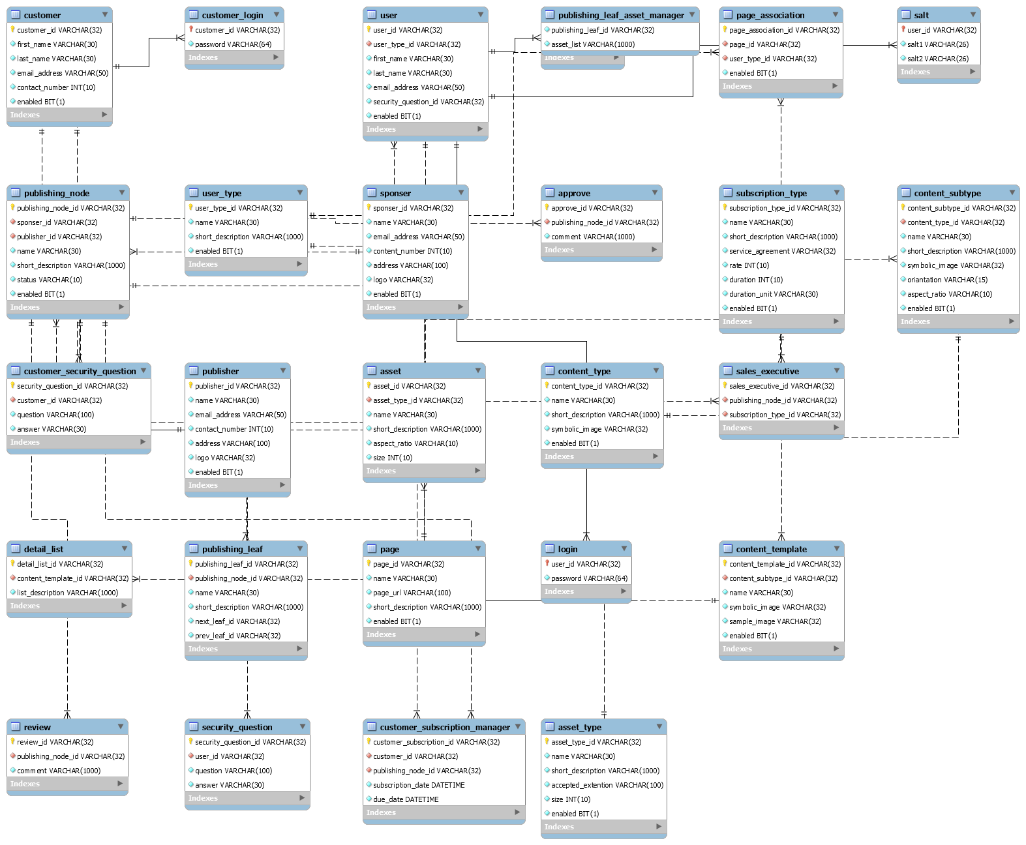

## CRC Index Cards

# Approve

|  |  |
| --- | --- |
| **Class Name :** | **Approve** |
| Class Type : | Interaction |
| Class Characteristics : | Tangibility : Intangible  Sequential : Concurrent  Persistence : Temporary  Inclusiveness : Aggregate  Integrity : Guarded |
| Responsibility : | Collaborations : |
| approveContent()  sendForReview() | Publishing Node |
| Responsibility : | Collaborations : |
| ManageUsers()  Login() | Users Type  Security Question |

# Approve

|  |  |
| --- | --- |
| **Class Name :** | **Approve** |
| Class Type : | Interaction |
| Class Characteristics : | Tangibility : Intangible  Sequential : Concurrent  Persistence : Temporary  Inclusiveness : Aggregate  Integrity : Guarded |
| Responsibility : | Collaborations : |
| Approve()  Publish() | Publishing Node |

# Asset Type

|  |  |
| --- | --- |
| **Class Name :** | **Asset Type** |
| Class Type : | Domain |
| Class Characteristics : | Tangibility : Tangible  Sequential : Sequential  Persistence : Temporary  Inclusiveness : Stand Alone  Integrity : Guarded |
| Responsibility : | Collaborations : |
| Create()  Update()  Delete() | Asset  Content Type Asset Type Association  Module Asset Type Association |

# Asset Type Extension Association

|  |  |
| --- | --- |
| **Class Name :** | **Asset Type** |
| Class Type : | Domain |
| Class Characteristics : | Tangibility : Tangible  Sequential : Sequential  Persistence : Temporary  Inclusiveness : Stand Alone  Integrity : Guarded |
| Responsibility : | Collaborations : |
| Create()  Update()  Delete() | Asset Type |

# Asset

|  |  |
| --- | --- |
| **Class Name :** | **Asset** |
| Class Type : | Domain |
| Class Characteristics : | Tangibility : Tangible  Sequential : Sequential  Persistence : Temporary  Inclusiveness : Aggregate  Integrity : Guarded |
| Responsibility : | Collaborations : |
| Create()  Update()  Delete() | Asset Type  Product Content Asset |

# Authorized

|  |  |
| --- | --- |
| **Class Name :** | **Asset Type** |
| Class Type : | Domain |
| Class Characteristics : | Tangibility : Tangible  Sequential : Sequential  Persistence : Temporary  Inclusiveness : Stand Alone  Integrity : Guarded |
| Responsibility : | Collaborations : |
| Create()  Update()  Delete() | Login |

# Content Type

|  |  |
| --- | --- |
| **Class Name :** | **Content Type** |
| Class Type : | Domain |
| Class Characteristics : | Tangibility : Tangible  Sequential : Sequential  Persistence : Temporary  Inclusiveness : Stand Alone  Integrity : Guarded |
| Responsibility : | Collaborations : |
| Create()  Update()  Delete() | Content Subtype  Content Template  Content Type Asset Type Association  Product Manager |

# Content Subtype

|  |  |
| --- | --- |
| **Class Name :** | **Content Subtype** |
| Class Type : | Domain |
| Class Characteristics : | Tangibility : Tangible  Sequential : Sequential  Persistence : Temporary  Inclusiveness : Aggregate  Integrity : Guarded |
| Responsibility : | Collaborations : |
| Create()  Update()  Delete() | Content Type  Product Manager |

# Content Template

|  |  |
| --- | --- |
| **Class Name :** | **Content Template** |
| Class Type : | Domain |
| Class Characteristics : | Tangibility : Tangible  Sequential : Concurrent  Persistence : Permanent  Inclusiveness : Aggregate  Integrity : Guarded |
| Responsibility : | Collaborations : |
| Create()  Update()  Delete() | Content Type  Detail List  Content Template Hint  Product Template |

# Content Template Hint

|  |  |
| --- | --- |
| **Class Name :** | **Asset Type** |
| Class Type : | Domain |
| Class Characteristics : | Tangibility : Tangible  Sequential : Sequential  Persistence : Temporary  Inclusiveness : Stand Alone  Integrity : Guarded |
| Responsibility : | Collaborations : |
| Create()  Update()  Delete() | Content Template |

# Content Type Asset Type Association

|  |  |
| --- | --- |
| **Class Name :** | **Asset Type** |
| Class Type : | Domain |
| Class Characteristics : | Tangibility : Tangible  Sequential : Sequential  Persistence : Temporary  Inclusiveness : Stand Alone  Integrity : Guarded |
| Responsibility : | Collaborations : |
| Create()  Update()  Delete() | Asset Type  Content Type |

# Detail List

|  |  |
| --- | --- |
| **Class Name :** | **Detail List** |
| Class Type : | Interaction |
| Class Characteristics : | Tangibility : Intangible  Sequential : Concurrent  Persistence : Temporary  Inclusiveness : Aggregate  Integrity : Guarded |
| Responsibility : | Collaborations : |
| Create()  Update()  Delete() | Content Template |

# Content Manager

|  |  |
| --- | --- |
| **Class Name :** | **Content Manager** |
| Class Type : | Interaction |
| Class Characteristics : | Tangibility : Intangible  Sequential : Concurrent  Persistence : Temporary  Inclusiveness : Aggregate  Integrity : Guarded |
| Responsibility : | Collaborations : |
| Manage() | Content Type  Content Subtype |

# Customer

|  |  |
| --- | --- |
| **Class Name :** | **Customer** |
| Class Type : | Domain |
| Class Characteristics : | Tangibility : Intangible  Sequential : Concurrent  Persistence : Temporary  Inclusiveness : Stand Alone  Integrity : Guarded |
| Responsibility : | Collaborations : |
| Login() |  |

# Customer Login

|  |  |
| --- | --- |
| **Class Name :** | **Customer Login** |
| Class Type : | Interaction |
| Class Characteristics : | Tangibility : Intangible  Sequential : Concurrent  Persistence : Temporary  Inclusiveness : Aggregate  Integrity : Guarded |
| Responsibility : | Collaborations : |
| Login() | Customer Security Question  Customer Subscription Manager |

# Customer Security Question

|  |  |
| --- | --- |
| **Class Name :** | **Customer Security Question** |
| Class Type : | Interaction |
| Class Characteristics : | Tangibility : Intangible  Sequential : Concurrent  Persistence : Temporary  Inclusiveness : Aggregate  Integrity : Guarded |
| Responsibility : | Collaborations : |
| Insert() | Customer Login |

# Customer Subscription Manager

|  |  |
| --- | --- |
| **Class Name :** | **Customer Subscription Manager** |
| Class Type : | Interaction |
| Class Characteristics : | Tangibility : Intangible  Sequential : Concurrent  Persistence : Temporary  Inclusiveness : Aggregate  Integrity : Guarded |
| Responsibility : | Collaborations : |
| Manage() | Customer Login  Publishing Node |

# Extension

|  |  |
| --- | --- |
| **Class Name :** | **Asset Type** |
| Class Type : | Domain |
| Class Characteristics : | Tangibility : Tangible  Sequential : Sequential  Persistence : Temporary  Inclusiveness : Stand Alone  Integrity : Guarded |
| Responsibility : | Collaborations : |
| Create()  Update()  Delete() |  |

# Module

|  |  |
| --- | --- |
| **Class Name :** | **Asset Type** |
| Class Type : | Domain |
| Class Characteristics : | Tangibility : Tangible  Sequential : Sequential  Persistence : Temporary  Inclusiveness : Stand Alone  Integrity : Guarded |
| Responsibility : | Collaborations : |
| Create()  Update()  Delete() | Module Asset Type Association  Module Association |

# Module Asset Type Association

|  |  |
| --- | --- |
| **Class Name :** | **Asset Type** |
| Class Type : | Domain |
| Class Characteristics : | Tangibility : Tangible  Sequential : Sequential  Persistence : Temporary  Inclusiveness : Stand Alone  Integrity : Guarded |
| Responsibility : | Collaborations : |
| Create()  Update()  Delete() | Module  Asset Type |

# Module Association

|  |  |
| --- | --- |
| **Class Name :** | **Asset Type** |
| Class Type : | Domain |
| Class Characteristics : | Tangibility : Tangible  Sequential : Sequential  Persistence : Temporary  Inclusiveness : Stand Alone  Integrity : Guarded |
| Responsibility : | Collaborations : |
| Create()  Update()  Delete() | Page  Module |

# Page

|  |  |
| --- | --- |
| **Class Name :** | **Asset Type** |
| Class Type : | Domain |
| Class Characteristics : | Tangibility : Tangible  Sequential : Sequential  Persistence : Temporary  Inclusiveness : Stand Alone  Integrity : Guarded |
| Responsibility : | Collaborations : |
| Create()  Update()  Delete() | Module Association  Page Association |

# Page Association

|  |  |
| --- | --- |
| **Class Name :** | **Asset Type** |
| Class Type : | Domain |
| Class Characteristics : | Tangibility : Tangible  Sequential : Sequential  Persistence : Temporary  Inclusiveness : Stand Alone  Integrity : Guarded |
| Responsibility : | Collaborations : |
| Create()  Update()  Delete() | Page  User Type |

# Product

|  |  |
| --- | --- |
| **Class Name :** | **Asset Type** |
| Class Type : | Domain |
| Class Characteristics : | Tangibility : Tangible  Sequential : Sequential  Persistence : Temporary  Inclusiveness : Stand Alone  Integrity : Guarded |
| Responsibility : | Collaborations : |
| Create()  Update()  Delete() | Product Approval  Product Content  Product Display  Product Manager  Product Review |

# Product Approval

|  |  |
| --- | --- |
| **Class Name :** | **Asset Type** |
| Class Type : | Domain |
| Class Characteristics : | Tangibility : Tangible  Sequential : Sequential  Persistence : Temporary  Inclusiveness : Stand Alone  Integrity : Guarded |
| Responsibility : | Collaborations : |
| Create()  Update()  Delete() | Product |

# Product Content

|  |  |
| --- | --- |
| **Class Name :** | **Asset Type** |
| Class Type : | Domain |
| Class Characteristics : | Tangibility : Tangible  Sequential : Sequential  Persistence : Temporary  Inclusiveness : Stand Alone  Integrity : Guarded |
| Responsibility : | Collaborations : |
| Create()  Update()  Delete() | Product  Product Content Flow  Product Template  Product Content Asset |

# Product Content Asset

|  |  |
| --- | --- |
| **Class Name :** | **Asset Type** |
| Class Type : | Domain |
| Class Characteristics : | Tangibility : Tangible  Sequential : Sequential  Persistence : Temporary  Inclusiveness : Stand Alone  Integrity : Guarded |
| Responsibility : | Collaborations : |
| Create()  Update()  Delete() | Asset  Product Content |

# Product Content Flow

|  |  |
| --- | --- |
| **Class Name :** | **Asset Type** |
| Class Type : | Domain |
| Class Characteristics : | Tangibility : Tangible  Sequential : Sequential  Persistence : Temporary  Inclusiveness : Stand Alone  Integrity : Guarded |
| Responsibility : | Collaborations : |
| Create()  Update()  Delete() | Product Content |

# Product Display

|  |  |
| --- | --- |
| **Class Name :** | **Asset Type** |
| Class Type : | Domain |
| Class Characteristics : | Tangibility : Tangible  Sequential : Sequential  Persistence : Temporary  Inclusiveness : Stand Alone  Integrity : Guarded |
| Responsibility : | Collaborations : |
| Create()  Update()  Delete() | Product  Sponsor  Publisher  Product Subscription |

# Product Template

|  |  |
| --- | --- |
| **Class Name :** | **Asset Type** |
| Class Type : | Domain |
| Class Characteristics : | Tangibility : Tangible  Sequential : Sequential  Persistence : Temporary  Inclusiveness : Stand Alone  Integrity : Guarded |
| Responsibility : | Collaborations : |
| Create()  Update()  Delete() | Product Content  Content Template |

# Product Manager

|  |  |
| --- | --- |
| **Class Name :** | **Asset Type** |
| Class Type : | Domain |
| Class Characteristics : | Tangibility : Tangible  Sequential : Sequential  Persistence : Temporary  Inclusiveness : Stand Alone  Integrity : Guarded |
| Responsibility : | Collaborations : |
| Create()  Update()  Delete() | Product  Content Type  Content Subtype |

# Product Review

|  |  |
| --- | --- |
| **Class Name :** | **Asset Type** |
| Class Type : | Domain |
| Class Characteristics : | Tangibility : Tangible  Sequential : Sequential  Persistence : Temporary  Inclusiveness : Stand Alone  Integrity : Guarded |
| Responsibility : | Collaborations : |
| Create()  Update()  Delete() | Product |

# Product Subscription

|  |  |
| --- | --- |
| **Class Name :** | **Asset Type** |
| Class Type : | Domain |
| Class Characteristics : | Tangibility : Tangible  Sequential : Sequential  Persistence : Temporary  Inclusiveness : Stand Alone  Integrity : Guarded |
| Responsibility : | Collaborations : |
| Create()  Update()  Delete() | Product Display  Subscription |

# Publisher

|  |  |
| --- | --- |
| **Class Name :** | **Publisher** |
| Class Type : | Interaction |
| Class Characteristics : | Tangibility : Intangible  Sequential : Concurrent  Persistence : Temporary  Inclusiveness : Aggregate  Integrity : Guarded |
| Responsibility : | Collaborations : |
| Create()  Update()  Delete() | Publishing Node  Product Display |

# Publishing Node

|  |  |
| --- | --- |
| **Class Name :** | **Publishing Node** |
| Class Type : | Domain |
| Class Characteristics : | Tangibility : Intangible  Sequential : Concurrent  Persistence : Temporary  Inclusiveness : Aggregate  Integrity : Guarded |
| Responsibility : | Collaborations : |
| Create()  Update()  Delete() | Approve  Customer Subscription Manager  Publishing Leaf  Sponsor  Publisher  Review  Sales Executive |

# Publishing Leaf

|  |  |
| --- | --- |
| **Class Name :** | **Publishing Leaf** |
| Class Type : | Interaction |
| Class Characteristics : | Tangibility : Intangible  Sequential : Concurrent  Persistence : Temporary  Inclusiveness : Aggregate  Integrity : Guarded |
| Responsibility : | Collaborations : |
| Create()  Update()  Delete() | Publishing Node |

# Publishing Leaf Asset Manager

|  |  |
| --- | --- |
| **Class Name :** | **Publishing Leaf Asset Manager** |
| Class Type : | Interaction |
| Class Characteristics : | Tangibility : Intangible  Sequential : Concurrent  Persistence : Temporary  Inclusiveness : Aggregate  Integrity : Guarded |
| Responsibility : | Collaborations : |
| Manage() |  |

# Publishing Leaf Manager

|  |  |
| --- | --- |
| **Class Name :** | **Publishing Leaf Manager** |
| Class Type : | Interaction |
| Class Characteristics : | Tangibility : Intangible  Sequential : Concurrent  Persistence : Temporary  Inclusiveness : Aggregate  Integrity : Guarded |
| Responsibility : | Collaborations : |
| Manage() | Content Type  Content Subtype  Content Template |

# Salt

|  |  |
| --- | --- |
| **Class Name :** | **Asset Type** |
| Class Type : | Domain |
| Class Characteristics : | Tangibility : Tangible  Sequential : Sequential  Persistence : Temporary  Inclusiveness : Stand Alone  Integrity : Guarded |
| Responsibility : | Collaborations : |
| Create()  Update()  Delete() | User |

# Review

|  |  |
| --- | --- |
| **Class Name :** | **Review** |
| Class Type : | Interaction |
| Class Characteristics : | Tangibility : Intangible  Sequential : Concurrent  Persistence : Temporary  Inclusiveness : Aggregate  Integrity : Guarded |
| Responsibility : | Collaborations : |
| Create()  Update()  Delete() | Publishing Node |

# Subscription Type

|  |  |
| --- | --- |
| **Class Name :** | **Subscription Type** |
| Class Type : | Domain |
| Class Characteristics : | Tangibility : Intangible  Sequential : Concurrent  Persistence : Temporary  Inclusiveness : Stand Alone  Integrity : Guarded |
| Responsibility : | Collaborations : |
| Create()  Update()  Delete() | Sales Executive |

# Sales Executive

|  |  |
| --- | --- |
| **Class Name :** | **Sales Executive** |
| Class Type : | Interaction |
| Class Characteristics : | Tangibility : Intangible  Sequential : Concurrent  Persistence : Temporary  Inclusiveness : Aggregate  Integrity : Guarded |
| Responsibility : | Collaborations : |
| Create()  Update()  Delete() | Publishing Node  Subscription Type |

# Sponsor

|  |  |
| --- | --- |
| **Class Name :** | **Sponsor** |
| Class Type : | Domain |
| Class Characteristics : | Tangibility : Intangible  Sequential : Concurrent  Persistence : Temporary  Inclusiveness : Stand Alone  Integrity : Guarded |
| Responsibility : | Collaborations : |
| Create()  Update()  Delete() | Publishing Node  Product Display |

# Users Type

|  |  |
| --- | --- |
| **Class Name :** | **Users Type** |
| Class Type : | Domain |
| Class Characteristics : | Tangibility : Intangible  Sequential : Concurrent  Persistence : Temporary  Inclusiveness : Stand Alone  Integrity : Guarded |
| Responsibility : | Collaborations : |
| Create()  Update()  Delete() | User  Page Association |

# User

|  |  |
| --- | --- |
| **Class Name :** | **User** |
| Class Type : | Interaction |
| Class Characteristics : | Tangibility : Intangible  Sequential : Concurrent  Persistence : Temporary  Inclusiveness : Aggregate  Integrity : Guarded |
| Responsibility : | Collaborations : |
| Create()  Update()  Delete() | Users Type  Security Question  Salt |

# Login

|  |  |
| --- | --- |
| **Class Name :** | **Login** |
| Class Type : | Interaction |
| Class Characteristics : | Tangibility : Intangible  Sequential : Concurrent  Persistence : Temporary  Inclusiveness : Aggregate  Integrity : Guarded |
| Responsibility : | Collaborations : |
| Login() | Authorized |

# Security Question

|  |  |
| --- | --- |
| **Class Name :** | **Security Question** |
| Class Type : | Interaction |
| Class Characteristics : | Tangibility : Intangible  Sequential : Concurrent  Persistence : Temporary  Inclusiveness : Aggregate  Integrity : Guarded |
| Responsibility : | Collaborations : |
| Insert() | User |

# Subscription

|  |  |
| --- | --- |
| **Class Name :** | **Asset Type** |
| Class Type : | Domain |
| Class Characteristics : | Tangibility : Tangible  Sequential : Sequential  Persistence : Temporary  Inclusiveness : Stand Alone  Integrity : Guarded |
| Responsibility : | Collaborations : |
| Create()  Update()  Delete() | Product Subscription |