CSD-4464 Programming Java EE

WEEK 8

Assignment 4

Date: 18th March 2022

Output

Group E Members:

Anirudh Vallampatla C0796429

Meghana Kondaveeti C0784302

Srikanth Ajith Kumar Yarram C0793406

Vishal Kumar C0793379

Yamini Rathod C0796390

Edited Book

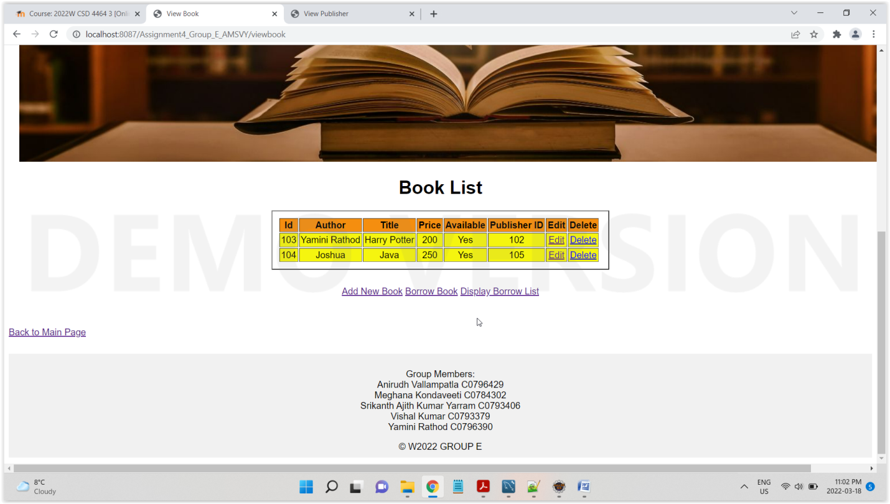

Delete Book

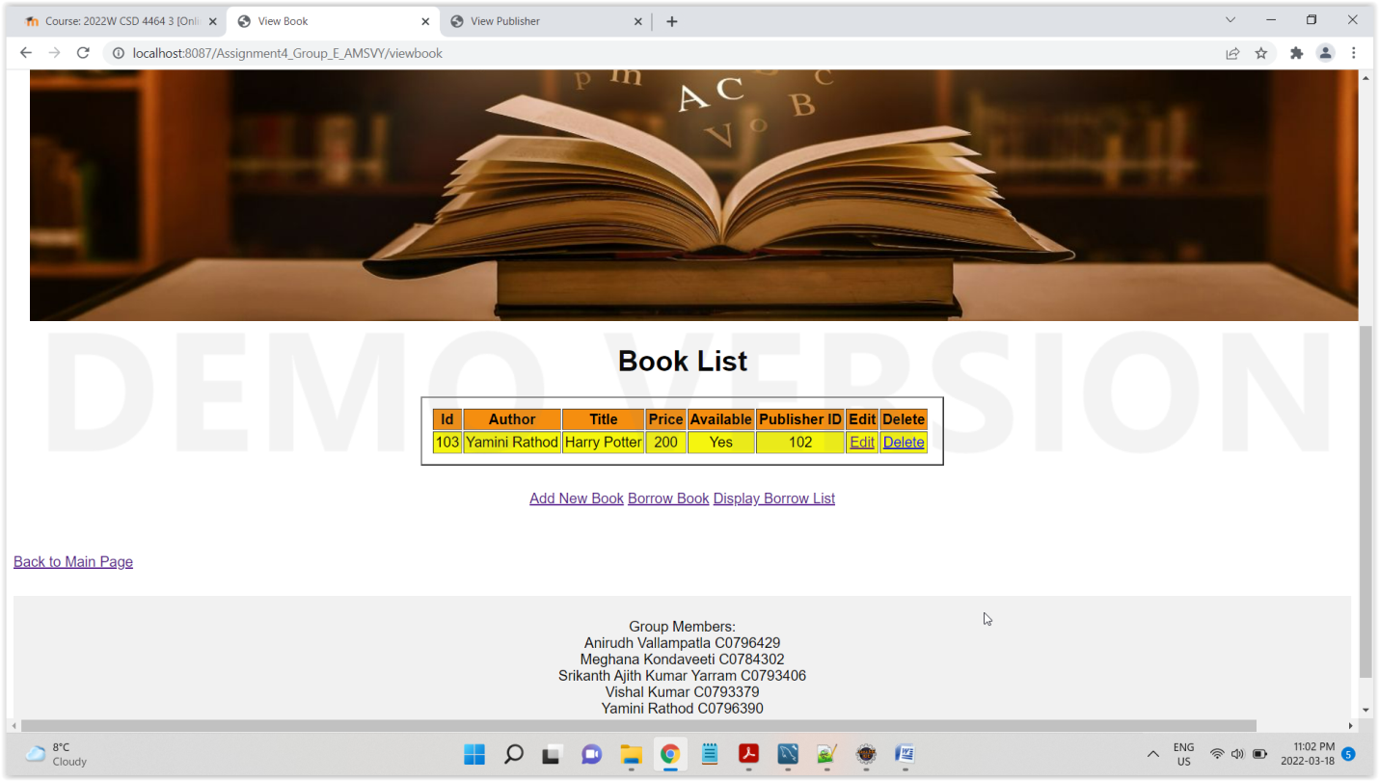

Issue Book (Notes: Tables are connected using referential Integrity, i.e. FK and PK. Application would throw an error if constraint rules are not followed, I am adding member id as 104 because it exists in member table, if we add any other values which does not exist in member table, then it would throw an error)

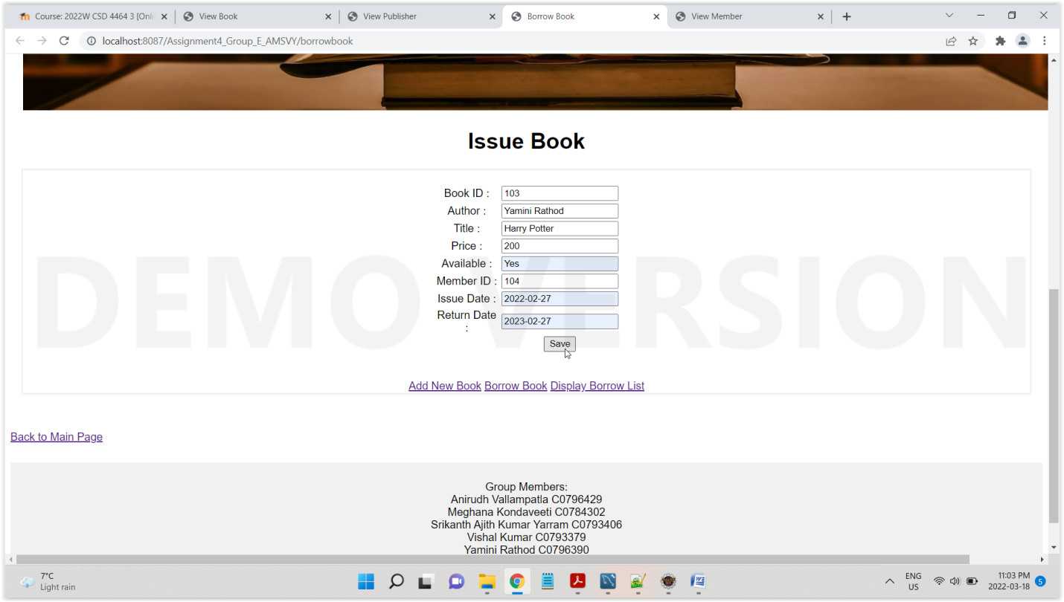

Display Borrow List

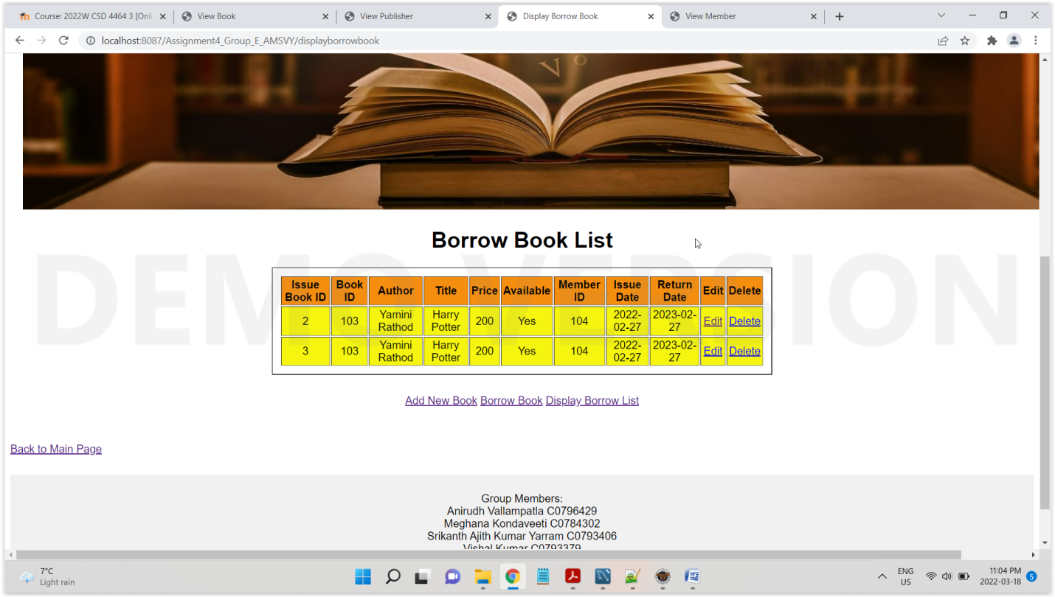

Edit Borrow List, try to edit with incorrect member id that does not exist in member table, it would throw referential integrity error

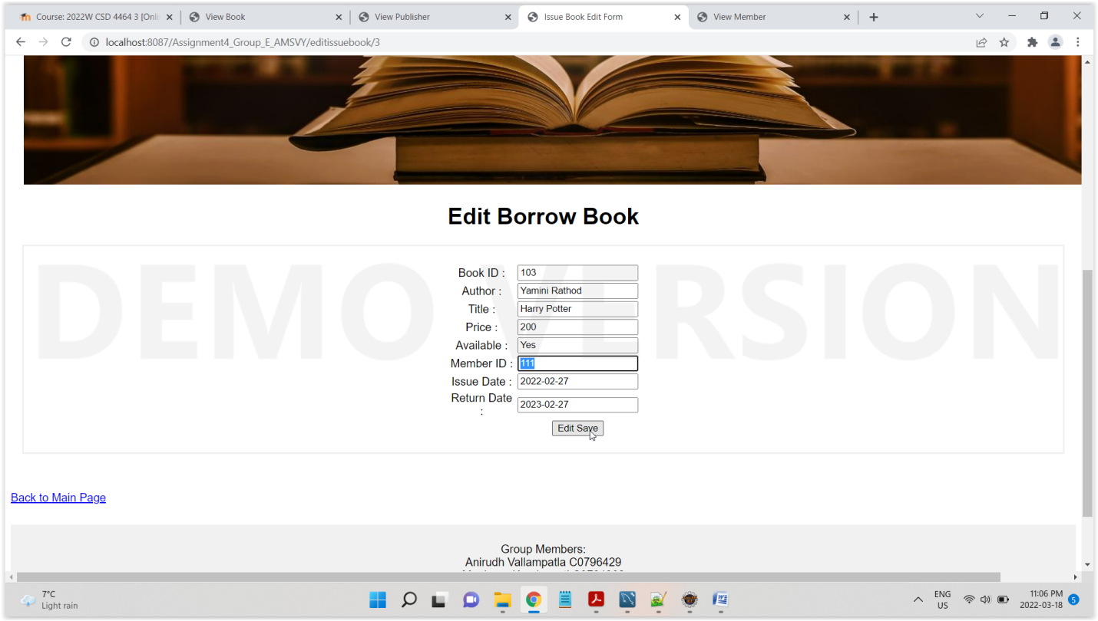

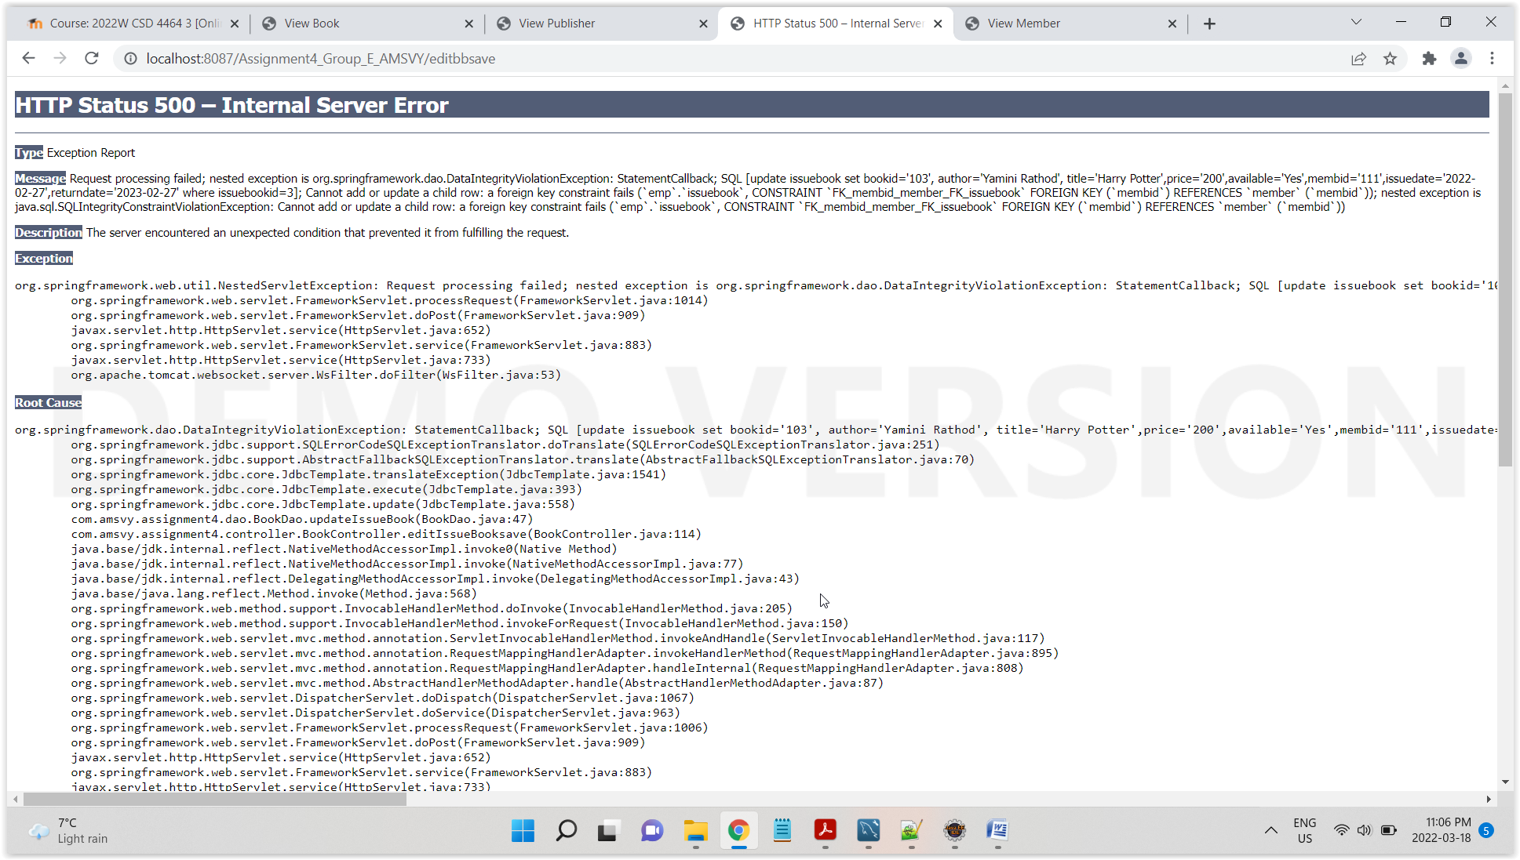

Edit with correct data, modifying return date

