Project: Predicting house prices using Machine learning

Name: Yamini T

AI Phase2 Submission

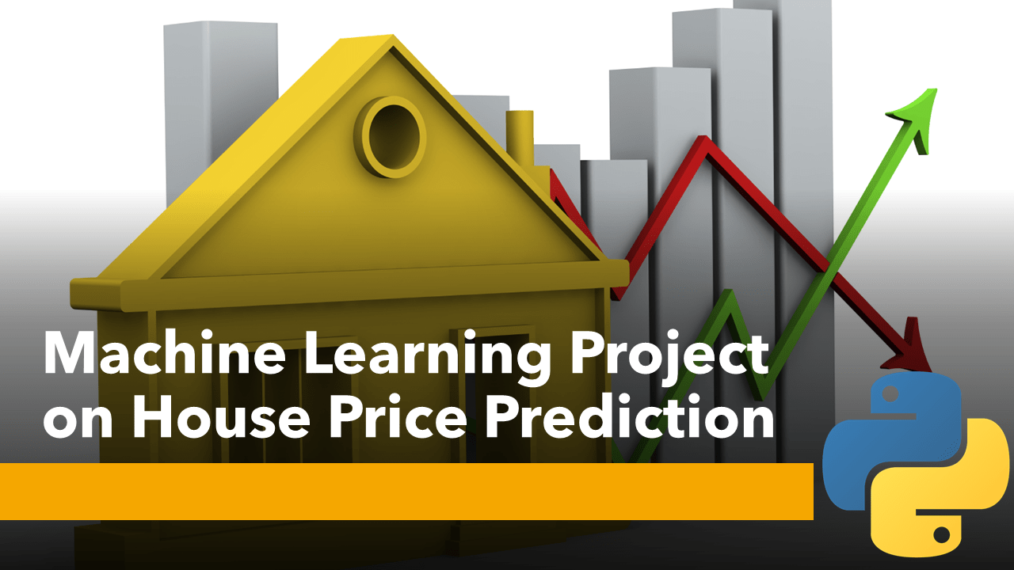

Description:

Traditional house price prediction models rely heavily on property-specific features like square footage, number of bedrooms, and location. However, this innovative approach incorporates sentiment analysis of neighborhood data to improve accuracy and provide more comprehensive insights into property valuation.

Methodology

1.Data Collection

* Gather comprehensive data on housing attributes (e.g., size, age, amenities) and neighborhood-specific information (e.g., crime rates, school quality, proximity to public transport).
* Collect user-generated content from social media, forums, and review platforms related to the neighborhoods in question.

2.Sentiment Analysis:

* Utilize Natural Language Processing (NLP) techniques to perform sentiment analysis on the collected textual data.
* Extract sentiment scores and sentiments associated with various aspects of a neighborhood, such as safety, schools, parks, and public transport.

3.Feature Engineering:

* Combine the sentiment analysis results with property-specific features to create an enriched dataset.
* Engineer new features that capture the sentiment-based insights, such as a "neighborhood sentiment score."

4.Machine Learning Model:

* Train a machine learning model, such as a regression model or a neural network, using the enriched dataset.
* The model should predict house prices based on both traditional features and neighborhood sentiment scores.

5.Model Evaluation:

* Evaluate the model's performance using standard metrics like Mean Absolute Error (MAE) and Root Mean Square Error (RMSE).
* Compare the sentiment-augmented model with traditional models to assess its improvement in accuracy.

Benefits:

* More Accurate Predictions: By incorporating neighborhood sentiment, the model can capture intangible factors that influence property values, such as the perceived safety and desirability of the area.
* Better Decision-Making: Homebuyers and real estate investors can make more informed decisions by considering both property features and neighborhood sentiment.
* Market Insights: Analyzing sentiment data can provide insights into changing neighborhood trends, which can be valuable for real estate professionals and urban planners.
* This innovative approach combines traditional property features with sentiment analysis to create a holistic model for house price prediction, offering a more comprehensive understanding of the real estate market.

Workflow:

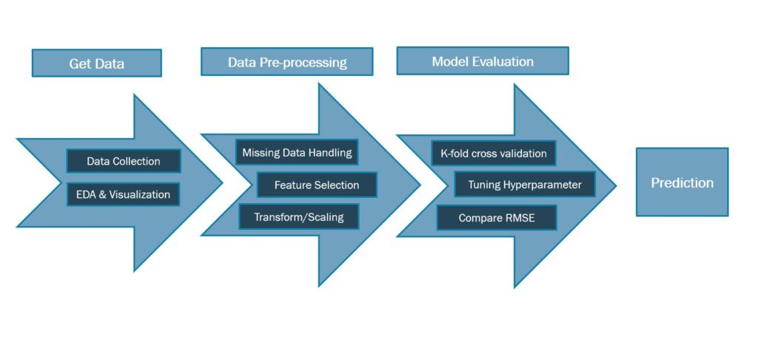

THANK YOU!!