Campus Service Request System - MVC Design Document

A) Analysis

1. Requirements List
- The system must support two user roles: Student and Staff.
- Students can submit a new service request containing a title, description, location (e.g., "Room A201"), and category (e.g., "IT", "Facilities").
- The system must automatically capture the date and time a request is submitted.
- All newly submitted requests must default to a "Pending" status.
- Students must be able to view a list of all the requests they have personally submitted.
- Staff members must be able to view a master list of all requests submitted by all students.
- Both Students and Staff can click on a specific request to view its full details.
- Staff members can update the status of a request (Pending → In Progress → Done).
- The system must restrict Students from updating the status of any request.
- The system must validate that request titles and descriptions are not empty before saving.

2. User Roles
- Student: Can create new requests and view the status of their own requests.
- Staff: Can view all requests across the campus and manage/update their resolution statuses.

3. Use Cases
Use Case 1: Submit a Request
- Actor: Student
- Trigger: Student clicks the "Create Request" button.
- Main Flow: 1. Student fills out the title, description, and location in a form. 2. Student submits the form. 3. System validates the input data. 4. System saves the request to the database with a "Pending" status.
- Success Outcome: The request is saved, and the student is redirected to their request list with a success message.
Use Case 2: View a List of Requests
- Actor: Staff
- Trigger: Staff member logs in or navigates to the dashboard.
- Main Flow:
  - Staff requests to see the dashboard.
  - System retrieves all requests from the database.
  - System formats the data into a list/table.
  - System displays the page to the staff member.
- Success Outcome: Staff sees an up-to-date table of all campus issues.
Use Case 3: View Request Details
- Actor: Student / Staff
- Trigger: User clicks on a specific request ID or title from the list view.
- Main Flow:
  - System receives the request ID from the URL.
  - System queries the database for that specific request's full details.
  - System loads the detailed view template.
- Success Outcome: User sees the full description, location, and current status of the specific issue.
Use Case 4: Update Request Status
- Actor: Staff
- Trigger: Staff member selects a new status from a dropdown on the details page and clicks "Update".
- Main Flow:
  - Staff submits the new status (e.g., "In Progress").
  - System checks if the user has staff permissions.
  - System updates the status field for that request in the database.
  - System reloads the detail page to reflect the new status.
- Success Outcome: The issue is marked with its new operational state.

B) Design

4. Class Responsibility Table (SRP)
Class Name | Responsibility | Reason to Change (1 reason)
Request | Stores the data structure for a single request (title, status, etc.). | The data fields we track change.
RequestRepository | Handles all PDO database queries (INSERT, SELECT, UPDATE) for requests. | The underlying database schema or storage method changes.
RequestService | Applies business rules, such as verifying staff permissions before a status update. | The business rules or workflow logic change.
RequestValidator | Checks form inputs to ensure titles and descriptions meet length/format rules. | The validation rules or required fields change.
RequestController | Receives HTTP requests, coordinates services, and selects the correct view. | The application's routing or user flows change.
ViewRenderer | Loads HTML templates and injects PHP variables into them safely. | The way HTML is compiled or templated changes.

5. Simple UML Class Diagram

6. MVC Mapping Table
Item | MVC Layer | Why?
Request (Entity) | Model | It represents the core application data structure
RequestRepository | Model | It is responsible for data access and storage logic
RequestController@index | Controller | It orchestrates the flow between the Model and View
requests/index.php | View | It strictly handles the UI presentation (HTML) for lists
requests/show.php | View | It strictly handles the UI presentation (HTML) for details

7. Route Table
HTTP Method | URL | Controller@Action | Purpose
GET | /requests | RequestController@index | Display list of student's requests
GET | /requests/create | RequestController@create | Show the form to submit a new request
POST | /requests | RequestController@store | Process and save the new request
GET | /requests/{id} | RequestController@show | View details of a single request
POST | /requests/{id}/status | RequestController@updateStatus | Staff action to update the status
GET | /staff/requests | RequestController@staffIndex | Display master list for staff

C) Minimal Code Skeletons
app/Models/Request.php
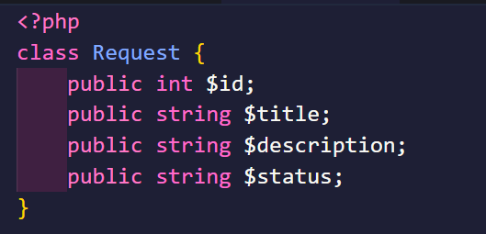
app/Controllers/RequestController.php
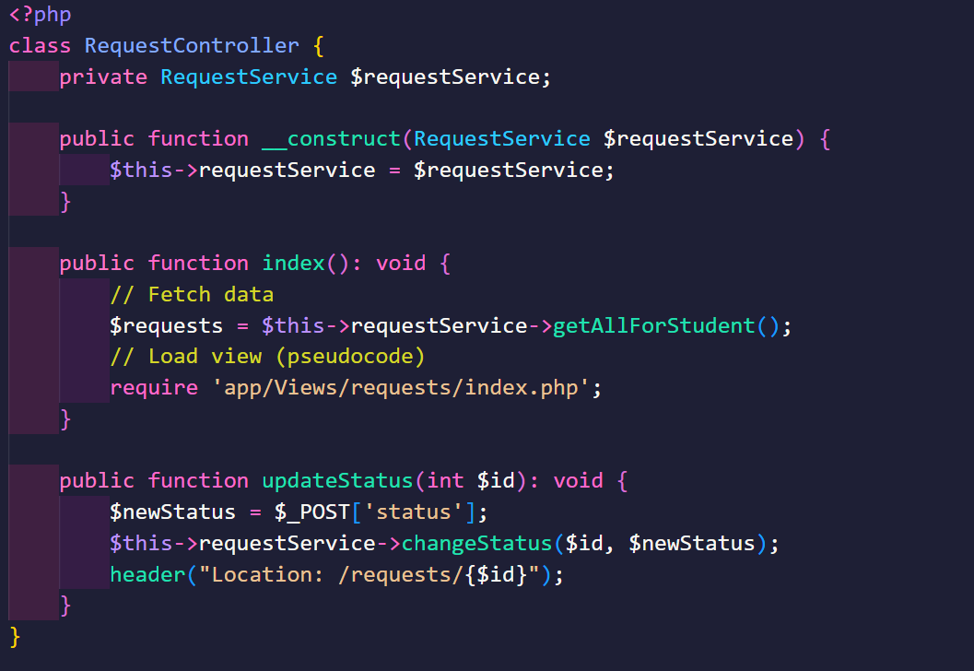
app/Views/requests/index.php
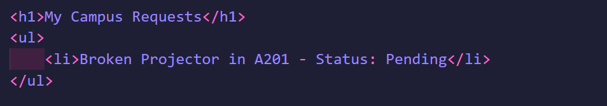
app/Views/requests/show.php
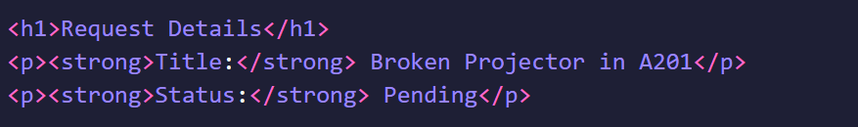

public/index.php
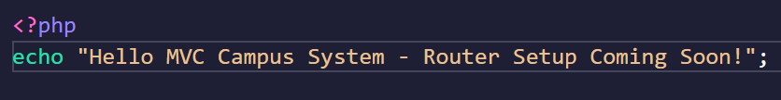

D) Reflection
- Which parts of your design are Model, View, and Controller? The Model consists of the Request entity, the RequestRepository (handling database interactions), and the RequestService (handling business logic). The View consists of the .php files inside the app/Views folder that render HTML. The Controller is the RequestController, acting as the traffic cop between the models and views.
- Where should validation happen, and why? Validation should occur in a dedicated RequestValidator class or within the RequestService, triggered by the Controller before the data reaches the Repository. This prevents malicious or malformed data (like empty titles) from ever interacting with the database layer.
- What would break if you put SQL inside a View file? Putting SQL in a View violates the Single Responsibility Principle. If the database schema changes, you have to dig through HTML files to fix broken queries. Furthermore, it makes the view impossible to test independently, creates massive security risks (like SQL injection if handling form data directly in HTML files), and makes the code very difficult to read.
- What code do you expect to write next week to make this real? Next week, I expect to write the central Router inside public/index.php to map URLs to specific controller methods. I will also need to write the actual PDO connection logic inside the Repository to execute CRUD operations against a live MySQL database, and set up an autoloader so classes don't need to be manually required.

