1.

I really don’t understand what “define suitable variables” means in this context. Variable (for example): my_number = 999999. I assume I’m supposed to tell the data types:

1. Integer
2. Float
3. String
4. String
5. Float
6. Integer
7. Integer
8. Integer
9. Integer

2.

3.

b.

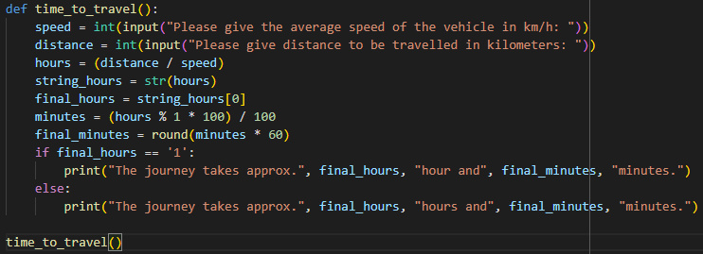



4.

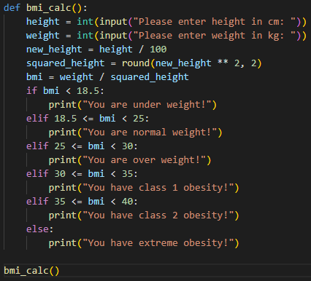





5.

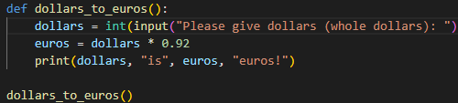



6.

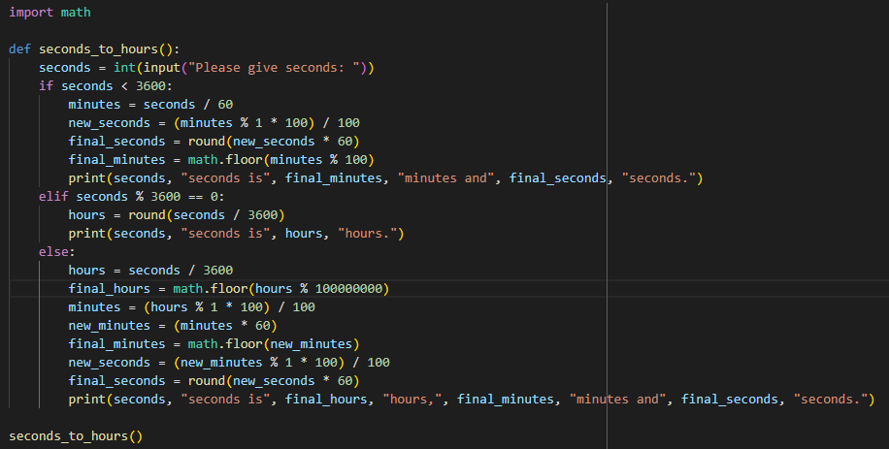





7.



