Ex.1



Ex.2

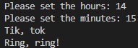

Ex.3

