1.



2.



3.



4.



5.

6.

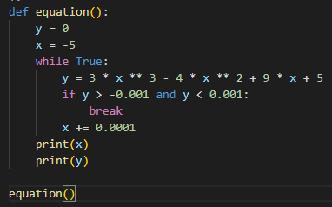



7.

8.



9.

