Ex.1

Ex.2

Ex.3

Ex.4



Ex.5



Ex.6

Ex.7



Ex.8



Ex.9



Ex.10

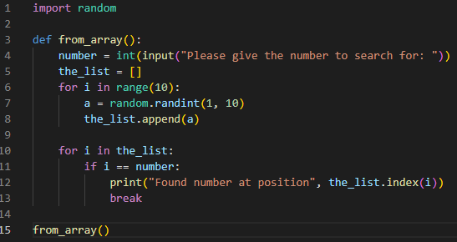



Ex.11

Ex.12

