**Tutorial – Part2: Mbed**

**I. Overview**

In this tutorial, you will use ‘mbed’ online compiler to handle several peripherals of MCU (ARM-Cortex M4). Using the given platform, you will perform some tasks about UART, PWM and ADC.

The objectives of this tutorial are

* Practice serial UART communication between MCU and PC.
* Understand how to control the period and pulse-width of PWM output.
* Understand how to measure analog voltage in MCU using ADC.

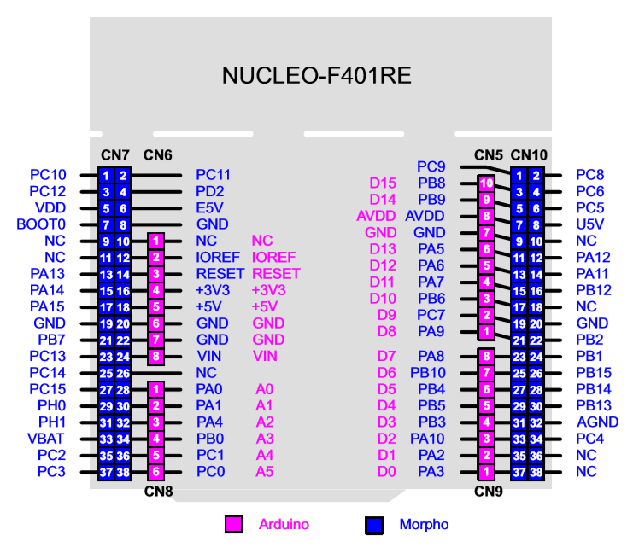

Figure 1. Pin configuration for NUCLEO-F401RE board

**II. Tutorial**

**A. U(S)ART (Universal Asynchronous/synchronous Receiver and Transmitter)**

* You can receive and transmit 8-bit character data through UART communication. NUCLEO-F401RE board offers UART2 channel with USB connector.
* Create new program as ‘**Tutorial2_UART**’.
* Open ‘main.cpp’ and delete the example codes. Write the following source code on ‘main.cpp’.

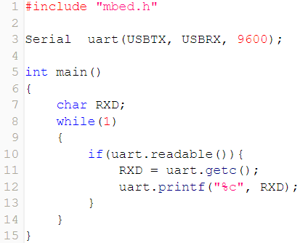

* Click on ‘**Compile’** button, then the binary file will be created and downloaded on your computer.
* Connect the MCU board to your PC via USB cable.
* To load the program onto the MCU, copy the downloaded binary file to the drive “NODE_F411RE (E:)”. If the program is loaded successfully then LED(LD1) will be green light.
* Open ‘Tera Term’ and connect serial port(‘**COMx: STMicroelectronics STLink**’). Check if the baud rate is selected as 9600 [bps].
* Press the reset button(black) and verify the operation. If you put any letter in Tera Term, MCU will receive it and transmit it to PC immediately, so you can see the pushed letters showed in Tera Term.

**B. PWM (Pulse Width Modulation)**

* You can generate PWM with ‘PwmOut’ class. In this tutorial, you will use ultrasonic sensor ‘HC-SR04’ and refer its datasheet. You have to generate trigger signal with 10[us] pulse-width on D10 pin. Also, you should capture the echo signal on D7 pin and measure its pulse-width to calculate the distance. The calculation formula is shown below.

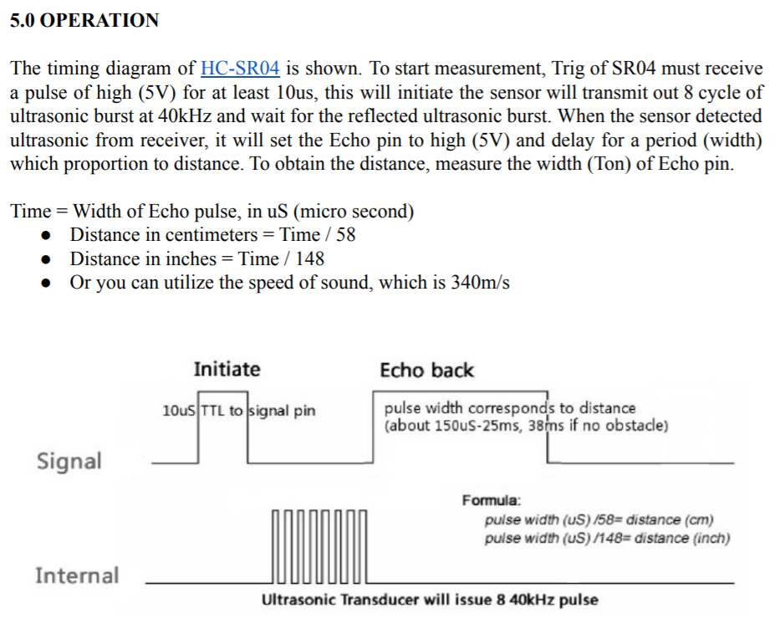

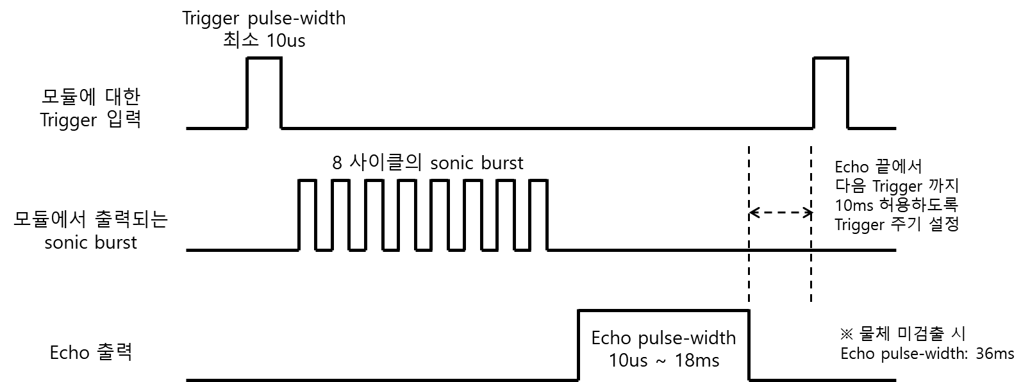

* Create new program as ‘**Tutorial2_PWM**’.
* Write the following code on ‘main.cpp’.

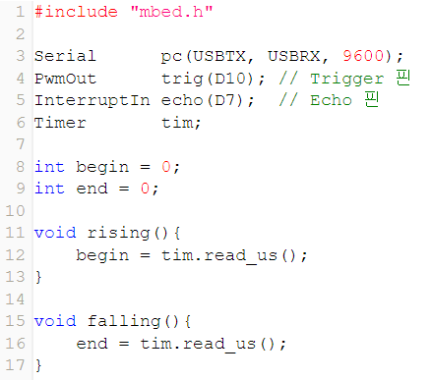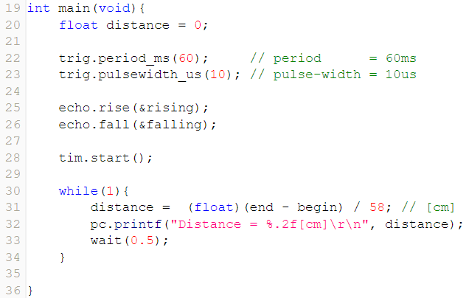

* Click on **Compile** button. Then, the binary files will be created and downloaded.
* Connect the MCU board to your PC via USB cable and check if a new memory drive of “NODE_F401RE (E:)” is created.
* Open ‘Tera Term’ and connect serial port(‘**COMx: STMicroelectronics STLink**’). Check if the baud rate is selected as 9600 [bps].
* Press the reset button(black) and verify the operation. The distance between ultrasonic sensor and obstacle will be shown in Tera Term.

**C. ADC**

* If you want to measure analog voltage, you can use ‘AnalogIn’ class. You will measure the output voltage of photo-resistor(조도센서) in this tutorial. This module outputs low voltage in bright condition, and vice versa.

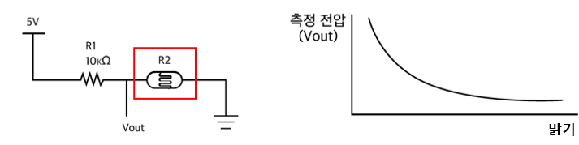

* Create new program as ‘**Tutorial2_ADC**’.
* Write the following code on ‘main.cpp’.

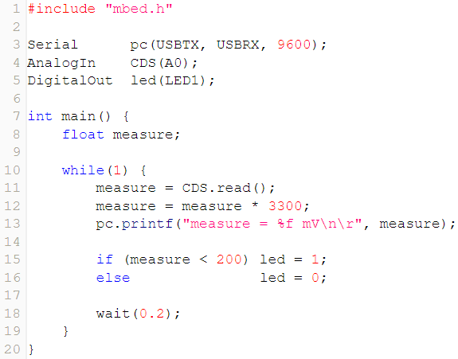

* Click on **Compile** button. Then, the binary files will be created and downloaded.
* Then, the binary file will be created and downloaded on your computer.
* To load the program onto the MCU, copy the downloaded binary file to the drive “NODE_F401RE (E:)”. If the program is loaded successfully then LED(LD1) will be green light.
* To verify the performance, firstly open ‘Tera Term’ and follow the sequences.
* Push the reset button(black) and verify the operation. If you turn on flashlight at photo-resistor with your phone, sensor output voltage will be decreased. When the output voltage is below 0.2V, which means high brightness is given, LED(LD2) will be turned on.