Airline Data Analysis

Yamkela Macwili

2023-10-16

Table of Contents

## Introduction

Delays in airline flight can be frustrating for both passengers and airlines. While some delays are caused by factors beyond anyone’s control, others can be predicted and possibly prevented. To address this issue, we aim to answer the question: “can we predict the likelihood of a flight delay?”.

Predicting flight delays is a critical task that can have a significant impact on the aviation industry. By identifying the factors that contribute to delays and developing predictive models, enhance passenger experience, and reduce the financial burden of delays on airlines.

In this analysis, we will explore historical flight data to uncover patterns and relationships that may help us predict flight delays. We will investigate various factors such as departure delays, carrier-related delays, and more.

### Load Required Libraries

library("tidyverse")

## ── Attaching core tidyverse packages ──────────────────────── tidyverse 2.0.0 ──  
## ✔ dplyr 1.1.3 ✔ readr 2.1.4  
## ✔ forcats 1.0.0 ✔ stringr 1.5.0  
## ✔ ggplot2 3.4.4 ✔ tibble 3.2.1  
## ✔ lubridate 1.9.3 ✔ tidyr 1.3.0  
## ✔ purrr 1.0.2   
## ── Conflicts ────────────────────────────────────────── tidyverse_conflicts() ──  
## ✖ dplyr::filter() masks stats::filter()  
## ✖ dplyr::lag() masks stats::lag()  
## ℹ Use the conflicted package (<http://conflicted.r-lib.org/>) to force all conflicts to become errors

library("Hmisc")

##   
## Attaching package: 'Hmisc'  
##   
## The following objects are masked from 'package:dplyr':  
##   
## src, summarize  
##   
## The following objects are masked from 'package:base':  
##   
## format.pval, units

library("corrplot")

## corrplot 0.92 loaded

library(knitr)

### Load and Inspect the Dataset

# Define the file path and read the dataset  
file_path <- "C:/Users/yamke/Downloads/airline_2m/airline_2m.csv"  
sub_airline <- read.csv(file_path, nrows = 8000)  
  
# Display the structure of the dataset  
glimpse(sub_airline)

## Rows: 8,000  
## Columns: 109  
## $ Year <int> 1998, 2009, 2013, 2010, 2006, 1995, 20…  
## $ Quarter <int> 1, 2, 2, 3, 1, 4, 3, 2, 3, 1, 4, 2, 3,…  
## $ Month <int> 1, 5, 6, 8, 1, 11, 8, 6, 8, 2, 11, 4, …  
## $ DayofMonth <int> 2, 28, 29, 31, 15, 29, 7, 11, 3, 8, 21…  
## $ DayOfWeek <int> 5, 4, 6, 2, 7, 3, 1, 2, 7, 4, 4, 4, 7,…  
## $ FlightDate <chr> "1998-01-02", "2009-05-28", "2013-06-2…  
## $ Reporting_Airline <chr> "NW", "FL", "MQ", "DL", "US", "DL", "C…  
## $ DOT_ID_Reporting_Airline <int> 19386, 20437, 20398, 19790, 20355, 197…  
## $ IATA_CODE_Reporting_Airline <chr> "NW", "FL", "MQ", "DL", "US", "DL", "C…  
## $ Tail_Number <chr> "N297US", "N946AT", "N665MQ", "N6705Y"…  
## $ Flight_Number_Reporting_Airline <int> 675, 671, 3297, 1806, 465, 1198, 1431,…  
## $ OriginAirportID <int> 13487, 13342, 11921, 12892, 11618, 112…  
## $ OriginAirportSeqID <int> 1348701, 1334202, 1192102, 1289201, 11…  
## $ OriginCityMarketID <int> 31650, 33342, 31921, 32575, 31703, 301…  
## $ Origin <chr> "MSP", "MKE", "GJT", "LAX", "EWR", "DF…  
## $ OriginCityName <chr> "Minneapolis, MN", "Milwaukee, WI", "G…  
## $ OriginState <chr> "MN", "WI", "CO", "CA", "NJ", "TX", "M…  
## $ OriginStateFips <int> 27, 55, 8, 6, 34, 48, 25, 13, 17, 17, …  
## $ OriginStateName <chr> "Minnesota", "Wisconsin", "Colorado", …  
## $ OriginWac <int> 63, 45, 82, 91, 21, 74, 13, 34, 41, 41…  
## $ DestAirportID <int> 14869, 13204, 11298, 11433, 11057, 148…  
## $ DestAirportSeqID <int> 1486902, 1320401, 1129803, 1143301, 11…  
## $ DestCityMarketID <int> 34614, 31454, 30194, 31295, 31057, 304…  
## $ Dest <chr> "SLC", "MCO", "DFW", "DTW", "CLT", "SH…  
## $ DestCityName <chr> "Salt Lake City, UT", "Orlando, FL", "…  
## $ DestState <chr> "UT", "FL", "TX", "MI", "NC", "LA", "O…  
## $ DestStateFips <int> 49, 12, 48, 26, 37, 22, 39, 45, 39, 48…  
## $ DestStateName <chr> "Utah", "Florida", "Texas", "Michigan"…  
## $ DestWac <int> 87, 33, 74, 43, 36, 72, 44, 37, 44, 74…  
## $ CRSDepTime <int> 1640, 1204, 1630, 1305, 1820, 639, 175…  
## $ DepTime <int> 1659, 1202, 1644, 1305, 1911, 639, 175…  
## $ DepDelay <dbl> 19, -2, 14, 0, 51, 0, -4, 221, 2, 16, …  
## $ DepDelayMinutes <dbl> 19, 0, 14, 0, 51, 0, 0, 221, 2, 16, 2,…  
## $ DepDel15 <dbl> 1, 0, 0, 0, 1, 0, 0, 1, 0, 1, 0, 0, 0,…  
## $ DepartureDelayGroups <int> 1, -1, 0, 0, 3, 0, -1, 12, 0, 1, 0, 0,…  
## $ DepTimeBlk <chr> "1600-1659", "1200-1259", "1600-1659",…  
## $ TaxiOut <dbl> 24, 10, 9, 23, 19, 29, 33, 19, 26, 34,…  
## $ WheelsOff <int> 1723, 1212, 1653, 1328, 1930, 708, 182…  
## $ WheelsOn <int> 1856, 1533, 1936, 2008, 2050, 736, 195…  
## $ TaxiIn <dbl> 3, 8, 6, 7, 8, 5, 4, 6, 3, 5, NA, 3, N…  
## $ CRSArrTime <int> 1836, 1541, 1945, 2035, 2026, 730, 200…  
## $ ArrTime <int> 1859, 1541, 1942, 2015, 2058, 741, 200…  
## $ ArrDelay <dbl> 23, 0, -3, -20, 32, 11, 2, 214, 10, 29…  
## $ ArrDelayMinutes <dbl> 23, 0, 0, 0, 32, 11, 2, 214, 10, 29, 6…  
## $ ArrDel15 <dbl> 1, 0, 0, 0, 1, 0, 0, 1, 0, 1, 0, 0, 0,…  
## $ ArrivalDelayGroups <int> 1, 0, -1, -2, 2, 0, 0, 12, 0, 1, 0, -1…  
## $ ArrTimeBlk <chr> "1800-1859", "1500-1559", "1900-1959",…  
## $ Cancelled <dbl> 0, 0, 0, 0, 0, 0, 0, 0, 0, 0, 0, 0, 0,…  
## $ CancellationCode <chr> "", "", "", "", "", "", "", "", "", ""…  
## $ Diverted <dbl> 0, 0, 0, 0, 0, 0, 0, 0, 0, 0, 0, 0, 0,…  
## $ CRSElapsedTime <dbl> 176, 157, 135, 270, 126, 51, 125, 67, …  
## $ ActualElapsedTime <dbl> 180, 159, 118, 250, 107, 62, 131, 60, …  
## $ AirTime <dbl> 153, 141, 103, 220, 80, 28, 94, 35, 59…  
## $ Flights <dbl> 1, 1, 1, 1, 1, 1, 1, 1, 1, 1, 1, 1, 1,…  
## $ Distance <dbl> 991, 1066, 773, 1979, 529, 190, 563, 1…  
## $ DistanceGroup <int> 4, 5, 4, 8, 3, 1, 3, 1, 2, 4, 1, 3, 5,…  
## $ CarrierDelay <dbl> NA, NA, NA, NA, 0, NA, NA, 0, NA, 0, N…  
## $ WeatherDelay <dbl> NA, NA, NA, NA, 0, NA, NA, 0, NA, 0, N…  
## $ NASDelay <dbl> NA, NA, NA, NA, 0, NA, NA, 0, NA, 13, …  
## $ SecurityDelay <dbl> NA, NA, NA, NA, 0, NA, NA, 0, NA, 0, N…  
## $ LateAircraftDelay <dbl> NA, NA, NA, NA, 32, NA, NA, 214, NA, 1…  
## $ FirstDepTime <int> NA, NA, NA, NA, NA, NA, NA, NA, NA, NA…  
## $ TotalAddGTime <dbl> NA, NA, NA, NA, NA, NA, NA, NA, NA, NA…  
## $ LongestAddGTime <dbl> NA, NA, NA, NA, NA, NA, NA, NA, NA, NA…  
## $ DivAirportLandings <int> NA, 0, 0, 0, NA, NA, NA, 0, NA, 0, NA,…  
## $ DivReachedDest <dbl> NA, NA, NA, NA, NA, NA, NA, NA, NA, NA…  
## $ DivActualElapsedTime <dbl> NA, NA, NA, NA, NA, NA, NA, NA, NA, NA…  
## $ DivArrDelay <dbl> NA, NA, NA, NA, NA, NA, NA, NA, NA, NA…  
## $ DivDistance <dbl> NA, NA, NA, NA, NA, NA, NA, NA, NA, NA…  
## $ Div1Airport <chr> "", "", "", "", "", "", "", "", "", ""…  
## $ Div1AirportID <int> NA, NA, NA, NA, NA, NA, NA, NA, NA, NA…  
## $ Div1AirportSeqID <int> NA, NA, NA, NA, NA, NA, NA, NA, NA, NA…  
## $ Div1WheelsOn <int> NA, NA, NA, NA, NA, NA, NA, NA, NA, NA…  
## $ Div1TotalGTime <dbl> NA, NA, NA, NA, NA, NA, NA, NA, NA, NA…  
## $ Div1LongestGTime <dbl> NA, NA, NA, NA, NA, NA, NA, NA, NA, NA…  
## $ Div1WheelsOff <int> NA, NA, NA, NA, NA, NA, NA, NA, NA, NA…  
## $ Div1TailNum <chr> "", "", "", "", "", "", "", "", "", ""…  
## $ Div2Airport <lgl> NA, NA, NA, NA, NA, NA, NA, NA, NA, NA…  
## $ Div2AirportID <lgl> NA, NA, NA, NA, NA, NA, NA, NA, NA, NA…  
## $ Div2AirportSeqID <lgl> NA, NA, NA, NA, NA, NA, NA, NA, NA, NA…  
## $ Div2WheelsOn <lgl> NA, NA, NA, NA, NA, NA, NA, NA, NA, NA…  
## $ Div2TotalGTime <lgl> NA, NA, NA, NA, NA, NA, NA, NA, NA, NA…  
## $ Div2LongestGTime <lgl> NA, NA, NA, NA, NA, NA, NA, NA, NA, NA…  
## $ Div2WheelsOff <lgl> NA, NA, NA, NA, NA, NA, NA, NA, NA, NA…  
## $ Div2TailNum <lgl> NA, NA, NA, NA, NA, NA, NA, NA, NA, NA…  
## $ Div3Airport <lgl> NA, NA, NA, NA, NA, NA, NA, NA, NA, NA…  
## $ Div3AirportID <lgl> NA, NA, NA, NA, NA, NA, NA, NA, NA, NA…  
## $ Div3AirportSeqID <lgl> NA, NA, NA, NA, NA, NA, NA, NA, NA, NA…  
## $ Div3WheelsOn <lgl> NA, NA, NA, NA, NA, NA, NA, NA, NA, NA…  
## $ Div3TotalGTime <lgl> NA, NA, NA, NA, NA, NA, NA, NA, NA, NA…  
## $ Div3LongestGTime <lgl> NA, NA, NA, NA, NA, NA, NA, NA, NA, NA…  
## $ Div3WheelsOff <lgl> NA, NA, NA, NA, NA, NA, NA, NA, NA, NA…  
## $ Div3TailNum <lgl> NA, NA, NA, NA, NA, NA, NA, NA, NA, NA…  
## $ Div4Airport <lgl> NA, NA, NA, NA, NA, NA, NA, NA, NA, NA…  
## $ Div4AirportID <lgl> NA, NA, NA, NA, NA, NA, NA, NA, NA, NA…  
## $ Div4AirportSeqID <lgl> NA, NA, NA, NA, NA, NA, NA, NA, NA, NA…  
## $ Div4WheelsOn <lgl> NA, NA, NA, NA, NA, NA, NA, NA, NA, NA…  
## $ Div4TotalGTime <lgl> NA, NA, NA, NA, NA, NA, NA, NA, NA, NA…  
## $ Div4LongestGTime <lgl> NA, NA, NA, NA, NA, NA, NA, NA, NA, NA…  
## $ Div4WheelsOff <lgl> NA, NA, NA, NA, NA, NA, NA, NA, NA, NA…  
## $ Div4TailNum <lgl> NA, NA, NA, NA, NA, NA, NA, NA, NA, NA…  
## $ Div5Airport <lgl> NA, NA, NA, NA, NA, NA, NA, NA, NA, NA…  
## $ Div5AirportID <lgl> NA, NA, NA, NA, NA, NA, NA, NA, NA, NA…  
## $ Div5AirportSeqID <lgl> NA, NA, NA, NA, NA, NA, NA, NA, NA, NA…  
## $ Div5WheelsOn <lgl> NA, NA, NA, NA, NA, NA, NA, NA, NA, NA…  
## $ Div5TotalGTime <lgl> NA, NA, NA, NA, NA, NA, NA, NA, NA, NA…  
## $ Div5LongestGTime <lgl> NA, NA, NA, NA, NA, NA, NA, NA, NA, NA…  
## $ Div5WheelsOff <lgl> NA, NA, NA, NA, NA, NA, NA, NA, NA, NA…  
## $ Div5TailNum <lgl> NA, NA, NA, NA, NA, NA, NA, NA, NA, NA…

The dataset has 8000 rows and 109 columns.

## Dataset Glossary

Now let’s look at the features and description of the dataset.

url <- "C:/Users/yamke/OneDrive/Documents/Airline Analysis/Airline/table3.csv"  
dataset_glossary <- read.csv(url)  
  
# Print the dataset glossary in tabular format  
kable(dataset_glossary)

| Feature | Description |
| --- | --- |
| Year | Year |
| Quarter | Quarter |
| Month | Month |
| DayofMonth | Day of Month |
| DayOfWeek | Day of Week (numeric) |
| FlightDate | Date of Flight |
| Reporting_Airline | Airline Unique Carrier Code |
| DOT_ID_Reporting_Airline | Number assigned by US DOT to identify a unique airline |
| IATA_CODE_Reporting_Airline | Airline Code assigned by IATA |
| Tail_Number | Aircraft tail number |
| Flight_Number_Reporting_Airline | Flight Number |
| OriginAirportID | Origin Airport ID |
| OriginAirportSeqID | Origin Airport Sequence ID |
| OriginCityMarketID | Origin City Market ID |
| Origin | Origin Airport Code |
| OriginCityName | Origin City Name |
| OriginState | Origin State |
| OriginStateFips | Origin State FIPS place code |
| OriginStateName | Origin State Name |
| OriginWac | Origin Airport World Area Code |
| DestAirportID | Destination Airport ID |
| DestAirportSeqID | Destination Airport Sequence ID |
| DestCityMarketID | Destination City Market ID |
| Dest | Destination Airport Code |
| DestCityName | Destination City Name |
| DestState | Destination State |
| DestStateFips | Destination State FIPS code |
| DestStateName | Destination State Name |
| DestWac | Destination Airport World Area Code |
| CRSDepTime | Computer Reservation System (scheduled) Departure Time |
| DepTime | Departure Time (hhmm) |
| DepDelay | Departure delay (minutes) |
| DepDelayMinutes | Absolute value of DepDelay |
| DepDel15 | Departure Delay >15? |
| DepartureDelayGroups | Departure delay 15 minute interval group |
| DepTimeBlk | Computer Reservation System (scheduled) time block |
| TaxiOut | Taxi out time (minutes) |
| WheelsOff | Wheels off time (local time, hhmm) |
| WheelsOn | Wheels on time (local time hhmm) |
| TaxiIn | Taxi in time (minutes) |
| CRSArrTime | Computer Reservation System (scheduled) Arrival Time |
| ArrTime | Arrival time (local time, hhmm) |
| ArrDelay | Arrival delay (minutes) |
| ArrDelayMinutes | Absolute value of ArrDelay |
| ArrDel15 | Arrival Delay >15? |
| ArrivalDelayGroups | Arrival delay 15 minute interval group |
| ArrTimeBlk | Computer Reservation System (scheduled) arrival time block |
| Cancelled | 1 = canceled |
| CancellationCode | A = Carrier, B = Weather, C = National Air System, D = Security |
| Diverted | 1 = diverted |
| CRSElapsedTime | Computer Reservation System (scheduled) elapsed time |
| ActualElapsedTime | Actual elapsed time |
| AirTime | Flight time (minutes) |
| Flights | Number of flights |
| Distance | Distance between airports (miles) |
| DistanceGroup | 250 mile distance interval group |
| CarrierDelay | Carrier delay (minutes) |
| WeatherDelay | Weather delay (minutes) |
| NASDelay | National Air System delay (minutes) |
| SecurityDelay | Security delay (minutes) |
| LateAircraftDelay | Late aircraft delay (minutes) |
| FirstDepTime | First gate departure time at origin airport |
| TotalAddGTime | Total ground time away from gate |
| LongestAddGTime | Longest time away from gate |
| DivAirportLandings | Number of diverted airport landings |
| DivReachedDest | 1 = diverted flight reached scheduled destination |
| DivActualElapsedTime | Elapsed time of diverted flight reaching scheduled destination |
| DivArrDelay | Difference in minutes between scheduled and actual arrival time |
| DivDistance | Distance between scheduled and diverted airport |
| Div1Airport | Diverted Airport 1 |
| Div1AirportID | Diverted Airport 1 ID |
| Div1AirportSeqID | Diverted Airport 1 Sequence ID |
| Div1WheelsOn | Diverted Airport 1 wheels on time (local, hhmm) |
| Div1TotalGTime | Diverted Airport 1 total ground time away from gate |
| Div1LongestGTime | Diverted Airport 1 longest ground time away from gate |
| Div1WheelsOff | Diverted Airport 1 wheels off time (local, hhmm) |
| Div1TailNum | Diverted Airport 1 aircraft tail number |
| Div2Airport | Diverted Airport 2 |
| Div2AirportID | Diverted Airport 2 ID |
| Div2AirportSeqID | Diverted Airport 2 Sequence ID |
| Div2WheelsOn | Diverted Airport 2 wheels on time (local, hhmm) |
| Div2TotalGTime | Diverted Airport 2 total ground time away from gate |
| Div2LongestGTime | Diverted Airport 2 longest ground time away from gate |
| Div2WheelsOff | Diverted Airport 2 wheels off time (local, hhmm) |
| Div2TailNum | Diverted Airport 2 aircraft tail number |
| Div3Airport | Diverted Airport 3 |
| Div3AirportID | Diverted Airport 3 ID |
| Div3AirportSeqID | Diverted Airport 3 Sequence ID |
| Div3WheelsOn | Diverted Airport 3 wheels on time (local, hhmm) |
| Div3TotalGTime | Diverted Airport 3 total ground time away from gate |
| Div3LongestGTime | Diverted Airport 3 longest ground time away from gate |
| Div3WheelsOff | Diverted Airport 3 wheels off time (local, hhmm) |
| Div3TailNum | Diverted Airport 3 aircraft tail number |
| Div4Airport | Diverted Airport 4 |
| Div4AirportID | Diverted Airport 4 ID |
| Div4AirportSeqID | Diverted Airport 4 Sequence ID |
| Div4WheelsOn | Diverted Airport 4 wheels on time (local, hhmm) |
| Div4TotalGTime | Diverted Airport 4 total ground time away from gate |
| Div4LongestGTime | Diverted Airport 4 longest ground time away from gate |
| Div4WheelsOff | Diverted Airport 4 wheels off time (local, hhmm) |
| Div4TailNum | Diverted Airport 4 aircraft tail number |
| Div5Airport | Diverted Airport 5 |
| Div5AirportID | Diverted Airport 5 ID |
| Div5AirportSeqID | Diverted Airport 5 Sequence ID |
| Div5WheelsOn | Diverted Airport 5 wheels on time (local, hhmm) |
| Div5TotalGTime | Diverted Airport 5 total ground time away from gate |
| Div5LongestGTime | Diverted Airport 5 longest ground time away from gate |
| Div5WheelsOff | Diverted Airport 5 wheels off time (local, hhmm) |
| Div5TailNum | Diverted Airport 5 aircraft tail number |

Variables of the Airline-Reporting Carrier On-Time Performance dataset include:

* The target value “ArrDelay” or “ArrDelayMinutes”.
* Reasons for delay.

## Data Preprocessing

Lets us have a look at the our dataset for missing values.

# Count missing values in all columns  
missing_values <- sub_airline %>% map(~sum(is.na(.)))  
missing_values

## $Year  
## [1] 0  
##   
## $Quarter  
## [1] 0  
##   
## $Month  
## [1] 0  
##   
## $DayofMonth  
## [1] 0  
##   
## $DayOfWeek  
## [1] 0  
##   
## $FlightDate  
## [1] 0  
##   
## $Reporting_Airline  
## [1] 0  
##   
## $DOT_ID_Reporting_Airline  
## [1] 0  
##   
## $IATA_CODE_Reporting_Airline  
## [1] 0  
##   
## $Tail_Number  
## [1] 0  
##   
## $Flight_Number_Reporting_Airline  
## [1] 0  
##   
## $OriginAirportID  
## [1] 0  
##   
## $OriginAirportSeqID  
## [1] 0  
##   
## $OriginCityMarketID  
## [1] 0  
##   
## $Origin  
## [1] 0  
##   
## $OriginCityName  
## [1] 0  
##   
## $OriginState  
## [1] 0  
##   
## $OriginStateFips  
## [1] 1  
##   
## $OriginStateName  
## [1] 0  
##   
## $OriginWac  
## [1] 0  
##   
## $DestAirportID  
## [1] 0  
##   
## $DestAirportSeqID  
## [1] 0  
##   
## $DestCityMarketID  
## [1] 0  
##   
## $Dest  
## [1] 0  
##   
## $DestCityName  
## [1] 0  
##   
## $DestState  
## [1] 0  
##   
## $DestStateFips  
## [1] 2  
##   
## $DestStateName  
## [1] 0  
##   
## $DestWac  
## [1] 0  
##   
## $CRSDepTime  
## [1] 0  
##   
## $DepTime  
## [1] 133  
##   
## $DepDelay  
## [1] 133  
##   
## $DepDelayMinutes  
## [1] 133  
##   
## $DepDel15  
## [1] 133  
##   
## $DepartureDelayGroups  
## [1] 133  
##   
## $DepTimeBlk  
## [1] 0  
##   
## $TaxiOut  
## [1] 1661  
##   
## $WheelsOff  
## [1] 1661  
##   
## $WheelsOn  
## [1] 1672  
##   
## $TaxiIn  
## [1] 1672  
##   
## $CRSArrTime  
## [1] 0  
##   
## $ArrTime  
## [1] 147  
##   
## $ArrDelay  
## [1] 152  
##   
## $ArrDelayMinutes  
## [1] 152  
##   
## $ArrDel15  
## [1] 152  
##   
## $ArrivalDelayGroups  
## [1] 152  
##   
## $ArrTimeBlk  
## [1] 0  
##   
## $Cancelled  
## [1] 0  
##   
## $CancellationCode  
## [1] 0  
##   
## $Diverted  
## [1] 0  
##   
## $CRSElapsedTime  
## [1] 2  
##   
## $ActualElapsedTime  
## [1] 152  
##   
## $AirTime  
## [1] 1677  
##   
## $Flights  
## [1] 0  
##   
## $Distance  
## [1] 0  
##   
## $DistanceGroup  
## [1] 0  
##   
## $CarrierDelay  
## [1] 7136  
##   
## $WeatherDelay  
## [1] 7136  
##   
## $NASDelay  
## [1] 7136  
##   
## $SecurityDelay  
## [1] 7136  
##   
## $LateAircraftDelay  
## [1] 7136  
##   
## $FirstDepTime  
## [1] 7990  
##   
## $TotalAddGTime  
## [1] 7990  
##   
## $LongestAddGTime  
## [1] 7990  
##   
## $DivAirportLandings  
## [1] 5055  
##   
## $DivReachedDest  
## [1] 7993  
##   
## $DivActualElapsedTime  
## [1] 7995  
##   
## $DivArrDelay  
## [1] 7995  
##   
## $DivDistance  
## [1] 7993  
##   
## $Div1Airport  
## [1] 0  
##   
## $Div1AirportID  
## [1] 7992  
##   
## $Div1AirportSeqID  
## [1] 7992  
##   
## $Div1WheelsOn  
## [1] 7992  
##   
## $Div1TotalGTime  
## [1] 7992  
##   
## $Div1LongestGTime  
## [1] 7992  
##   
## $Div1WheelsOff  
## [1] 7995  
##   
## $Div1TailNum  
## [1] 0  
##   
## $Div2Airport  
## [1] 8000  
##   
## $Div2AirportID  
## [1] 8000  
##   
## $Div2AirportSeqID  
## [1] 8000  
##   
## $Div2WheelsOn  
## [1] 8000  
##   
## $Div2TotalGTime  
## [1] 8000  
##   
## $Div2LongestGTime  
## [1] 8000  
##   
## $Div2WheelsOff  
## [1] 8000  
##   
## $Div2TailNum  
## [1] 8000  
##   
## $Div3Airport  
## [1] 8000  
##   
## $Div3AirportID  
## [1] 8000  
##   
## $Div3AirportSeqID  
## [1] 8000  
##   
## $Div3WheelsOn  
## [1] 8000  
##   
## $Div3TotalGTime  
## [1] 8000  
##   
## $Div3LongestGTime  
## [1] 8000  
##   
## $Div3WheelsOff  
## [1] 8000  
##   
## $Div3TailNum  
## [1] 8000  
##   
## $Div4Airport  
## [1] 8000  
##   
## $Div4AirportID  
## [1] 8000  
##   
## $Div4AirportSeqID  
## [1] 8000  
##   
## $Div4WheelsOn  
## [1] 8000  
##   
## $Div4TotalGTime  
## [1] 8000  
##   
## $Div4LongestGTime  
## [1] 8000  
##   
## $Div4WheelsOff  
## [1] 8000  
##   
## $Div4TailNum  
## [1] 8000  
##   
## $Div5Airport  
## [1] 8000  
##   
## $Div5AirportID  
## [1] 8000  
##   
## $Div5AirportSeqID  
## [1] 8000  
##   
## $Div5WheelsOn  
## [1] 8000  
##   
## $Div5TotalGTime  
## [1] 8000  
##   
## $Div5LongestGTime  
## [1] 8000  
##   
## $Div5WheelsOff  
## [1] 8000  
##   
## $Div5TailNum  
## [1] 8000

Dealing with the missing values first. N/A on our delay type means no delay, therefore we replace the missing values with 0.

#Replace the missing values   
sub_airline <- sub_airline %>%  
 mutate(across(contains("Delay"), ~replace(., is.na(.), 0)))  
  
# Select and view the delay-related columns  
delay_columns <- select(sub_airline, contains("Delay"))  
kable(head(delay_columns))

| DepDelay | DepDelayMinutes | DepartureDelayGroups | ArrDelay | ArrDelayMinutes | ArrivalDelayGroups | CarrierDelay | WeatherDelay | NASDelay | SecurityDelay | LateAircraftDelay | DivArrDelay |
| --- | --- | --- | --- | --- | --- | --- | --- | --- | --- | --- | --- |
| 19 | 19 | 1 | 23 | 23 | 1 | 0 | 0 | 0 | 0 | 0 | 0 |
| -2 | 0 | -1 | 0 | 0 | 0 | 0 | 0 | 0 | 0 | 0 | 0 |
| 14 | 14 | 0 | -3 | 0 | -1 | 0 | 0 | 0 | 0 | 0 | 0 |
| 0 | 0 | 0 | -20 | 0 | -2 | 0 | 0 | 0 | 0 | 0 | 0 |
| 51 | 51 | 3 | 32 | 32 | 2 | 0 | 0 | 0 | 0 | 32 | 0 |
| 0 | 0 | 0 | 11 | 11 | 0 | 0 | 0 | 0 | 0 | 0 | 0 |

Everything seems good, all the missing values are replaced with 0. Now we can visualize the data.

## Data Visualization

Histogram of ArrDelay

# Check the range   
range(sub_airline$ArrDelay)

## [1] -60 954

# Create a histogram of ArrDelay  
ggplot(data = sub_airline, mapping = aes(x = ArrDelay)) +  
 geom_histogram(binwidth = 10, color = "white", fill = "red") +  
 coord_cartesian(xlim = c(-60, 954))

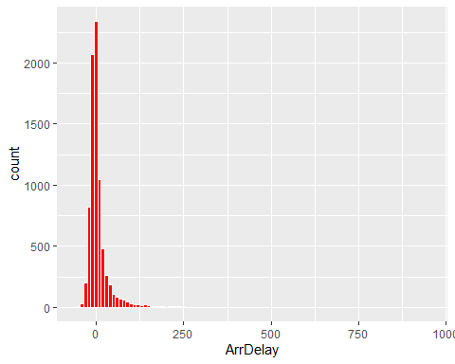 The plot shows that, the count of flight which arrive on time is much greater than the flights that arrive early or the ones that arrive late. Thought it is visible that most flight arrive late, so our next question is, What causes a flight delay?

### Descriptive Statistics - Mean and Standard Deviation of ArrDelayMinutes

count_airline <- sub_airline%>%  
 count(sub_airline$Reporting_Airline)  
kable(count_airline)

| sub_airline$Reporting_Airline | n |
| --- | --- |
| 9E | 83 |
| AA | 942 |
| AS | 178 |
| B6 | 118 |
| CO | 330 |
| DH | 26 |
| DL | 1079 |
| EA | 30 |
| EV | 274 |
| F9 | 60 |
| FL | 99 |
| G4 | 5 |
| HA | 38 |
| HP | 157 |
| KH | 4 |
| ML (1) | 3 |
| MQ | 330 |
| NK | 40 |
| NW | 432 |
| OH | 90 |
| OO | 461 |
| PA (1) | 14 |
| PI | 45 |
| PS | 3 |
| TW | 147 |
| TZ | 15 |
| UA | 758 |
| US | 723 |
| VX | 16 |
| WN | 1239 |
| XE | 131 |
| YV | 99 |
| YX | 31 |

# Descriptive Statistics - Mean and Standard Deviation of ArrDelayMinutes  
summary_airline_delay <- sub_airline %>%  
 group_by(Reporting_Airline) %>%  
 summarise(mean = mean(ArrDelayMinutes), std_dev = sd(ArrDelayMinutes))  
kable(summary_airline_delay)

| Reporting_Airline | mean | std_dev |
| --- | --- | --- |
| 9E | 15.578313 | 37.349085 |
| AA | 11.145435 | 27.128910 |
| AS | 11.247191 | 28.045476 |
| B6 | 11.262712 | 27.922796 |
| CO | 12.866667 | 31.748161 |
| DH | 10.461538 | 21.628187 |
| DL | 10.142725 | 27.598164 |
| EA | 10.933333 | 18.754187 |
| EV | 13.645985 | 49.372423 |
| F9 | 28.733333 | 85.276195 |
| FL | 11.050505 | 24.889705 |
| G4 | 6.800000 | 7.563068 |
| HA | 3.947368 | 7.986297 |
| HP | 13.057325 | 44.700032 |
| KH | 12.250000 | 21.203380 |
| ML (1) | 3.666667 | 6.350853 |
| MQ | 11.215151 | 25.902185 |
| NK | 14.925000 | 29.452602 |
| NW | 9.104167 | 21.059650 |
| OH | 18.166667 | 43.053207 |
| OO | 15.477223 | 60.050758 |
| PA (1) | 5.928571 | 11.605465 |
| PI | 11.200000 | 15.862477 |
| PS | 7.333333 | 12.701706 |
| TW | 12.231293 | 30.210691 |
| TZ | 7.733333 | 25.038447 |
| UA | 16.875989 | 42.584539 |
| US | 10.201936 | 23.761118 |
| VX | 23.562500 | 74.635978 |
| WN | 10.263922 | 24.938320 |
| XE | 11.847328 | 32.571454 |
| YV | 13.373737 | 39.244806 |
| YX | 23.774193 | 100.237621 |

# Create a simple average across Reporting_Airline and DayOfWeek  
average_delays <- sub_airline %>%   
 group_by(Reporting_Airline, DayOfWeek)%>%  
 summarise(mean_delays = mean(ArrDelayMinutes))

## `summarise()` has grouped output by 'Reporting_Airline'. You can override using  
## the `.groups` argument.

kable(head(average_delays))

| Reporting_Airline | DayOfWeek | mean_delays |
| --- | --- | --- |
| 9E | 1 | 8.473684 |
| 9E | 2 | 29.545455 |
| 9E | 3 | 18.619048 |
| 9E | 4 | 4.333333 |
| 9E | 5 | 18.933333 |
| 9E | 6 | 3.857143 |

#Sort the dataframe  
arrange_avg_delay <- average_delays %>%  
 arrange(desc(mean_delays))  
kable(head(arrange_avg_delay))

| Reporting_Airline | DayOfWeek | mean_delays |
| --- | --- | --- |
| YX | 5 | 187.33333 |
| VX | 4 | 150.50000 |
| F9 | 1 | 74.63636 |
| OH | 4 | 46.63636 |
| KH | 1 | 44.00000 |
| OO | 5 | 39.97015 |

# Visualize the data using Heatmap  
average_delays %>%  
 ggplot(aes( x = Reporting_Airline,  
 y = DayOfWeek,  
 fill = mean_delays))+  
 geom_tile(color = "white", linewidth = 0.2)+  
 scale_fill_gradient(low = "yellow",  
 high = "red")

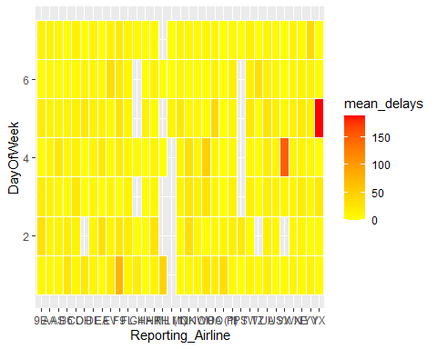

ggplot(data = sub_airline, mapping = aes(x = Reporting_Airline, y = ArrDelayMinutes))+  
 geom_boxplot(fill = "lightblue", color = "blue")+  
 labs(title = "Distribution of Arrival Delays by Airline",  
 x = "Airline", y = "Arrival Delay (minutes)")+  
 theme_minimal()+  
 theme(axis.text.x = element_text(angle = 45, hjust =1))

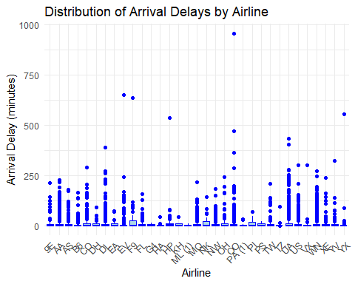

### Linear Relationships

### Correlation Matrix Heatmap

# Correlation between different delay types and ArrDelayMinutes  
corr_airline <- sub_airline %>%  
 select(ArrDelayMinutes, DepDelayMinutes, CarrierDelay, WeatherDelay, NASDelay, SecurityDelay, LateAircraftDelay)  
  
airline_correlation <- rcorr(as.matrix(corr_airline), type = "pearson")  
correlation_matrix <- airline_correlation$r  
kable(correlation_matrix, format = "markdown")

|  | ArrDelayMinutes | DepDelayMinutes | CarrierDelay | WeatherDelay | NASDelay | SecurityDelay | LateAircraftDelay |
| --- | --- | --- | --- | --- | --- | --- | --- |
| ArrDelayMinutes | 1.0000000 | 0.9510640 | 0.6266076 | 0.1293258 | 0.3583874 | 0.0289321 | 0.5169887 |
| DepDelayMinutes | 0.9510640 | 1.0000000 | 0.6484311 | 0.1291708 | 0.2634974 | 0.0315422 | 0.5303645 |
| CarrierDelay | 0.6266076 | 0.6484311 | 1.0000000 | -0.0053310 | 0.0180580 | -0.0020372 | 0.0888572 |
| WeatherDelay | 0.1293258 | 0.1291708 | -0.0053310 | 1.0000000 | 0.0224852 | -0.0010936 | 0.0149123 |
| NASDelay | 0.3583874 | 0.2634974 | 0.0180580 | 0.0224852 | 1.0000000 | -0.0028939 | 0.0731567 |
| SecurityDelay | 0.0289321 | 0.0315422 | -0.0020372 | -0.0010936 | -0.0028939 | 1.0000000 | 0.0013452 |
| LateAircraftDelay | 0.5169887 | 0.5303645 | 0.0888572 | 0.0149123 | 0.0731567 | 0.0013452 | 1.0000000 |

# Set the position of x-axis labels to the bottom (order = "hclust")  
corrplot(correlation_matrix, method = "color", tl.col = "black", tl.srt = 45, addCoef.col = "black", type = "full",diag = FALSE,  
 title = "Correlation Heatmap", order = "hclust")

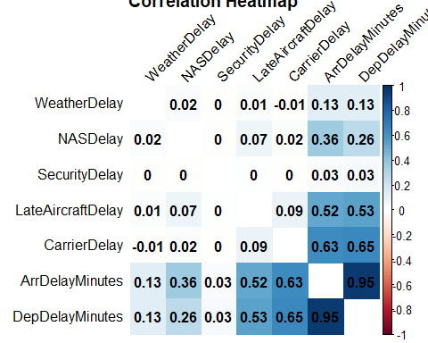

## Model development

### The question: Can we predict the arrival delay of a flight?

mult_linear_reg <- lm(ArrDelay ~ DepDelayMinutes + CarrierDelay + WeatherDelay + NASDelay + SecurityDelay + LateAircraftDelay, data = sub_airline)  
summary(mult_linear_reg)

##   
## Call:  
## lm(formula = ArrDelay ~ DepDelayMinutes + CarrierDelay + WeatherDelay +   
## NASDelay + SecurityDelay + LateAircraftDelay, data = sub_airline)  
##   
## Residuals:  
## Min 1Q Median 3Q Max   
## -162.674 -6.923 -0.391 6.313 253.618   
##   
## Coefficients:  
## Estimate Std. Error t value Pr(>|t|)   
## (Intercept) -4.522694 0.154887 -29.200 < 2e-16 ***  
## DepDelayMinutes 0.913642 0.007986 114.402 < 2e-16 ***  
## CarrierDelay 0.086193 0.010719 8.041 1.02e-15 ***  
## WeatherDelay 0.140914 0.034342 4.103 4.11e-05 ***  
## NASDelay 0.414829 0.013742 30.187 < 2e-16 ***  
## SecurityDelay 0.123307 0.125513 0.982 0.326   
## LateAircraftDelay 0.106597 0.012083 8.822 < 2e-16 ***  
## ---  
## Signif. codes: 0 '***' 0.001 '**' 0.01 '*' 0.05 '.' 0.1 ' ' 1  
##   
## Residual standard error: 13.03 on 7993 degrees of freedom  
## Multiple R-squared: 0.8756, Adjusted R-squared: 0.8755   
## F-statistic: 9379 on 6 and 7993 DF, p-value: < 2.2e-16

plot(mult_linear_reg)

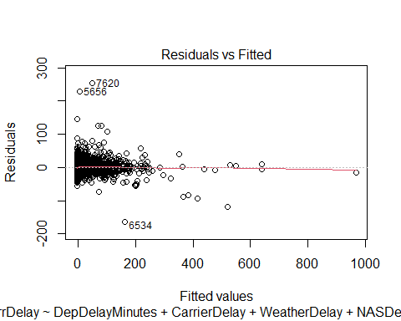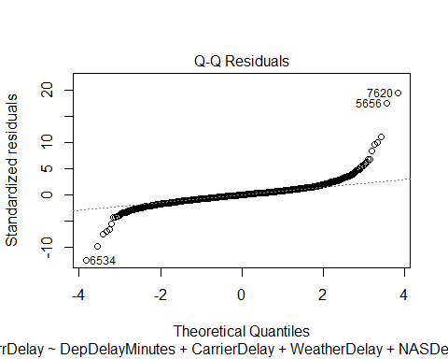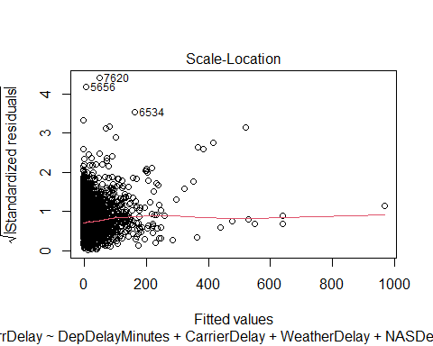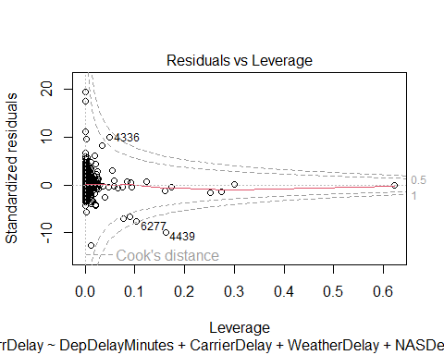

## Conclusion

This R Markdown document covers various aspects of airline data analysis, including data preprocessing, data visualization, and examining linear relationships through a correlation matrix heatmap.