YBot
6-DOF Robot Arm
Yanyu Chen · 2023 – 2025 ·
Goal  An unprecedentedly capable and affordable robotic arm for developers and early adopters.  At a glance  Status  Incomplete: the arm is designed and built, but the software is unfinished  Type  6-DOF robotic arm, open-source hardware  Timeline  2023 – 2025  Software  ROS 2 (C++ nodes), MoveIt path planning, URDF exported from Fusion 360  Actuation  Stepper motors with closed-loop servo drivers, harmonic-drive reducers and belt drives, chained over a serial bus  Estimated cost  S$610.55 per unit, excluding labour and electricity | 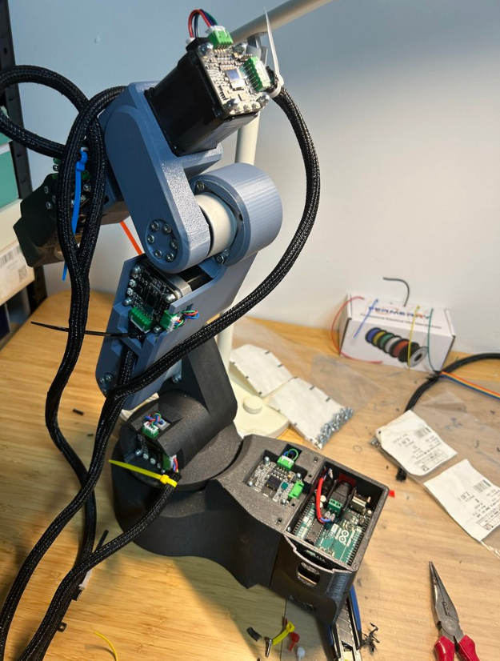  The assembled YBot

1. How It All Started (2023)
Like the childhood dreams of many, ever since I saw the Iron Man movie, I have not for one second stopped wanting a Jarvis for myself. I was captivated by the scenes in Iron Man's basement workshop: the mechanical beauty of the robotic arms and how they moved.
In 2023, this dream felt distant. The market was polarised: there were ultra-precise industrial arms costing thousands, or simple, low-precision hobbyist kits that were honestly painful for me to look at. There was no middle ground.
So, I decided to build one. I wanted to design an open-source robotic arm that delivered high repeatability and precision at a fraction of the cost, making advanced robotics accessible to more developers, creators, and broke students like myself. This was also a chance for me to learn as I built, and to acquire skills in robotics, the field I am passionate about.

2. The Project Plan: YBot N1
N1 is the project plan I laid out from the start. It maps the whole system: electronics, power management, the motion system, structural and mechanical design, and the control system. YBot was designed according to this plan. The full breakdown is written up in YBot_N1.md.
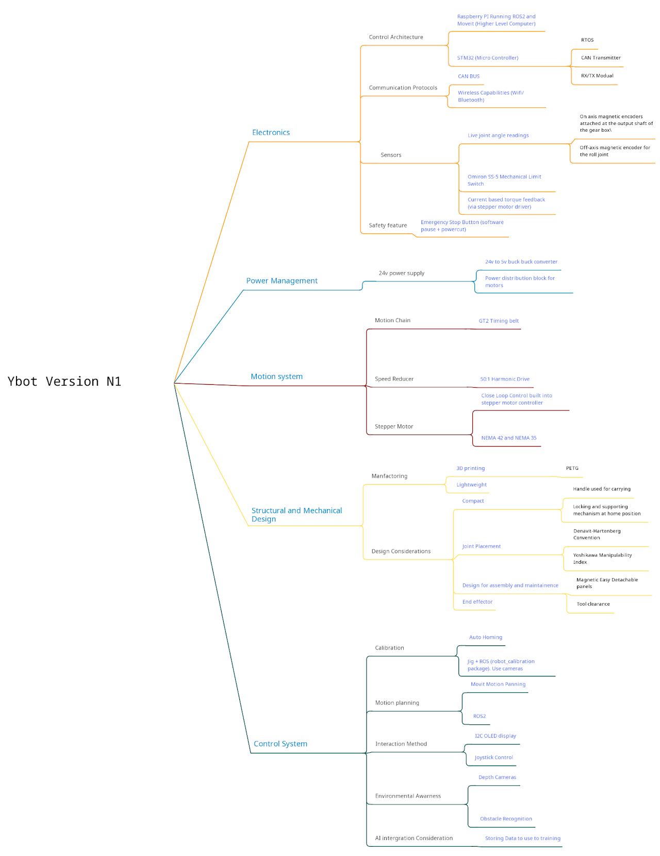
YBot N1 project plan (mind map)

3. Design Iterations

Version 1: Joint Geometry
Main progress
- Defined the general shape and geometry of the joints
- Converted it into a 3D scale model
Lessons learned
- For compactness of the arm, and to ensure 360° of movement, the third joint should take an L shape
- The base of the robot is extremely difficult to make
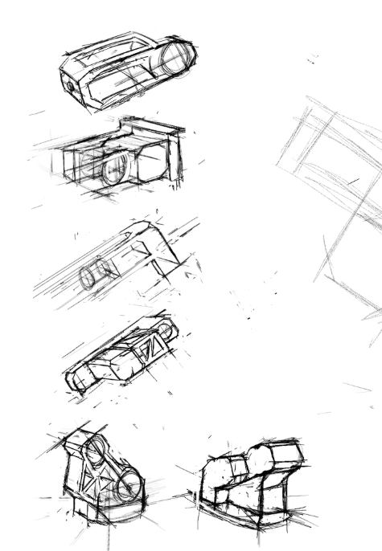  Early hand sketches of joint concepts | 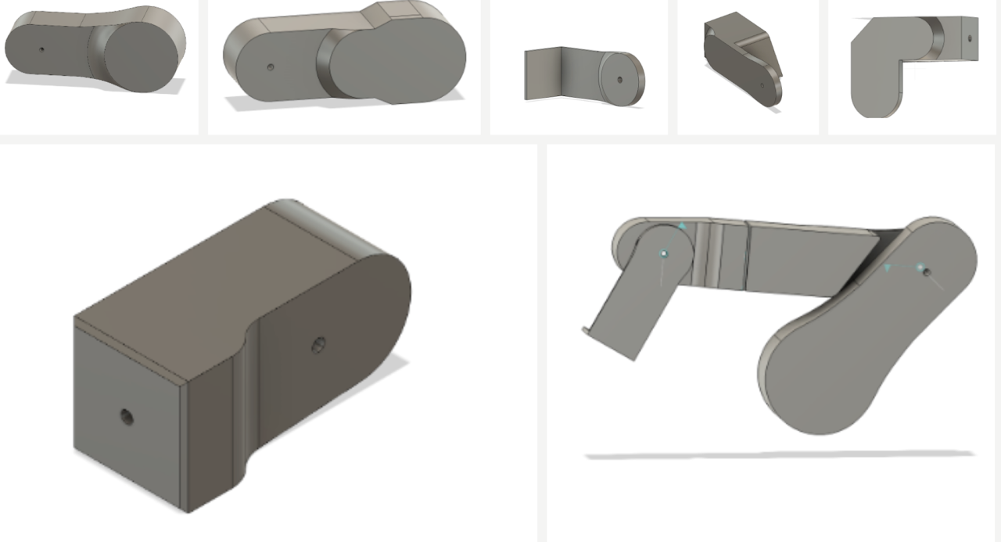  First CAD block-outs of the joints and a scale arm model

Version 2: Components and Style
Main progress
- Determined the specific model of motor and reducer
- Considered the arrangement of components and detailed dimensions of the limbs
- Determined the design style of the robot
Lessons learned
- Always have a holistic view when designing (model, components, wiring)
- Still didn't know how to design the base joint
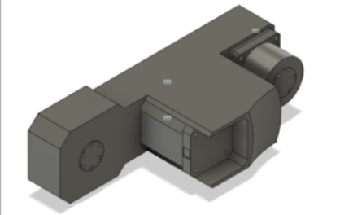  Arm link with motor and reducer housings | 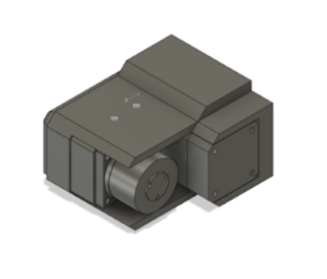  Joint module with motor mount | 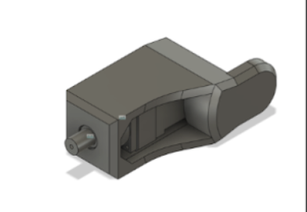  Joint housing with output shaft
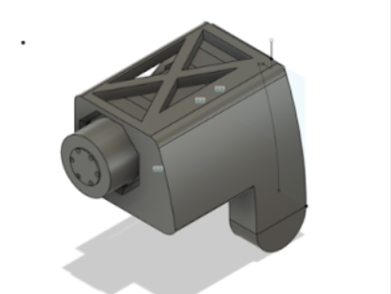  Joint housing with X-braced top | 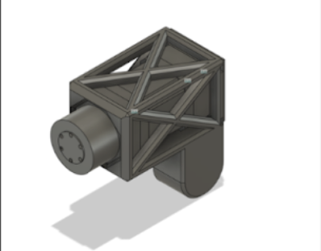  Joint housing, fully X-braced

Version 3: Base, Cable Management and Weight
Main progress
- Finally designed the base
- Designed with cable management in mind
- Refined and determined design details
- Optimised weight
Lesson learned: ALWAYS, ALWAYS consider wire management when designing, and before modelling.
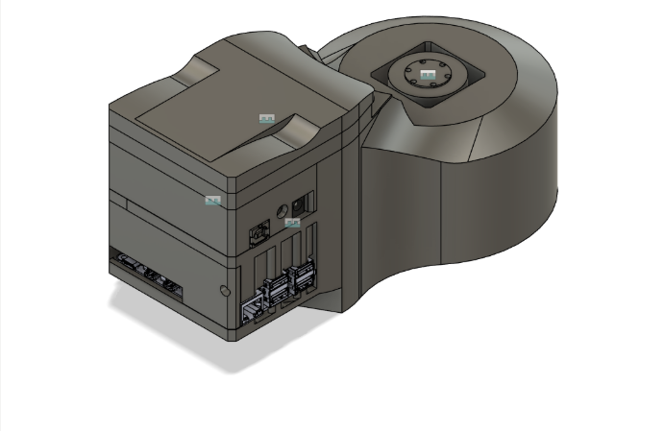  Base with electronics bay and connector ports | 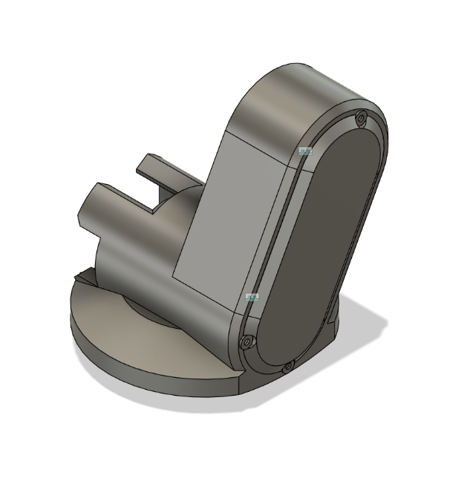  Shoulder joint on the base turntable | 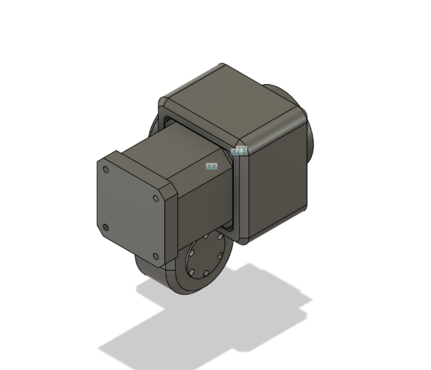  Motor and reducer joint module
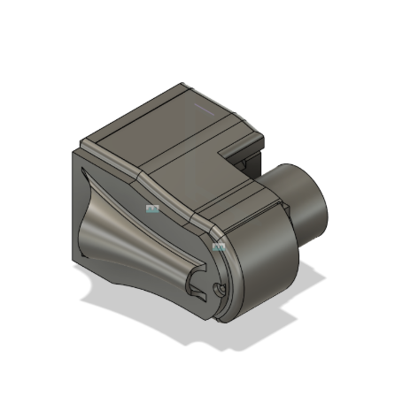  Joint housing | 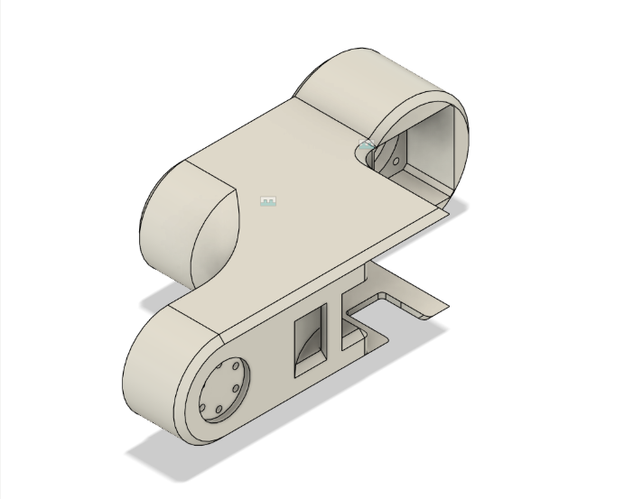  Elbow link | 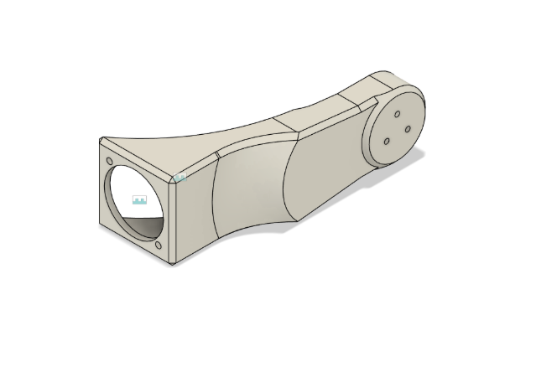  Arm link
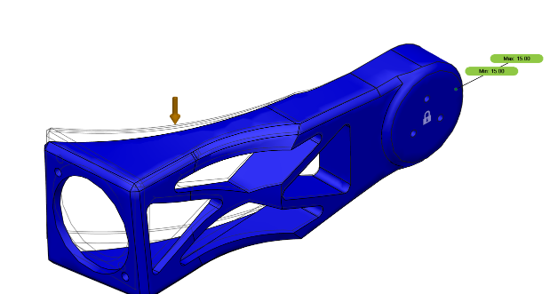  Arm link structural study, lightened | 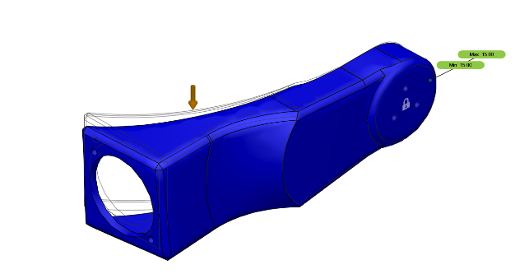  Arm link structural study, solid

4. What I Built (2023 – 2025)
I designed the CAD, selected motor/reducer combos, built the physical structure, and developed C++ ROS 2 nodes to translate MoveIt path plans into serial commands for chained servos. Along the way I learned URDF export quirks, coordinate transforms between Fusion 360 and ROS, and the trade-offs of serial-bus vs. multi-pin control.
Video: ybot(full) v14.mp4 on Google Drive
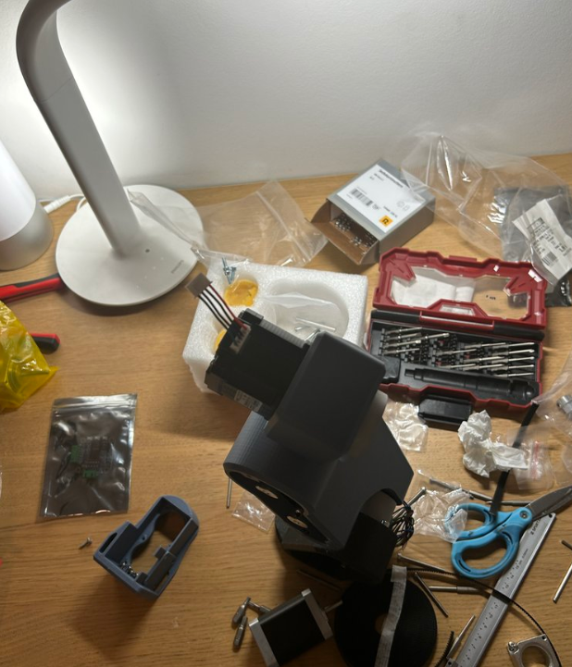  Assembly in progress | 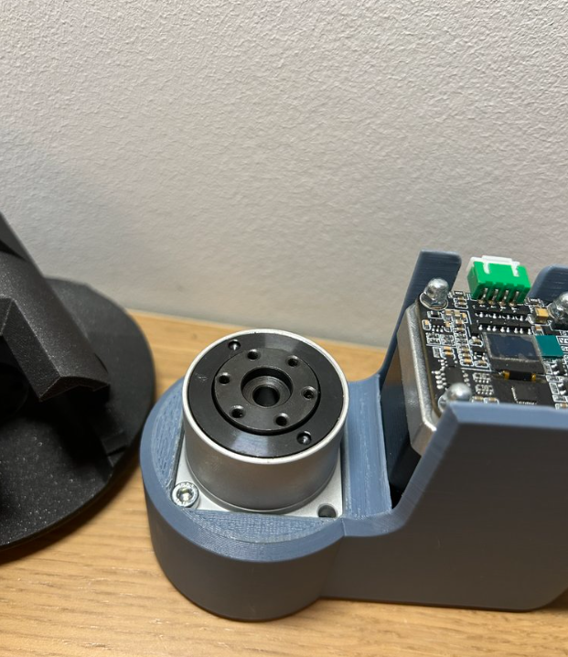  Harmonic drive seated in a joint housing, next to its driver board
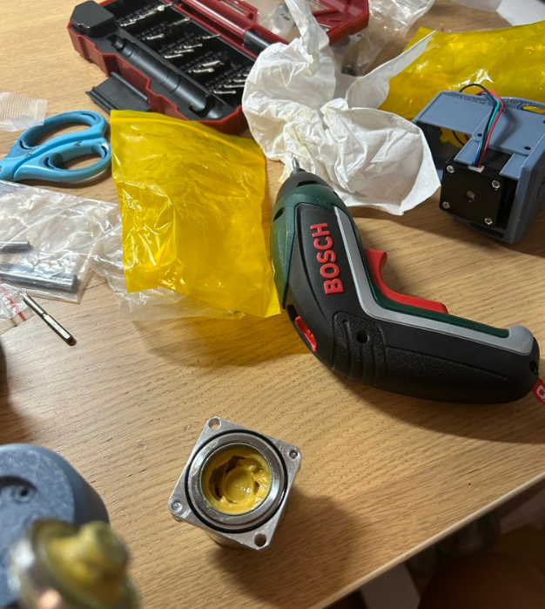  Greasing a harmonic drive during assembly | 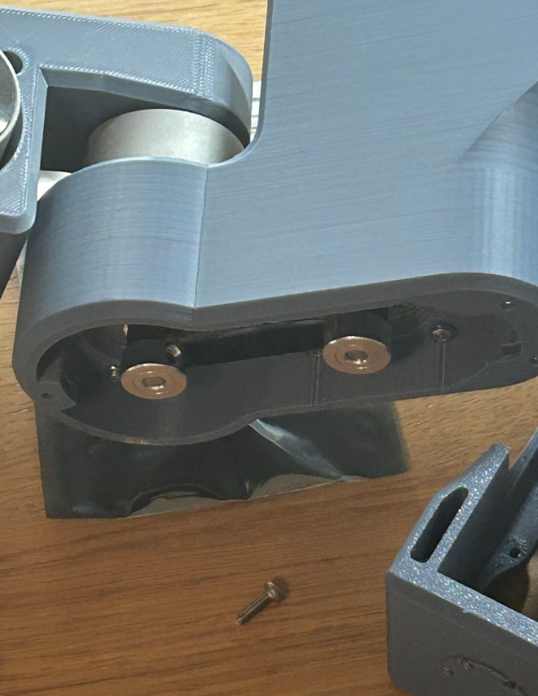  Timing-belt drive inside a joint
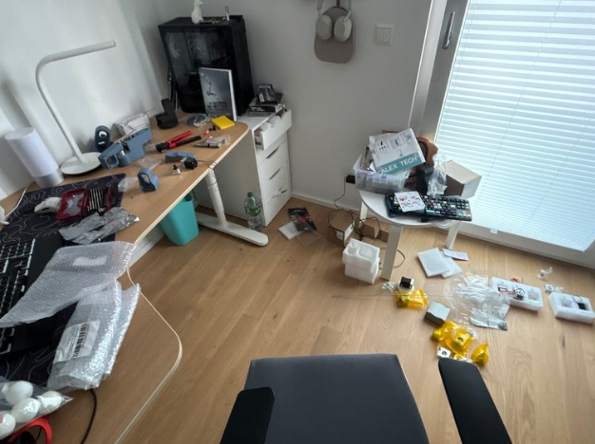
The workspace mid-build

5. Challenges and Lessons
From this point onward, I was in the coding phase of the project, which is by far the most challenging part for me, as it's the area I'm least familiar with. I encountered several major obstacles during this stage.

Compatibility and Reliability Issues
One of the first issues I faced was compatibility between ROS 2 and the newest Ubuntu version. The lack of documentation and community threads for the relatively new ROS 2 also made this problem harder to solve. I ultimately had to rely on trial and error; the solution was to downgrade to an older Ubuntu release for more reliable performance.

MoveIt Path Planning
Setting up the MoveIt path planning plugin was another major challenge. The main difficulty came from the need to export the CAD model of the arm into a URDF file, a format not natively supported by Fusion 360, so I had to use a third-party plugin for the export. This caused several very confusing problems, including a weird orientation issue where the exported model would always be lying on its side. I later discovered this was due to the different XYZ coordinate systems that Fusion and ROS use.

Hardware Interface and Integration
My original plan was to use the 5 pins on the servo motor controller, each controlling one aspect of the motor's motion (e.g. speed, angle, acceleration). For six motors, this would need 30 pins that can individually output changing voltages. However, midway through construction, I realised that the off-the-shelf components I bought actually supported an alternative communication method called serial bus. This let me use only 2 pins and 2 wires in total, as the wire chains all the motors together.
For the hardware interface, I learned C++ and used it to write a node that listens for the planned path and converts it into serial signals the motors can understand. Surprisingly, it actually worked, however...

Design Flaws Discovered
It was during this phase that I discovered a major design flaw: I had completely overlooked the need for angle sensors or limiters. This meant there was no way for the robot to calibrate its joint positions, so the arm's movements lacked any real precision or accuracy. Although it appeared to be moving correctly, there were no sensors I could use to calibrate it against its simulated position.
That was not all. As I continued testing, I identified several additional mechanical design flaws:
- Glue belts: often either over-tensioned (causing them to snap under load) or under-tensioned (leading to slippage).
- Wobbly axles: the axles connecting the motor and speed reducer were only supported on one side, causing wobbling during motion. This reduced tension consistency and put undue stress on the reducers.
- Poor cable management: the arm couldn't rotate 180° without the cables tangling, and the cables weren't properly secured to the arm's structure.
These issues still need to be solved before the software can go much further. Section 7 explains where the project stands.

6. Production Cost Estimate
The estimated cost to produce one unit of the robot arm, excluding labour and electricity, is S$610.55. Even with those included, the eventual retail price should not exceed $1,000. This is very attractive, considering that robots able to achieve YBot's planned accuracy easily cost tens of thousands.
Component | Qty | Unit (S$) | Total (S$)
Sanser NEMA 17 stepper motor (0.38 N·m) | 2 | 22.50 | 45.00
Sanser NEMA 17 stepper motor (0.54 N·m) | 2 | 27.90 | 55.80
Sanser NEMA 14 stepper motor (0.14 N·m) | 2 | 27.90 | 55.80
MakerBase Servo 42C stepper motor driver | 4 | 7.56 | 30.23
MakerBase Servo 35C stepper motor driver | 2 | 8.28 | 16.56
Harmonic drive speed reducer, NEMA 17 (11-30) | 4 | 45.36 | 181.44
Harmonic drive speed reducer, NEMA 14 (11-30) | 2 | 52.56 | 105.12
Raspberry Pi 5 | 1 | 59.40 | 59.40
STM32 dev board | 1 | 18.00 | 18.00
24 V DC power supply | 1 | 6.84 | 6.84
DC-DC voltage step-down | 1 | 6.12 | 6.12
3D-printed parts (filament) | 1.2 kg | 25.20 / kg | 30.24
Total cost estimate |  |  | 610.55
Prices converted from CNY and rounded; totals as in the original estimate.

7. Project Status: Incomplete
YBot is an incomplete project. The arm is designed and built, but the software and coding side is unfinished.
In 2025 I was busy with my college entrance exams, so I didn't have time to continue with the software and coding.
Now that I'm at university in the RMI course, I'm properly learning coding and ROS 2. I really want to finish YBot, so perhaps this will be a project I can pick backup soon.

