> unique(new_shr_type)
[1] "Industrial firm."
[2] "Finance: Pension fund/Mutual fund/Nominee/Trust/Trustee."
[3] "Finance: Other financial company."
[4] "Public authorities: States/Governments/Municipalities."
[5] "Foundation/Research Institute."
[6] "Finance: Bank."
[7] "Other unnamed shareholders, aggregated."
[8] "Finance: Insurance company."
[9] "Public is used only for publicly quoted companies."
[10] "Unknown."
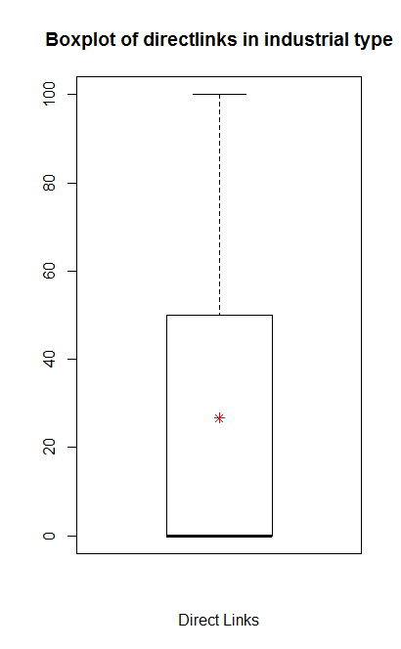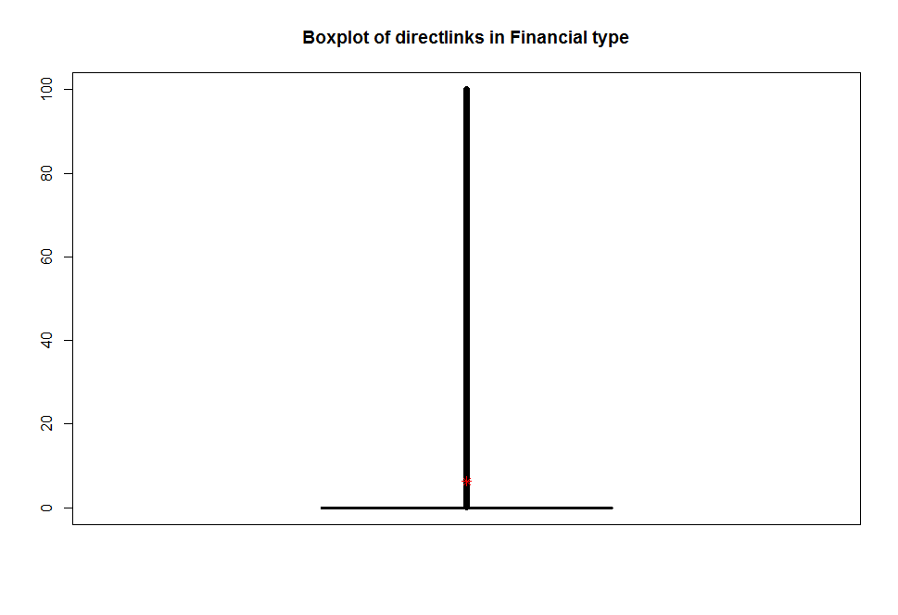

> max(db_financial$link_Dcf)
[1] 100
> min(db_financial$link_Dcf)
[1] 0
> mean(db_financial$link_Dcf)
[1] 6.26996

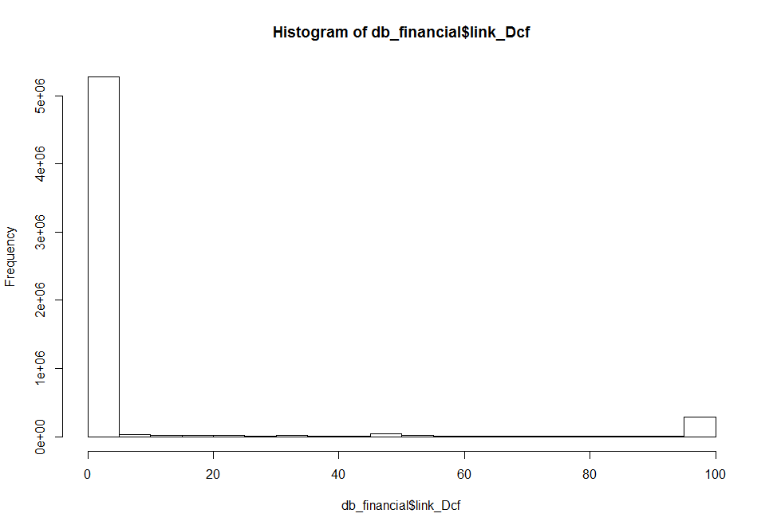
Subsidiary ITTO0702122 has maximum incoming links. Among 1901, 615 from Financial and 1271 from Industrial firms and 15 links are from other firms

But ITTO0702122 is not the subsidiary of the node CH46911(having maximum outgoing nodes)

CH46911 is an industrial firm
CH46911 is the largest hub in the network
CH46911 has maximum outgoing links 55632
CH46911 acts a both shareholder and subsidiary
CH46911 has 3 incoming links all from financial firm
hol_id sub_id link_Dcf hol_shr_type
US66385 CH46911 14.15 Finance: Bank.
US78-994-8150 CH46911 0.00 finance
GB00248239 CH46911 7.99 Finance

ITTO0702122 has maximum incoming link 1901
ITTO0702122 is a subsidiary
ITTO0702122 has no outgoing link

Among 11068025 links, 8591831 links has 0.00 for the direct link value only 2476194 links has link_Dcf greater than 0.
ie. Only 22% links has link_Dcf greater than 0.

Boxplot for degree
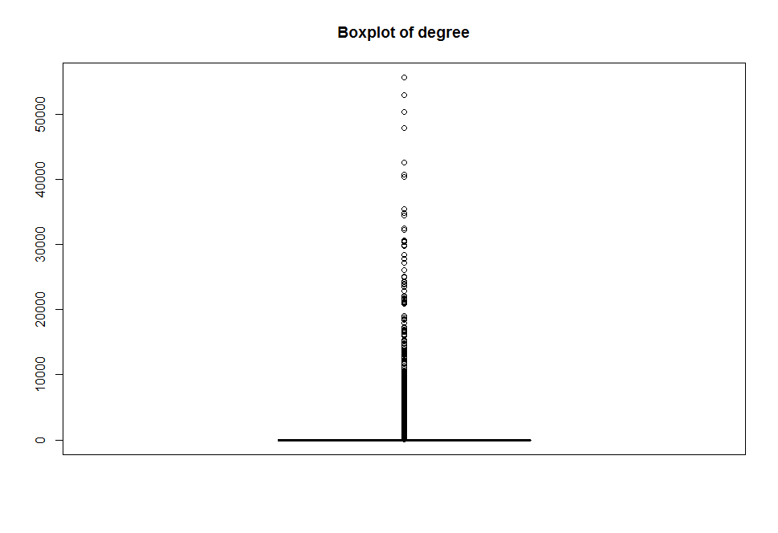

deg[which(deg>40000)]
9022935 GB206486 BE45621 CH0007257104
52985 40747 40368 50325
CH46911 FR11150 FR11948
55635 42563 47879

deg[which(deg<40000 & deg>30000)]
BE0442733140 ES22628 FR11792 FR11804
32298 35422 30579 30637
FR17481 FR19792 FR439208190 FR444369607
30455 30674 34497 34858
GB04303322 PT500097488
32470 32435

- 9022935 Public is used only for publicly quoted companies.(Max Closeness)
- GB206486 Finance
- BE45621 Finance
- CH0007257104 Industrial
- CH46911 Industrail (Max Degree)
- FR11150 Finance
- FR11948 Finance ( Has max outgoing links )
- BE0442733140 Finance
- ES22628 Finance
- FR11792 Finance
- FR11804 Finance
- FR17481 Finance
- FR439208190 Industrial (Having max betweenness)
- FR444369607 Finance
- GB04303322 Finance
- PT500097488 Industrial

Among these sixteen larger hubs, 11 hubs are Financial type.
Among top 4 hubs, two are from financial and 1 from industrial and 1 from other

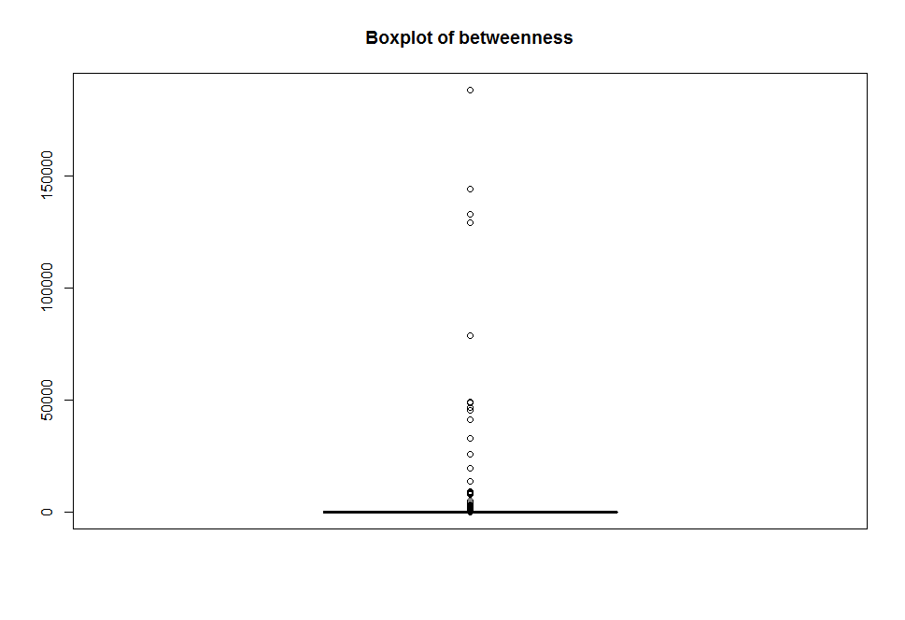

bet[which(bet > 100000)]
FR439208190 PT22541 PT500697256 PT206934
188342.8 132867.6 144245.1 129057.2

FR439208190 Industrial
PT22541 Finance
PT500697256 Industrial
PT206934 Finance

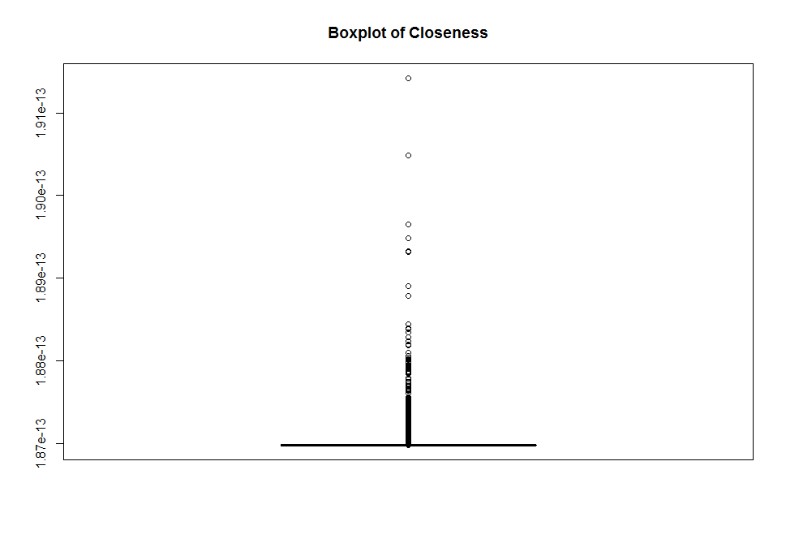

are.connected(SSNetwork,which.max(deg),which.max(bet))
[1] FALSE
are.connected(SSNetwork,which.max(deg),which.max(clos))
[1] FALSE

Some results
1. Nodes having max incoming links and node having maximum outgoing link has no connection.

Subsidiary ITMI0758334 has maximum incoming links from all financial firms.
FR11948 has maximum outgoing links.

