betweenness(g)

[1] 1.6666667 0.0000000 1.6666667 0.6666667 0.0000000 0.6666667

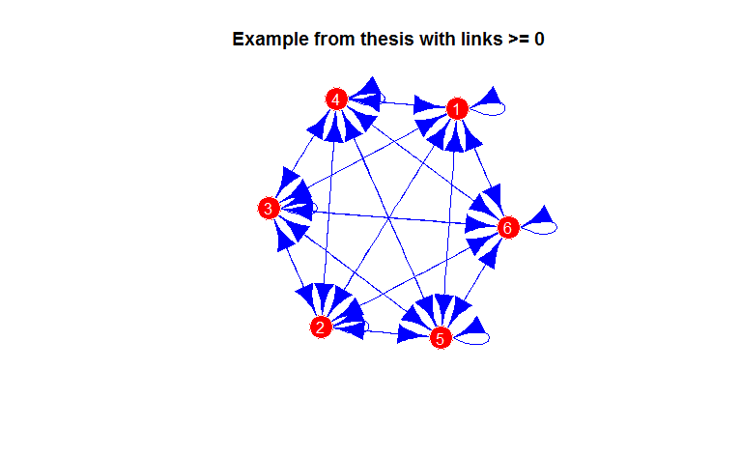

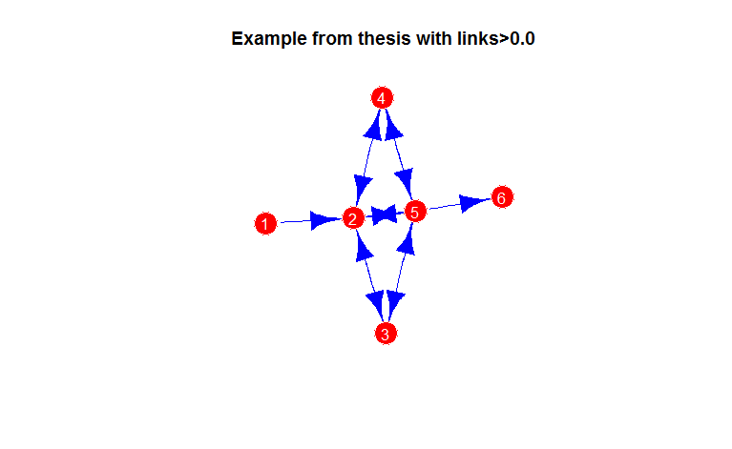

> betweenness(g1)

[1] 0 7 0 0 5 0

> betweenness(Network)

1 2 3 4 5 6

0 5 0 0 5 0

new Data after removing all rows having shareholder assets is 0.

nrow(newData)

[1] 2057944

which.max(newData$hol_toas)

[1] 1208181

|  |
| --- |
| newData[1208181,]  hol_id sub_id link_Dcf hol_toas sub_toas hol_shr_type  7637799 GB04930598 GB05137608 98 292252.4 1416.119 Industrial firm. |
| v<-as.matrix(newData$hol_toas) |
| |  | | --- | | > dim(v)  [1] 2057944 1  Dimension of adjacency matrix for the data set containing all shareholders  > dim(adj)  [1] 617462 617462  Dimension of adjacency matrix for the data set containing only GB  > dim(adjGB)  [1] 253478 253478  Trying to get the identity matrix of same size as adjGB  > I <- diag(nrow(W))  Error: cannot allocate vector of size 478.7 Gb  Filtering data with those shareholders starting with only CH  Size of adjacency matrix is:  > dim(adjCH)  [1] 711 711  newData[newData$hol_id=="CH0000033415",]  hol_id sub_id link_Dcf hol_toas sub_toas hol_shr_type  4750895 CH0000033415 CH0000041572 16.7 1442.848 NA Industrial f  6326108 CH0000033415 CH0000041572 16.7 1442.848 NA "  7545719 CH0000033415 CH0000041572 16.7 1442.848 NA "  8504613 CH0000033415 CH0000041572 16.7 1442.848 NA "  9256619 CH0000033415 CH0000041572 16.7 1442.848 NA "  9687804 CH0000033415 CH0000041572 16.7 1442.848 NA "  10779816 CH0000033415 CH0000041572 16.7 1442.848 NA "  W_I_inv[13:16,13:16]  CH0000033712 CH0000042897 CH0000033778 CH0000033415  CH0000033712 1 92.2 0 0 shr  CH0000042897 0 1.0 0 0 shr  CH0000033778 0 0.0 1 15 shr  CH0000033415 0 0.0 0 1 sub  DataCH[1:5,1:4]  hol_id sub_id link_Dcf hol_toas  461308 CH0000021697 CH0000339965 59.3 4.392768  461450 CH0000024144 CH0000067494 92.0 81.437271  461451 CH0000024144 FR414881268 5.1 81.437271  461452 CH0000024144 FR428739825 26.0 81.437271  461476 CH0000024386 CH0000024372 64.3 188.607790  > adjCH[1:5,1:5]  5 x 5 sparse Matrix of class "dgCMatrix"  CH0000021697 CH0000339965 CH0000024144 CH0000067494 FR414881268  CH0000021697 . 59.3 . . .  CH0000339965 . . . . .  CH0000024144 . . . 92 5.1  CH0000067494 . . . . .  FR414881268 . . . . . | |