**Dataset with value of direct links greater than or equal to zero( Original data sets)**

Top 20 nodes with respect to their outgoing degree.

top20DegreeNames share_hol_type

1 9022935 Public is used only for publicly quoted companies.

2 GB206486 Finance

3 US78-994-8150 Finance

4 BE0442733140 Finance

5 BE45621 Finance

6 CH0007257104 Industrial firm.

7 CH46911 Industrial firm.

8 ES22628 Finance

9 FR11150 Finance

10 FR11792 Finance

11 FR11804 Finance

12 FR11948 Finance

13 FR17481 Finance

14 FR19792 Finance

15 FR439208190 Industrial firm.

16 FR444369607 Finance

17 GB00248239 Finance

18 GB04303322 Finance

19 PT500097488 Industrial firm.

20 US06-384-3387 Finance

Among 20 shareholders, 15 firms are financial form. But these data are not ordered by their number of degrees. These are the nodes having degrees greater than 29,000.

table below shows the hubs sorted according to their out degrees.

top20DegreeNames share_hol_type

1 CH46911 Industrial

2 9022935 Other

3 CH0007257104 Industrial

4 FR11948 Financial

5 FR11150 Financial

6 GB206486 Financial

7 BE45621 Financial

8 ES22628 Financial

9 FR444369607 Financial

10 FR439208190 Industrial

11 GB04303322 Financial

12 PT500097488 Industrial

13 BE0442733140 Financial

14 FR19792 Financial

15 FR11804 Financial

16 FR11792 Financial

17 FR17481 Financial

18 US06-384-3387 Financial

19 US78-994-8150 Financial

20 GB00248239 Financial

Among these 20 firms, 17 firms are both shareholder and subsidiary, only 3 firms are sole share holders.

Sole share holders are "9022935" "GB206486" "US78-994-8150"

**Dataset with direct links value greater than zero**

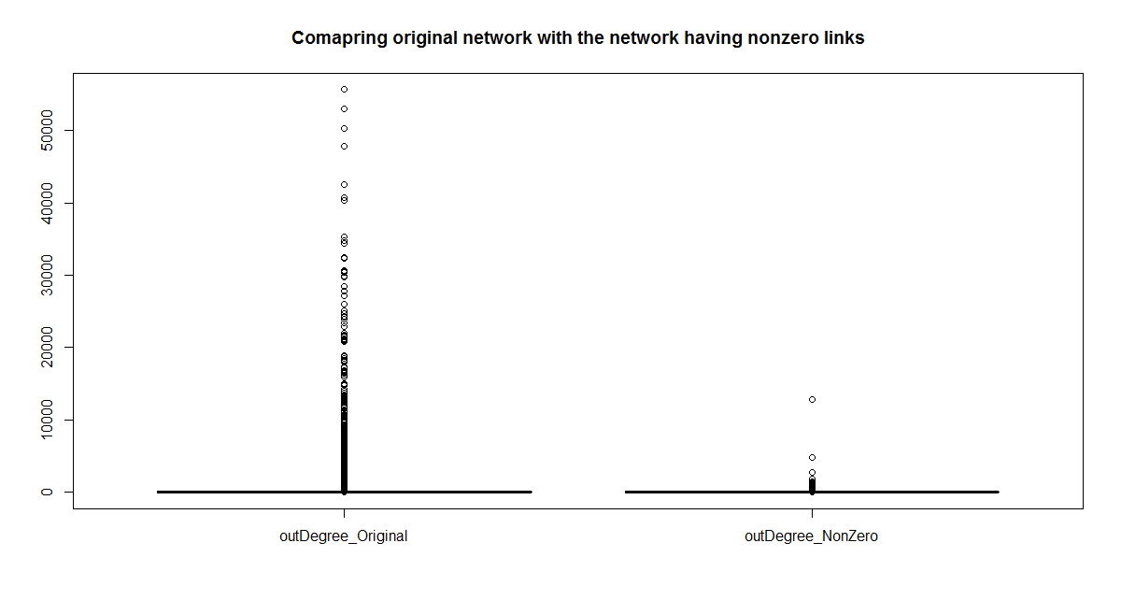

**Figure showing the difference in out degrees among the original data and the data having only directlinks greater than zero.**

**Table showing the top 20 hubs having direct link greater than zero and their corresponding types.**

top20DegreeNames_nonZero type

1 10119030 Other unnamed shareholders, aggregated.

2 10241004 Public authorities:States/Governments/Municipali

3 GB03524904 Industrial firm.

4 GB03524885 Industrial firm.

5 FR602036444 Industrial firm.

6 GB05044445 Industrial firm.

7 9022935 Public is used only for publicly quoted co

8 GB04493804 Industrial firm.

9 ITMI0589396 Finance

10 FR733001010 Industrial firm.

11 DE6190011029 Finance

12 FR552059024 Industrial firm.

13 ESA6123461 Industrial firm.

14 DE5050207671 Finance

15 GB02425251 Finance

16 2686528 Industrial firm.

17 IT21413 Finance

18 DE5050010479 Finance

19 ITTO0488477 Industrial firm.

20 10694585 Industrial firm.

**Among these 20 nodes, 8 of these are only share holders and remaining 12 are both share holders and subisdiary.**

**Only Shareholders are:**

"10119030" "10241004" "GB03524904" "GB03524885" "9022935" "GB04493804" "2686528" "10694585"

**In degree Analysis for original dataset**

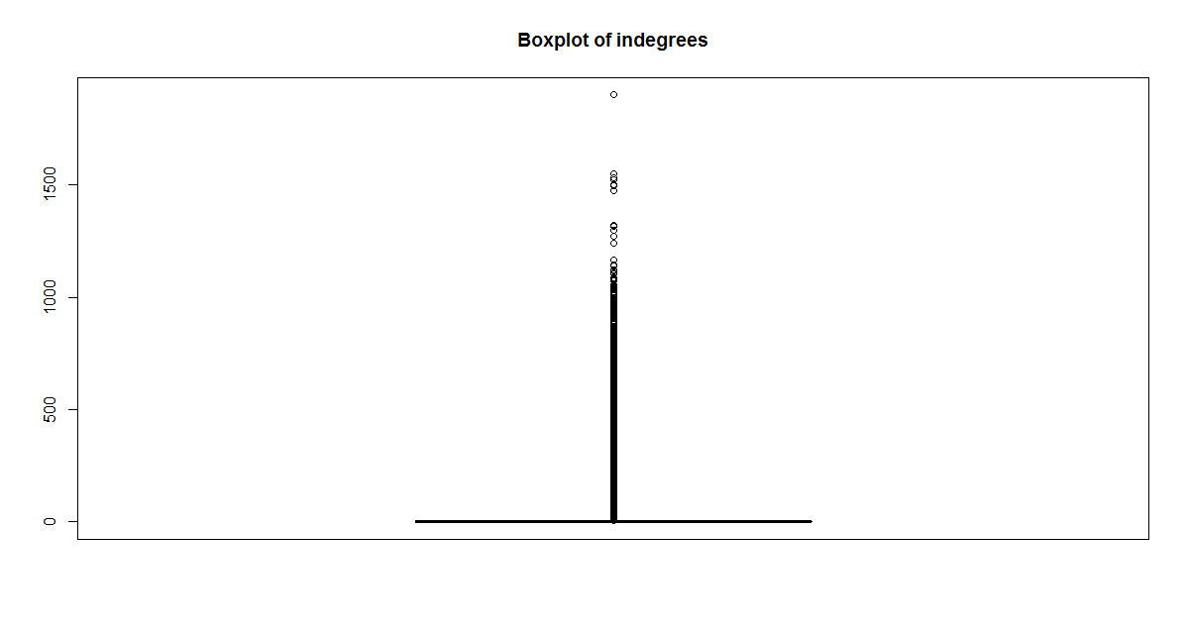

**Here is the list of subsidiaries having maximum indegrees**

ITTO0702122 DE5250167156 DE6250173514 DE8170724555 ITVA0131937 DE2150655467

1901 1549 1549 1549 1531 1523

AT9110288218 DE2150374821

1523 1523

DE2150865884 DE7330798220 ITMI0854742 DE2150374820 ITMI0758334 DE7170184825

1523 1523 1503 1497 1475 1322

ITVE0271927 ITMI1793295

1317 1298

DE2010358878 DE5250012783 ITMI0429222 ITNA0708331

1297 1274 1272 1242

These all nodes are sole subsidiaries so I didn't try to find their type.

Indegrees for direct link greater than zero.

"ITTO0702122" "ITTO0553690" "ITTO0814188" "ITMI1580695" "ITNA0454874" "ITTO0543483"

"ITTO0577851" "ITMI1385874" "ITRM0756032" "GBGE000142" "ITTO0545664" "ITTO0833885"

"DE2190034330" "ITNO0188902" "DE2150374820" "ITMI1524326" "DE5030041131" "ITMI0171672"

"DE5250012783" "ITTO0000118"

Among them, 6 nodes are sole subsidiaries 14 are both subsidiaries and shareholders.

For those acting as both shareholder and subsidiary,

hol type

1 DE2150374820 Industrial firm.

2 ITMI1385874 Finance

3 ITMI1524326 Industrial firm.

4 ITMI1580695 Industrial firm.

5 ITNO0188902 Industrial firm.

6 ITRM0756032 Industrial firm.

7 ITTO0000118 Industrial firm.

8 ITTO0553690 Industrial firm.

9 ITTO0814188 Industrial firm.

10 ITNA0454874 Industrial firm.

11 ITTO0543483 Industrial firm.

12 ITTO0545664 Industrial firm.

13 ITTO0577851 Industrial firm.

14 ITTO0833885 Industrial firm.

**Betweeness Analysis on original dataset:**

Table showing the name, type and betweenness value of the shareholders having highest betweencess values and are sorted accordingly.

top20BetweenNames new_type betweenness

1 FR439208190 Industrial firm. 188342.801

2 PT500697256 Industrial firm. 144245.094

3 PT22541 Finance 132867.587

4 PT206934 Finance 129057.174

5 ESA48010615 Industrial firm. 78637.134

6 ESA78932514 Industrial firm. 78633.706

7 PT45638 Finance 48935.392

8 PT22561 Finance 8935.392

9 PT503529524 Finance 48495.966

10 IT21480 Finance 46753.133

11 IT45296 Finance 45337.683

12 TW04382114 Industrial firm. 41142.895

13 FR542051180 Industrial firm. 32806.892

14 BE0404676971 Finance 25500.428

15 ITMI0186864 Finance 19454.957

16 BE19947 Finance 13456.124

17 IT206911 Finance 8804.947

18 ESA78342656 Finance 8455.291

19 ESA83033613 Finance 8455.291

20 ESA28004885 Industrial firm. 7968.562