My final project will be building an online calendar and reminder app. Users can create an account and sign in and view several calendars all on one screen. New calendars can be created, and new events can be created on a calendar. Calendars can be shared and synced with other users, as well as individual events. Events can be given reminders that will send notifications to the user. One “stretch goal” i have for the project is to make the app a single-page experience; user loads the page and all data after that point is exchanged using apis and javascript.

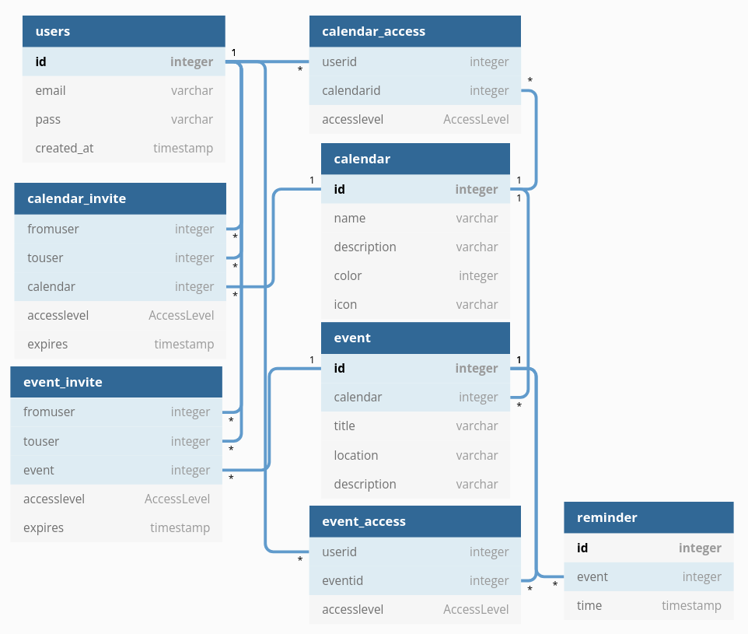

_access tables manage permanent access to another user’s calendars and events while the _invite tables hold an invitation and get moved to the _access table if accepted by the user receiving the invitation.