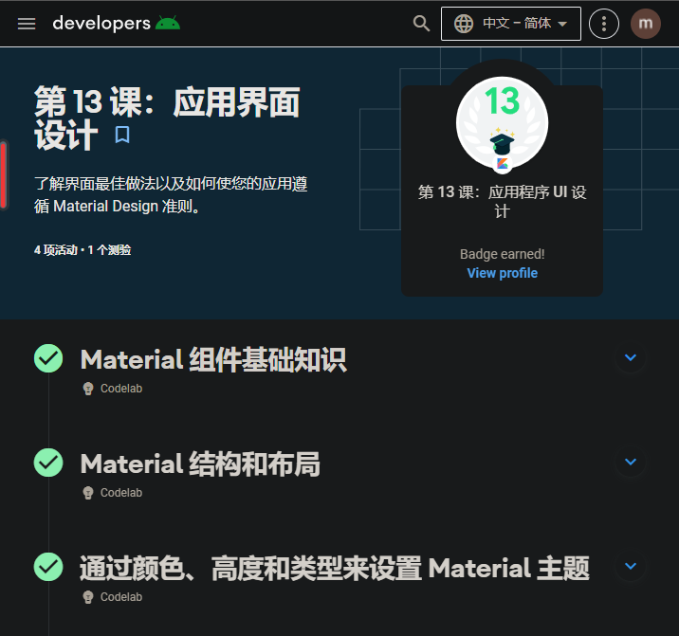

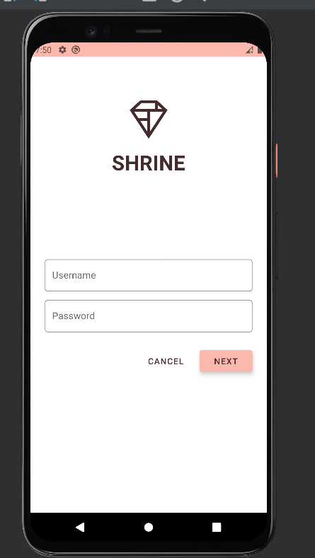

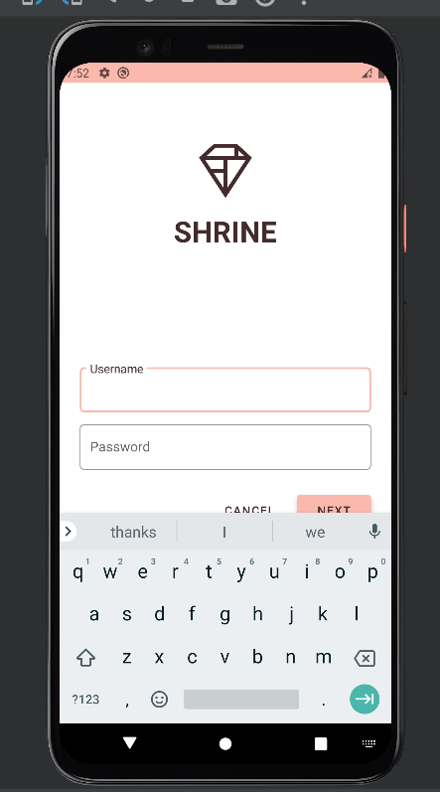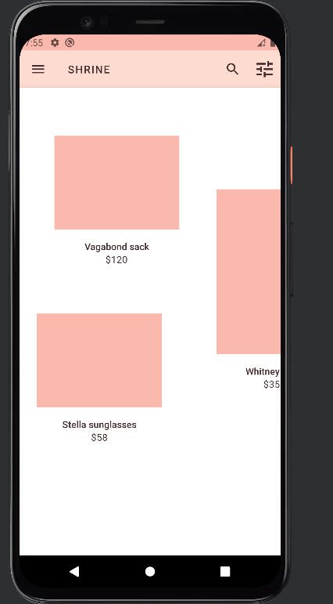

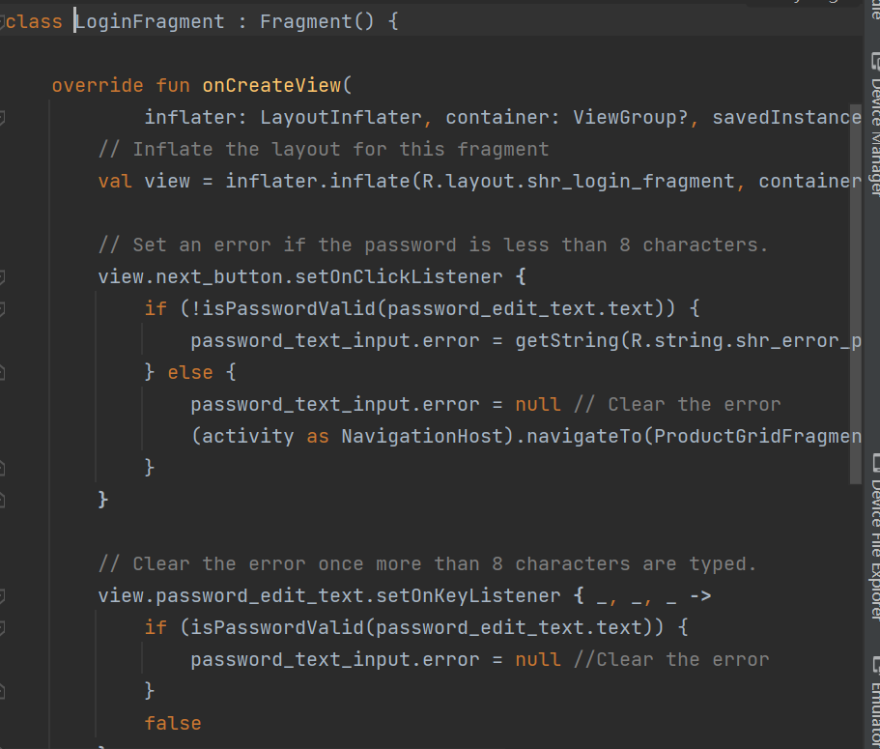

<?xml version="1.0" encoding="utf-8"?>  
<resources>  
 <color name="colorPrimary">#E0E0E0</color>  
 <color name="colorPrimaryDark">#FBB8AC</color>  
 <color name="colorAccent">#FEDBD0</color>  
 <color name="textColorPrimary">#442C2E</color>  
 <color name="toolbarIconColor">@color/textColorPrimary</color>  
 <color name="loginPageBackgroundColor">#FFFFFF</color>  
 <color name="productGridBackgroundColor">#FFFFFF</color>  
 <color name="textInputOutlineColor">#FBB8AC</color>  
</resources>

<resources>  
 <string name="shr_app_name">Shrine</string>  
 <string name="shr_hint_username">Username</string>  
 <string name="shr_hint_password">Password</string>  
 <string name="shr_button_next">Next</string>  
 <string name="shr_button_cancel">Cancel</string>  
 <string name="shr_error_password">Password must contain at least 8 characters.</string>  
 <string name="shr_filter_title">Filter</string>  
 <string name="shr_search_title">Search</string>  
 <string name="shr_product_title">Title</string>  
 <string name="shr_product_description">Secondary text</string>  
  
 <!-- Shrine backdrop menu labels -->  
 <string name="shr_featured_label">Featured</string>  
 <string name="shr_apartment_label">Apartment</string>  
 <string name="shr_accessories_label">Accessories</string>  
 <string name="shr_shoes_label">Shoes</string>  
 <string name="shr_tops_label">Tops</string>  
 <string name="shr_bottoms_label">Bottoms</string>  
 <string name="shr_dresses_label">Dresses</string>  
 <string name="shr_account_label">My Account</string>  
 <string name="shr_logo_content_description">Shrine Logo</string>  
</resources>

<resources xmlns:tools="http://schemas.android.com/tools">  
  
 <!-- Base application theme. -->  
 <style name="Theme.Shrine" parent="Theme.MaterialComponents.Light.NoActionBar">  
 <!-- Customize your theme here. -->  
 <item name="colorPrimary">@color/colorPrimary</item>  
 <item name="colorPrimaryDark">@color/colorPrimaryDark</item>  
 <item name="colorAccent">@color/colorAccent</item>  
 <item name="android:windowLightStatusBar" tools:targetApi="m">true</item>  
 <item name="android:textColorPrimary">@color/textColorPrimary</item>  
 </style>  
  
 <style name="Widget.Shrine.TextInputLayout" parent="Widget.MaterialComponents.TextInputLayout.OutlinedBox">  
 <item name="hintTextAppearance">@style/TextAppearance.Shrine.TextInputLayout.HintText</item>  
 <item name="hintTextColor">@color/textColorPrimary</item>  
 <item name="android:paddingBottom">8dp</item>  
 <item name="boxStrokeColor">@color/textInputOutlineColor</item>  
 </style>  
  
 <style name="TextAppearance.Shrine.TextInputLayout.HintText" parent="TextAppearance.MaterialComponents.Subtitle2">  
 <item name="android:textColor">?android:attr/textColorPrimary</item>  
 </style>  
  
 <style name="Widget.Shrine.Button" parent="Widget.MaterialComponents.Button">  
 <item name="android:textColor">?android:attr/textColorPrimary</item>  
 <item name="backgroundTint">?attr/colorPrimaryDark</item>  
 <item name="android:stateListAnimator" tools:ignore="NewApi">  
 @animator/shr_next_button_state_list_anim  
 </item>  
 </style>  
  
 <style name="Widget.Shrine.Button.TextButton" parent="Widget.MaterialComponents.Button.TextButton">  
 <item name="android:textColor">?android:attr/textColorPrimary</item>  
 </style>  
  
 <style name="Widget.Shrine.Toolbar" parent="Widget.AppCompat.Toolbar">  
 <item name="android:background">?attr/colorAccent</item>  
 <item name="android:theme">@style/Theme.Shrine</item>  
 <item name="popupTheme">@style/ThemeOverlay.AppCompat.Light</item>  
 <item name="titleTextAppearance">@style/TextAppearance.Shrine.Toolbar</item>  
 </style>  
  
 <style name="TextAppearance.Shrine.Toolbar" parent="TextAppearance.MaterialComponents.Button">  
 <item name="android:textSize">16sp</item>  
 </style>  
  
 <style name="TextAppearance.Shrine.Title" parent="TextAppearance.MaterialComponents.Headline4">  
 <item name="textAllCaps">true</item>  
 <item name="android:textStyle">bold</item>  
 <item name="android:textColor">?android:attr/textColorPrimary</item>  
 </style>  
  
</resources>

<?xml version="1.0" encoding="utf-8"?>  
<FrameLayout xmlns:android="http://schemas.android.com/apk/res/android"  
 xmlns:app="http://schemas.android.com/apk/res-auto"  
 xmlns:tools="http://schemas.android.com/tools"  
 android:layout_width="match_parent"  
 android:layout_height="match_parent"  
 tools:context=".ProductGridFragment">  
  
 <com.google.android.material.appbar.AppBarLayout  
 android:layout_width="match_parent"  
 android:layout_height="wrap_content"  
 app:elevation="0dp">  
  
 <androidx.appcompat.widget.Toolbar  
 android:id="@+id/app_bar"  
 style="@style/Widget.Shrine.Toolbar"  
 android:layout_width="match_parent"  
 android:layout_height="?attr/actionBarSize"  
 app:navigationIcon="@drawable/shr_menu"  
 app:title="@string/shr_app_name" />  
 </com.google.android.material.appbar.AppBarLayout>  
  
 <androidx.core.widget.NestedScrollView  
 android:layout_width="match_parent"  
 android:layout_height="match_parent"  
 android:layout_marginTop="56dp"  
 android:background="@color/productGridBackgroundColor"  
 android:elevation="8dp"  
 app:layout_behavior="@string/appbar_scrolling_view_behavior">  
  
 <androidx.recyclerview.widget.RecyclerView  
 android:id="@+id/recycler_view"  
 android:layout_width="match_parent"  
 android:layout_height="match_parent" />  
  
 </androidx.core.widget.NestedScrollView>  
  
</FrameLayout>

<?xml version="1.0" encoding="utf-8"?>  
<com.google.android.material.card.MaterialCardView xmlns:android="http://schemas.android.com/apk/res/android"  
 xmlns:app="http://schemas.android.com/apk/res-auto"  
 android:layout_width="match_parent"  
 android:layout_height="wrap_content"  
 app:cardBackgroundColor="@android:color/transparent"  
 app:cardElevation="0dp"  
 app:cardPreventCornerOverlap="true">  
  
 <LinearLayout  
 android:layout_width="match_parent"  
 android:layout_height="wrap_content"  
 android:orientation="vertical">  
  
 <com.android.volley.toolbox.NetworkImageView  
 android:id="@+id/product_image"  
 android:layout_width="match_parent"  
 android:layout_height="wrap_content"  
 android:background="?attr/colorPrimaryDark"  
 android:scaleType="centerCrop" />  
  
 <LinearLayout  
 android:layout_width="match_parent"  
 android:layout_height="wrap_content"  
 android:orientation="vertical"  
 android:padding="16dp">  
  
 <TextView  
 android:id="@+id/product_title"  
 android:layout_width="match_parent"  
 android:layout_height="wrap_content"  
 android:text="@string/shr_product_title"  
 android:textAlignment="center"  
 android:textAppearance="?attr/textAppearanceSubtitle2" />  
  
 <TextView  
 android:id="@+id/product_price"  
 android:layout_width="match_parent"  
 android:layout_height="wrap_content"  
 android:text="@string/shr_product_description"  
 android:textAlignment="center"  
 android:textAppearance="?attr/textAppearanceBody2" />  
 </LinearLayout>  
 </LinearLayout>  
</com.google.android.material.card.MaterialCardView>

<?xml version="1.0" encoding="utf-8"?>  
<FrameLayout xmlns:android="http://schemas.android.com/apk/res/android"  
 xmlns:tools="http://schemas.android.com/tools"  
 android:id="@+id/container"  
 android:layout_width="match_parent"  
 android:layout_height="match_parent"  
 tools:context=".MainActivity" />

<?xml version="1.0" encoding="utf-8"?>  
<ScrollView xmlns:android="http://schemas.android.com/apk/res/android"  
 xmlns:app="http://schemas.android.com/apk/res-auto"  
 xmlns:tools="http://schemas.android.com/tools"  
 android:layout_width="match_parent"  
 android:layout_height="match_parent"  
 android:background="@color/loginPageBackgroundColor"  
 tools:context=".LoginFragment">  
  
 <LinearLayout  
 android:layout_width="match_parent"  
 android:layout_height="wrap_content"  
 android:clipChildren="false"  
 android:clipToPadding="false"  
 android:orientation="vertical"  
 android:padding="24dp"  
 android:paddingTop="16dp">  
  
 <ImageView  
 android:layout_width="64dp"  
 android:layout_height="64dp"  
 android:layout_gravity="center_horizontal"  
 android:layout_marginTop="48dp"  
 android:layout_marginBottom="16dp"  
 android:tint="?android:attr/textColorPrimary"  
 app:srcCompat="@drawable/shr_logo"  
 android:contentDescription="@string/shr_logo_content_description" />  
  
 <TextView  
 android:layout_width="wrap_content"  
 android:layout_height="wrap_content"  
 android:layout_gravity="center_horizontal"  
 android:layout_marginBottom="132dp"  
 android:text="@string/shr_app_name"  
 android:textAppearance="@style/TextAppearance.Shrine.Title" />  
  
 <com.google.android.material.textfield.TextInputLayout  
 style="@style/Widget.Shrine.TextInputLayout"  
 android:layout_width="match_parent"  
 android:layout_height="wrap_content"  
 android:hint="@string/shr_hint_username">  
  
 <com.google.android.material.textfield.TextInputEditText  
 android:layout_width="match_parent"  
 android:layout_height="wrap_content"  
 android:inputType="text"  
 android:maxLines="1" />  
 </com.google.android.material.textfield.TextInputLayout>  
  
 <com.google.android.material.textfield.TextInputLayout  
 android:id="@+id/password_text_input"  
 style="@style/Widget.Shrine.TextInputLayout"  
 android:layout_width="match_parent"  
 android:layout_height="wrap_content"  
 android:hint="@string/shr_hint_password"  
 app:errorEnabled="true">  
  
 <com.google.android.material.textfield.TextInputEditText  
 android:id="@+id/password_edit_text"  
 android:layout_width="match_parent"  
 android:layout_height="wrap_content"  
 android:inputType="textPassword" />  
 </com.google.android.material.textfield.TextInputLayout>  
  
 <RelativeLayout  
 android:layout_width="match_parent"  
 android:layout_height="wrap_content">  
  
 <com.google.android.material.button.MaterialButton  
 android:id="@+id/next_button"  
 style="@style/Widget.Shrine.Button"  
 android:layout_width="wrap_content"  
 android:layout_height="wrap_content"  
 android:layout_alignParentEnd="true"  
 android:layout_alignParentRight="true"  
 android:text="@string/shr_button_next" />  
  
 <com.google.android.material.button.MaterialButton  
 android:id="@+id/cancel_button"  
 style="@style/Widget.Shrine.Button.TextButton"  
 android:layout_width="wrap_content"  
 android:layout_height="wrap_content"  
 android:layout_marginEnd="12dp"  
 android:layout_marginRight="12dp"  
 android:layout_toStartOf="@id/next_button"  
 android:layout_toLeftOf="@id/next_button"  
 android:text="@string/shr_button_cancel" />  
  
 </RelativeLayout>  
 </LinearLayout>  
</ScrollView>