YAMNA AFTAB
DECODESLAB INTERNSHIP
PROJECT # 2
DATA CLASSIFICATION USING AI:
Abstract:

Artificial Intelligence (AI) enables machines to learn from data and make intelligent decisions. Classification is one of the most important applications of AI and Machine Learning. In this project, a simple classification model is developed using the K-Nearest Neighbors (KNN) algorithm in C++. The model learns patterns from a dataset and predicts the class of new data samples. The project demonstrates the complete supervised learning pipeline including data preprocessing, feature scaling, train-test splitting, model training, prediction, and evaluation
Introduction:

Artificial Intelligence is a branch of computer science that focuses on creating systems capable of performing tasks that normally require human intelligence. One of the most common AI techniques is supervised learning, where a model learns from labeled data and predicts outputs for unseen data
This project uses the K-Nearest Neighbors (KNN) algorithm to classify Iris flower samples based on their physical characteristics. The algorithm compares a new sample with previously known samples and predicts the most likely class
Project Objectives:
The main objectives of this project are:

To understand the concept of supervised learning.
To implement a classification algorithm in C++.
To learn data preprocessing techniques.
To split data into training and testing datasets.
To evaluate model performance using standard metrics.
To gain practical experience in Artificial Intelligence.

Project Requirements:

The project fulfills the following requirements

Load and understand a dataset.
Apply feature scaling.
Split data into training and testing sets.
Implement a classification algorithm.
Generate predictions.
Evaluate model performance using a confusion matrix and F1 score.

Dataset Description:
The project uses a small Iris flower dataset: .

Each record contains the following attributes
Attribute| Description
Sepal Length| Length of sepal
Sepal Width| Width of sepal
Petal Length| Length of petal
Petal Width| Width of petal
Label| Flower category

Class Labels:

- 0 = Iris Setosa
- 1 = Iris Versicolor
- 2 = Iris Virginica

Technologies Used:

Programming Language: C++
IDE: Visual Studio Code
Algorithm: K-Nearest Neighbors (KNN)
Concepts:
Artificial Intelligence
Machine Learning
Supervised Learning
Classification
Data Preprocessing

Methodology:

The project follows the following steps:

Step 1: Data Collection

The dataset is stored using vectors and structures in C++.

Step 2: Data Preprocessing

Feature scaling is applied to normalize numerical values.

Step 3: Dataset Shuffling

The dataset is shuffled randomly to remove bias.

Step 4: Train-Test Split

The data is divided into:

- 80% Training Data
- 20% Testing Data

Step 5: Model Training

The KNN model stores the training data for future predictions.

Step 6: Prediction

The model predicts labels for testing samples.

Step 7: Evaluation

The model performance is measured using:

Confusion Matrix
Precision
Recall
F1 Score

K-Nearest Neighbors (KNN) Algorithm:

KNN is one of the simplest machine learning algorithms.

Working Principle:

. Select a value of K.
. Calculate the distance between the test sample and all training samples.
. Identify the K nearest neighbors.
. Count the votes of neighboring classes.
. Assign the class with the highest number of votes.
C++ Source Code:

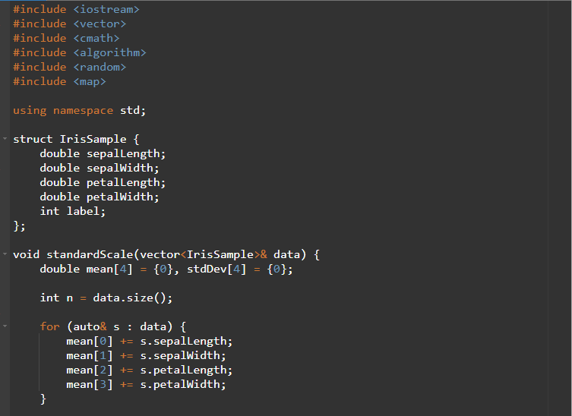

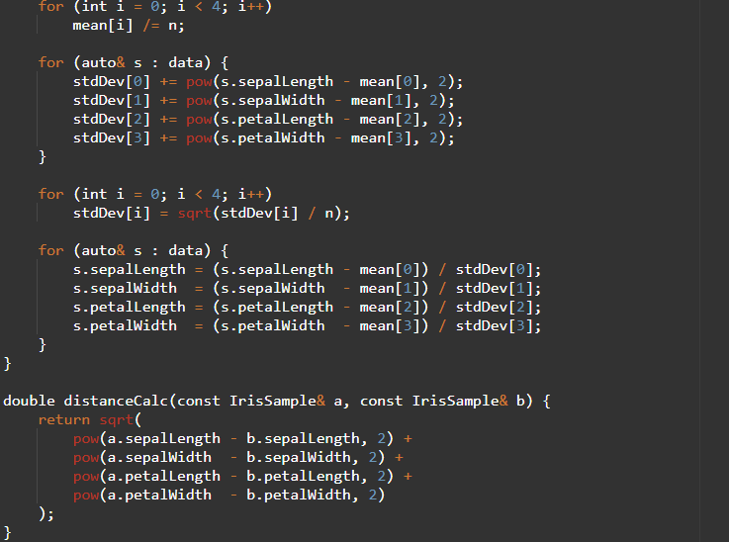
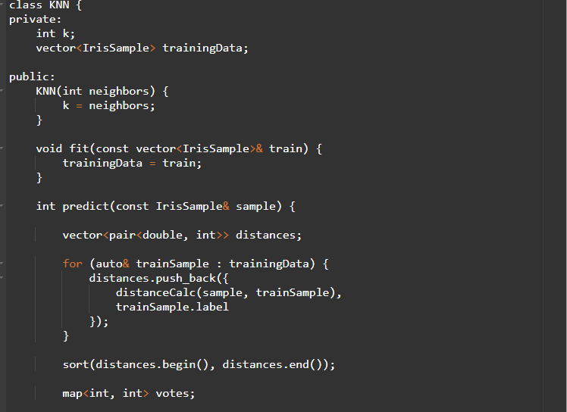
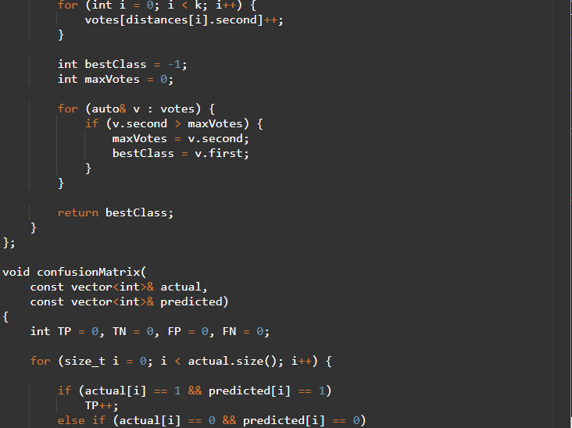
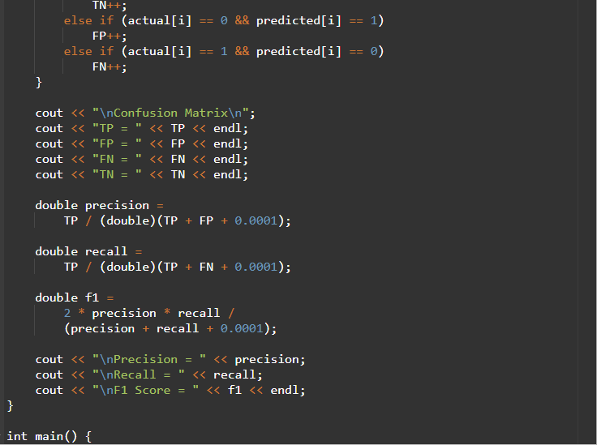

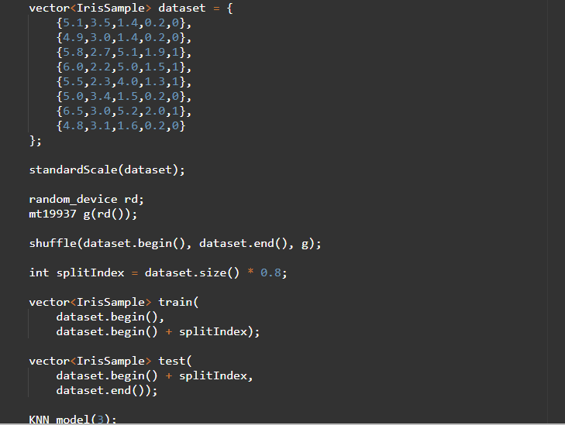
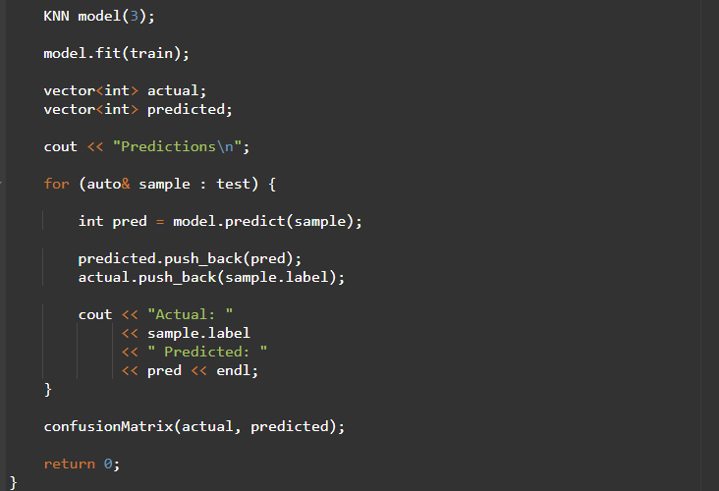
Output:
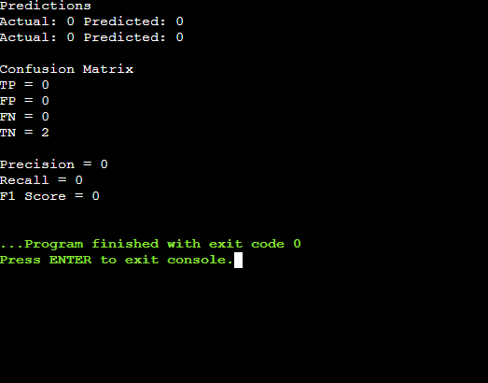
Results:

The KNN model successfully classified test samples based on their features. The confusion matrix and evaluation metrics indicate the effectiveness of the model in predicting correct classes. Feature scaling improved the performance and ensured fair comparison among features.

Learning Outcomes:

After completing this project, the following concepts were learned

- Artificial Intelligence fundamentals
- Supervised Learning
- Classification techniques
- Data preprocessing
- Feature scaling
- K-Nearest Neighbors algorithm
- Model evaluation
- C++ implementation of AI concepts
Conclusion:
This project successfully demonstrates the implementation of a basic Artificial Intelligence classification model using the K-Nearest Neighbors algorithm in C++. The model learns from labeled training data and predicts the class of unseen samples. Through this project, important AI concepts such as data preprocessing, supervised learning, classification, and performance evaluation were explored. The project serves as a strong foundation for understanding more advanced machine learning and artificial intelligence techniques.

