YAMNA AFTAB
DECODESLAB INTERNSHIP
PROJECT # 3

AI Recommendation System Using C++:
Introduction:
Recommendation systems are widely used in modern applications such as Netflix, YouTube, Amazon, and Spotify. These systems analyze user preferences and recommend items that match their interests
This project implements a basic recommendation engine using pattern matching and similarity logic. The program takes user interests as input and compares them with predefined item categories to generate recommendations.

Features:

Takes user interests as input.
Stores items with categories.
Matches user interests with item attributes.
Calculates similarity scores.
Displays recommended items.
Uses simple AI recommendation logic.

Tools and Technologies:

Programming Language: C++
IDE: Visual Studio Code
Concepts Used:
Structures
Vectors
Loops
Functions
Pattern Matching
Similarity Scoring

Algorithm:

. Start the program.
. Store items and their categories.
. Ask the user to enter interests.
. Compare interests with item categories.
. Calculate similarity scores.
. Display matching recommendations.
. End the program.

C++ Source Code:
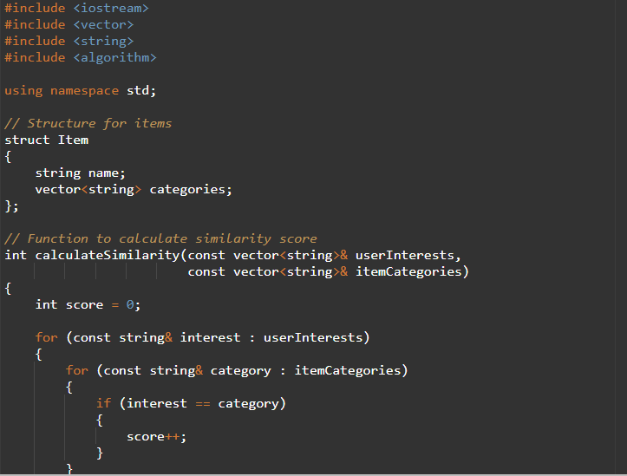
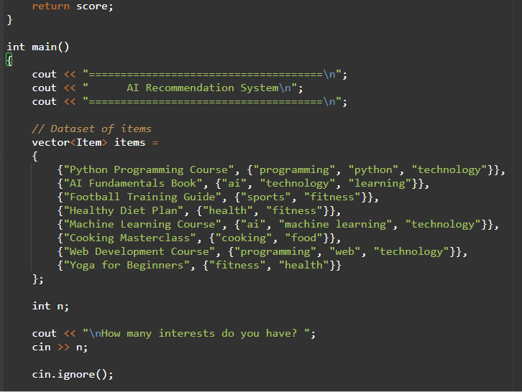

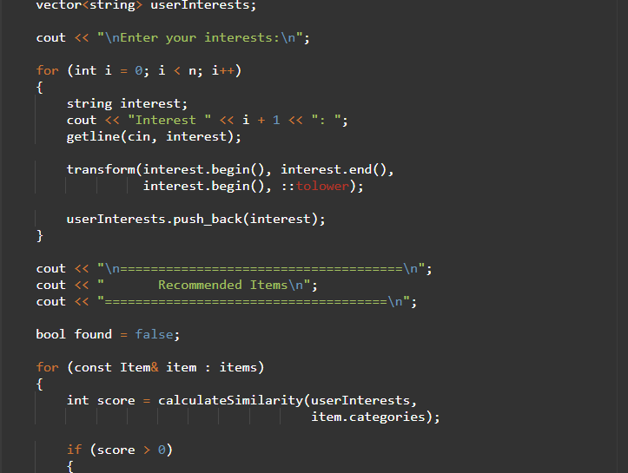
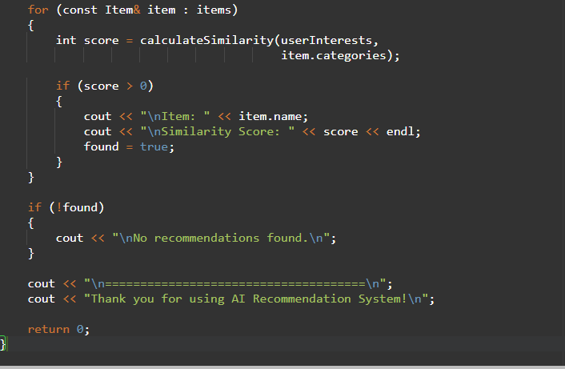
Output: 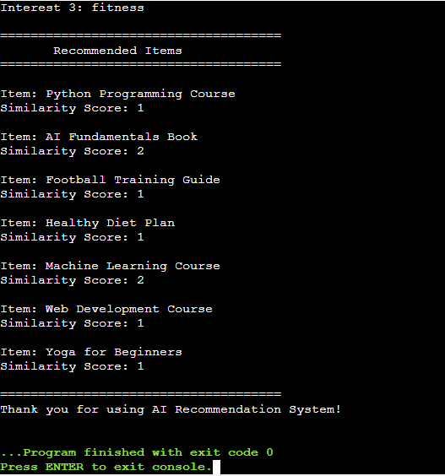
Applications:

E-commerce Product Recommendation
Movie Recommendation Systems
Music Recommendation Systems
Online Learning Platforms
Social Media Content Suggestions
Future Enhancements:

Add item ratings.
Store user history.
Use machine learning algorithms.
Add a graphical user interface.
Save recommendations to files.

Conclusion:

This project successfully demonstrates the basic working of an AI recommendation system using similarity-based logic. It collects user preferences, compares them with item categories, calculates matching scores, and recommends relevant items. The project provides a strong foundation for understanding recommendation systems and AI-based personalization.

