QB:
RB:
WR:
TE:
K:
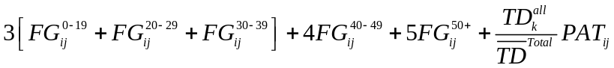
DEF:
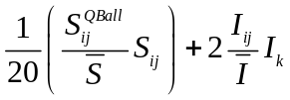 INCOMPLETE!

where,

i = index for Team Offense
j = index for player on the Offensive Team
k = index for Opposing Defense

*** Neglect 2 pt. conversions AND safeties??? ***
Blocked kicks = missed FGs???
Need to find probability of Int for TD per Int (for Defenses)

