Making Optimal Decisions with Minimum Risk:
Fantasy Football Lineups

Project by
JD Yamokoski
Ben Smarslok

Reviewed by
Timofey Turko
Nikita Boyko

ESI6912 – Stochastic Optimization Project

December 5, 2007

Introduction to Fantasy Football
A fantasy sport is one where participants are owners of a team in a league of other fantasy owners, who each constructs a team of professional athletes that gain fantasy points based on the athletes’ statistical performance in a game. Each owner’s fantasy team competes with the others in either weekly matches or cumulative points during the year. A fantasy sport can be geared towards nearly any athletic competition, but in this case, we are considering fantasy football. The reason fantasy sports exist is because they are essentially another venue for gamblers of the world to attempt to predict the future. However, unlike traditional wagers on the outcome of games, fantasy owners try to determine the combination of players that will achieve the maximum amount of fantasy points. This paper will discuss some of the history of fantasy football, rules for the game type considered, explanation of the model used for predicting player performance, and discussion of the optimization problem and results.

Origins and Popularity
Fantasy football originated in 1962 in New York City and has since been an extremely popular form of competition amongst friends. The popularity of fantasy football has grown exponentially in recent years due to the ease of obtaining and organizing information and statistics from the internet. Now, even the most amateur sports fan has nearly as much knowledge at their disposal as professional fantasy sports researchers. Many of these researchers have websites and books devoted to fantasy football, such as FF Today, KFFL, Fantasy Sharks, and Fantasy Forecast. In addition to the subjective predictions made by these professionals, several groups have devised models for estimating performance based on statistics. The Football Outsiders have a book called Pro Football Prospectus, which bases each player’s performance on their derived measure called the Defense-adjusted Value Over Average (DVOA). This value considers each individual play and situation during a game and measures the amount of success the player had on that play. Another group called the Football Scientists has their performance metric based on whether it was the offensive player doing “good,” or the defense playing “bad.” However, not much has been found on the optimization methods used to determine the best roster.

Salary Cap Fantasy Rules, Roster, and Scoring
There are several different ways to play fantasy football, but the fantasy team that one is attempting to maximize always has a similar structure. The fantasy roster, which is designed to resemble a real football roster, usually consists of 1 quarterback (QB), 2 running backs (RB), 3 wide receivers (WR), 1 tight end (TE), 1 kicker (K), and 1 team defense (Def). Quickly, for those completely unfamiliar with American football, a normal offensive play is either a passing play or a rushing play. The quarterback is the offensive player who can throw the ball on a passing play to a wide receiver, tight end, or running back. On a rushing play, the quarterback gives the ball to the running back, who runs with it (as their name implies). The objective is to move down the field (gaining yards) and score a touchdown. The kicker gets points for kicking extra points after touchdowns and kicking field goals, when the offense is unable to get a touchdown. The defense’s job is to prevent the offense from scoring and getting the ball back to their team’s offense. Each of the jobs described for the players has some statistics associated with it, which is where the fantasy points are based (such as, 6 fantasy points for each touchdown by a QB, RB, WR, or TE). A more thorough break down of the statistics and scoring will be presented in the subsequent section.
The style of fantasy football considered in this study is a salary cap league, based on Yahoo!’s rules. This type of league resembles the salary cap used in real-life sports, which restricts the amount of money a team can spend on players. Therefore, each player on the fantasy owner’s roster must be purchased for a predetermined price, set by Yahoo! based on their own algorithm for determining the market value. Though the formula for determining the price is unknown, it takes into account their real-life performance from the current and prior National Football League (NFL) seasons.
Since the American football schedule is organized according to weeks, so is the fantasy football. The objective is to purchase the optimal combination of players prior to that week's set of NFL games, while staying under the $100 salary cap limit. The fantasy football roster is similar to a stock portfolio; however, this involves picking what stocks to use instead of how much of each stock. However, since there is substantial uncertainty in the future performance of the players, determining the optimal lineup for the upcoming week can be quite difficult. In Yahoo!’s salary cap rules, if a fantasy owner buys a player early in the season and the player’s value rises, the owner does not profit from this. However, an owner can lose money if they sell a player back at a lower value than they were originally purchased. To simplify the problem, without taking away the strategy of the game, each week of was optimized independently of previous week’s purchases. That is, we assume that the owner has an empty roster every week that they want to fill to maximize the fantasy points of the next week by purchasing players at current, market value. Therefore, our model neglects future performance beyond the week of interest.
DISCUSS
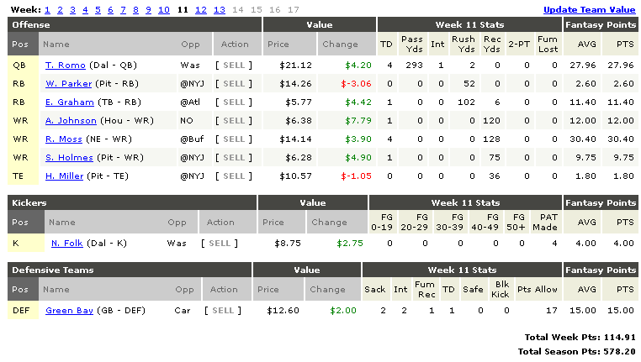
First, this fantasy football optimization project develops a model to predict future player performance based on several random variables such as individual performance history, opposing defense, and home field advantage. Then an optimization program was devised to select a roster, which minimizes the risk of under-performance. The remainder of this project draft will discuss the fantasy scoring and proposed optimization problem for this project.
Origin, popularity, history, research Roster, scoring, player selection
Work in terms of fantasy points

Salary Cap Fantasy Football Rules and Scoring

The scoring for fantasy football is a simple linear function. Table A1 in the appendix describes the scoring, however, Eqs. through show the fantasy scoring functions for each position. Where, FP is fantasy points, Y is yards, TD is touchdown, I is interception thrown (or received), F is fumble lost (or recovered), FG is field goal, PAT is point after touchdown, S is sack, and Pts_{All} is points allowed by defense. All of these statistics are for the week of interest, and therefore, are not cumulative. The corresponding fantasy points for all nine players on the roster are summed to give the total team fantasy points, TFP.

Fantasy Projections and Optimization Problem
As with any sport, the star players in professional football are well known; however, their statistical output each week varies from numerous intangible factors. The predictor model we are proposing will account for two significant factors: opposing defense and good, moderate, or poor team performance. Consider, for example, the quarterback estimator shown in Eq. .
In Eq. , all of the terms are averages based on previous performance and the index notation corresponds to k for defense, j for offense, and i for individual player. The predictor formula is similar to fantasy scoring (Eq. ), however it adds a defensive adjustment and a performance scenario for the offense and defense. The defensive adjustment is a ratio of the opposing defense’s average to the NFL average for each component. This normalization essentially tells weather the opposing defense is above or below the NFL average in the statistic of interest. The scenarios for each game are represented with Δ_{k} and Δ_{j}, referring to the home and away team. The nine combinations of scenarios are presented in Table 1.

Table 1 – Scenarios of performance for home and away teams
Scenario | Home Scenario | Away Scenario | Δ Home | Δ Away
1 | Good | Good | +15% | +10%
2 | Good | Average | +15% | 0%
3 | Good | Poor | +15% | -10%
4 | Average | Good | +5% | +10%
5 | Average | Average | +5% | 0%
6 | Average | Poor | +5% | -10%
7 | Poor | Good | -5% | +10%
8 | Poor | Average | -5% | 0%
9 | Poor | Poor | -5% | -10%

This is the current method considered for introducing scenarios. Another option would be to consider each of the previous week’s results as a scenario. With the set of scenarios defined, the problem lends itself to the stochastic optimization problem in Eq. .
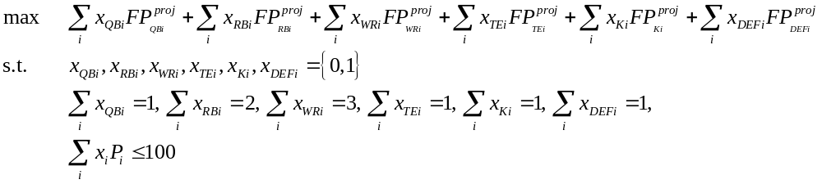
Where, x is the binary decision variable for each of the players and P is the current price for each player (in millions of dollars). A player assigned a value of x = 1 is on the active lineup and x = 0 means the player is not included. Since this problem does include binary variables, then it can not be performed in the current version of Portfolio SafeGuard. Therefore, Solver in Excel or MATLAB will be used to solve the optimization problem. The FP points for each player will be different for each decision.
The analysis portion of this project will be primarily comparing the predicted fantasy points to actual fantasy points and comparing the predicted optimal lineup to the true-optimal lineup. In addition, using the predicted points for each optimization, we can also consider the value of stochastic solution (VSS) and expected value of perfect information (EVPI). The VSS will not account for the true data for that week, but rather the improvement from using the scenarios for stochastic optimization instead of the averages. However, EVPI will use the true data versus the average data prediction. Finally, we will add conditional value-at-risk (CVaR) as a constraint with a specified threshold.
This optimization will be conducted for several weeks, while tracking our performance over this time. One of the greatest challenges associated with the project is simply extracting and organizing the player’s statistics each week. This information is not available all in one location, so numerous pages of statistics from Yahoo!’s database must be used to obtain all of the relevant data. There is still substantial post-processing of the data, which requires matching the “home” and “away” teams for each player to use our predictor properly.

Appendix
Table A1 – Fantasy scoring from Yahoo! Salary Cap Fantasy Football
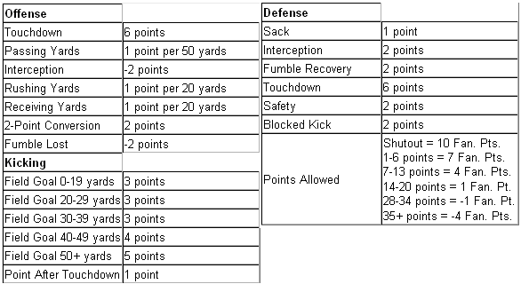
Fantasy football site used for data acquisition and has their own method for predicting stats
Fftoday.com same - Kffl.com, http://www.fftoolbox.com/index.cfm, http://www.fantasysharks.com/index.php

Story of the origin of fantasy football
http://www.sfgate.com/cgi-bin/article.cgi?file=/chronicle/archive/2004/11/27/SPG10A29D61.DTL
Fantasy football home page at yahoo.com
http://football.fantasysports.yahoo.com
Economics major website, Defense-adjusted Value Over Average looks at every play and situation and scales it as a success or failure of the offensive player
http://www.footballoutsiders.com/methods.php
Another advanced analysis of fantasy football based on evaluating the performance of player as being either him doing good, or the defense doing bad. “Performance metric”
http://www.thefootballscientist.com/

Pages devoted to looking at the consistency and pay-off of players, in terms of standard deviation “Consistent vs. Volatile” players
http://sports.yahoo.com/fantasy/nfl/news?slug=mb-qbbreakdown_2006final
http://www.pro-football-reference.com/articles/corrgaus.htm
http://www.footballguys.com/shickstandard_1.htm
http://sports.espn.go.com/fantasy/football/ffl/story?page=numbersnfl926

http://help.yahoo.com/l/us/yahoo/footballsalcap/rules/rules-05.html

