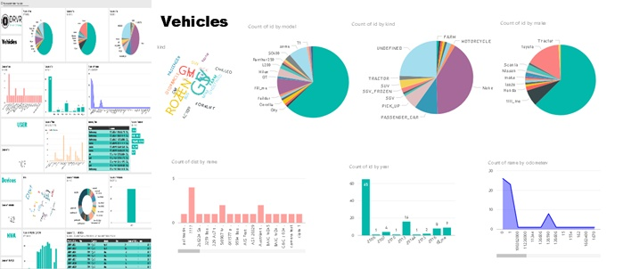

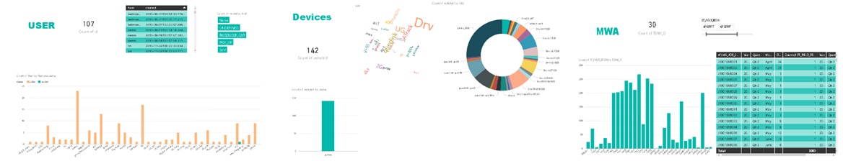

|  |  |
| --- | --- |
| Partner :  DRVR Co., Ltd.  Technologies:  Power BI Desktop , Power BI Service, SSMS  Power BI Dashboard | Power BI Dashboard collects DRVR users who provide Fleet Management services on the dashboard for use in analyzing data for service improvement, or otherwise. Which contains information about the type of car of all users. Time of in - out of work vehicles such as Delivery, Passenger, Farmed, etc. and equipment status of the hardware. |

|  |  |
| --- | --- |
| Date | List |
| 12/06/ 2017 – 14/06/2017 | I was introduced to various personnel and received my project assignment. |
| 15/06/2017 - 21/06/2017 | Pulled user data from Web API to PowerBI but it wasn’t real-time update. |
| 22/06/2017 – 30/06/2017 | Wrote a program for pulled user data to SQLserver. |
| 3/07/2017 - 7 /07/2017 | Connected SQL server to PowerBI. |
| 11/07/2017 -14 /072017 | Creating a dashboard in PowerBI service. |
| 15/07/2017 - 21 /07/2017 | Improved a program and dashboard. |