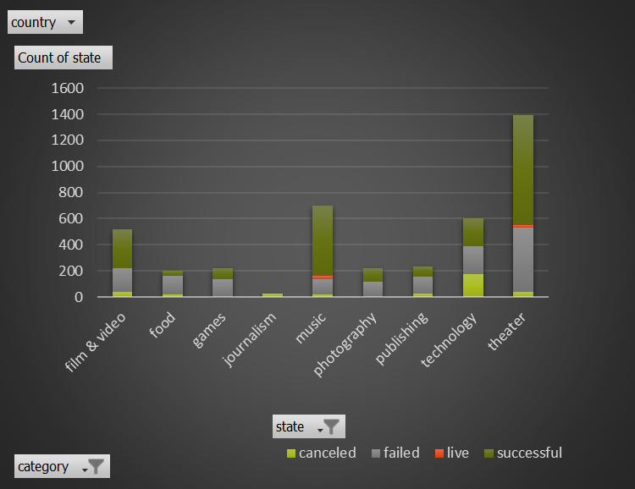

PivotChart: Categories Stats

What are the 3 conclusions we can make about Kickstarts campaigns given provided data?

* From above pivot chart the theater category is most successful category in all countries.
* The difference between the grand total of failed category (1530) state and successful category (2185) state is very less.
* The music, food and theater are only in live state.

### 

Pivot Chart: LaunchDateoutcomes

Conclusion: 1. From the above pivot chart, if we analyze data points for every month, the successful rate is more compare to failed and canceled. Only during the month of September, the difference between failed (127) and the successful (147) is very less.

Pivot Chart: Outcomes based on goal

In the above pivot chart, the x-axis represents goal range and y axis represents different categories in percentage value. The bakers invested their money in less than $1000 range and the chart represents the highest successful rate which is 71%. As well as ,when we look at the chart, as goal increases the chances of investing money is either failed or canceled.

What are some of the limitations of the dataset?

* The most important aspect to know about launching a Kickstarter project is that if the project falls short of meeting its minimum funding goal, the project will not receive any fund.
* If a fundraising goal isn't reached by a certain time, the bakers will not get nothing , even if they fall behind by just one dollar.

What other some possible graphs or table that we could create?

* The next thing I want to do with this Dataset is to predict the day in which a successful project will achieve its goal. Also, I would like to predict the expected pledged for a Project.
* Bakers already set specific goals and if they offer rewards to the public based on the size of each contribution, maybe it will lead to the success. In future I will add Rewards column to the table.