Introduction
In November 2022, Massachusetts voters approved a constitutional amendment which imposed a surtax of 4% on annual incomes over $1 million. The 4% surtax raises the effective state tax rate to 9% on high income earners and was popularly known as the “Millionaires tax”. Its proponents claimed that revenue loss due to outmigration of high-net-income individuals would be negligible, and that the increased revenue from the tax would help the state fund initiatives like education, infrastructure, and public transportation. Critics of the surtax claimed that in response to the tax, high income earners would flee to neighboring states like New Hampshire, which doesn’t have a state income tax. New Hampshire also repealed its state tax on income and dividends, meant to go into effect beginning December 31, 2024. This paper uses difference in difference regression analysis to determine if the surtax led to an outmigration of individuals to neighboring states with lower effective tax rates and if that had an impact on state revenue collection. The paper finds that outmigration was negligible, and that Massachusetts’ revenues weren’t affected compared to its neighbors in the control group. The DiD model is appropriate for this question as I hope to isolate the causal impact of the surtax. In the absence of a randomized control trial where the surtax was only applied to certain rich counties to study its impact, a DiD model allows us to create a control group – Massachusetts’(MA) New England neighbors who are similar culturally, economically, and politically – and a treatment group (MA) which was “treated” with the surtax. By using panel data (from 2013 to 2024), the DiD model also controls for shocks like the COVID pandemic in 2020.
Literature Review
The impact of taxation on outmigration of high-income earners has been a subject of research not just in the United States, but in Europe too where there aren’t many barriers for citizens of European Union (EU) countries to migrate within the EU. This literature review will primarily focus on research on state-state migration within the US, which is related to the topic of this paper.
The most cited academic work on the topic of tax related outmigration of the wealthy comes from Cristobal Young, a sociologist is who is currently a professor at Cornell. In Young et al., 2016, the authors analyzed tax returns for all million-dollar income earners over 13 years, tracking the states from which millionaires file their taxes. Their dataset of 45 million tax records provided exceptional panel data on top income-earners and was used to answer two questions: 1. How do millionaires migrate state-state over the long-term, and 2. What happens to millionaires who reside along the borders of states with a tax-rate differential?
In the paper, the authors first analyze overall migration rates and find that migration rates flatten out with increasing income and then rise slightly at incomes above $1.2 million as shown in Figure 1.
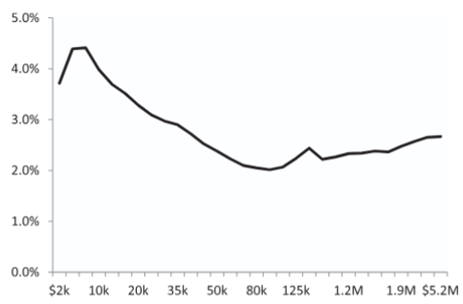
Figure 1: Migration rates by Income Level, 1999 to 2011, Young et al.2016
A deeper look at the demographic make-up of the migration data (Table 1) reveal that factors associated with “embeddedness” – having a family with children, owning a business, and age – reduce migration rates for millionaires. This makes sense as these demographic groups have a strong attachment to where they live and moving to a different state is associated with frictions that don’t make the move worthwhile, no matter what the tax differential.
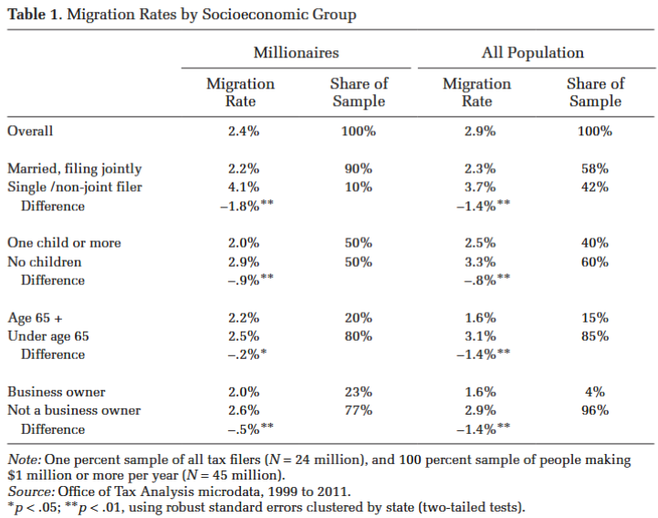
This data runs counter to models of previous analysis (Mirrlees, 1982; Simula and Tannoy, 2011) which assume that income is exogenous to location. Income earning capacity derives not just from individual talent, but also from other place-based factors like quality of educational institutions, social and business connections, and clusters or eco-systems of industries like finance and technology that pay high-salaries.
When analyzing long-run millionaire migration flows between all states over 13 years, Young et al.,2016, find that there is a statistically significant outmigration effect in response to tax increases, in particular, Florida seems to be the biggest beneficiary of millionaire inflows. However, the size of this migration effect was very small and the net revenue, i.e. the revenue gained from the majority of high-income earners who stayed in the state was greater than the revenue lost from the tiny number that left. For millionaire migration along state borders, the authors used a regression discontinuity technique and found no evidence of short-run cross-border migration in response to tax policy changes. Even in the long run, they discovered weak evidence that millionaires chose to move to the low tax state on the other side of the border.
In Rauh, Shyu et. al.2019, the authors looked at how California’s highest-income earners responded to two major tax increases in 2012 (Proposition 30), and 2016 (proposition 55). The authors used administrative tax data from the state of California and discovered that the highest income earners (those making between $5 million to $10 million), out-migrated at a 0.8% rate higher than the baseline rate of 2.1%. The other key finding of the paper was that top income earners used tax avoidance strategies to reduce their reported taxable income which led to an erosion of potential tax revenue. The paper provides evidence that migration isn’t the only strategy that top 1% earners can use to avoid paying taxes and provides evidence of a behavioral response to increased taxation.
Moretti et al, 2017, looked at another impact of state taxes on top earning inventors. The authors linked US patent data with earnings data and identified the highest paid inventors and the state they filed their patents from over a 35-year period. Using a DiD technique they compared the top-earning inventors in high-tax states to those in the control group who were in lower tax states over time. The authors discovered that top inventors were highly sensitive to state taxes – for a 1% increase in state taxes, the number of superstar inventors who lived in the state dropped by 1% the following year. The paper is an important reference as it highlights a specific group of people who are sensitive to state tax increases, a group which states usually compete to attract.
Data Section
Several data sources were considered for this paper. The IRS has some excellent data sources on individual tax statistics. The “SOI Tax stats – Migration data” page has migration data for the United States based on the address changes reported every year on individual income tax returns. Using this data, one can identify state and country level flows based on the number of returns filed and the size of adjusted gross income (AGI) and age of the primary taxpayer. This data is invaluable and was used to look at the state-state flows for MA and its neighbors in New England states.
However, the data end in 2022 which is the year when the surtax in MA was approved. The data for 2023 will be released later this year. Despite this limitation, the data can be used to gauge migration flows from 2011-2022 and the Python code and results of this analysis will be presented in this paper.
The IRS also provides individual income tax data classified by state, size of adjusted gross income and AGI percentiles. This data can be used to isolate county level and even Zip code income to determine which areas in MA have the highest concentration of top-income earners. However, these data do not list the highest income percentiles (the highest AGI level is > $200,000 which makes isolating the number of millionaires hard). This data was used to identify the richest counties in MA and its neighbors.
To plug the gaps in the SOI data, results of the American community survey were used to identify state-state migration flows. ACS data give state-state migration flows up to 2023 which gives us one full year of data after the surtax was implemented.
To get revenue statistics for the panel data, a combination of MA’s department of revenue website, bureau of Labor statistics, and tax foundation data were used. These data were combined with the population estimates from the census bureau.
To get the tax rate differentials between states, data from the Tax foundation was used.
The panel data put together from the various data sources is shown below. Note that the panel only includes data used in the core DiD analysis – Revenue per capita, population and top marginal tax rate. This is because these are the only data available up to Q1 of 2025. The remaining data were used to identify historical trends in migration patterns to check if the DiD analysis results made sense.
Methodology
A two-way fixed effects difference in differences technique was used to gauge the impact of the surtax on Massachusetts’ revenue per capita. The control group in this case comprises of New England states and one non-New England border state (New York). New England states were chosen because they share common historical and cultural features with Massachusetts. A lot of major cities like Portland, Manchester, Providence, Hartford, and Burlington are less than a four-hour drive from major cities in Massachusetts.
The control group states therefore are New Hampshire, Vermont, Connecticut, Rhode Island, Maine, and New York. The treatment group comprises of just Massachusetts where the surtax was implemented in November 2022. Note that the surtax only went into effect in 2023.
The main DiD model described in the equation below was used:
$log$(${Revenue per capita}_{it}$) = $β_{0}+ β_{1}\left({Treated}_{i}* {Post Surtax}_{t}\right)+ α_{i}+ δ_{t}+$ $ε_{it}$
The state fixed effects, $α_{i}$, control for the fact that the states in the analysis have different populations, population densities, income distributions, and other factors. We can explicitly control for any other factors, but the state fixed effects are first used to even the analysis and isolate the causal impact of the surtax in Massachusetts. The time fixed effects account for shocks like COVID in 2020, and the subsequent move to remote work which led to some people migrating to neighboring states so they could buy bigger houses. The remote work trend has since reversed as more firms are requiring that their employees work on-site.
There are some limitations of this model which are partly driven by limitations with the available data. Unlike other academics, Since I didn’t have access to confidential data from the state department of revenue, or data from the IRS up to 2024/2025, I was unable to isolate the millionaire population within MA and study their migration patterns over time. Ideally, one can use the migration data from wealthy neighborhoods as a proxy, but even that data aren’t directly available from the census bureau. One could use postal service address change data for that, but I didn’t have the time to scrape and validate that data.

References
Young, C., Varner, C., Lurie, I. Z., & Prisinzano, R. (2016). Millionaire migration and state taxation of top incomes: Evidence from a natural experiment. National Tax Journal, 69(3), 596–627.
Rauh, J., & Shyu, R. J. (2019). Behavioral responses to state income taxation of high earners: Evidence from California (NBER Working Paper No. 26349). National Bureau of Economic Research. https://www.nber.org/papers/w26349
Moretti, E., & Wilson, D. J. (2019). Taxing the rich: The effect of high-end state tax increases on top earning inventors. American Economic Review, 109(10), 2726–2772. https://doi.org/10.1257/aer.20171545
https://www.irs.gov/statistics/soi-tax-stats-migration-data
https://www.census.gov/data/tables/time-series/demo/geographic-mobility/state-to-state-migration.html
https://www.census.gov/data/tables/time-series/demo/geographic-mobility/state-to-state-migration.html
https://files.taxfoundation.org/legacy/docs/sr180.pdf

