**Design database for Zen class programme**

users

codekata

attendance

topics

tasks

company_drives

mentors

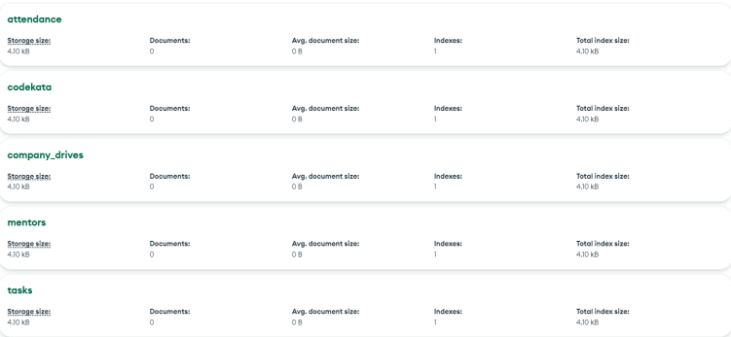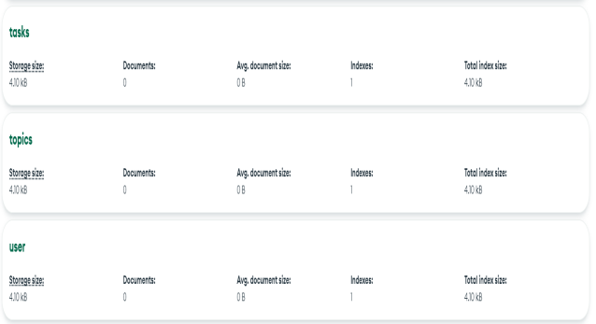

1. Find all the topics and tasks which are thought in the month of October

Query:

db.tasks.aggregate([

{

$lookup: {

from: "topics",

localField: "top_id",

foreignField: "_id",

as: "task_topics"

}

},

{

$unwind: "$task_topics"

},

{ $project: {

topic_name:"$task_topics.name",

topic_date:"$task_topics.date",

task_description:1,

date:1,

submitted:1 }

}]);

Output:

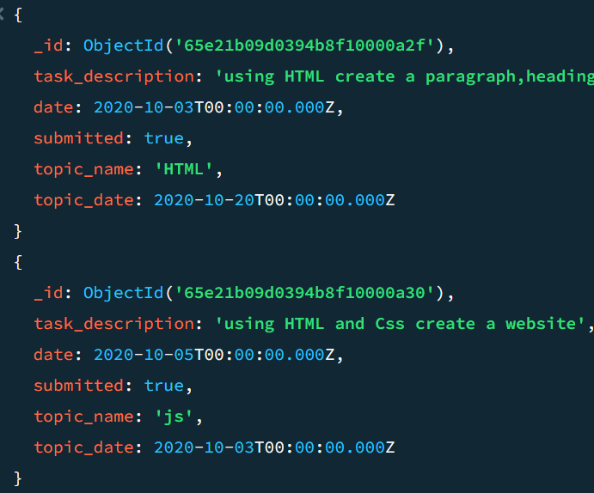 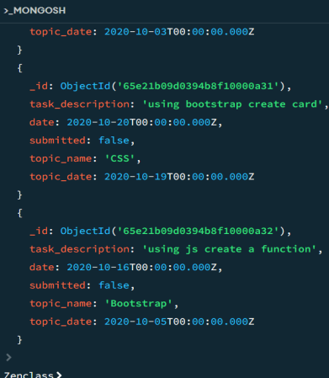

1. Find all the company drives which appeared between 15 oct-2020 and 31-oct-2020

Query: db.company_drives.aggregate([

{

$match: {date:{$gte: ISODate("2020-10-15"),$lte: ISODate("2020-10-31")}}

}

]);

Output:

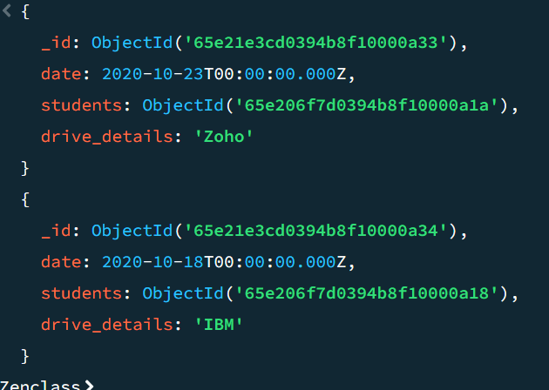

1. Find all the company drives and students who are appeared for the placement.

Query: db.company_drives.aggregate([

{

$lookup:{

from:"user",

localField:"_id",

foreignField:"drive_id",

as:"placement_details"

}},

{

$unwind: "$placement_details"

},

{

$match: {

"placement_details.drive_status": "attended"

}

},

{

$project: {

_id: 0,

drive_details: 1,

user_name: "$placement_details.name",

user_email: "$placement_details.email",

placement_status: "$placement_details.drive_status"

}

}

]);

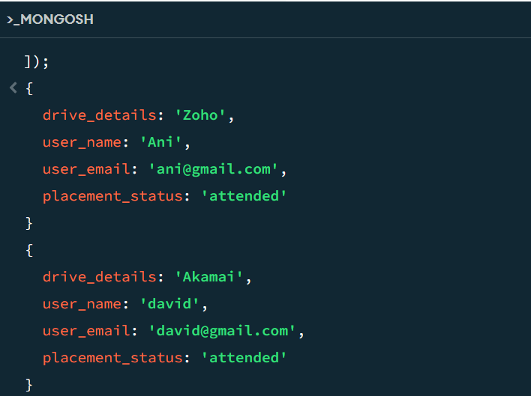

1. Find the number of problems solved by the user in codekata

Query: db.codekata.aggregate([

{

$lookup: {

from: "user",

localField: "user_id",

foreignField: "_id",

as: "codekata_solved"

}

},

{

$unwind: "$codekata_solved"

},

{

$group: {

_id: "$codekata_solved._id",

user_name: { $first: "$codekata_solved.name" },

user_email: { $first: "$codekata_solved.email" },

solved: { $sum: 1 }

}

},

{

$project: {

_id: 0,

user_name: 1,

user_email: 1,

solved: 1

}

}

]);

Output:

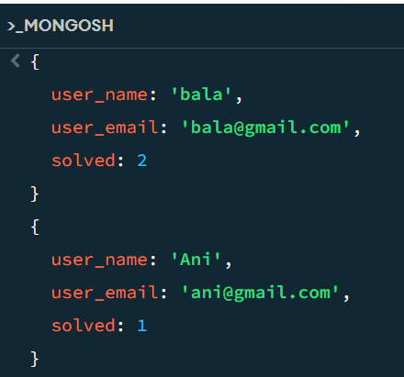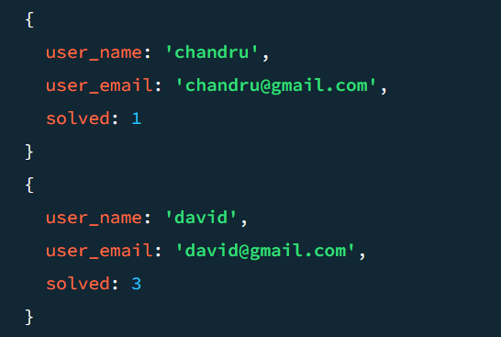

1. Find all the mentors with who has the mentee's count more than 15

Query:

db.mentors.aggregate([

{

$match: {mentees:{$gte:15}}

}

]);

Output:

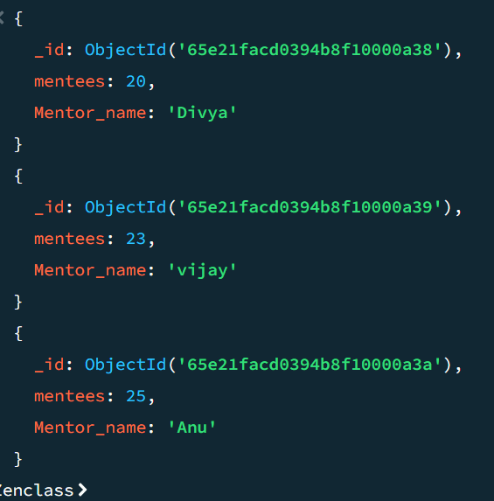

1. Find the number of users who are absent and task is not submitted  between 15 oct-2020 and 31-oct-2020

Query:

db.user.aggregate([

{

$lookup: {

from: "attendance",

localField: "_id",

foreignField: "user_id",

as: "atten_details"

}

},

{

$lookup: {

from: "tasks",

localField: "_id",

foreignField: "user_id",

as: "task_details"

}

},

{ $unwind: "$atten_details" },

{ $unwind: "$task_details" },

{

$match: {

$and: [

{ "task_details.date": { $gte: ISODate("2020-10-15"), $lte: ISODate("2020-10-31") } },

{ "task_details.submitted": false },

{ "atten_details.status": "absent" }

]

}

},

{

$group: {

_id: null,

user_count: { $sum: 1 }

}

},

{

$project: {

_id: 0, user_count: 1,

task_submitted: { $literal: false },

status: { $literal: "absent" }

}

}

]);

