**AIM:TO CALCULATE INTEREST FOR FIXED DEPOSIT AMOUNT USING CURSORS**

CREATE TABLE FIXED(ACCNO NUMBER(10),YEARS NUMBER(4),AMOUNT NUMBER,INTEREST NUMBER);

INSERT INTO FIXED(ACCNO,YEARS,AMOUNT) VALUES(:ACCNO,:YEARS,:AMOUNT);

SELECT * FROM FIXED;

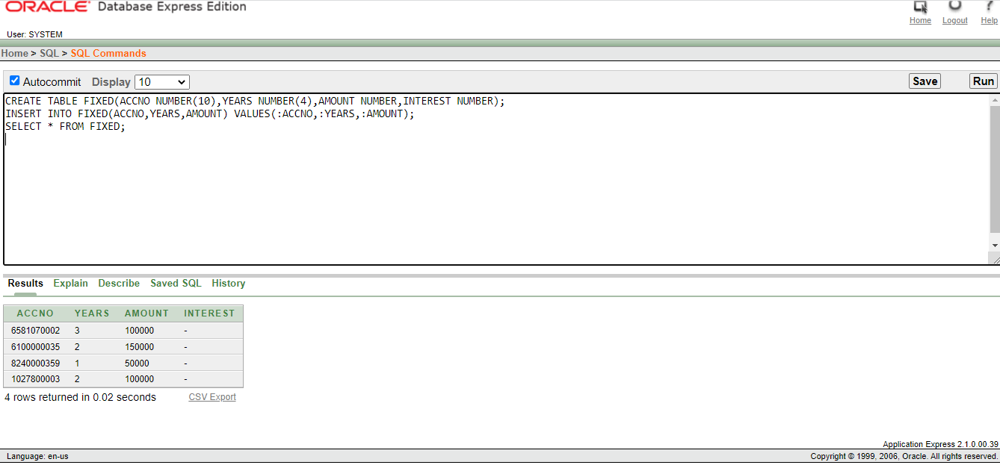

DECLARE

CURSOR CUR IS SELECT * FROM FIXED;

BEGIN

FOR I IN CUR

LOOP

IF I.YEARS<=2 THEN

UPDATE FIXED SET INTEREST=I.AMOUNT*0.09*(1/12) WHERE ACCNO=I.ACCNO;

ELSIF I.YEARS>=2 AND I.YEARS<=5 THEN

UPDATE FIXED SET INTEREST=I.AMOUNT*0.11*(1/12) WHERE ACCNO=I.ACCNO;

ELSE

UPDATE FIXED SET INTEREST=I.AMOUNT*0.15*(1/12) WHERE ACCNO=I.ACCNO;

END IF;

END LOOP;

END;

SELECT * FROM FIXED;

