create table Emp5(Empno number,Empname varchar(20),Deptno number);

insert into Emp5 values(:Empno,:Empname,:Deptno);

select * from Emp5;

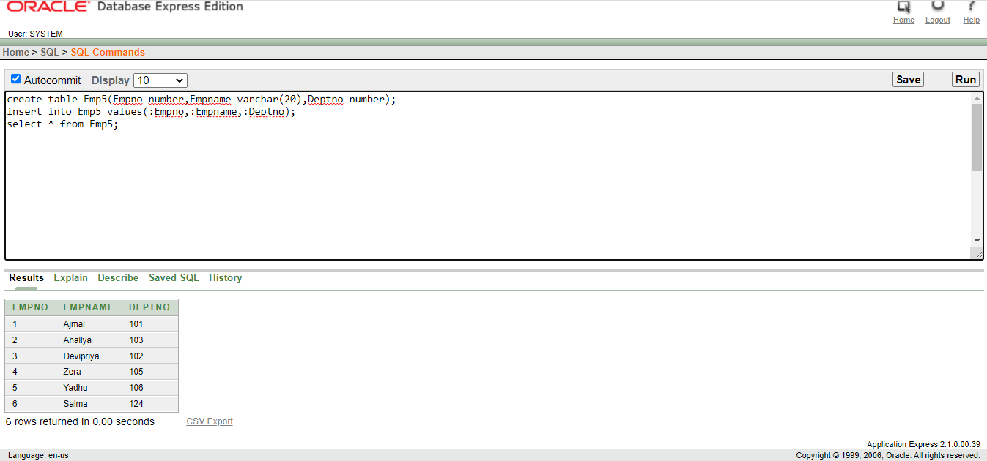

declare

Veno Emp5.Empno%type:=:Empno;

Vename Emp5.Empname%type;

Vdeptno Emp5.Deptno%type;

begin

select Empno,Empname,Deptno into Veno,Vename,Vdeptno from Emp5 where Empno=Veno;

dbms_output.put_line('Deptno is '||Vdeptno);

dbms_output.put_line('Empname is '||Vename);

exception

when no_data_found then

dbms_output.put_line('No record found');

end;

