PHASE4-IMPLEMENTATION

4.1 Introduction
- Implementation is the process of developing and configuring the required features in the ServiceNow platform. In this project, UI Policies and Client Scripts are used to control Incident form behavior, automate field values, and prevent invalid data submission.

4.2 UI Policy – High Impact Control
UI Policy Name: High Impact Control
Table: Incident
Condition: Impact is 1 – High
Active: True
Reverse if False: True

Configuration

Assignment Group is made mandatory when Impact is High.

The UI Policy controls the field behavior dynamically.

When the condition becomes false, the original field behavior is restored.
Expected Result: Assignment Group becomes mandatory for High Impact incidents.

4.3 UI Policy Action – Urgency Read-only
Field Name: Urgency
Read-only: True
Visible: Leave unchanged

Configuration
- Urgency field is configured as read-only when the UI Policy condition is satisfied.
- Users cannot manually modify the field under this condition.
- When the condition becomes false, the field behavior is reversed.
Expected Result: Urgency becomes read-only for High Impact incidents.

4.4 Client Script – onChange
Name: Auto set urgency for high impact
Table: Incident
Type: onChange
Field: Impact
Active: True

Script
function onChange(control, oldValue, newValue, isLoading) {
if (isLoading || newValue == '') {
return;
}
if (newValue == '1') {
g_form.setValue('urgency', '1');
g_form.addInfoMessage('Urgency set to High for High impact incident.');
}
}

Explanation

The script runs when the Impact field value changes
- If Impact is High, Urgency is automatically set to High.
- An information message is displayed to the user.
Expected Result: Urgency is automatically populated when Impact is High.
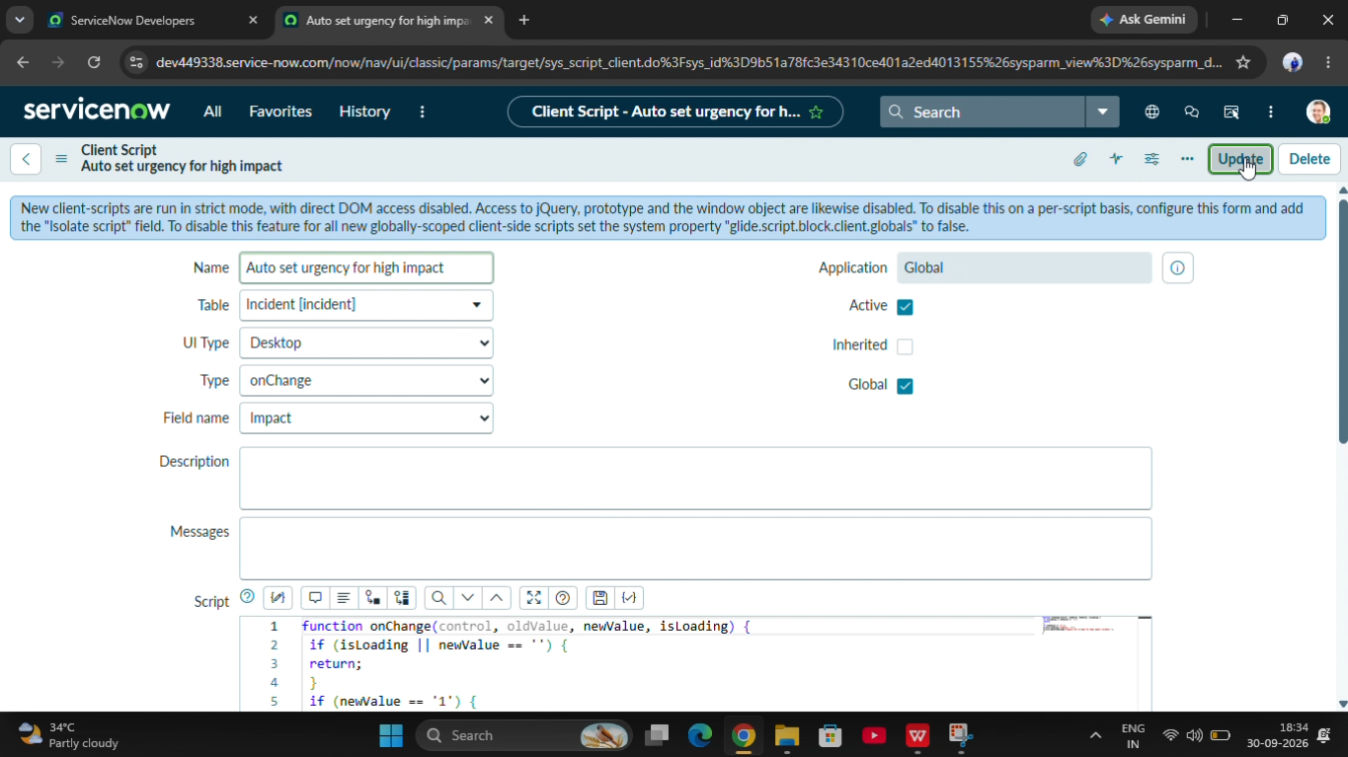

4.5 Client Script – onSubmit
Name: Prevent save if Assigned To missing
Table: Incident
Type: onSubmit
Active: True

Script
function onSubmit() {
if (g_form.getValue('impact') == '1' &&
g_form.getValue('assigned_to') == '') {
g_form.showErrorBox(
'assigned_to',
'Assigned To is mandatory for High impact incidents.'
);
return false;
}
return true;
}

Explanation
- The script executes when the user submits the Incident form.
- It checks whether Impact is High.
- If Assigned To is empty, an error message is displayed.
- The form submission is cancelled.
- If the condition is satisfied, the record can be submitted.
Expected Result: High Impact incidents cannot be saved without Assigned To.
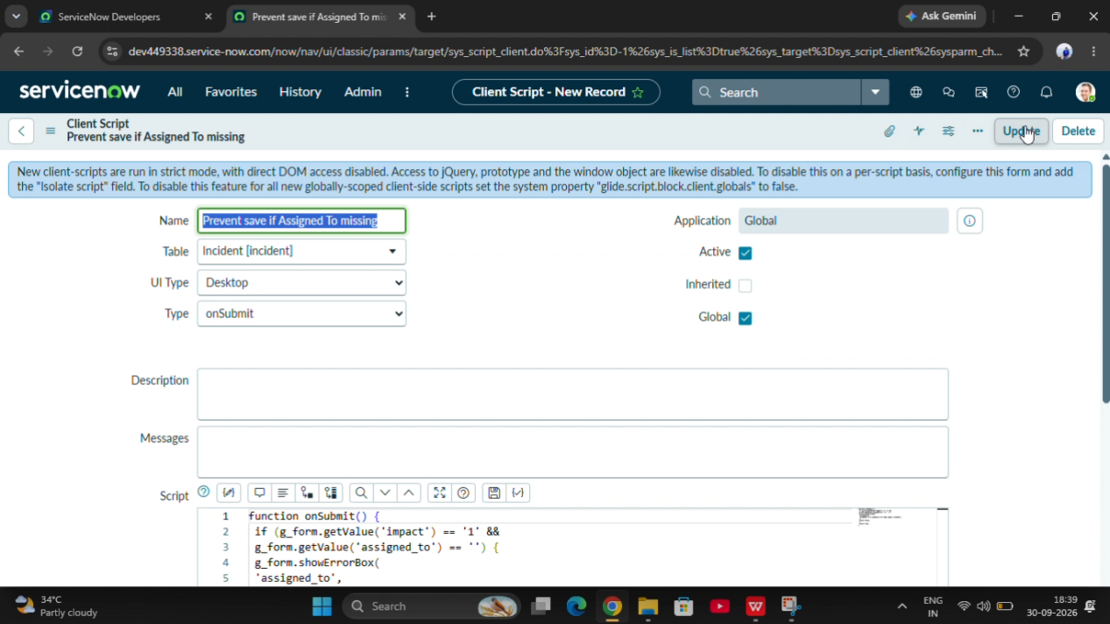

4.6 Client Script – onCellEdit
Name: Prevent state change via list edit
Table: Incident
Type: onCellEdit
Field: State
Active: True

Script
function onCellEdit(sysIDs, table, oldValues, newValue, callback) {
alert('State cannot be updated using list editing. Please open the Incident.');
callback(false);
}

Explanation
- This script controls direct editing of the State field from the Incident list.
- An alert message is displayed to the user.
- The callback returns false to reject the list edit.
Expected Result: State cannot be updated directly through list editing.
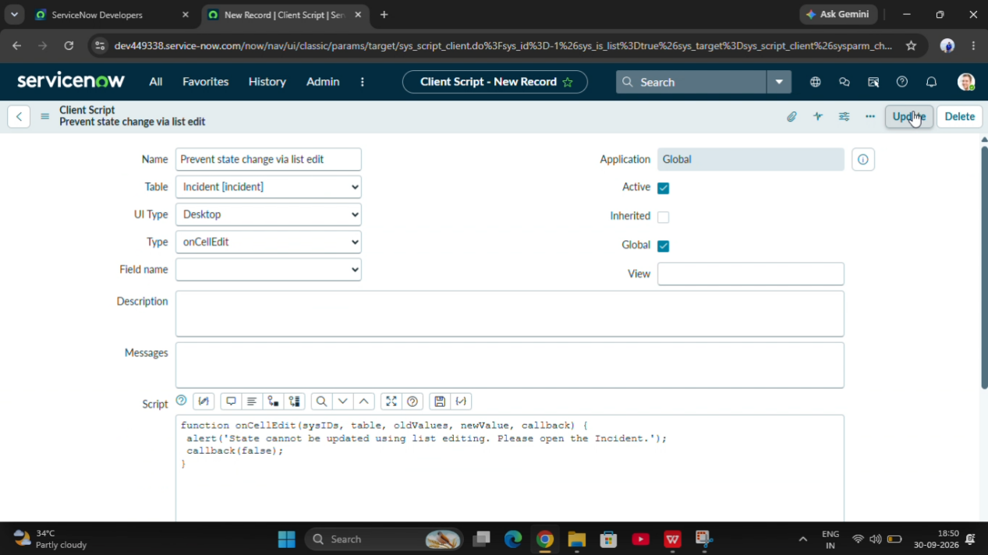

4.7 Testing and Validation
The following test cases are used to verify the implementation.
Test Case | Expected Result
- Select High Impact | - Assignment Group becomes mandatory
- Select High Impact | - Urgency becomes read-only
- Change Impact to High | - Urgency is set to High
- Save without Assigned To | - Submission is prevented
- Save with Assigned To | - Submission is allowed
- Change Impact from High to Medium | - UI Policy condition is reversed
- Edit State from list | - Direct edit is rejected
- Update State from Incident form | - Form-based update is allowed

4.8 Conclusion
- The implementation of UI Policies and Client Scripts helps improve Incident form behavior in ServiceNow. It ensures mandatory field validation, automatic field population, controlled field editing, and prevention of invalid submissions.

