- What are the two values of the Boolean data type? How do you write them?
The two values of Boolean data type is True or False,
Ex:
Boolen= True
Boolen=False
We represent True as yes or 1 and False as no or 0

- What are the three different types of Boolean operators?
and, or, not are three different types of Boolean operators
- Make a list of each Boolean operator's truth tables (i.e. every possible combination of Boolean values for the operator and what it evaluate ).
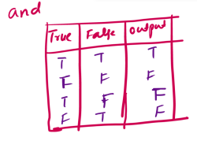
- and

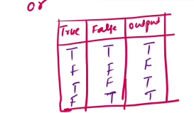
- or

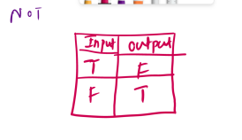
- not

3. What are the values of the following expressions?
(5 > 4) and (3 == 5) = False
not (5 > 4) =False
(5 > 4) or (3 == 5) =True
not ((5 > 4) or (3 == 5)) =False
(True and True) and (True == False) =False
(not False) or (not True) =True
4.What are the six comparison operators?
The six comparison operators are
== equal
!= not equal
> greater than
< less than
>= greater than or equal to
<= less than or equal to
5.How do you tell the difference between the equal to and assignment operators?Describe a condition and when you would use one.
Equal operators(==) means we are comparing the value to a variable, we use equal operators in logical and conditional statements.
Assignment operators(=) means we are assigning the value to a variable,we use assignment operators in to add data to variables.
6. Identify the three blocks in this code:
spam = 0
Block1
if spam == 10:
print('eggs')

Block2
if spam > 5:
print('bacon')

Block3
else:
print('ham')
print('spam')
print('spam')

but this block code not indented properly
7. Write code that prints Hello if 1 is stored in spam, prints Howdy if 2 is stored in spam, and prints Greetings! if anything else is stored in spam.
spam=1
if spam==1:
print("hello")
elif spam ==2:
print("howdy")
else:
print("greetings")
8.If your programme is stuck in an endless loop, what keys you’ll press?
Cntrl+c on windows
Command+.(period) on mac
- How can you tell the difference between break and continue?
break:
- when break is encountered the switch or loop execution immediately stopped.
- break statements is used in switch and loops
continue
- when continue encountered, the statements after it are skipped and the loop control jump to next iteration
- continue statement is used in loops only

- In a for loop, what is the difference between range(10), range(0, 10), and range(0, 10, 1)?
range(10)= it takes values from 0 to 9 excludes the 10
range(0,10)= means lower-limit is 0 and upper-limit is 10
range(0,10,1) = means lower-limit is 0, upper-limit is 10 and 1 represents step number(increase the value by one)
the expressions range(10), range(0, 10), and range(0, 10, 1) produce the same sequence of numbers [0, 1, 2, 3, 4, 5, 6, 7, 8, 9] in a for loop, but they differ in their syntax and the way the start, end, and step values are specified.
- Write a short program that prints the numbers 1 to 10 using a for loop. Then write an equivalent program that prints the numbers 1 to 10 using a while loop.
for i in range(1,11):
print(i)

i=1
while i<=10:
i+=1
print(i)

13. If you had a function named bacon() inside a module named spam, how would you call it after importing spam?
from spam import bacon
Or
Import spam
name=spam.bacon()

