Course: BCSNT 6063 – Object Oriented Programming
Program: Bsc Csit
Semester: 2nd Semester
Submitted By: Yamuna Khadka
Assignment:Frist

2. Basic Java Programming Tasks Write and run the following programs in IntelliJ: A. Hello World Program
● Create a class Main.
● Print: Hello, Java World!

public class question1 {
public static void main(String[] args) {
System.out.println("Hello, Java World!");
}
}
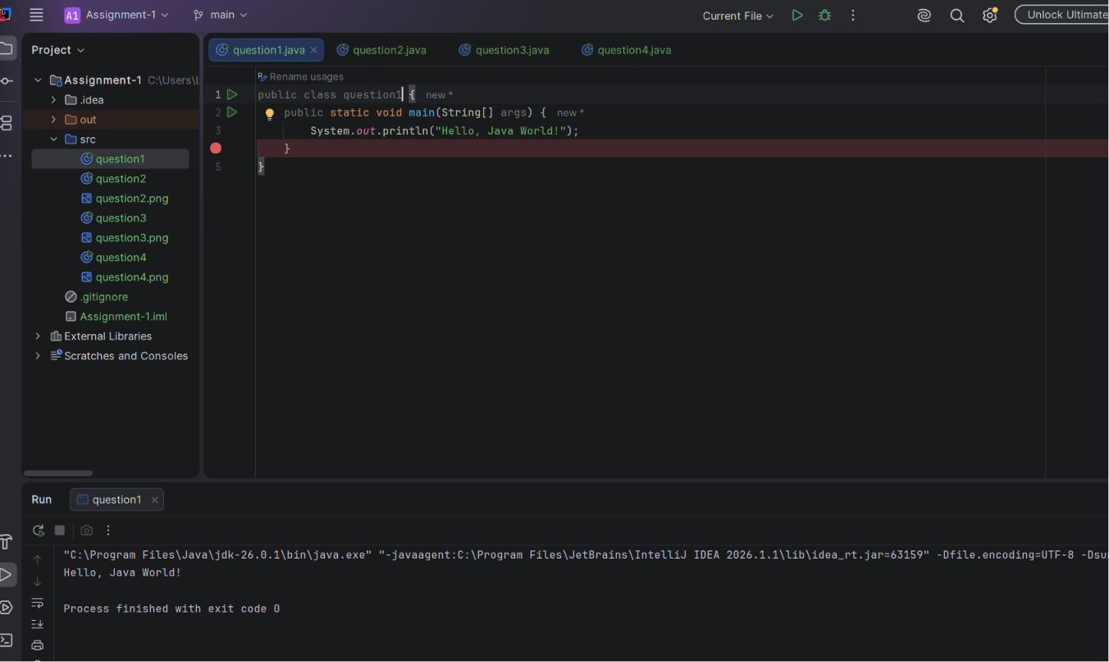

B. Variables & Data Types Write a program demonstrating: ● int, double, boolean, char, String ● Print their values.

public class question2 {
public static void main(String[] args) {
int number = 10;
double price = 99.99;
boolean isJavaFun = true;
char grade = 'A';
String name = "Java Programming";
System.out.println("int value: " + number);
System.out.println("double value: " + price);
System.out.println("boolean value: " + isJavaFun);
System.out.println("char value: " + grade);
System.out.println("String value: " + name);
}
}
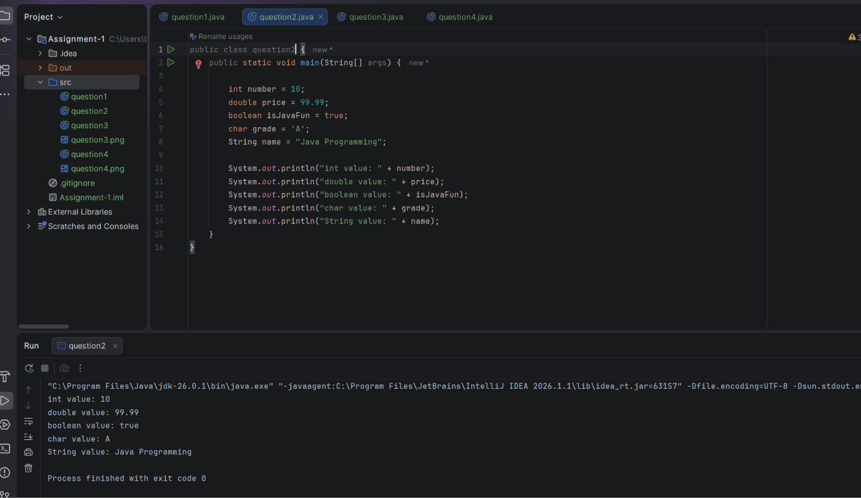

C. Operators Program Write a Java program showing: ● Arithmetic operators (+, -, *, /, %) ● Relational operators (>,

public class question3 {
public static void main(String[] args) {
int a = 10;
int b = 5;
// Arithmetic
System.out.println("Addition: " + (a + b));
System.out.println("Subtraction: " + (a - b));
System.out.println("Multiplication: " + (a * b));
System.out.println("Division: " + (a / b));
System.out.println("Modulus: " + (a % b));
// Relational
System.out.println("a > b: " + (a > b));
System.out.println("a < b: " + (a < b));
System.out.println("a == b: " + (a == b));
System.out.println("a != b: " + (a != b));
// Logical
boolean x = true;
boolean y = false;
System.out.println("x && y: " + (x && y));
System.out.println("x || y: " + (x || y));
System.out.println("!x: " + (!x));
}
}
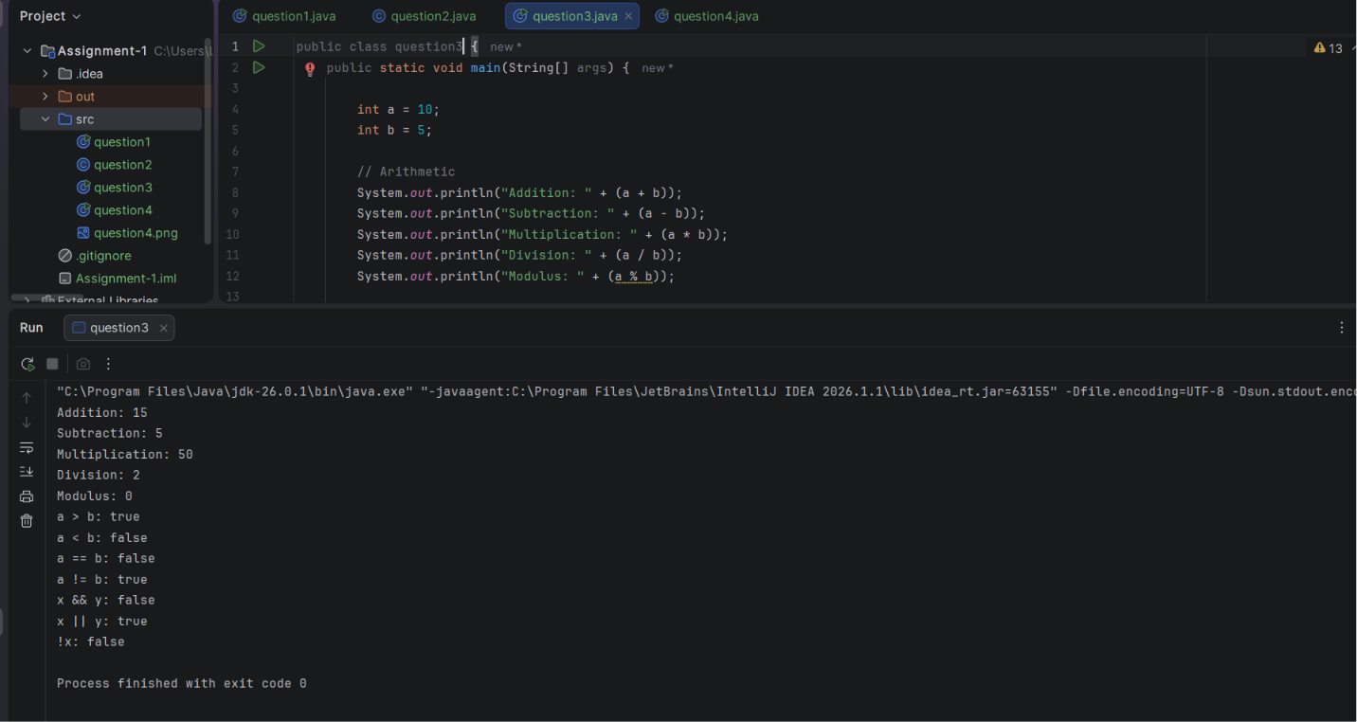

D. User Input Program (Bonus for extra marks) Use Scanner to take two numbers and print their sum.

import java.util.Scanner;
public class question4 {
public static void main(String[] args) {
Scanner sc = new Scanner(System.in);
System.out.print("Enter first number: ");
int num1 = sc.nextInt();
System.out.print("Enter second number: ");
int num2 = sc.nextInt();
int sum = num1 + num2;
System.out.println("Sum = " + sum);
sc.close();
}
}
