CLOUD DATA CENTER RESOURCE MANAGEMENT AND PERFORMANCE EVALUATION
FINAL ASSIGNMENT
Course: Operating Systems
Program: BSC CSIT
Submitted By:
YAMUNA KHADKA
Student ID: LC00014002616
Submitted To:
KFA BUSINESS SCHOOL
Submission Date:
7 September 2026

Table of Contents
Contents
Table of Contents 2
1. INTRODUCTION 4
1.1 Background and Objective 4
2. ORGANIZATION AND SYSTEM REQUIREMENTS 5
2.1 Organization and Workloads 5
2.1.1 CloudCore Workloads 5
3. Hardware, Resource, Performance and Bandwidth Requirements 6
3.1 Bandwidth Requirements 7
3.1 Security, Reliability, Availability and Scalability 8
CloudCore System Requirements 9
4. OPERATING SYSTEM ARCHITECTURE AND DESIGN 9
4.1 OS Purpose, Functions and Architecture 9
4.1.1 Selected Architecture and Resource Management 10
4.1.1.1 System Calls, APIs and User–Kernel Mode Transitions 11
5. BANDWIDTH AND SYSTEM PERFORMANCE 12
5.1 Performance Requirements and Bottlenecks 12
5.1.1 Performance Optimization and Power Trade-offs 13
6.PROCESS AND CPU MANAGEMENT 14
6.1 Processes, PCB, Creation and State Transitions 14
6.1.1 Schedulers, Queues and Context Switching 15
6.1.1.1 CPU Scheduling Analysis 15
7. Recommended Scheduling Approach 17
8. THREAD MANAGEMENT 18
8.1 Processes Versus Threads 18
8.1.1 Thread Models and Lifecycle 18
9. DEADLOCK MANAGEMENT 19
9.1 Deadlock Conditions and Resource-Allocation Model 19
9.1.1 Swapping, Relocation and Copy-on-Write 20
10. VIRTUAL MEMORY 20
10.1 Demand Paging and Page-Fault Handling 20
10.1.1 Page-Replacement Analysis 20
10.1.1 Thrashing and Frame Allocation 21
11. MEMORY MANAGEMENT 21
11.1 Memory Management in CloudCore 21
11.1.1 Memory Allocation and Protection 22
11.1.2 Paging and Swapping 22
11.1.3 Page Replacement 22
12. FILE-SYSTEM MANAGEMENT 23
12.1 File Abstraction, Operations and Directories 23
12.1.1 File Allocation and Free-Space Management 24
13. DISK MANAGEMENT 24
13.1 Disk Structure, Formatting and Reliability 24
13.1.1 Disk Scheduling Algorithms 24
13.1.1.1 Disk-Scheduling Calculation 24
13.1.1.1.1 DMA, Buffering, Caching, and Spooling 25
14. I/O and Device Management 25
14.1 I/O Management 25
14.1.1 Buffering, Caching, and Spooling 25
15. INTEGRATED OPERATING-SYSTEM DESIGN 26
15.1 Integrated CloudCore Solution 26
15.1.1 Design Justification 27
16. CRITICAL EVALUATION 27
16.1 Performance and Resource Utilization 27
16.1.1 Security, Reliability, and Availability 27
16.1.1.1 Strengths, Limitations and Future Improvements 28
17. RECOMMENDATIONS AND CONCLUSION 28
17.1 Recommendations 28
17.1.1 Project Work Plan 29
18. Conclusion 29
18.1 Summary of Findings 30
19.REFERENCES 30

1. INTRODUCTION

1.1 Background and Objective
The operating system plays a crucial role in a computer system, acting as a bridge between application software and computer hardware. It's responsible for managing key resources like the central processing unit, memory, storage, files, network connections, and input/output devices. This is especially important in a data center, where multiple applications, users, and services need to share the available resources simultaneously. The operating system ensures that these resources are allocated efficiently, allowing the system to run smoothly and effectively. By managing these resources, the operating system enables the computer system to perform tasks and provide services to users, making it a vital component of the overall system.
This assignment focuses on CloudCore Data Center, a proposed medium-scale data center that provides services such as web hosting, application hosting, database services, file storage, backup, monitoring, and virtual machines. The CloudCore scenario is used to understand how operating-system concepts can be applied to a practical data-center environment.
This project aims to explore the needs of CloudCore and create an operating system solution to manage its resources efficiently. We've chosen a Linux-based server operating system for this task. The reason for this choice is simple: Linux offers excellent resource management, solid networking support, robust security features, flexible file systems, and great support for virtualization, making it an ideal fit for our needs. By using Linux, we can ensure that CloudCore's resources are utilized effectively, which is crucial for its overall performance.
The main objectives are to:
i. Identify CloudCore's hardware, workload, storage, network, and security requirements.
ii. Analyse operating-system architectures and select a suitable approach.
iii. Study processes, CPU scheduling, deadlocks, memory, virtual memory, file systems, disk scheduling, and I/O.
iv. Perform relevant operating-system calculations.
v. Evaluate the proposed design in terms of performance, security, reliability, availability, scalability, and maintainability.
vi. Recommend suitable techniques for improving the future performance of CloudCore Data Center.

2. ORGANIZATION AND SYSTEM REQUIREMENTS

2.1 Organization and Workloads
CloudCore Data Center is a proposed medium-scale facility that provides computing, storage, and application services over a network. The main services include web hosting, application hosting, database services, virtual machines, file storage, monitoring, and backup.
CloudCore is planned to have 20 physical servers connected through a high-speed network. The servers can be organized according to their workloads so that a problem with one service has less effect on other services.
The main users of CloudCore include:
• System administrators
• Developers
• Database administrators
• Cloud-service users
System administrators manage servers, user accounts, system performance, and security. Developers maintain and deploy applications, while database administrators manage databases and protect stored information. Cloud users mainly access applications and services through the network

2.1.1 CloudCore Workloads
CloudCore has different types of workloads. Some workloads require a quick response, while others can run in the background for longer periods.
For example, web and application requests require fast response times because users expect the system to respond quickly. Database services require sufficient CPU, memory, and storage performance. Virtual machines also require proper resource management because several virtual systems may operate on the same physical server.
The major workloads include:
i.Web and application requests : These require quick response and consistent CPU and memory resources.
ii. Database transactions : These require sufficient processing power, memory, and fast storage.
iii. Virtual machines : Different applications and operating systems can run in separate virtual environments.
iv. File storage and backups : These can generate large amounts of storage and network traffic.
v. Monitoring and management services : These should continue operating even when the system is under heavy workload.
Workload is not constant throughout the day. During normal periods, resource usage may be moderate, while peak periods can produce many requests at the same time. Scheduled backups may also increase storage and network activity.
Therefore, CloudCore needs an operating system that can monitor resource usage, allocate resources efficiently, and provide sufficient resources when demand increases.

3. Hardware, Resource, Performance and Bandwidth Requirements
Each CloudCore server is expected to use a multi-core processor, 128 GB of RAM, SSD storage, and high-speed network connectivity.
A multi-core processor allows multiple tasks to run at the same time. The 128 GB RAM provides enough memory for the operating system, databases, virtual machines, applications, and file caching.
SSD storage is suitable for CloudCore because SSDs provide faster access to data than traditional hard disk drives. This is especially useful for databases and applications that perform frequent read and write operations.
CloudCore should not measure performance using CPU speed alone. Several performance indicators should be monitored, including:

i. CPU utilization
ii. Memory utilization
iii. Page-fault rate
iv. Storage latency
v. I/O activity
vi. Network traffic
vii. Application response time
viii.Service availability
To figure out what's really causing performance issues, you need to look at some key measurements. This helps administrators pinpoint the actual source of the problem. For instance, let's say you think adding more CPU power will solve the issue, but it won't make a difference if the real problem is that you don't have enough RAM or your storage is too slow.

3.1 Bandwidth Requirements
Network bandwidth is also important because CloudCore services communicate with users and with other servers.
Activities such as:
i. Database replication
ii. Virtual-machine communication
iii. File transfers
iv. Backups
v. Application requests
can generate significant network traffic.
To ensure smooth operation, CloudCore needs to utilize fast network connections and keep a close eye on how much bandwidth is being used. If the network is often getting close to its limit, it's a good idea to add more network capacity before it becomes a big problem and slows everything down. This way, CloudCore can keep running quickly and efficiently, even when there's a lot of network traffic.

3.1.1 Security, Reliability, Availability and Scalability
Security
Security is important because CloudCore stores user and organizational data. The operating system should provide authentication, user permissions, firewall protection, encryption, logging, and regular security updates.
To keep things safe, users and service accounts should only get the permissions they really need. This is called the principle of least privilege. It helps reduce the damage that can be done if someone gets access who shouldn't have it. By giving only the necessary permissions, we can limit the potential harm from unauthorized access.
Reliability
Reliability means that the system should continue functioning properly and should be able to recover when failures occur.
CloudCore should use:
i. Regular backups
ii. System monitoring
iii. Redundant hardware
iv. Recovery procedures
v. Error detection
vi. Tested backup restoration
Availability
Availability refers to the ability of the system to provide services when users need them. Using multiple servers and distributing workloads can reduce dependence on a single server.
If one server fails, services can potentially be moved or redirected to another available server.

Scalability
Scalability allows CloudCore to handle increasing workloads in the future. This can be achieved by adding more RAM or storage to existing servers or adding new servers.
Virtualization also makes it easier to deploy new services without requiring a dedicated physical server for every application.

CloudCore System Requirements
Requirement | Proposed CloudCore Response
CPU | Multi-core processors and balanced CPU scheduling
Memory | 128 GB of RAM per server plus virtual memory
Storage | SSDs for active services and separate storage for backups
Network/Bandwidth | Fast network connections, with traffic monitoring
Security | Authentication, permissions, firewall, encryption and updates
Reliability | Backups, monitoring, redundancy and recovery steps
Availability | Multiple servers and workload sharing
Scalability | Add servers, RAM, storage or network capacity as required

4. OPERATING SYSTEM ARCHITECTURE AND DESIGN

4.1 OS Purpose, Functions and Architecture
The operating system at CloudCore has two major roles: resource manager and service provider.
As a resource manager, the operating system controls access to CPU time, memory, storage, files, and network resources. As a service provider, it provides an environment where applications can execute without directly controlling hardware resources (Stallings, 2018).
There are several common operating-system architectures, including:
i. Monolithic architecture
ii. Layered architecture
iii. Microkernel architecture
iv. Modular architecture
A monolithic operating system places many operating-system services inside the kernel. This can provide good performance but can make the system more complex to maintain.
A layered architecture divides the operating system into different levels. This makes the design easier to understand and manage.
A microkernel is a type of kernel that only includes the most basic functions, and moves everything else outside of it. This design can help make the system more reliable and secure, because if something goes wrong with one of the external services, it won't affect the whole kernel. However, when different parts of the system need to talk to each other, it can take a little longer because they have to communicate through the kernel, which can add some extra delay.
For CloudCore, a Linux-based server operating system with a modular kernel design is selected.

4.1.1 Selected Architecture and Resource Management
CloudCore will use a Linux-based kernel on its servers. This kernel handles tasks such, as scheduling CPU time, managing processes and threads controlling memory usage, handling file systems, managing network traffic and supporting device drivers. Virtualization technology will also be used to let multiple services share hardware efficiently. This ensures that each service gets what it needs without interfering with others.
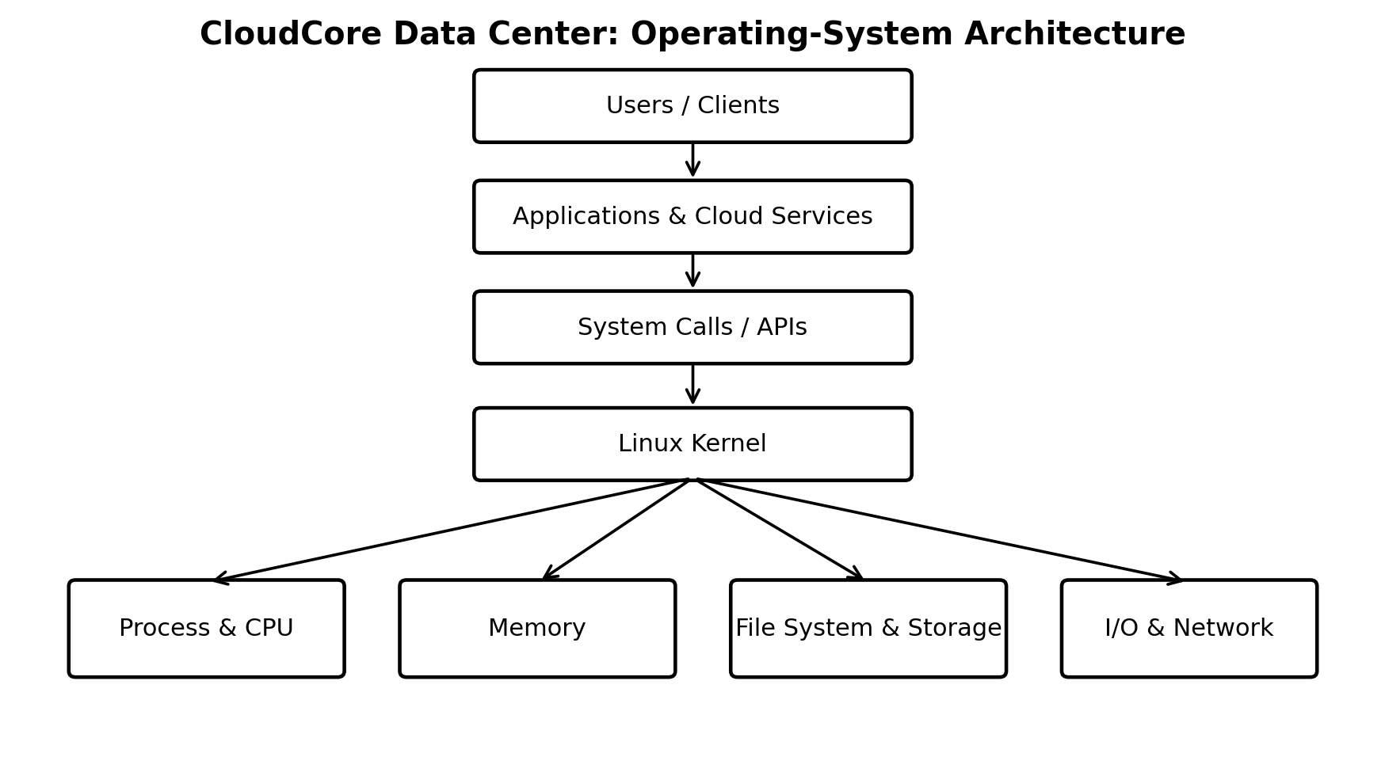

The design of CloudCore is a good fit because it needs to be both efficient and flexible. This is important because a server can be running multiple services all at once, and the hardware can vary depending on the role of the server. The modular design makes it possible to manage drivers and kernel features in a way that's tailored to each machine, rather than having one fixed configuration that applies to every server. This approach also allows for security and resource controls to be applied in a more targeted way, both at the kernel level and at the service level, which helps to keep everything running smoothly and securely.

4.1.1.1 System Calls, APIs and User–Kernel Mode Transitions
Applications normally do not access hardware directly. Instead, they use APIs and system calls to request services from the operating system.
For example, an application may use a system call to:
i. Create a process
ii.Open a file
iii.Read or write data
iv. Allocate memory
v. Communicate with a device
Modern operating systems use two main execution modes: user mode and kernel mode.Applications normally execute in user mode, where access to sensitive system resources is restricted. When an application needs a service controlled by the operating system, it makes a system call. Control is then transferred to the kernel.
The kernel acts as a middleman, checking what the application needs, doing the necessary work, and then giving the result back to the application. This helps keep everything safe by preventing an application from messing with the operating system or other applications directly.
The CloudCore operating system has design goals to make sure it works well in cloud environments:
i. Performance: Finish tasks fast. With little extra work as possible.
ii. Resource efficiency: Use CPU, memory, storage and network resources carefully and properly.
iii. Security: Control who can access things and keep users and services separate, from each other.
iv. Reliability: Spot problems early. Fix them whenever possible.
v. Scalability: Manage work as the system grows or more people use it.
vi. Maintainability: Make the system easier to change watch and fix when issues happen.

5. BANDWIDTH AND SYSTEM PERFORMANCE

5.1 Performance Requirements and Bottlenecks
CloudCore's overall performance depends on CPU, memory, storage, and network resources working together. For instance, a website might have more than enough processing power, but it still takes forever to load because it's waiting for the database to catch up. Similarly, backing up your files might go smoothly on your storage system, but it can still cause a traffic jam on your network. This is because different parts of your system can affect how well it performs overall. If one part is slow, it can hold up the whole process, even if other parts are working just fine.
Important performance measurements include:
i. CPU utilization
ii. Memory usage
iii. Response time
iv. Page faults
v. Storage latency
vi. I/O wait
vii. Network traffic
viii. Packet loss
ix. Service availability
CloudCore should establish normal operating ranges for these measurements and generate alerts when resource usage remains unusually high.
Common bottlenecks include:
i. Insufficient RAM
ii. CPU contention
iii. Slow storage
iv. Network congestion
v. Excessive virtual-machine activity
vi. Excessive context switching
Resource limits and appropriate scheduling can reduce competition between workloads.

5.1.1 Performance Optimization and Power Trade-offs
CloudCore should improve the resource that is actually causing the bottleneck.
For example:
i. Additional RAM can help when memory is insufficient.
ii. Faster SSDs can improve storage performance.
iii. Additional network capacity can reduce network congestion.
iv. CPU upgrades can help when processor utilization remains consistently high.
Power consumption should also be considered. Running all servers at maximum performance all the time can increase electricity and cooling costs.
When things are quiet, CloudCore can bring workloads together using virtualization and cut back on using resources that aren't needed. But it's still important to have enough capacity available for critical services and unexpected spikes in demand. This way, CloudCore can make sure everything runs smoothly and efficiently, even when things get busy. By doing this, it can help prevent problems and make sure important services are always available.

6.PROCESS AND CPU MANAGEMENT

6.1 Processes, PCB, Creation and State Transitions
A program that's currently running is called a process. This process has its own state and it uses resources that the operating system provides. At CloudCore, these processes can be used for a variety of things like powering web services, databases, monitoring, backups, virtualization, and administration. The operating system is in charge of managing these processes, which includes creating them, scheduling them, suspending them, resuming them, and terminating them when they're no longer needed, as explained by Silberschatz and his team in their 2018 research.
The Process Control Block (PCB) keeps information about a process. The PCB holds the process ID, current state, program counter, CPU registers, scheduling data, memory data and accounting data. During a context switch, the operating system saves the data of the process and loads the data of the next process (Silberschatz et al., 2018).
A process normally moves through several states:
New → Ready → Running → Waiting → Ready → Running → Terminated
A new process enters the system while a ready process waits for the CPU. A running process carries out instructions. If a process needs I/O, the process moves to the waiting state. It comes back to the ready state when I/O finishes. After a process finishes its work, the process enters the terminated state.
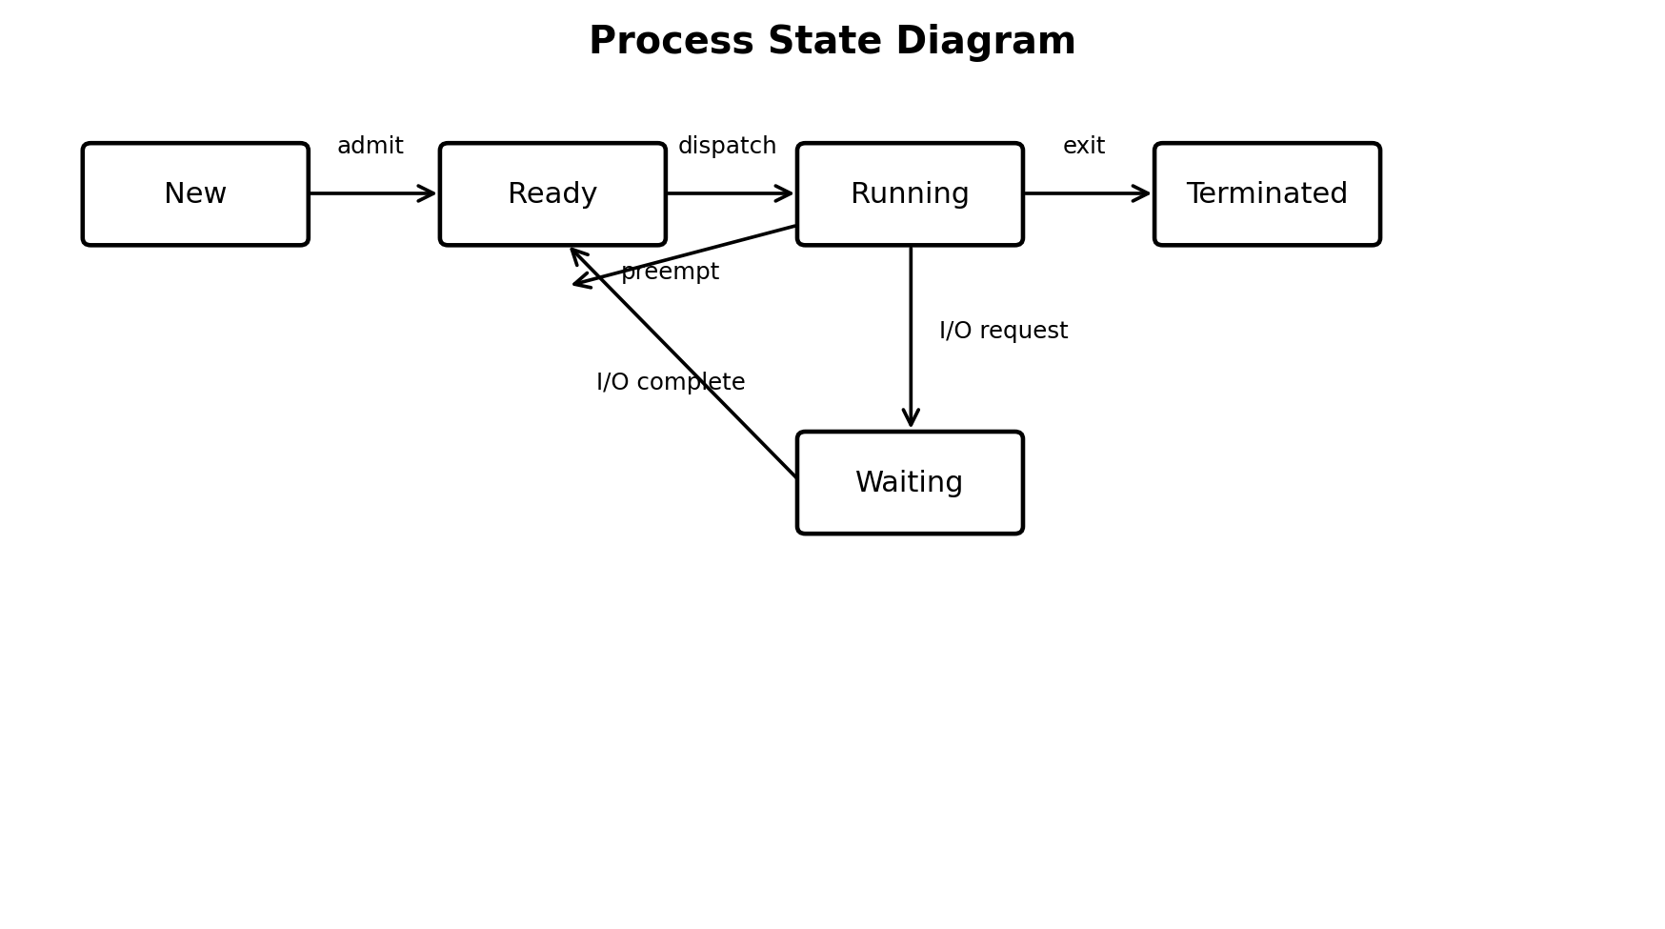

6.1.1 Schedulers, Queues and Context Switching
The ready queue has processes that are waiting for CPU time. The scheduler decides which process runs next based on the scheduling policy. The short-term scheduler makes decisions, while the long-term scheduler controls how many processes enter the system. Context switching happens when the operating system saves one process and loads another. Context switching helps with multitasking. It uses some CPU time.

6.1.1.1 CPU Scheduling Analysis
Two common scheduling algorithms are First-Come, First-Served (FCFS) and Round Robin (RR).
FCFS executes processes in the order they arrive. It is simple, but a long process can make shorter processes wait for a long time.
Round Robin gives each process a fixed time quantum. It is more suitable for interactive and time-sharing systems.
For this analysis, consider the following processes:
Process | Arrival Time | Burst Time
P1 | 0 | 8
P2 | 1 | 4
P3 | 2 | 6
P4 | 3 | 3
FCFS Scheduling
The execution order is:
P1 → P2 → P3 → P4
Process | Arrival | Burst | Completion | Waiting | Turnaround
P1 | 0 | 8 | 8 | 0 | 8
P2 | 1 | 4 | 12 | 7 | 11
P3 | 2 | 6 | 18 | 10 | 16
P4 | 3 | 3 | 21 | 15 | 18
Average |  |  |  | 8 | 13.25
Waiting time:
Waiting Time = Completion Time − Arrival Time − Burst Time
Turnaround time:
Turnaround Time = Completion Time − Arrival Time
Therefore:
Average Waiting Time = 8 time units
Average Turnaround Time = 13.25 time units
Round Robin Scheduling
For Round Robin, the time quantum is 3 time units.
The execution sequence is:
P1 → P2 → P3 → P4 → P1 → P2 → P3 → P1
The completion times are:
P4 = 12
P2 = 16
P3 = 19
P1 = 21
For this workload:
Average Waiting Time = 10.25 time units
Average Turnaround Time = 15.5 time units
The result shows that FCFS gives better average waiting and turnaround times for this particular workload. However, Round Robin provides more regular CPU opportunities to each process and is therefore more appropriate for interactive and time-sharing workloads.

7. Recommended Scheduling Approach
CloudCore should not depend on FCFS alone because the data center has several different types of workloads.
For general services, a fair time-sharing scheduling approach is more appropriate. Long-running applications should not be allowed to continuously occupy CPU resources while other services are waiting.
CloudCore should therefore use:
i. Fair CPU scheduling
ii. Appropriate process priorities
iii. Resource limits
iv. Separate handling of heavy batch workloads
v. Monitoring of CPU utilization
FCFS can still be useful for simple batch-processing workloads, but interactive services should receive fair CPU access.
This approach can improve responsiveness while preventing one workload from consuming an unreasonable amount of CPU resources.

8. THREAD MANAGEMENT

8.1 Processes Versus Threads
A process provides an execution environment, while a thread is a smaller unit of execution inside a process.Threads belonging to the same process share resources such as memory and files. Because of this, threads can communicate more quickly than separate processes. However, shared memory also creates the possibility of synchronization problems.
At CloudCore, multithreading can be useful for web servers, database services, monitoring systems, and other applications that need to handle many tasks at the same time.
For example, a web server can use different threads to process multiple client requests. On a multi-core processor, multiple threads can also execute in parallel.

8.1.1 Thread Models and Lifecycle
Threads can be managed at the user level or by the operating system kernel.
Common thread models include:
i. Many-to-one
ii. One-to-one
iii. Many-to-many
Each model provides different levels of parallelism and management overhead.
A thread normally moves through states such as:
Ready → Running → Waiting → Ready → Terminated
Thread libraries provide functions for creating, joining, synchronizing, and terminating threads.
Synchronization mechanisms such as mutexes and condition variables can be used to protect shared data.
Although multithreading can improve performance, creating too many threads can increase context switching and synchronization overhead. CloudCore should therefore select the number of threads according to workload and available CPU and memory resources.

9. DEADLOCK MANAGEMENT

9.1 Deadlock Conditions and Resource-Allocation Model
A deadlock happens when processes or threads wait for resources held by each other and cannot continue. Four conditions are required: mutual exclusion, hold and wait, no preemption, and circular wait (Silberschatz et al., 2018).
i. Mutual exclusion: A resource cannot be shared at the same time.
ii. Hold and wait: A process holds one resource while waiting for another.
iii. No preemption: A resource cannot be taken from a process forcefully.
iv. Circular wait: Each process waits for a resource held by another process in a chain.
For instance, consider a scenario where Process 1 is holding onto Resource 2 and waiting for Resource 1, while Process 2 has control of Resource 1 and is waiting for Resource 2. In this situation, neither process can proceed because each is waiting for a resource held by the other. This creates a deadlock, which can bring services to a halt and decrease the overall availability of the system. It's crucial for CloudCore to identify and manage such situations to prevent deadlocks from occurring and minimize their impact on system performance.

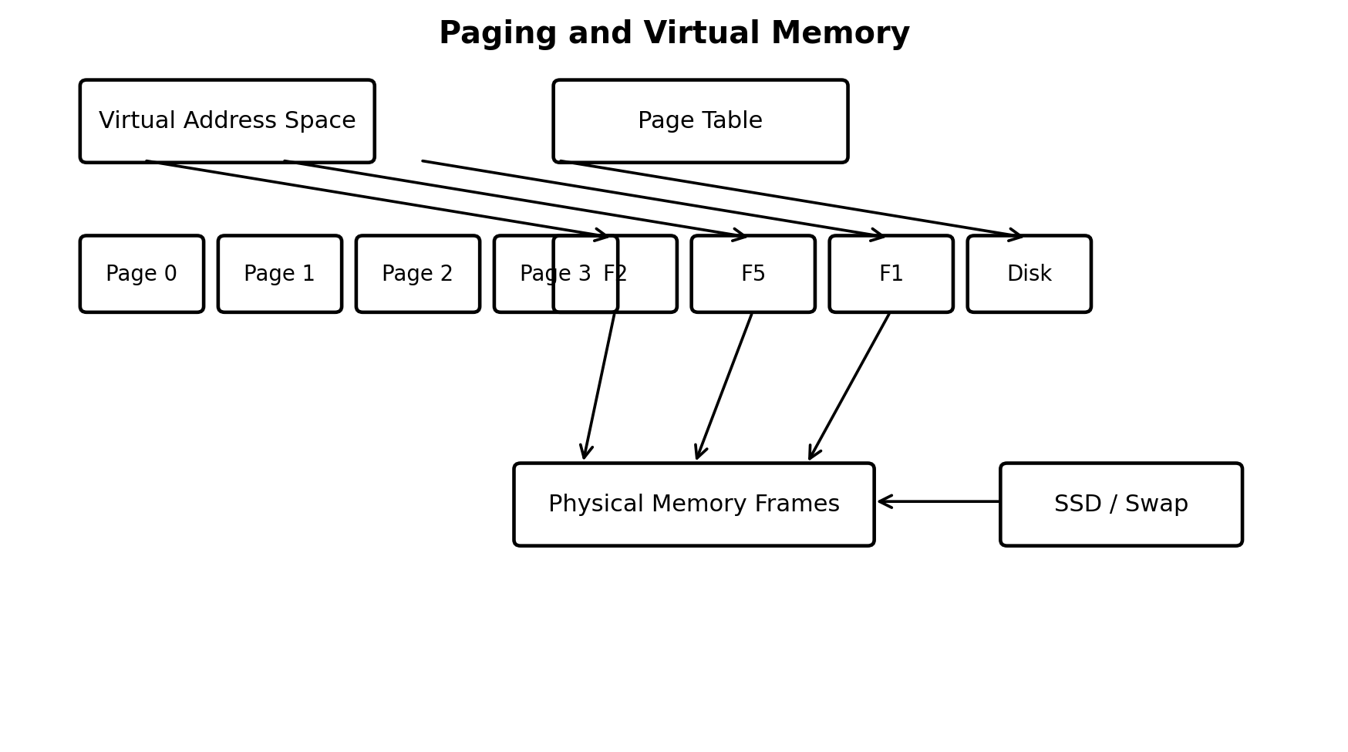

9.1.1 Swapping, Relocation and Copy-on-Write
Swapping moves data between RAM and storage when memory is limited. Relocation allows processes to operate correctly even when their physical memory locations change.
Copy-on-write allows processes to share memory pages until one of them needs to modify a page. This can reduce unnecessary memory usage.
CloudCore should avoid excessive swapping because storage is significantly slower than RAM. Sufficient physical memory and proper monitoring can reduce the risk of paging and thrashing.

10. VIRTUAL MEMORY

10.1 Demand Paging and Page-Fault Handling
Demand paging loads pages into RAM when needed. If a page is missing, a page fault occurs. The operating system loads it from storage (Silberschatz et al., 2018).
FIFO replaces the oldest page. LRU replaces the least recently used page. Optimal replaces the page needed farthest in the future. Clock provides an approximation of LRU.

10.1.1 Page-Replacement Analysis
The reference string is 1, 2, 3, 1, 4, 2, 5, 1, 2, 3. There are 3 frames. FIFO and LRU both produce 8 page faults for this example. Different reference strings can give different results.
Reference | FIFO Frames | Fault | LRU Frames | Fault
1 | 1 - - | Yes | 1 - - | Yes
2 | 1 2 - | Yes | 1 2 - | Yes
3 | 1 2 3 | Yes | 1 2 3 | Yes
1 | 1 2 3 | No | 1 2 3 | No
4 | 4 2 3 | Yes | 1 4 3 | Yes
2 | 4 2 3 | No | 1 4 2 | Yes
5 | 4 5 3 | Yes | 5 4 2 | Yes
1 | 4 5 1 | Yes | 5 1 2 | Yes
2 | 2 5 1 | Yes | 5 1 2 | No
3 | 2 3 1 | Yes | 3 1 2 | Yes
Total |  | 8 |  | 8

To keep your system running smoothly, it's a good idea for CloudCore to store frequently used pages in memory. This way, it can cut down on page faults, which can slow things down. Using techniques like LRU, or Least Recently Used, can help with this. Having enough RAM is also important, as it can prevent heavy paging from happening in the first place. By doing so, CloudCore can ensure that your system is working efficiently and effectively.

10.1.1 Thrashing and Frame Allocation
Thrashing happens when the system spends much time moving pages between RAM and storage instead of getting work done. It can happen because there is not enough RAM, too many processes are running, or the memory allocation is not good (Silberschatz et al., 2018).
CloudCore can help reduce thrashing by limiting the number of virtual machines, keeping an eye on page faults and swapping, and adding more RAM when it is needed.

11. MEMORY MANAGEMENT

11.1 Memory Management in CloudCore
Memory management is a crucial part of what the operating system does, especially since CloudCore servers have to run a lot of different things all at once, like web apps, databases, virtual machines, and backup systems. The operating system has to make sure it gives each process the right amount of memory, so that everything runs smoothly and doesn't interfere with anything else. This way, each process can get the memory it needs without slowing down other processes. The operating system has to balance everything out, so that all the different services and applications can run together without any problems.
Each CloudCore server is proposed to have 128 GB of RAM. This memory is shared among the operating system, applications, databases, virtual machines, and file caching.
The Linux-based operating system manages memory by allocating memory to processes, maintaining virtual address spaces, handling paging, and reclaiming memory when required. Virtualization also allows memory resources to be assigned to different virtual machines according to their workload.

11.1.1 Memory Allocation and Protection
CloudCore should use virtual memory so that each process has its own logical address space. This provides isolation between processes and prevents one application from directly accessing another application's memory.
Memory protection is especially important in a data center because many services and virtual machines may run simultaneously. If one process fails, memory isolation helps prevent the failure from affecting other processes.
The operating system needs to keep an eye on how much memory is being used and find out which processes or virtual machines are using too much of it. This helps administrators make changes to resource limits before the server gets too busy and slows down. By doing this, they can prevent the server from running out of memory and make sure it keeps working smoothly.

11.1.2 Paging and Swapping
CloudCore uses virtual memory to allow programs to operate even when their complete memory requirements cannot remain in RAM. Paging divides memory into fixed-size pages and loads required pages into physical memory.
When a program needs a page that's not already in memory, something called a page fault happens. At this point, the operating system jumps in and fetches the needed page from storage, then puts it into memory so the program can keep running. This process helps the computer keep running smoothly, even when it needs to access pages that aren't currently in memory.
Swapping moves data between RAM and storage when memory becomes limited. However, CloudCore should avoid excessive swapping because storage is slower than RAM. The project therefore recommends having sufficient physical memory and continuously monitoring memory usage.

11.1.3 Page Replacement
When the computer's memory is completely used up, the operating system has to make some space by getting rid of a page that's already open and replacing it with a new one that's needed. There are a few common ways that the operating system decides which page to get rid of, including:
i. FIFO: Replaces the page that has been in memory for the longest time.
ii. LRU: Replaces the page that has not been used for the longest period.
iii. Optimal: Replaces the page that will not be needed for the longest time in the future.
iv. Clock: Provides an approximation of LRU.
For the CloudCore example, the reference string 1, 2, 3, 1, 4, 2, 5, 1, 2, 3 with three frames produces 8 page faults for both FIFO and LRU.
For CloudCore, LRU is a practical choice because frequently used pages can remain in memory while less recently used pages can be replaced.

12. FILE-SYSTEM MANAGEMENT

12.1 File Abstraction, Operations and Directories
A file is a named group of data that the operating system takes care of. Common actions include create, open, read, write, close, rename, and delete. CloudCore uses files for applications, databases, logs, and backups (Silberschatz et al., 2018).
Sequential access reads data one after another, while direct access gets to specific data quickly. Indexed access uses an index to find data efficiently.
Directories help arrange files in a structure. Linux-style directories help keep applications, configuration, data, and logs separate. Mounting connects file systems to directories and helps manage storage.

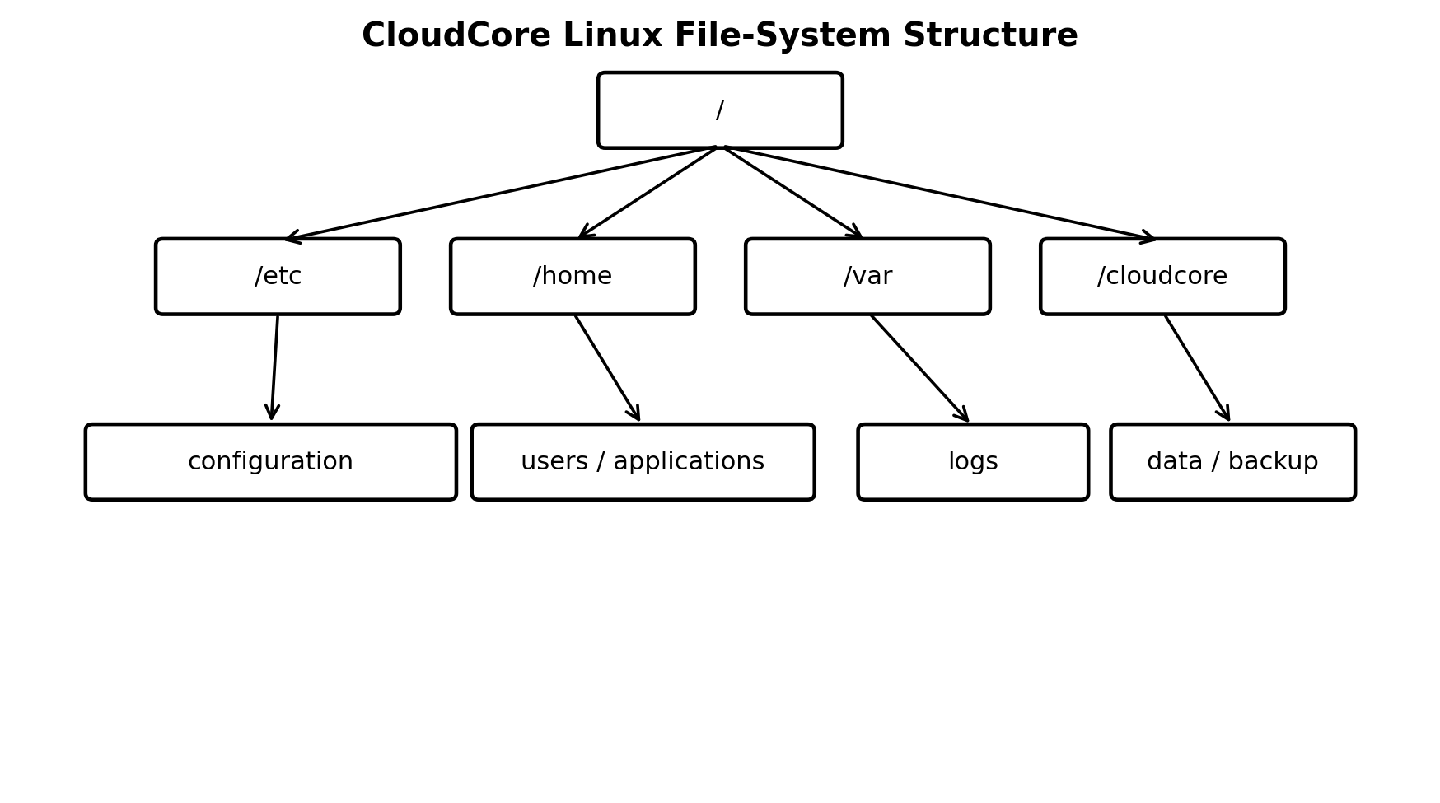

12.1.1 File Allocation and Free-Space Management
Contiguous allocation gives good performance but can cause fragmentation. Linked allocation avoids fragmentation but has slower direct access. Indexed allocation supports direct access and is suitable for CloudCore (Tanenbaum & Bos, 2015).CloudCore should use indexed allocation, proper free-space management, backups, journaling, and monitoring to improve reliability,

13. DISK MANAGEMENT

13.1 Disk Structure, Formatting and Reliability
Traditional disks use platters, tracks, sectors, and moving heads. SSDs are common in data centers and have no moving heads. Storage should be monitored for errors and bad blocks (Stallings, 2018).

13.1.1 Disk Scheduling Algorithms
Common methods are FCFS, SSTF, SCAN, C-SCAN, LOOK, and C-LOOK. FCFS is simple but may cause more movement, while SSTF usually reduces movement but may make some requests wait longer.

13.1.1.1 Disk-Scheduling Calculation
The initial head position is 50 and the request queue is 82, 170, 43, 140, 24, 16, 190. Under FCFS, the path is 50 → 82 → 170 → 43 → 140 → 24 → 16 → 190. The total movement is 32 + 88 + 127 + 97 + 116 + 8 + 174 = 642 cylinders.
Under SSTF, the closest pending request is selected at each step. The path is 50 → 43 → 24 → 16 → 82 → 140 → 170 → 1
Algorithm | Service Sequence | Total Head Movement
FCFS | 50 → 82 → 170 → 43 → 140 → 24 → 16 → 190 | 642 cylinders
SSTF | 50 → 43 → 24 → 16 → 82 → 140 → 170 → 190 | 208 cylinders
90. The movement is 7 + 19 + 8 + 66 + 58 + 30 + 20 = 208 cylinders.
For this workload, Shortest Seek Time First (SSTF) reduces head movement compared with First-Come, First-Served (FCFS). However, CloudCore mainly uses Solid-State Drives (SSDs), so the focus should be on latency, throughput, fairness, and efficient queue management.

13.1.1.1.1 DMA, Buffering, Caching, and Spooling
Direct Memory Access (DMA) transfers data between devices and memory with less CPU involvement. Buffering temporarily stores data, while caching keeps frequently used data for faster access. Spooling queues tasks for processing (Stallings, 2018).CloudCore should use DMA and interrupt-driven I/O for high-volume operations

14. I/O and Device Management
I/O (Input/Output) and device management is an important function of an operating system. It manages communication between the CPU, memory, storage devices, network devices, and other hardware. In a data center, efficient I/O management is necessary because servers handle many storage, network, database, and backup operations at the same time.

14.1 I/O Management
The operating system uses device drivers to communicate with hardware devices and manages I/O requests from different processes. At CloudCore Data Center, I/O management is required for database operations, file storage, backups, network communication, and virtual machines. The operating system must manage multiple requests efficiently so that heavy I/O activity from one service does not significantly affect other services.
Direct Memory Access (DMA) allows devices to transfer data directly to main memory with limited CPU involvement. The CPU starts the transfer, while the DMA controller manages the movement of data. This reduces CPU overhead and allows the processor to perform other tasks. CloudCore can use DMA for high-volume storage and network transfers to improve CPU utilization and overall system efficiency.

14.1.1 Buffering, Caching, and Spooling
Buffering temporarily stores data during transfers between devices operating at different speeds. Caching keeps frequently accessed data in faster memory so that it can be accessed more quickly. Spooling stores I/O requests in a queue until the required device becomes available. These techniques help CloudCore handle multiple I/O operations efficiently and reduce delays.
Interrupt-driven I/O allows a device to notify the CPU when an I/O operation requires attention or has been completed. This prevents the CPU from continuously checking the status of devices and allows it to perform other tasks. CloudCore can use interrupt-driven I/O together with DMA to reduce CPU overhead and improve server responsiveness.
Overall, effective I/O and device management helps CloudCore improve resource utilization, reduce delays, and support reliable operation of its data-center services.

15. INTEGRATED OPERATING-SYSTEM DESIGN

15.1 Integrated CloudCore Solution
CloudCore's operating-system components work together to manage the complete data-center environment. Applications communicate with the operating system through APIs and system calls, while the kernel manages processes, memory, storage, file systems, networking, and I/O devices. Security controls are applied to protect users, services, and stored information.
The proposed design uses Linux servers with virtualization to manage different workloads efficiently. Web applications, databases, monitoring services, and other workloads can run in separate virtual machines. CPU and memory limits can be assigned to virtual machines to prevent a single workload from consuming excessive resources. SSD storage provides fast access for active applications and databases, while backup storage protects important data.
Monitoring is also included in the design. CPU utilization, memory usage, storage latency, network traffic, page faults, and service availability should be monitored regularly. This allows administrators to identify performance problems and make resource adjustments before services are affected.

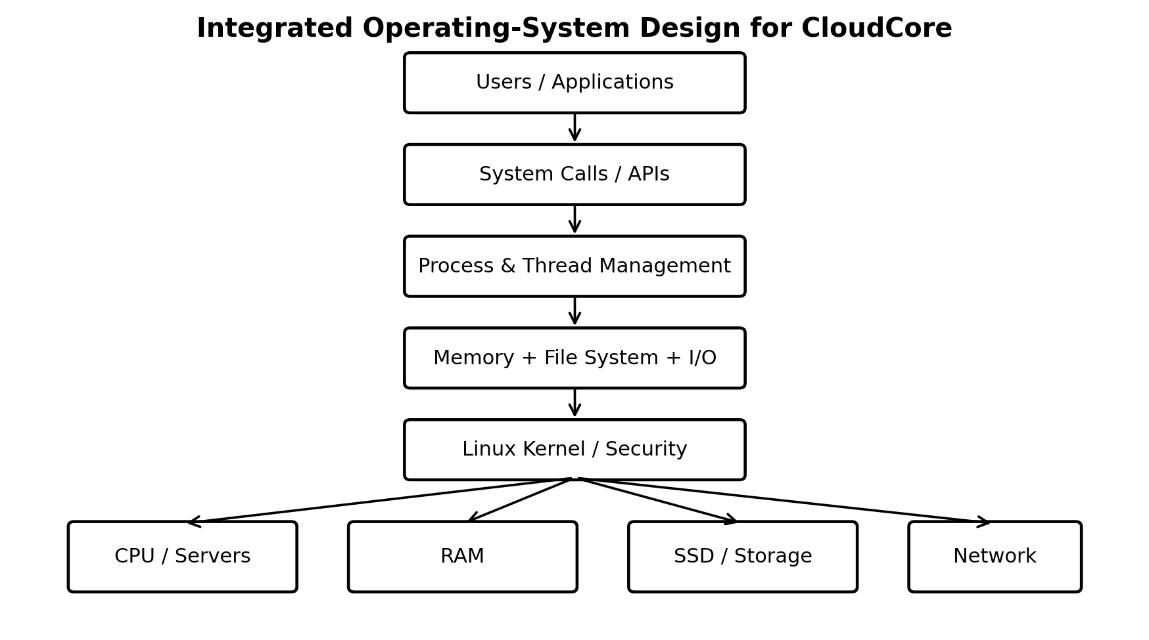
I like how this design uses Linux servers with virtualization to manage workloads. Different services can run in virtual machines with CPU and memory limits to prevent overuse of resources. SSDs provide fast storage, while backups keep important data safe.

15.1.1 Design Justification
The proposed design is suitable for CloudCore because it provides performance, flexibility, security, and scalability. Linux provides strong resource-management and networking features, while virtualization allows multiple workloads to share physical hardware. Resource limits and scheduling policies help prevent individual workloads from affecting the entire system.
The design can also grow with future demand. CloudCore can add physical servers, increase RAM or storage, and expand network capacity when workloads increase. Backup, monitoring, redundancy, and security controls further improve reliability and availability.
servers. Linux provides system-management features, while virtualization and monitoring help keep the system running well. More servers can be added when demand grows.

16. CRITICAL EVALUATION

16.1 Performance and Resource Utilization
CloudCore's performance depends on the effective use of CPU, memory, storage, and network resources. Monitoring these resources can help identify bottlenecks and prevent server overload. Fair CPU scheduling, sufficient RAM, SSD storage, and efficient I/O management can improve the responsiveness of applications and services.

16.1.1 Security, Reliability, and Availability
Security is supported through user permissions, authentication, isolation, logging, firewall protection, and regular security updates. Backups and monitoring improve reliability by helping administrators recover from failures. Using multiple servers reduces dependence on a single server and allows services to continue operating when one server becomes unavailable.
Scalability, Maintainability, and Power
Virtualization makes CloudCore easier to scale because additional workloads can be deployed without requiring a separate physical server for every service. However, increasing the number of servers also increases power, cooling, and maintenance requirements. CloudCore should therefore monitor capacity and consolidate workloads when possible without affecting performance.

16.1.1.1 Strengths, Limitations and Future Improvements
Area | Strength | Limitation / Risk | Improvement
Architecture | Flexible Linux modular design | Configuration complexity | Standardize server images and configurations
CPU | Fair scheduling supports mixed workloads | Context-switch overhead and contention | Use priorities and workload limits
Memory | Paging provides flexible address spaces | Excessive paging reduces performance | Add RAM and monitor memory pressure
Storage | SSD improves active-workload latency | Higher cost and finite capacity | Tier storage and plan capacity
Security | Strong permissions and controls | Misconfiguration remains possible | Regular audits, updates and least privilege
Availability | Multiple servers reduce single points of failure | Higher infrastructure cost | Use redundancy and tested recovery
Scalability | Servers and virtual machines can be added | Power, space and network constraints | Plan capacity before saturation

Future improvement should include real or simulated CloudCore workload testing. This will give performance data when comparing CloudCore scheduling, memory, storage and network policies.

17. RECOMMENDATIONS AND CONCLUSION

17.1 Recommendations
CloudCore should use Linux servers and continuously monitor CloudCore system performance. CloudCore should:
i. Use fair CPU. Enough RAM.
ii. Use SSDs for workloads and regular backups.
iii. Apply security controls and regular updates.
iv. Distribute services across multiple servers.
v. Monitor CloudCore resources. Add capacity before overload occurs.

17.1.1 Project Work Plan
The project covers requirement analysis, research, design, analysis, evaluation, documentation, review and submission. The timeline can be adjusted to the project dates.
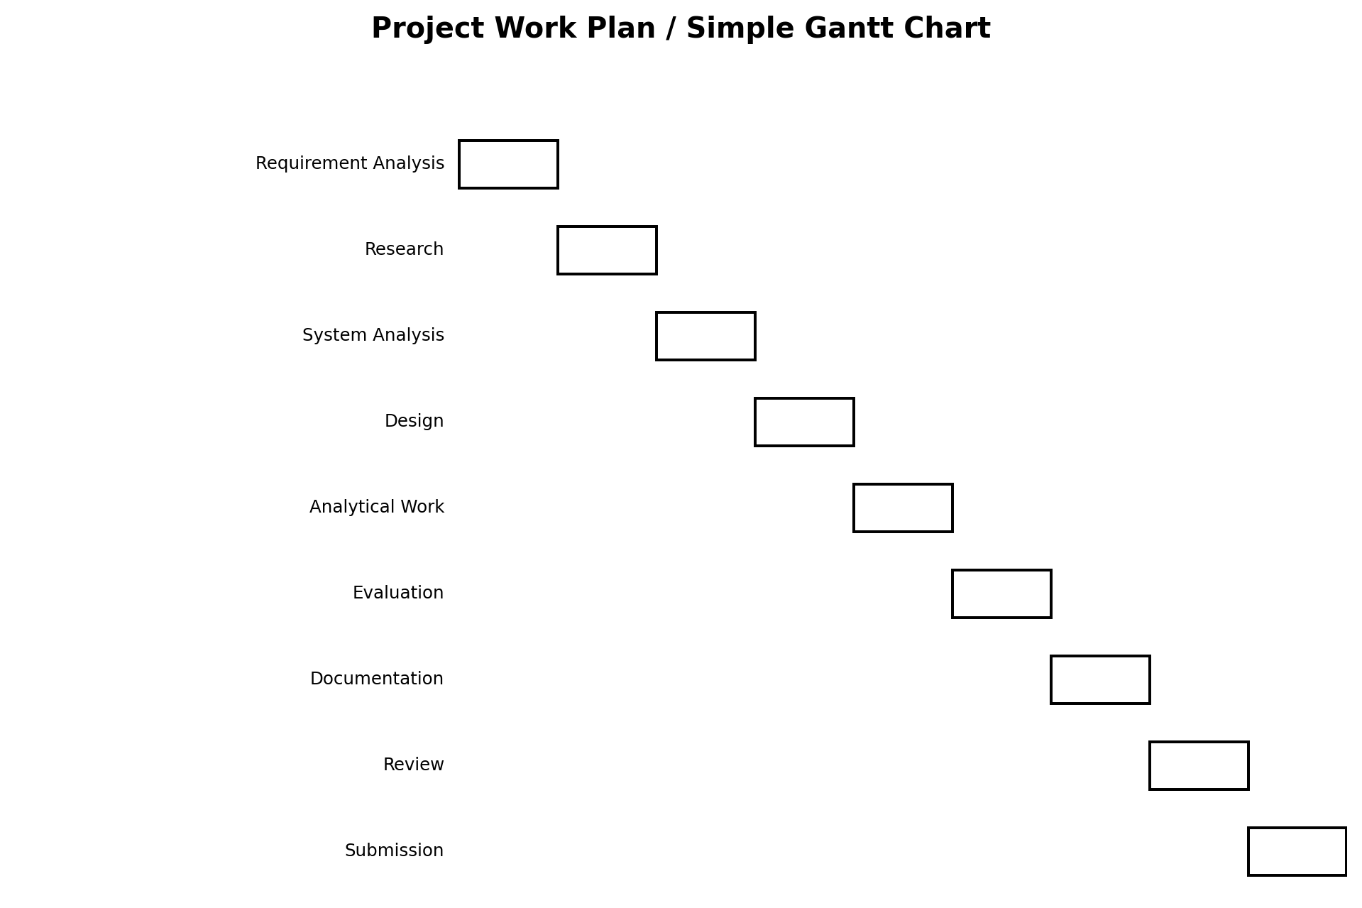

18. Conclusion
This project looked at and built an operating-system solution for the CloudCore Data Center. It explored OS architecture, resource management, CPU and process management, memory and virtual memory, file systems, disk handling, I/O, security, reliability, scalability, and power control.
The analysis shows that different OS techniques are useful for different workloads. FCFS is simple, while Round Robin provides better time-sharing. The Banker's Algorithm helps keep resources in a safe state. FIFO and LRU gave similar results in the example. SSTF reduced disk head movement compared with FCFS, although SSDs require different performance considerations.
The final design combines Linux, virtualization, fair scheduling, efficient memory and I/O management, security, monitoring, backups, and redundancy. This gives CloudCore a scalable operating-system solution.

18.1 Summary of Findings
i. CloudCore needs an operating system that can handle changing workloads.
ii. Linux offers flexibility, security, performance, and maintainability.
iii. CPU, memory, storage, and I/O should be managed together.
iv. Deadlock control needs practical methods.
v. Security, reliability, and scalability should be planned from the start.
vi. Monitoring and capacity planning are vital for future growth.

19.REFERENCES
Arpaci-Dusseau, R. H., & Arpaci-Dusseau, A. C. (2018). Operating systems: Three easy pieces. Arpaci-Dusseau Books.
Love, R. (2010). Linux kernel development (3rd ed.). Addison-Wesley.
Silberschatz, A., Galvin, P. B., & Gagne, G. (2018). Operating system concepts (10th ed.). Wiley.
Stallings, W. (2018). Operating systems: Internals and design principles (9th ed.). Pearson.
Tanenbaum, A. S., & Bos, H. (2015). Modern operating systems (4th ed.). Pearson.

