

**SCHOOL**

**OF**

**NATURAL**

**AND**

**SOCIAL**

**SCIENCES**

**DEPARTMENT**

**OF**

**COMPUTER**

**SCIENCE AND**

**INFORMATION**

**TECHNOLOGY**

***PROJECT TITLE***

***:***

***EMPLOYEES PERFOMANCE EVALUAT***

***ION***

**STUDENT**

**NAME:**

**YAMUNGU NYABENDA JOHN**

**STUDENT**

**REG NO: BITAM/9/21/015**

**/TZ**

**COURSE CODE: INF**

**-**

**CSS 2215**

**COURSE TITLE:**

**WEB APPLICATION**

**LECTURE NAME: MR. MASOUD HAMAD**

**YEAR: 2022/2023**



# PROJECT TITLE :EMPLOYEES PERFORMANCE E VALUATION INTRODUCTION

Web-based systems are living systems. They rapidly evolve in their functionality, scope, content and use. An employee performance evaluation, also known as a “performance review” is **a process used by organizations to give employees feedback on their job performance and formally document that performance**. Although companies determine their own evaluation cycles, most conduct employee performance evaluations once per year.

An employee's job performance has a significant impact on their longevity and upward mobility within an organization as well as prospective job opportunities with other organizations.

Companies use employee performance evaluations as a tool to document an employee's performance over time.

Being informed about the evaluation’s potential benefits helps to ensure that the process is a

positive one. In this article, we describe what an employee performance evaluation is, its benefits

and how to prepare for one.

# RELATIONAL

Employee performance evaluations have many potential benefits for employees and employers alike.

 **For employers**

A few of the benefits of evaluations for employers include:

# Protection against litigation

In situations where current or former employees are pursuing legal action against a company, having clear documentation of that employee's performance is very important. This is especially relevant in situations where an employee is terminated or turned down for a promotion. In these cases, the performance evaluation can serve as objective evidence that confirms the company's decision-making.

# Encouragement of good work

With the busy pace of many organizations, an employee performance evaluation may be one of only a few times that employers give structured positive feedback and reinforcement to their employees. Doing so boosts employee morale, shows them what to continue doing and helps build a positive relationship between the employer and employee. This can help minimize employee turnover as employees identify clear ways that their work is valued and valuable.

# Informing hiring practices

Employee performance evaluations, when considered in totality, can offer valuable insight into past recruitment and/or hiring practices and inform future practices. For example, if a company notices a trend in employees having underdeveloped skills in a certain area, they can add additional screening items for that skill set to their hiring process. Assessing the number of people who are likely to be retained and the number likely to be let go as a result of their evaluation informs the extent and nature of recruitment necessary to rehire.

 **For employees**

A few of the benefits of employee performance evaluations for employees include:

# Growth and development

Employee performance evaluations provide a dedicated time for managers to focus on individual performance and growth and development opportunities. This is an ideal time for employees to discuss their salary, career goals and learn what they need to do to achieve those goals. By identifying areas of strength and areas for improvement, employers and employees can develop a growth plan that expands the employee's skills and benefits the company. This can open doors to the advancement and attainment of long-term career goals.

# Senior leadership visibility

There may be members of senior-level management that are not easily accessible and do not have frequent interaction with employees. The performance evaluation process can provide insight into these leaders about the workforce including who the top performers are and where to support promotional opportunities.

# Potential for a pay increase and/or bonus

In certain companies, merit-based pay increases and/or bonuses are issued to employees who perform well on evaluations. A strong performance evaluation may also lead to opportunities for advancement within the company. This can include formal advancement through a promotion or assignment of leadership responsibilities.

# Improved communication

The structured nature of an employee performance evaluation lends itself to productive communication. For both positive reinforcement and constructive criticism, it has mechanisms to guide the conversation and provide very specific feedback. This can ease tensions when discussing something challenging. In some instances, this process opens the door to more meaningful communication outside of the evaluation process as well.

**OBJECTIVES**

# General Objectives

The main objective of performance appraisals is to design a web based system that will measure and improve the performance of employees and increase their future potential and value to the company. Other objectives include providing feedback, improving communication, understanding training needs, clarifying roles and responsibilities and determining how to allocate rewards.

· To identify the strengths and weaknesses of employees to place right men on right job.

· To maintain and assess the potential present in a person for further growth and development.

· To provide a feedback to employees regarding their performance and related status. · To provide a feedback to employees regarding their performance and related status. · It serves as a basis for influencing working habits of the employees.

# Challenges of the current Existing System

At present all above mentioned evaluation are done manually. Thus both the evaluators and supervisors have to fill in the evaluation forms and submit them to the office. It takes time to fill the forms and to get all the marks together.

The Current Existing system according to my research are mostly Traditional paper based system and some organization doesn’t have the system at all. This may lead to the following challenges:-

* **Low Quality Data:**

Many factors can affect the quality of data retrieved through in-class paper evaluations. Students may feel that their responses are not anonymous and worry that instructors can trace the feedback to them. They may feel their anonymity is compromised due to their writing or by the comments they divulge. This causes students to be less open and honest on their assessments. Other issues such as peer pressure and in class evaluation time limits can also negatively affect the quality of the data collected.

* **High Cost:**

A major disadvantage of using paper assessments is the high cost associated with the process. The number of personnel involved as well as the printing, distributing, scanning, rekeying, filing and archiving is very costly. When institutions move to an online system these significant costs can often be reduced by at least 50 percent.

 **Limited Flexibility:**

Using traditional paper-based assessments often does not allow for the customization of questions. The questions used may be standard, university set queries without instructors being able to add tailored course-specific questions. Using a paper-based process also doesn’t afford much flexibility in terms of the reports that can be generated for instructors and faculty. Standard reports are often used without the ability to present results differently, whether showing results over time or across multiple courses. **Length Process:**



The process of administering paper-based assessments is a lengthy one. It can take several months to complete the cycle from administering the forms to collecting and analyzing the results, to sharing reports and acting on the feedback obtained. As instructors do not receive results quickly, valuable time is lost in responding to student concerns and implementing possible course changes.

# Solution to current business operation

The solution for the current operation is implement a friendly web based system which help organization keep track of their employees performance and get user feedback and expectation. This system will overcome all the challenges facing the current system by providing solutions and adding more features to the system.

on the other hand, provides the advantages organizations seek in doing performance evaluation. But, performance management, when performed effectively and with the appropriate mindset, accomplishes the same goals, and more. Performance evaluation management also supplies additional advantages to both the manager and the employee. **DELIVERABLES**

Since goals, deliverables, and measurements are negotiated in an effective employee performance evaluation, the employee and the supervisor are committed to achieving them. The written personal development goals are a commitment from the organization to assist the employee to grow in their career.

Employee performance evaluation provides legal, ethical, and visible evidence that employees were actively involved in understanding the requirements of their jobs and their performance. The accompanying goal setting, performance feedback, and documentation ensure that employees understand their required outputs. The goal of employee performance evaluation is to create accurate appraisal documentation to protect both the employee and the employer. **FUNCTIONAL REQUIREMENTS**

1. The system should allow admin to register user the database.
2. The system should allow admin to ADD employee to the system.
3. The system should allow user to login.
4. The system should allow user to fill the evaluation form.
5. The system must allow user to edit his/her evaluation details.
6. The system must allow employee to view his/her own result.
7. The system must allow user to view his/her own result.
8. The system should allow user to fill the report evaluation form for the employees not supervised by him.
9. The system must allow manager to view employees evaluation results.
10. The system must store all Evaluation results in a database for future reference.
11. The system must allow Admin to remove non-existing employees on the system.
12. The system should allow user to submit his/her evaluation results.
13. The system should allow users to update the evaluation form.
14. The system should allow users to change their passwords.
15. The system should allow users to view their profiles.
16. The system must allow employees to view their profiles **17.**The system must allow employees to change their password.
17. The system must provide a user interface.
18. The system must allow employees to logout.
19. The system should allow user to logout.

# DEVELOPMENT METHOD

The method used to develop my web is Waterfall Software Development Life Cycle Model

**Advantages of waterfall model**

* Easy to explain to the user
* Stages and activities are well defined
* Helps to plan and schedule the project
* Verification at each stage ensures early detection of errors / misunderstanding

**Disadvantages of waterfall model**

* The model implies that you should attempt to complete a given stage before moving on to the next stage.

Does not account for the fact that requirement constantly (frequently) change. o Customers can not use anything until the entire system is complete.

* The model makes no allowances for prototyping

* It implies that you can get the requirements right by simply writing them.
* The model implies that once the product is finished, everything else is maintain

The reasons on why I decide to use this method are;

* Easy to explain to the user
* Stages and activities are well defined
* Helps to plan and schedule the project - Verification at each stage ensures early

detection of errors / misunderstanding

# ARCHITECTURE OF THE SYSTEM(PROCESS FLOW)

System architecture: For the system architecture, the 1-tier architecture model is the structure for our system. The other kind architecture that am going to use is the **Micro-services** architecture, The Micro-service architecture is the best structure for our system. Here is how the Micr0services architecture is incorporated into the system**.**

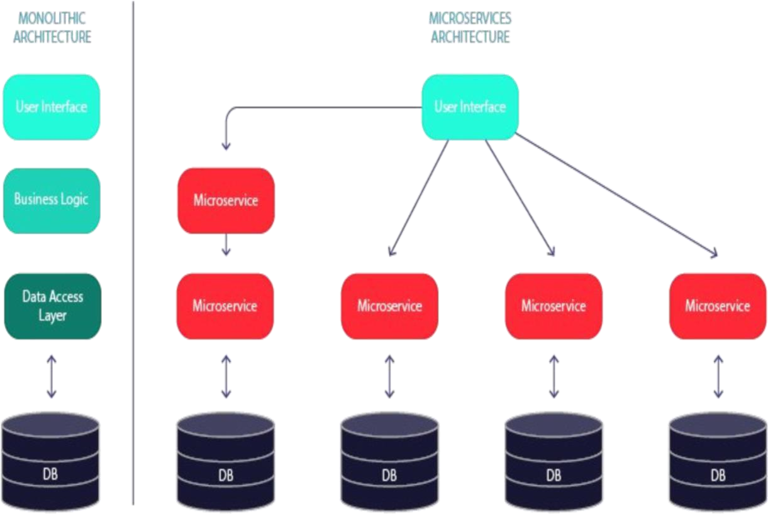

# ENTITY RELATION DIAGRAM & THEIR MAPPING

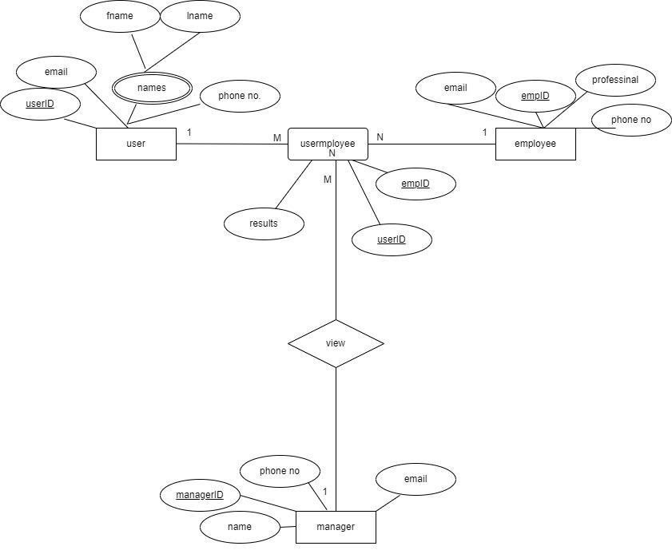

User(userID,Fname,Lname,email,phoneno.)

Customer(customerID,Fname,Lname,email,phoneno.)

Usermlpoyee(userID,customerID,status)

Manager(managerID,Fname,Lname,email,phoneno.)

# CLASS DIAGRAM

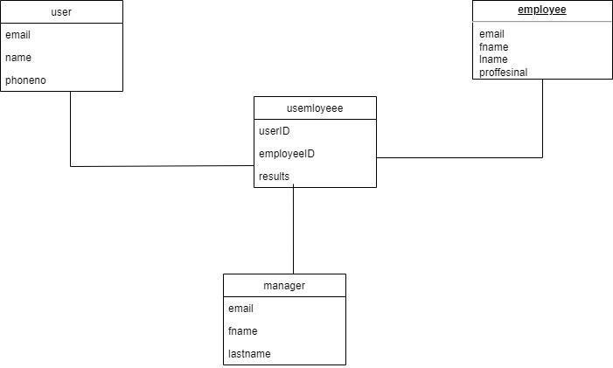

**ACTIVITY DIAGRAM**

**EMPLOYEE PERFORMANCE EVALUATION SYSTEM**

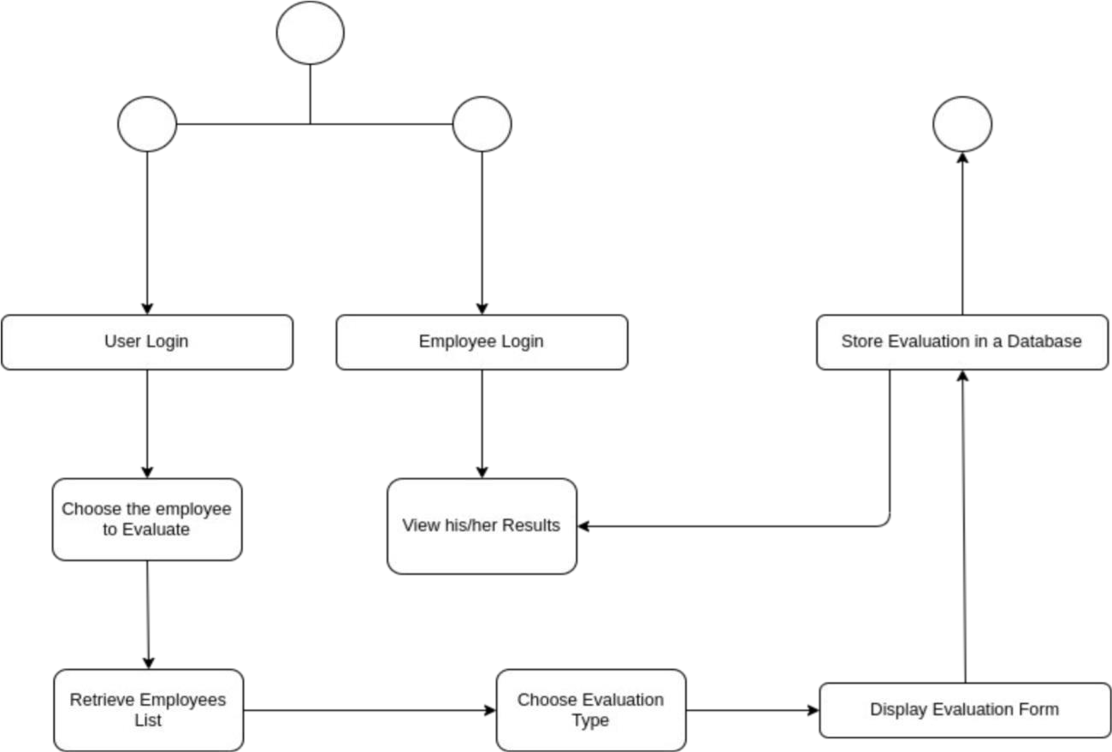



**CLASS DIAGRAM**

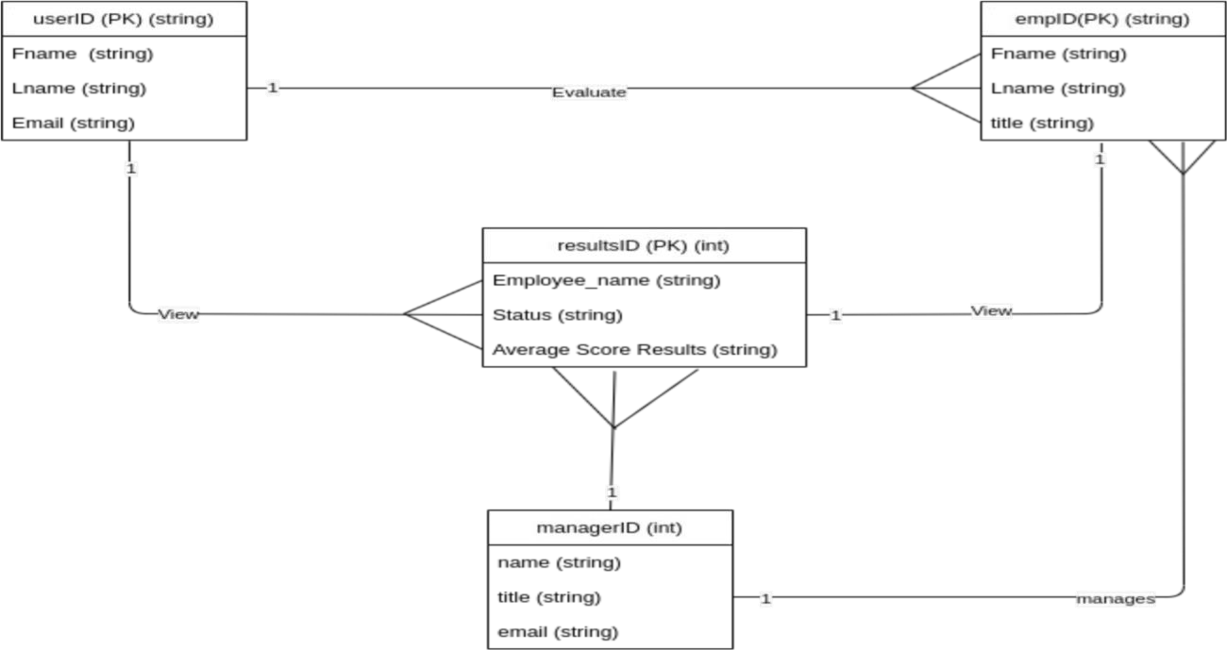

**USE CASE DIAGRAM**

**EMPLOYEE PERFORMANCE EVALUATION SYSTEM**

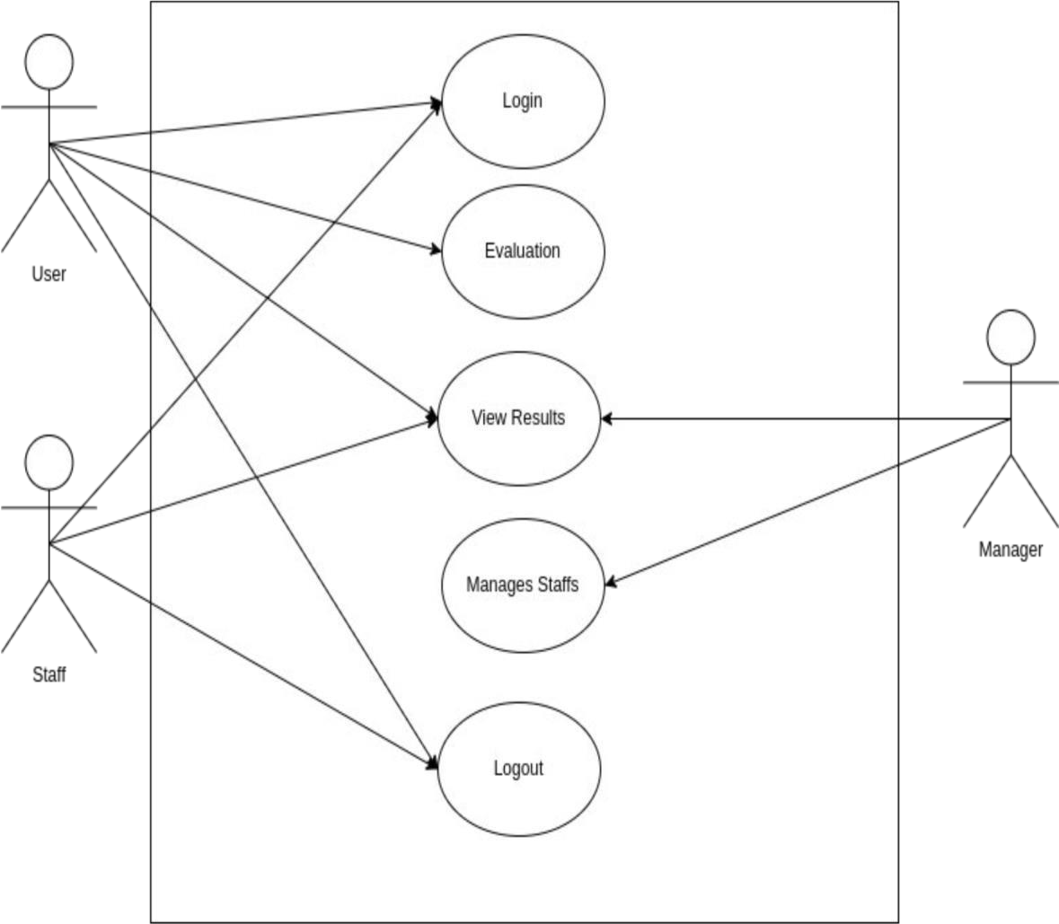

# DEVELOPMENT METHODS(METHODOLOGIES)

The development method that will be used is an **Agile methodology**. This is because the Development phase is the implementation of the Tentative Design. The implementation techniques will be different depending on the artifact to be created. In the Evaluation phase, the artifact is evaluated following the standards, which will be understood and clear in the Proposal. The results from evaluation is indicated the consideration of future work and used as feedback to another round of the Suggestion phase. The Conclusion phase is the last part of the design research methodology. The technology included will be as follows:-

**Languages** · **Html, css,python and Javascript (Front-end Development)** · **Angular (Javascript Framework) – Front-end Development.** · **Spring Boot (Back-end Development)**

**Databases:**

· **Postgresql (DBMS)**

· **Mysql Database**

**Editors(IDEs):**

· **Visual Studio Code** · **IntelliJea Education Edition**

# CONCLUSION

A web-based project evaluation system will be developed in order to enhance the projects evaluation process performance and increase the organizations staff productivity. In addition this web-based evaluation system can promote the users convenience by offering them a web option for performing their evaluation tasks which can be available anywhere anytime.

Screenshots of the project

**Angular frontend**

1. **Login page.**

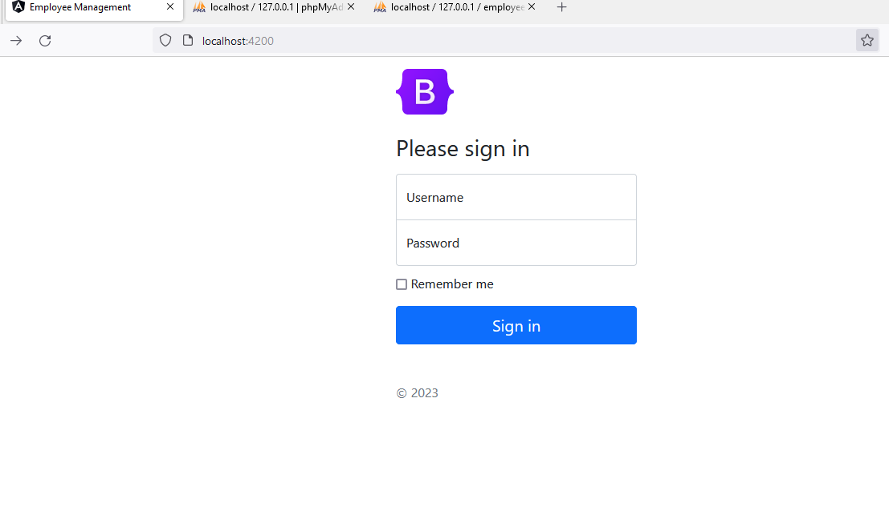

1. **Dashboard**

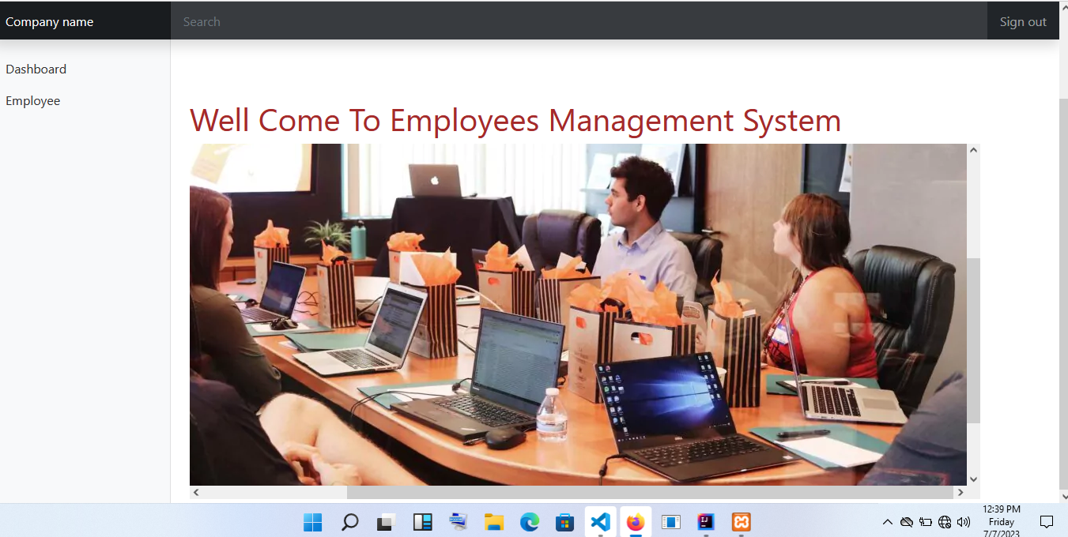

**3 . Employee CRUDE**

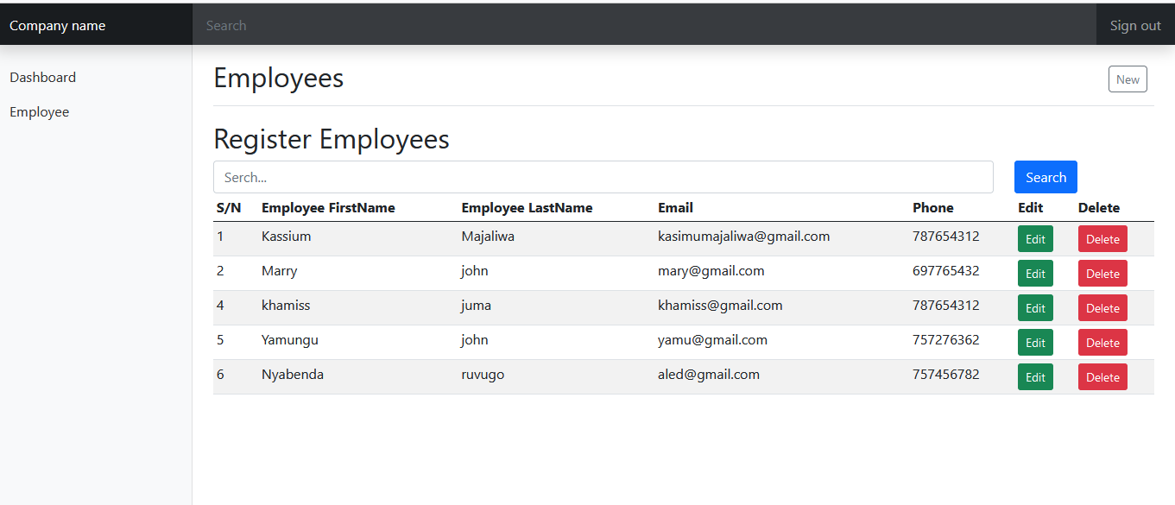

**4.Results in server database.**

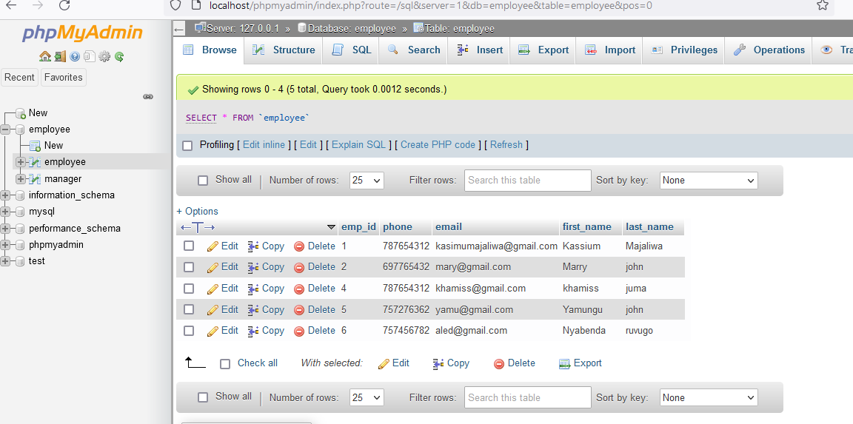

**5.POSTMAN api tests**

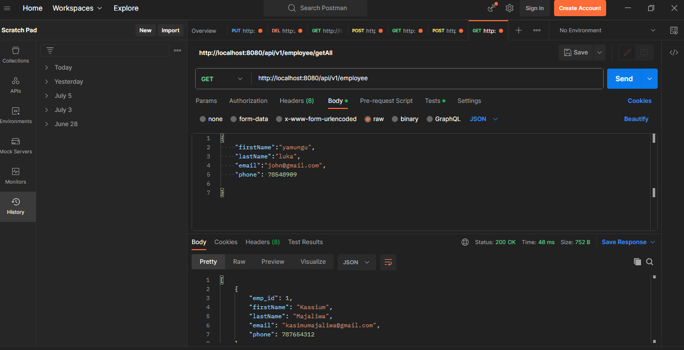

**6.Angular application.**

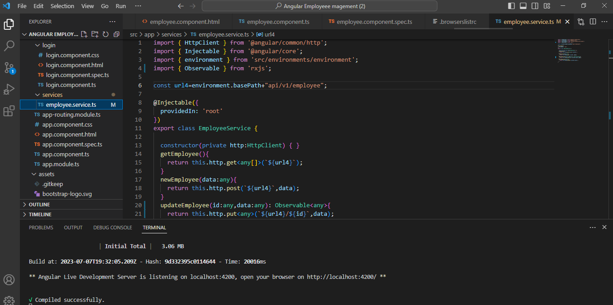

**BACKEND SPRING BOOT**

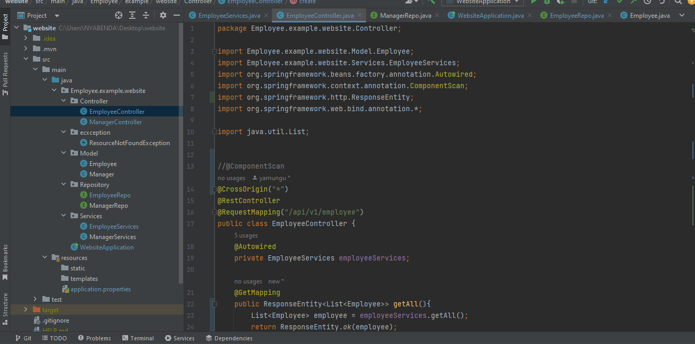

My application

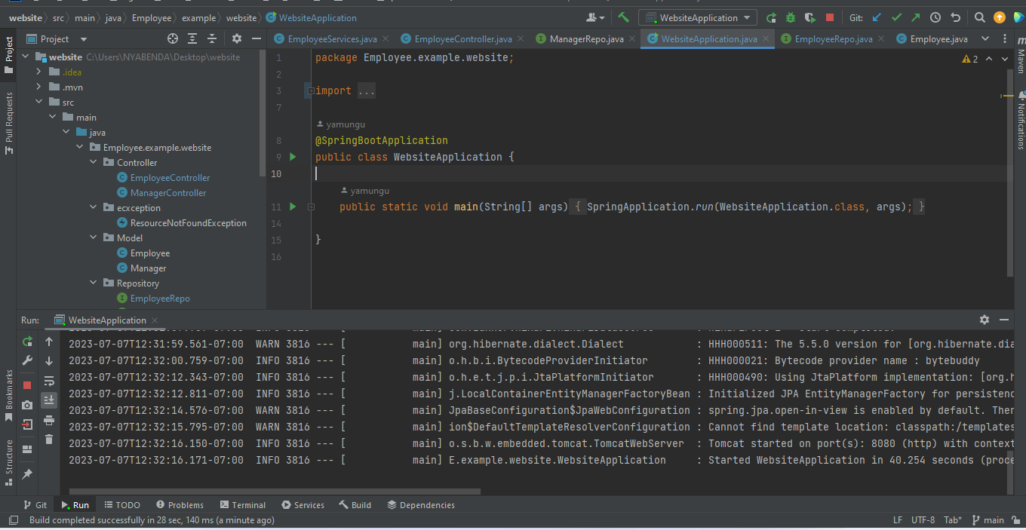

Models

