USER INTERFACE AND USER EXPERIENCE DESIGN
LAB ASSIGNMENTS
ASSIGNMENT NO: 6
Name: Ayan Ahmad Roll No.: 1032232862
Observations and Screenshots:
Figure 1. Investment cards and comparison section: recording shows exploration of Stocks, Mutual Funds, SIP, ETFs and IPOs.
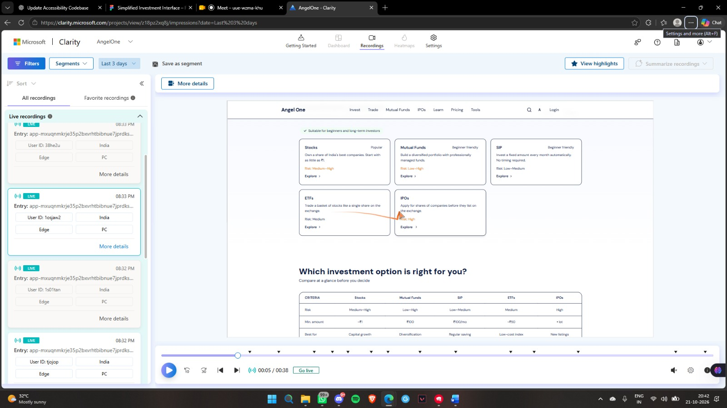
Figure 2. IPO page: user scrolls to the steps and the Open Free Account call to action.
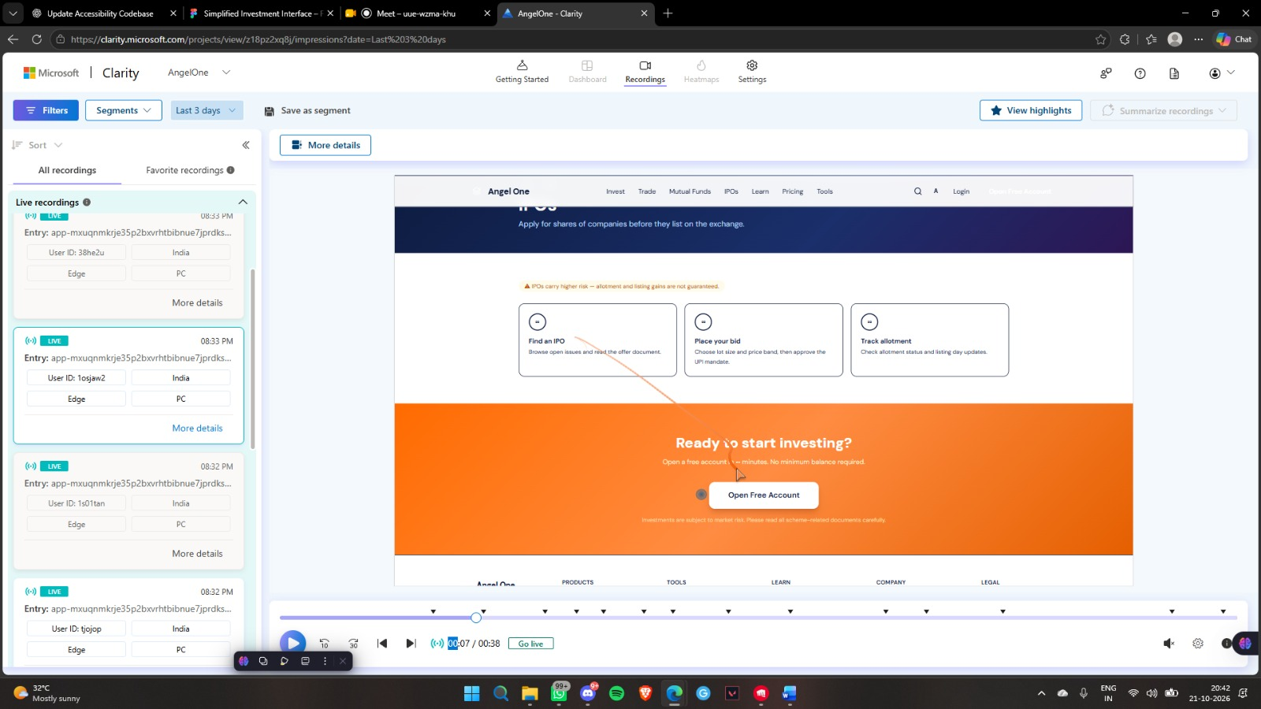
Figure 3. Account opening page: recording reaches the mobile-number entry form.
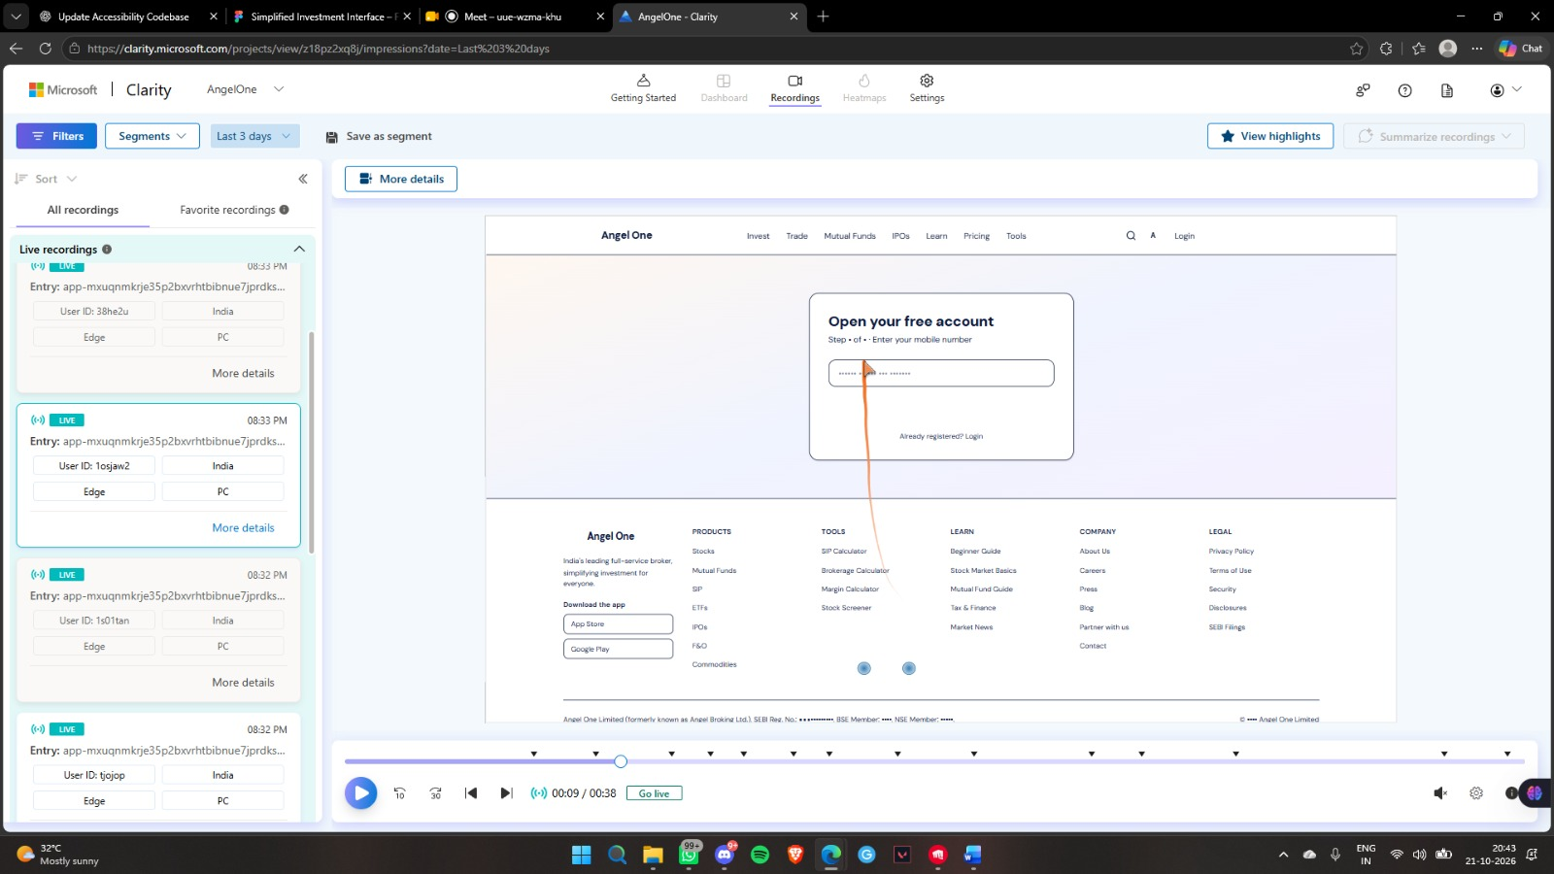
Figure 4. Trade page: visitor navigates to advanced products such as Intraday and Futures & Options.
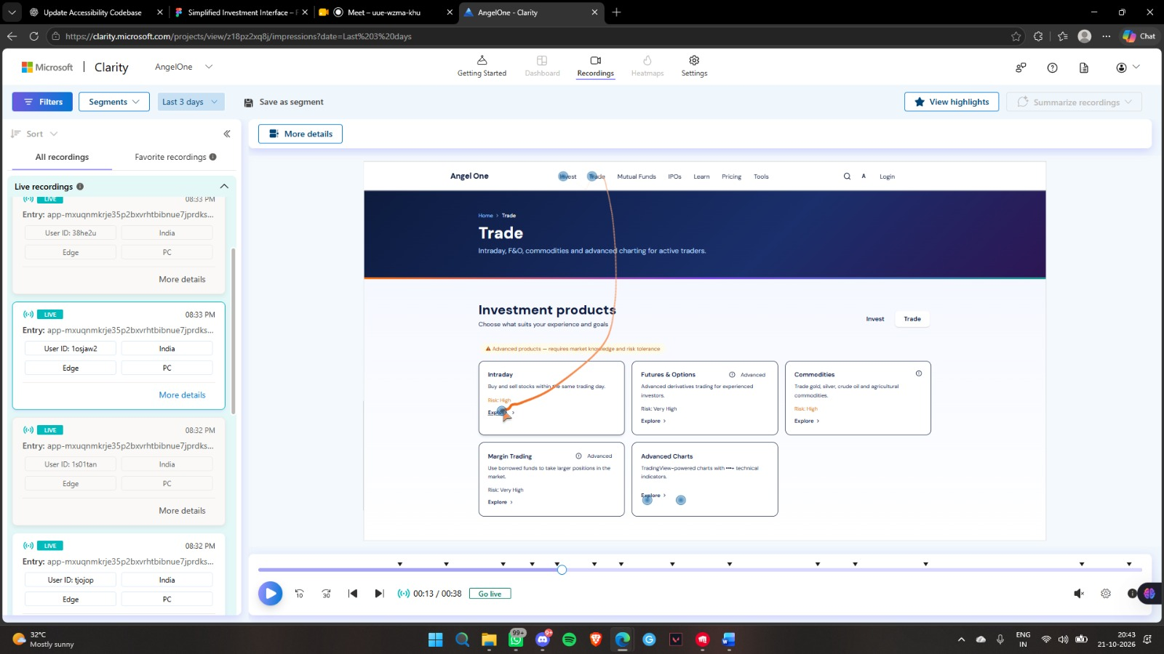
Figure 5. Comparison and pricing: recording shows the investment comparison table and fee information.
