USER INTERFACE AND USER EXPERIENCE DESIGN
LAB ASSIGNMENT NO: 7
Accessible and Inclusive Investment Interface
Name: Ayan Ahmad Roll No: 1032232862

OBSERVATIONS AND SCREENSHOTS
Observation 1: Original investment interface
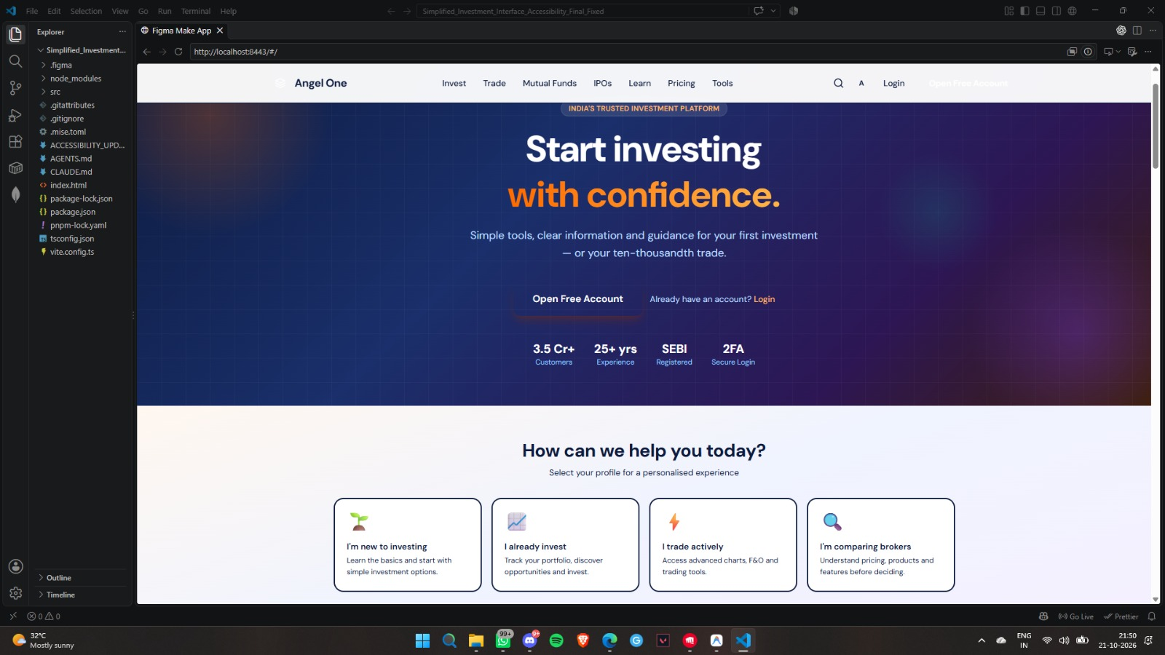
Observation 2: Accessibility settings panel
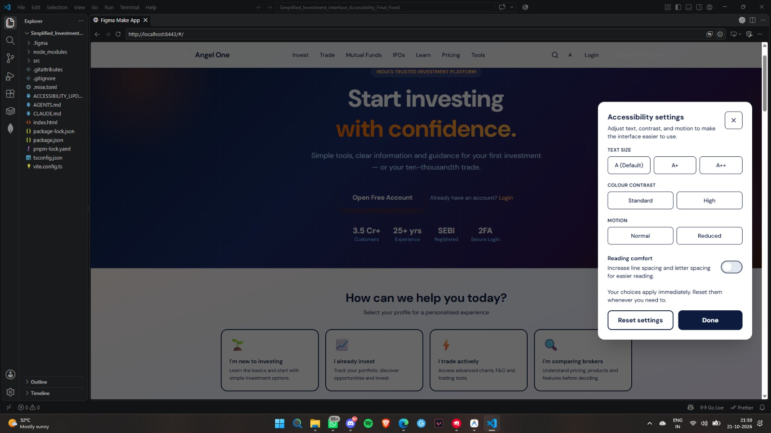

Observation 3: High contrast, enlarged text and reduced motion
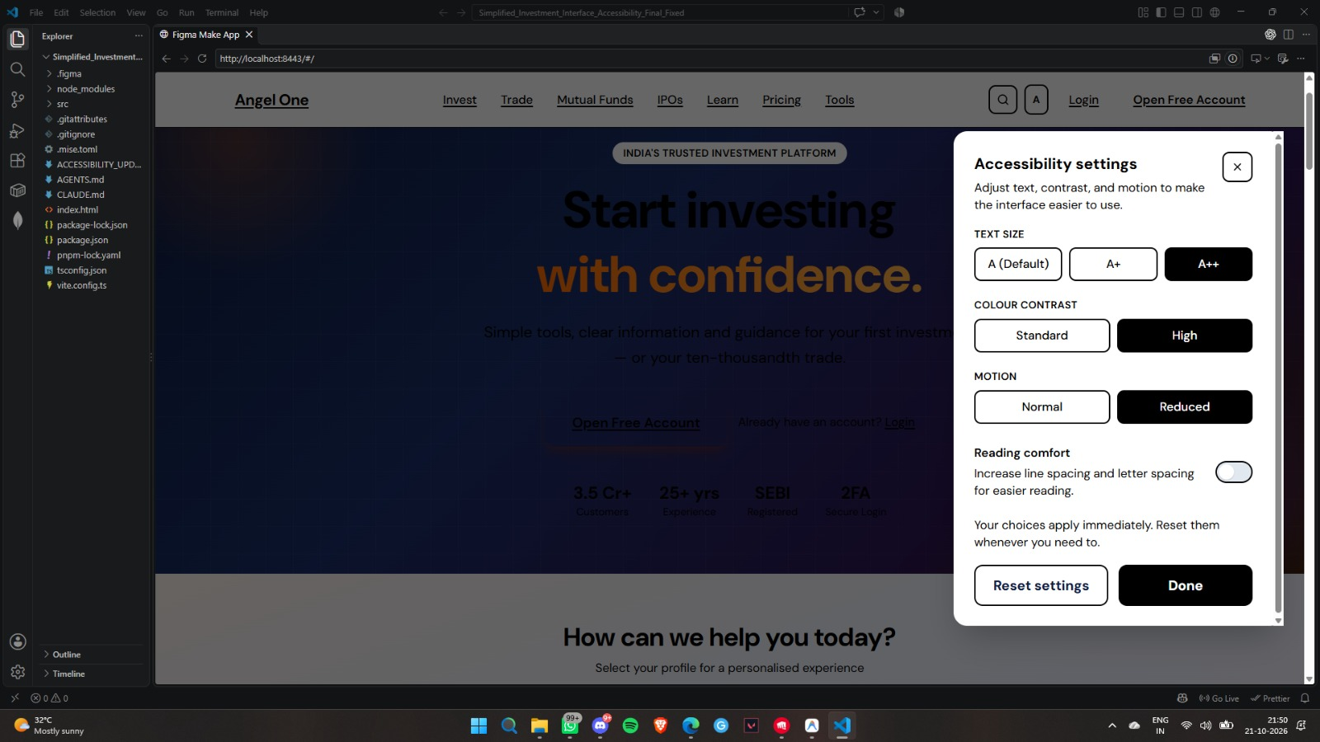
Observation 4: Reading comfort enabled
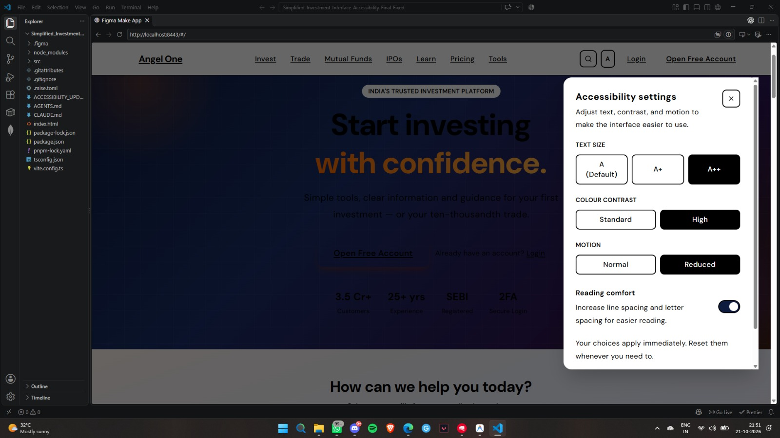

Observation 5: Investment tools and SIP calculator
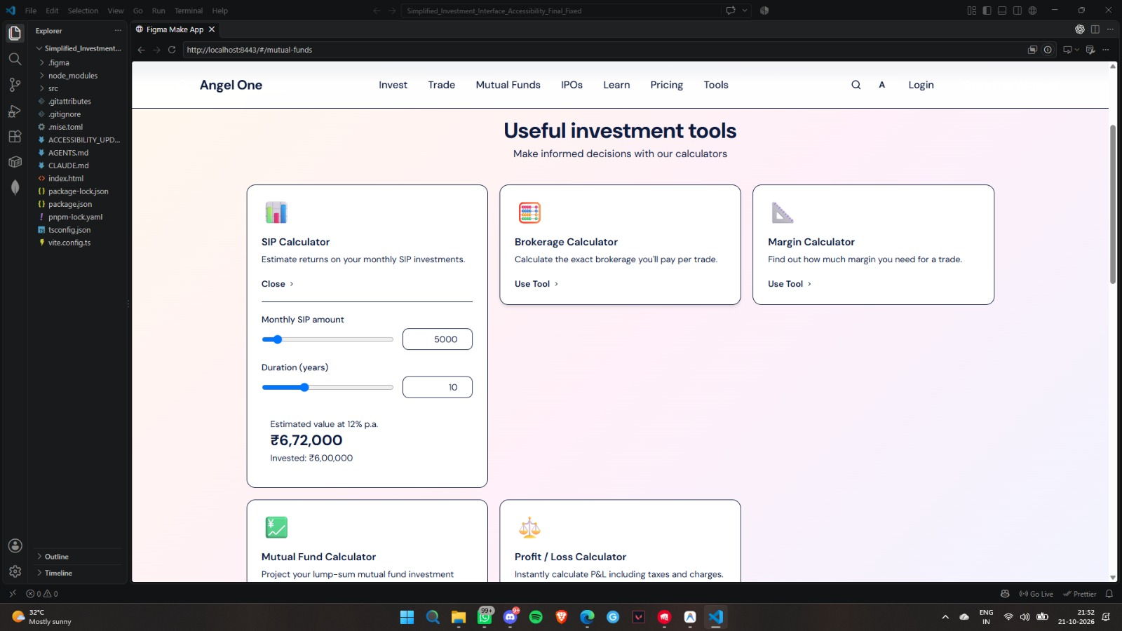
Observation 6: Accessibility settings on the investment tools screen
