附录 **A** 计算程序

## 问题 1 计算程序

% 计算符合光照条件的点在angle_1中的索引，存储在fit_triangle 中

axis_1 = zeros(4300,1); axis_2 = zeros(4300,1); axis_3 = zeros(4300,1); fit_triangle = zeros(4300,3); belong_index = 0;

for i = 1:4300

a = triangle(i,1); a = string(a);

axis_1(i,1) = find(strcmp(a, point_name)); b = triangle(i,2);

b = string(b);

axis_2(i,1) = find(strcmp(b, point_name)); c = triangle(i,3);

c = string(c);

axis_3(i,1) = find(strcmp(c, point_name));

end

% 找到符合半径条件的反射面板，有若三角形有两个点都在口径范围内，则视为满足条件

for i = 1:4300

mat_angle_1 = cell2mat(angle_1(:,5));

% belong_index = belong_index + (abs(mat_angle_1(axis_1(i,1),1)) > 60) + (abs(mat_angle_1(axis_2(i,1),1)) > 60) + (abs(mat_angle_1(axis_3(i,1),1)) > 60);

if axis_1(i,1) <= length(update_length(:,1)) && axis_2(i,1) <= length(update_length(:,1)) && axis_3(i,1) <= length(update_length(:,1))

fit_triangle(i,1) = axis_1(i,1); fit_triangle(i,2) = axis_2(i,1); fit_triangle(i,3) = axis_3(i,1);

end

end

% 去除不满足条件的三角面板（去除0值）

fit_triangle = fit_triangle(any(fit_triangle,2),:);

% 根据update_length伸长量来计算移动后的坐标索引,计算得到的索引存在new_axis中

new_axis = zeros(2226,3); r_new_axis = zeros(2226,3); dl_index = 1:5;

index_3 = zeros(length(dl_index),1);

global o;

for i = 1:length(o)

if inv_r_base_axis(i,1) < 0 o(i,2) = o(i,2) + 180;

end end

for i = 1:length(dl_index)

for j = 1:length(update_length) new_axis(j,1) =

update_length(j,dl_index(i))*cosd(angle_1_mat(j,1))*cosd(angle_1_mat(j,2)); new_axis(j,2) =

update_length(j,dl_index(i))*cosd(angle_1_mat(j,1))*sind(angle_1_mat(j,2)); new_axis(j,3) = update_length(j,dl_index(i))*sind(angle_1_mat(j,1));

end

[new_angle, new_line, temp_a, temp_b, temp_c, index_3(i,1)] = triangle_calculator(fit_triangle);

end

% global r_mat;

% for i = 1:length(update_length)

% r_new_axis(i,:) = new_axis(i,:)*r_mat;

% end

%

% plot3(r_new_axis(:,1),r_new_axis(:,2),r_new_axis(:,3),'r*');

% 生成一个有空位的元胞数组存储符合条件的结点，用于索引

% global angle_1

% fit_point_name_2 = cell(length(r_new_axis()),1);

% for i = 1:length(r_new_axis(:,1))

% if r_new_axis(i,1) ~= 0

% fit_point_name_2(i,1) = angle_1(i,1);

% end

% end

% fit_point_name_2_nan = fit_point_name_2;

% 生成一个没有空位的元胞数组存储符合条件的节点，用于计数

% fit_point_name_2(cellfun(@isempty,fit_point_name_2)) = [];

% 计算了每次抛物线上下移动相等的距离所产生的新的伸长量，第一次迭代

surface_1 = surface.'; o = zeros(2226,2); rad = zeros(2226,2); min_index = -0.6;

max_index = 0.6; for i = 1:2226

% 第一问

x = surface(i,1); y = surface(i,2); z = surface(i,3);

end

beta_d = asind(z/sqrt(x^2+y^2+z^2)); theta_d = atand(y/x);

beta = asin(z/sqrt(x^2+y^2+z^2)); theta = atan(y/x);

o(i,1) = real(beta_d); o(i,2) = real(theta_d); rad(i,1) = real(beta); rad(i,2) = real(theta);

z0 = -300.4;

F = 139.8;

unique_rad = unique(rad(:,1)); unique_angle = unique(o(:,1)); for i = 2:length(unique(rad(:,1)))

if abs(unique_rad(i)) < pi/3

% 由于光照区域角度是60度，所以大于一定角度的点直接舍去,根据角度索引筛出符合条件的点

% 将不在光照区域内的角度除去

unique_rad(i) = 0;

unique_angle(i) = 0; continue;

end

end

% 去除不满足的点unique_rad(unique_rad == 0) = []; unique_angle(unique_angle == 0) = [];

% 能够满足正负0.6的顶点移动距离条件的顶点移动距离

success_dl = zeros(num,1); success_index = 1;

fail_up = 0;

fail_down = 0;

max_move_length = zeros(num,0); min_move_length = zeros(num,0); begin = 0.1;

pace = 0.1;

final = 0.6;

num = ((final - begin)/pace + 1)*2; update_length = zeros(2226,num); sum = zeros(1,num);

show_length = zeros(1,length(unique_rad));

figure;

for dl = begin:pace:final fail_down = 0;

x = (-500:500);

% 顶点向上移动

z1 = z0 + dl;

% up_result代表向上移动后，各主索节点的横坐标up_result = zeros(1,length(unique_rad)); for i = 1:length(unique_rad)

if unique_rad(i) == -pi/2 && unique_rad(i) == pi/2

% 垂直的线不画出

continue; else

z_line = tan(unique_rad(i))*x;

% plot(x,z_line); syms x_1;

eqn = tan(unique_rad(i))*x_1 == x_1^2/(4*(F-dl))+z1;

% 联立方程

S = solve(eqn, x_1); S_double = double(S);

if abs(S_double(1,1)) > abs(S_double(2,1)) up_result(1,i) = S_double(2,1);

else

up_result(1,i) = S_double(1,1);

end

end

end

up_result(up_result==0) = [];

% 根据满足条件的各点横坐标计算各点到c的距离，将多次的结果都存储在update_length中, print_up是各下拉锁移动距离

print_up = zeros(length(up_result),1); for i = 1:length(up_result)

if i == 1

print_up(i,1) = dl; else

print_up(i,1) = up_result(i)/cos(unique_rad(i)) + z0;

% 检索当前角度的主索节点

angle_x = find(abs(angle_1_mat(:,1) - unique_angle(i)) < 0.000001); for j = 1:length(angle_x)

update_length(angle_x(j,1),int32(num/2+dl/pace)) = up_result(i)/cos(unique_rad(i));

end

% 第一问得到706行的update_length，第二问得到692行update_length

% 对每一次各个长度的求和

sum(int32(num/2+dl/pace)) = sum(int32(num/2+dl/pace)) + abs(print_up(i,1)); if abs(print_up(i,1)) > 0.6

% 有超过界限的直接排除

fail_up = 1; break;

end

end

end

% 假如促动器全部满足条件，视为成功,将dl存储,并且画出横坐标与伸长量print_up的图,

% 并且记录最大移动量和最小移动量

if fail_up == 0 success_dl(success_index,1) = dl; success_index = success_index + 1;

plot(up_result(1,2:end), -print_up(2:end,1)); hold on

max_move_length(int32(num/2+dl/pace),1) = max(print_up(2:end,1)); min_move_length(int32(num/2+dl/pace),1) = min(print_up(2:end,1));

end

% 将成功指标置为成功

fail_up = 0;

% 顶点向下移动

z2 = z0 - dl;

down_result = zeros(1,length(unique_rad)); for i = 1:length(unique_rad)

if unique_rad(i) == -pi/2 && unique_rad(i) == pi/2

% 垂直的线不画出

continue;

else

z_line = tan(unique_rad(i))*x; syms x_2;

eqn = tan(unique_rad(i))*x_2 == x_2^2/(4*(F+dl))+z2;

% 联立方程

S = solve(eqn, x_2); S_double = double(S);

if abs(S_double(1,1)) > abs(S_double(2,1)) down_result(1,i) = S_double(2,1);

else

down_result(1,i) = S_double(1,1);

end

end

end

down_result(down_result==0) = [];

% 促动器运动距离有超出范围的，失败, 继续下一次循环

print_down = zeros(length(down_result),1); for i = 1:length(down_result)

if i == 1

print_down(i,1) = -dl; else

print_down(i,1) = down_result(i)/cos(unique_rad(i)) + z0;

% 检索当前角度的主索节点

angle_x = find(abs(angle_1_mat(:,1) - unique_angle(i)) < 0.0001); for j = 1:length(angle_x)

update_length(angle_x(j,1),int32(num/2+1-dl/pace)) = abs(down_result(i)/cos(unique_rad(i)));

end

sum(int32(num/2+1-dl/pace)) = sum(int32(num/2+1-dl/pace)) + abs(print_down(i,1)); if abs(print_down(i,1)) > 0.6

fail_down = 1; break;

end

end

end

% 假如促动器全部满足条件，视为成功,将dl存储,并且画出横坐标与伸长量print_down的图,

% 并且记录最大移动量和最小移动量

if fail_down == 0 success_dl(success_index,1) = -dl; success_index = success_index + 1;

plot(down_result(1,2:end), -print_down(2:end,1)); hold on

max_move_length(int32(num/2+1-dl/pace),1) = max(print_down(2:end,1)); min_move_length(int32(num/2+1-dl/pace),1) = min(print_down(2:end,1));

end

% 将成功指标置为成功

fail_down = 0;

end hold off

%%

update_length(all(update_length==0,2),:) = [];

%%

% 加精计算-0.3 - -0.5的区间，第二次迭代

% 计算了每次抛物线上下移动相等的距离所产生的新的伸长量

surface_1 = surface.'; o = zeros(2226,2); rad = zeros(2226,2); min_index = -0.6;

max_index = 0.6; for i = 1:2226

% 第一问

x = surface(i,1); y = surface(i,2); z = surface(i,3);

beta_d = asind(z/sqrt(x^2+y^2+z^2)); theta_d = atand(y/x);

beta = asin(z/sqrt(x^2+y^2+z^2)); theta = atan(y/x);

o(i,1) = real(beta_d); o(i,2) = real(theta_d); rad(i,1) = real(beta); rad(i,2) = real(theta);

end

z0 = -300.4;

F = 139.8;

unique_rad = unique(rad(:,1)); unique_angle = unique(o(:,1)); for i = 2:length(unique(rad(:,1)))

if abs(unique_rad(i)) < pi/3

% 由于光照区域角度是60度，所以大于一定角度的点直接舍去,根据角度索引筛出符合条件的点

% 将不在光照区域内的角度除去

unique_rad(i) = 0;

unique_angle(i) = 0; continue;

end

end

% 去除不满足的点unique_rad(unique_rad == 0) = []; unique_angle(unique_angle == 0) = [];

% 能够满足正负0.6的顶点移动距离条件的顶点移动距离

begin = 0.3;

pace = 0.01;

final = 0.5;

num = int32((final - begin)/pace + 1) ; success_dl = zeros(num,1); success_index = 1;

fail_up = 0;

fail_down = 0;

max_move_length = zeros(num,0); min_move_length = zeros(num,0); update_length = zeros(2226,num); sum = zeros(1,num);

show_length = zeros(1,length(unique_rad));

figure;

for dl = begin:pace:final fail_down = 0;

x = (-500:500);

% 顶点向下移动

z2 = z0 - dl;

down_result = zeros(1,length(unique_rad)); for i = 1:length(unique_rad)

if unique_rad(i) == -pi/2 && unique_rad(i) == pi/2

% 垂直的线不画出

continue;

else

z_line = tan(unique_rad(i))*x;

syms x_2;

eqn = tan(unique_rad(i))*x_2 == x_2^2/(4*(F+dl))+z2;

% 联立方程

S = solve(eqn, x_2); S_double = double(S);

if abs(S_double(1,1)) > abs(S_double(2,1)) down_result(1,i) = S_double(2,1);

else

down_result(1,i) = S_double(1,1);

end

end

end

down_result(down_result==0) = [];

% 促动器运动距离有超出范围的，失败, 继续下一次循环

print_down = zeros(length(down_result),1); for i = 1:length(down_result)

if i == 1

print_down(i,1) = -dl; else

print_down(i,1) = down_result(i)/cos(unique_rad(i)) + z0;

% 检索当前角度的主索节点

angle_x = find(abs(angle_1_mat(:,1) - unique_angle(i)) < 0.0001); for j = 1:length(angle_x)

update_length(angle_x(j,1),int32((dl - begin)/pace + 1)) = abs(down_result(i)/cos(unique_rad(i)));

end

sum(int32((dl - begin)/pace + 1)) = sum(int32((dl - begin)/pace + 1)) + abs(print_down(i,1));

if abs(print_down(i,1)) > 0.6 fail_down = 1;

break;

end

end

end

% 假如促动器全部满足条件，视为成功,将dl存储,并且画出横坐标与伸长量print_down的图,

% 并且记录最大移动量和最小移动量

if fail_down == 0 success_dl(success_index,1) = -dl; success_index = success_index + 1;

plot(down_result(1,2:end), -print_down(2:end,1)); hold on

max_move_length(int32((dl - begin)/pace + 1),1) = max(print_down(2:end,1)); min_move_length(int32((dl - begin)/pace + 1),1) = min(print_down(2:end,1));

end

% 将成功指标置为成功

fail_down = 0;

end

hold off

%%

update_length(all(update_length==0,2),:) = [];

%%

% 一些变量的初始化surface_1 = surface.'; o = zeros(2226,2); rad = zeros(2226,2); for i = 1:2226

x = surface(i,1); y = surface(i,2); z = surface(i,3);

beta_d = asind(z/sqrt(x^2+y^2+z^2)); theta_d = atand(y/x);

beta = asin(z/sqrt(x^2+y^2+z^2)); theta = atan(y/x);

o(i,1) = real(beta_d); o(i,2) = real(theta_d); rad(i,1) = real(beta); rad(i,2) = real(theta);

end

z0 = -300.4;

F = 139.8;

unique_rad = unique(rad(:,1)); unique_angle = unique(o(:,1)); update_length = zeros(2226,1); for i = 2:length(unique(rad(:,1)))

if abs(unique_rad(i)) < pi/3

% 由于光照区域角度是60度，所以大于一定角度的点直接舍去,根据角度索引筛出符合条件的点

% 将不在光照区域内的角度除去

unique_rad(i) = 0;

unique_angle(i) = 0; continue;

end

end

% 去除不满足的点unique_rad(unique_rad == 0) = []; unique_angle(unique_angle == 0) = [];

% 首次成功的顶点移动距离

first_success_dl = 0;

begin = 0.1;

pace = 0.1;

final = 0.6;

num = ((final - begin)/pace + 1)*2; sum = zeros(1,num);

show_length = zeros(1,length(unique_rad));

## 问题 2 计算程序

% 根据update_length伸长量来计算移动后的坐标索引,计算得到的索引存在new_axis中

% 每次进行基准球面的计算时，需要先运行此脚本

new_axis = zeros(2226,3); r_new_axis = zeros(2226,3); dl_index = 1:5;

index_3 = zeros(length(dl_index),1);

global o;

for i = 1:length(o)

if inv_r_base_axis(i,1) < 0 o(i,2) = o(i,2) + 180;

end end

for j = 1:length(update_length)

new_axis(j,1) = update_length(j,3)*cosd(o(j,1))*cosd(o(j,2)); new_axis(j,2) = update_length(j,3)*cosd(o(j,1))*sind(o(j,2)); new_axis(j,3) = update_length(j,3)*sind(o(j,1));

end

% new_axis(1,1) = 0;

% new_axis(1,2) = 0;

% [new_angle, new_line, temp_a, temp_b, temp_c, index_3] = triangle_calculator(fit_triangle);

global r_mat;

for i = 1:length(update_length) r_new_axis(i,:) = new_axis(i,:)*r_mat;

end

plot3(r_new_axis(:,1),r_new_axis(:,2),r_new_axis(:,3),'r*');

% 生成一个有空位的元胞数组存储符合条件的结点，用于索引

global angle_1

fit_point_name_2 = cell(length(r_new_axis()),1); for i = 1:length(r_new_axis(:,1))

if r_new_axis(i,1) ~= 0 fit_point_name_2(i,1) = angle_1(i,1);

end

end

fit_point_name_2_nan = fit_point_name_2;

% 生成一个没有空位的元胞数组存储符合条件的节点，用于计数

fit_point_name_2(cellfun(@isempty,fit_point_name_2)) = [];

% 根据update_length伸长量来计算移动后的坐标索引,计算得到的索引存在new_axis中

new_axis = zeros(2226,3); r_new_axis = zeros(2226,3); dl_index = 1:5;

index_3 = zeros(length(dl_index),1);

global o;

for i = 1:length(o)

if inv_r_base_axis(i,1) < 0 o(i,2) = o(i,2) + 180;

end end

for i = 1:length(dl_index)

for j = 1:length(update_length)

new_axis(j,1) = update_length(j,dl_index(i))*cosd(o(j,1))*cosd(o(j,2)); new_axis(j,2) = update_length(j,dl_index(i))*cosd(o(j,1))*sind(o(j,2)); new_axis(j,3) = update_length(j,dl_index(i))*sind(o(j,1));

end

% new_axis(1,1) = 0;

% new_axis(1,2) = 0;

% [new_angle, new_line, temp_a, temp_b, temp_c, index_3] = triangle_calculator(fit_triangle);

end

global r_mat;

for i = 1:length(update_length) r_new_axis(i,:) = new_axis(i,:)*r_mat;

end

plot3(r_new_axis(:,1),r_new_axis(:,2),r_new_axis(:,3),'r*');

% 生成一个有空位的元胞数组存储符合条件的结点，用于索引

global angle_1

fit_point_name_2 = cell(length(r_new_axis()),1); for i = 1:length(r_new_axis(:,1))

if r_new_axis(i,1) ~= 0 fit_point_name_2(i,1) = angle_1(i,1);

end

end

fit_point_name_2_nan = fit_point_name_2;

% 生成一个没有空位的元胞数组存储符合条件的节点，用于计数

fit_point_name_2(cellfun(@isempty,fit_point_name_2)) = [];

% 计算了每次抛物线上下移动相等的距离所产生的新的伸长量,第一次迭代

surface_1 = surface.'; o = zeros(2226,2);

rad = zeros(2226,2); for i = 1:2226

% 处理第二问，需要将旋转坐标轴后的点坐标带入

x = inv_r_base_axis(i,1); y = inv_r_base_axis(i,2); z = inv_r_base_axis(i,3);

end

beta_d = asind(z/sqrt(x^2+y^2+z^2)); theta_d = atand(y/x);

beta = asin(z/sqrt(x^2+y^2+z^2)); theta = atan(y/x);

o(i,1) = real(beta_d); o(i,2) = real(theta_d); rad(i,1) = real(beta); rad(i,2) = real(theta);

z0 = -300.4;

F = 139.8;

unique_rad = unique(rad(:,1)); unique_angle = unique(o(:,1)); for i = 2:length(unique(rad(:,1)))

if abs(unique_rad(i)) < pi/3

% 由于光照区域角度是60度，所以大于一定角度的点直接舍去,根据角度索引筛出符合条件的点

% 将不在光照区域内的角度除去

unique_rad(i) = 0;

unique_angle(i) = 0; continue;

end

end

% 去除不满足的点unique_rad(unique_rad == 0) = []; unique_angle(unique_angle == 0) = [];

% 能够满足正负0.6的顶点移动距离条件的顶点移动距离

success_dl = zeros(num,1); success_index = 1;

fail_up = 0;

fail_down = 0;

max_move_length = zeros(num,0); min_move_length = zeros(num,0); begin = 0.1;

pace = 0.1;

final = 0.6;

num = ((final - begin)/pace + 1)*2; update_length = zeros(2226,num); sum = zeros(1,num);

show_length = zeros(1,length(unique_rad));

figure;

for dl = begin:pace:final fail_down = 0;

x = (-500:500);

% 顶点向上移动

z1 = z0 + dl;

% z = x.^2/(4*(F-dl))+z1;

% plot(x,z)

% hold on

% up_result代表向上移动后，各主索节点的横坐标up_result = zeros(1,length(unique_rad)); for i = 1:length(unique_rad)

if unique_rad(i) == -pi/2 && unique_rad(i) == pi/2

% 垂直的线不画出

continue; else

z_line = tan(unique_rad(i))*x;

% plot(x,z_line); syms x_1;

eqn = tan(unique_rad(i))*x_1 == x_1^2/(4*(F-dl))+z1;

% 联立方程

S = solve(eqn, x_1); S_double = double(S);

if abs(S_double(1,1)) > abs(S_double(2,1)) up_result(1,i) = S_double(2,1);

else

up_result(1,i) = S_double(1,1);

end

end

end

up_result(up_result==0) = [];

% 根据满足条件的各点横坐标计算各点到c的距离，将多次的结果都存储在update_length中, print_up是各下拉锁移动距离的绝对值

print_up = zeros(length(up_result),1); for i = 1:length(up_result)

print_up(i,1) = up_result(i)/cos(unique_rad(i)) + z0;

% 检索当前角度的主索节点

angle_x = find(abs(o(:,1) - unique_angle(i)) < 0.000001); for j = 1:length(angle_x)

update_length(angle_x(j,1),int32(num/2+dl/pace)) = abs(up_result(i)/cos(unique_rad(i)));

end

% 第一问得到706行的update_length，第二问得到692行update_length

% 对每一次各个长度的求和

sum(int32(num/2+dl/pace)) = sum(int32(num/2+dl/pace)) + abs(print_up(i,1));

if abs(print_up(i,1)) > 0.6 fail_up = 1;

break;

end

end

% 假如促动器全部满足条件，视为成功

if fail_up == 0 success_dl(success_index,1) = dl; success_index = success_index + 1;

plot(up_result(1,2:end), -print_up(2:end,1)); hold on

max_move_length(int32(num/2+dl/pace),1) = max(print_up(2:end,1)); min_move_length(int32(num/2+dl/pace),1) = min(print_up(2:end,1));

end

% 顶点向下移动

z2 = z0 - dl;

down_result = zeros(1,length(unique_rad)); for i = 1:length(unique_rad)

if unique_rad(i) == -pi/2 && unique_rad(i) == pi/2

% 垂直的线不画出

continue;

else

z_line = tan(unique_rad(i))*x;

% plot(x,z_line); syms x_2;

eqn = tan(unique_rad(i))*x_2 == x_2^2/(4*(F+dl))+z2;

% 联立方程

S = solve(eqn, x_2); S_double = double(S);

if abs(S_double(1,1)) > abs(S_double(2,1)) down_result(1,i) = S_double(2,1);

else

down_result(1,i) = S_double(1,1);

end

end

end

down_result(down_result==0) = [];

% 促动器运动距离有超出范围的，失败, 继续下一次循环

print_down = zeros(length(down_result),1); for i = 1:length(down_result)

print_down(i,1) = down_result(i)/cos(unique_rad(i)) + z0;

% 检索当前角度的主索节点

angle_x = find(abs(o(:,1) - unique_angle(i)) < 0.0001); for j = 1:length(angle_x)

update_length(angle_x(j,1),int32(num/2+1-dl/pace)) =

abs(down_result(i)/cos(unique_rad(i)));

end

sum(int32(num/2+1-dl/pace)) = sum(int32(num/2+1-dl/pace)) + abs(print_down(i,1)); if abs(print_down(i,1)) > 0.6

fail_down = 1; break;

end

end

% 假如促动器全部满足条件，视为成功

if fail_down == 0 success_dl(success_index,1) = -dl; success_index = success_index + 1;

plot(down_result(1,2:end), -print_down(2:end,1)); hold on

max_move_length(int32(num/2+1-dl/pace),1) = max(print_down(2:end,1)); min_move_length(int32(num/2+1-dl/pace),1) = min(print_down(2:end,1));

end end

%%

% update_length(all(update_length==0,2),:) = [];

%%

% 加精计算-0.3 - -0.5的区间，第二次迭代

% 计算了每次抛物线上下移动相等的距离所产生的新的伸长量

surface_1 = surface.'; o = zeros(2226,2); rad = zeros(2226,2); for i = 1:2226

% 处理第二问，需要将旋转坐标轴后的点坐标带入

x = inv_r_base_axis(i,1); y = inv_r_base_axis(i,2); z = inv_r_base_axis(i,3);

end

beta_d = asind(z/sqrt(x^2+y^2+z^2)); theta_d = atand(y/x);

beta = asin(z/sqrt(x^2+y^2+z^2)); theta = atan(y/x);

o(i,1) = real(beta_d); o(i,2) = real(theta_d); rad(i,1) = real(beta); rad(i,2) = real(theta);

z0 = -300.4;

F = 139.8;

unique_rad = unique(rad(:,1)); unique_angle = unique(o(:,1));

for i = 2:length(unique(rad(:,1))) if abs(unique_rad(i)) < pi/3

% 由于光照区域角度是60度，所以大于一定角度的点直接舍去,根据角度索引筛出符合条件的点

% 将不在光照区域内的角度除去

unique_rad(i) = 0;

unique_angle(i) = 0; continue;

end

end

% 去除不满足的点unique_rad(unique_rad == 0) = []; unique_angle(unique_angle == 0) = [];

% 能够满足正负0.6的顶点移动距离条件的顶点移动距离

success_dl = zeros(num,1); success_index = 1;

fail_up = 0;

fail_down = 0;

max_move_length = zeros(num,0); min_move_length = zeros(num,0); begin = 0.3;

pace = 0.01;

final = 0.5;

num = ((final - begin)/pace + 1)*2; update_length = zeros(2226,num); sum = zeros(1,num);

show_length = zeros(1,length(unique_rad));

figure;

for dl = begin:pace:final fail_down = 0;

x = (-500:500);

% 顶点向下移动

z2 = z0 - dl;

down_result = zeros(1,length(unique_rad)); for i = 1:length(unique_rad)

if unique_rad(i) == -pi/2 && unique_rad(i) == pi/2

% 垂直的线不画出

continue;

else

z_line = tan(unique_rad(i))*x;

% plot(x,z_line); syms x_2;

eqn = tan(unique_rad(i))*x_2 == x_2^2/(4*(F+dl))+z2;

% 联立方程

S = solve(eqn, x_2); S_double = double(S);

if abs(S_double(1,1)) > abs(S_double(2,1)) down_result(1,i) = S_double(2,1);

else

down_result(1,i) = S_double(1,1);

end

end

end

down_result(down_result==0) = [];

% 促动器运动距离有超出范围的，失败, 继续下一次循环

print_down = zeros(length(down_result),1); for i = 1:length(down_result)

print_down(i,1) = down_result(i)/cos(unique_rad(i)) + z0;

% 检索当前角度的主索节点

angle_x = find(abs(o(:,1) - unique_angle(i)) < 0.0001); for j = 1:length(angle_x)

update_length(angle_x(j,1),int32((dl - begin)/pace + 1)) = abs(down_result(i)/cos(unique_rad(i)));

end

sum(int32((dl - begin)/pace + 1)) = sum(int32((dl - begin)/pace + 1)) + abs(print_down(i,1));

if abs(print_down(i,1)) > 0.6 fail_down = 1;

break;

end

end

% 假如促动器全部满足条件，视为成功

if fail_down == 0 success_dl(success_index,1) = -dl; success_index = success_index + 1;

plot(down_result(1,2:end), -print_down(2:end,1)); hold on

max_move_length(int32((dl - begin)/pace + 1),1) = max(print_down(2:end,1)); min_move_length(int32((dl - begin)/pace + 1),1) = min(print_down(2:end,1));

end

% 将成功指标置为成功

fail_down = 0;

end hold off

%%

update_length(all(update_length==0,2),:) = [];

%%

% 加精计算-0.3 - -0.5的区间，第二次迭代

% 计算了每次抛物线上下移动相等的距离所产生的新的伸长量

surface_1 = surface.'; o = zeros(2226,2); rad = zeros(2226,2);

for i = 1:2226

% 处理第二问，需要将旋转坐标轴后的点坐标带入

x = inv_r_base_axis(i,1); y = inv_r_base_axis(i,2); z = inv_r_base_axis(i,3);

end

beta_d = asind(z/sqrt(x^2+y^2+z^2)); theta_d = atand(y/x);

beta = asin(z/sqrt(x^2+y^2+z^2)); theta = atan(y/x);

o(i,1) = real(beta_d); o(i,2) = real(theta_d); rad(i,1) = real(beta); rad(i,2) = real(theta);

z0 = -300.4;

F = 139.8;

unique_rad = unique(rad(:,1)); unique_angle = unique(o(:,1)); for i = 2:length(unique(rad(:,1)))

if abs(unique_rad(i)) < pi/3

% 由于光照区域角度是60度，所以大于一定角度的点直接舍去,根据角度索引筛出符合条件的点

% 将不在光照区域内的角度除去

unique_rad(i) = 0;

unique_angle(i) = 0; continue;

end

end

% 去除不满足的点unique_rad(unique_rad == 0) = []; unique_angle(unique_angle == 0) = [];

% 能够满足正负0.6的顶点移动距离条件的顶点移动距离

success_dl = zeros(num,1); success_index = 1;

fail_up = 0;

fail_down = 0;

max_move_length = zeros(num,0); min_move_length = zeros(num,0); begin = 0.3;

pace = 0.01;

final = 0.5;

num = ((final - begin)/pace + 1)*2; update_length = zeros(2226,num); sum = zeros(1,num);

show_length = zeros(1,length(unique_rad));

figure;

for dl = begin:pace:final fail_down = 0;

x = (-500:500);

% 顶点向下移动

z2 = z0 - dl;

down_result = zeros(1,length(unique_rad)); for i = 1:length(unique_rad)

if unique_rad(i) == -pi/2 && unique_rad(i) == pi/2

% 垂直的线不画出

continue;

else

z_line = tan(unique_rad(i))*x;

% plot(x,z_line); syms x_2;

eqn = tan(unique_rad(i))*x_2 == x_2^2/(4*(F+dl))+z2;

% 联立方程

S = solve(eqn, x_2); S_double = double(S);

if abs(S_double(1,1)) > abs(S_double(2,1)) down_result(1,i) = S_double(2,1);

else

down_result(1,i) = S_double(1,1);

end

end

end

down_result(down_result==0) = [];

% 促动器运动距离有超出范围的，失败, 继续下一次循环

print_down = zeros(length(down_result),1); for i = 1:length(down_result)

print_down(i,1) = down_result(i)/cos(unique_rad(i)) + z0;

% 检索当前角度的主索节点

angle_x = find(abs(o(:,1) - unique_angle(i)) < 0.0001); for j = 1:length(angle_x)

update_length(angle_x(j,1),int32((dl - begin)/pace + 1)) = abs(down_result(i)/cos(unique_rad(i)));

end

sum(int32((dl - begin)/pace + 1)) = sum(int32((dl - begin)/pace + 1)) + abs(print_down(i,1));

if abs(print_down(i,1)) > 0.6 fail_down = 1;

break;

end

end

% 假如促动器全部满足条件，视为成功

if fail_down == 0

end

success_dl(success_index,1) = -dl; success_index = success_index + 1;

plot(down_result(1,2:end), -print_down(2:end,1)); hold on

max_move_length(int32((dl - begin)/pace + 1),1) = max(print_down(2:end,1)); min_move_length(int32((dl - begin)/pace + 1),1) = min(print_down(2:end,1));

% 将成功指标置为成功

fail_down = 0;

end hold off

%%

update_length(all(update_length==0,2),:) = [];

%%

% 尝试将问题二转化为问题一，生成旋转矩阵，运行第二问的程序首先需要运行该脚本

beta_2 = 78.169;

alpha_2 =36.795;

r_mat = [sind(alpha_2), -cosd(alpha_2), 0;

sind(beta_2)*cosd(alpha_2), sind(beta_2)*sind(alpha_2), -cosd(beta_2); cosd(beta_2)*cosd(alpha_2), cosd(beta_2)*sind(alpha_2), sind(beta_2)];

r_base_axis = zeros(length(base_axis), 3); inv_r_base_axis = zeros(length(base_axis), 3); couple = zeros(length(base_axis), 2);

index = 1;

base_axis = cell2mat(angle_1(:,2:4));

% 将原来的基准面向目标光线旋转

for i = 1:length(base_axis) r_base_axis(i,:) = base_axis(i,:)*r_mat;

end

% 将轴旋转至和目标光线平行，

for i = 1:length(base_axis) inv_r_base_axis(i,:) = base_axis(i,:)/r_mat;

end

% 验证是否配对

for i = 1:length(base_axis) for j = 1:length(base_axis)

if abs(r_base_axis(i,1) - base_axis(j,1)) < 0.001 && abs(r_base_axis(i,2) - base_axis(j,2))

< 0.001 ...

&& abs(r_base_axis(i,3) - base_axis(j,3)) < 0.001 couple(index,1) = j;

couple(index,2) = i; index = index + 1;

end end

end

## 问题 3 计算程序

% 计算旋转坐标轴后基准球面的反射吸收率指标，方便与抛物面进行比较

axis_1 = zeros(4300,1); axis_2 = zeros(4300,1); axis_3 = zeros(4300,1); fit_triangle = zeros(4300,3); belong_index = 0;

for i = 1:4300

a = triangle(i,1); a = string(a);

axis_1(i,1) = find(strcmp(a, point_name)); b = triangle(i,2);

b = string(b);

axis_2(i,1) = find(strcmp(b, point_name)); c = triangle(i,3);

c = string(c);

axis_3(i,1) = find(strcmp(c, point_name));

end

% 找到符合半径条件的反射面板，若三角形三个点全在光照区域内，视作有效顶点

for i = 1:4300

% 当旋转后的基准面的每个三角形都在光照区域时，这个三角形有效

if abs(o(axis_1(i,1),1)) > 60 && abs(o(axis_2(i,1),1)) > 60 && abs(o(axis_3(i,1),1)) > 60 fit_triangle(i,1) = axis_1(i,1);

fit_triangle(i,2) = axis_2(i,1); fit_triangle(i,3) = axis_3(i,1);

end

% belong_index = 0; end

% 去除不满足条件的三角面板（去除0值）

fit_triangle = fit_triangle(any(fit_triangle,2),:); new_axis = inv_r_base_axis;

[new_angle, new_line, temp_a, temp_b, temp_c, valid_num, area_c] = triangle_calculator(fit_triangle);

% 计算每个符合条件反射面板的法向量以及法向量与z轴的夹角

axis_1 = zeros(4300,1); axis_2 = zeros(4300,1); axis_3 = zeros(4300,1); fit_triangle = zeros(4300,3); belong_index = 0;

for i = 1:4300

a = triangle(i,1); a = string(a);

axis_1(i,1) = find(strcmp(a, point_name)); b = triangle(i,2);

b = string(b);

axis_2(i,1) = find(strcmp(b, point_name)); c = triangle(i,3);

c = string(c);

axis_3(i,1) = find(strcmp(c, point_name));

end

% 找到符合半径条件的反射面板，若三角形三个点全在光照区域内，视作有效顶点

for i = 1:4300

% 等于0代表该点无效

pre_1 = (new_axis(axis_1(i,1),2) == 0); pre_2 = (new_axis(axis_2(i,1),2) == 0); pre_3 = (new_axis(axis_3(i,1),2) == 0);

% mat_angle_1 = cell2mat(angle_1(:,5));

% belong_index = belong_index + (abs(mat_angle_1(axis_1(i,1),1)) > 60) + (abs(mat_angle_1(axis_2(i,1),1)) > 60) + (abs(mat_angle_1(axis_3(i,1),1)) > 60); if pre_1 + pre_2 + pre_3 == 0

fit_triangle(i,1) = axis_1(i,1); fit_triangle(i,2) = axis_2(i,1); fit_triangle(i,3) = axis_3(i,1);

end

% belong_index = 0; end

% 去除不满足条件的三角面板（去除0值）

fit_triangle = fit_triangle(any(fit_triangle,2),:);

[new_angle, new_line, temp_a, temp_b, temp_c, valid_num, area_r] = triangle_calculator(fit_triangle);

## 关键程序

% 根据输入的（n,3）的点列索引，在new_axis中找到组成三角形的三个点，并且计算：各个三角形的法向量； 各个三角形反射光线方向向量；

% 各个三角形在馈源仓平面的投影，以及所有三角形与馈源仓交集区域的总面积（作为光线吸收率的重要指标）

% A = "A0";

% temp = string(new_axis(:,1));

% [i,j] = find(strcmp(A, temp));

function [j_angle, j_line, temp_a, temp_b, temp_c, valid_num, sum_area] = triangle_calculator(new_fit_index)

global new_axis;

j_line = zeros(length(new_fit_index),3); light_normal_vector = zeros(length(new_fit_index(:,1)),3);

global temp_a; global temp_b; global temp_c; global new_axis;

x_in = zeros(length(new_fit_index(:,1)),1); y_in = zeros(length(new_fit_index(:,1)),1); z_in = zeros(length(new_fit_index(:,1)),1); x_zp = zeros(length(new_fit_index(:,1)),3); y_zp = zeros(length(new_fit_index(:,1)),3); z_p = -160.2;

sum_area = 0;

valid_num = 0;

D = zeros(length(new_fit_index),1); for i = 1:length(new_fit_index(:,1))

% start_points = [new_axis(new_fit_index(i,1),1:3);new_axis(new_fit_index(i,2),1:3);new_axis(new_fit_index(i,3),1:3)];

% end_points = [new_axis(new_fit_index(i,1),1:3);new_axis(new_fit_index(i,2),1:3);new_axis(new_fit_index(i,3),1:3)];

% X=[start_points(:,1) end_points(:,1)]';

% Y=[start_points(:,2) end_points(:,2)]';

% Z=[start_points(:,3) end_points(:,3)]';

% line(X, Y ,Z)

% 获取同一个面的三个点坐标

temp_a(i,:) = new_axis(new_fit_index(i,1),1:3); temp_b(i,:) = new_axis(new_fit_index(i,2),1:3); temp_c(i,:) = new_axis(new_fit_index(i,3),1:3);

% 求解平面的法向量

j_line(i, 1) = (temp_b(i,2) - temp_a(i,2))*(temp_c(i,3) - temp_a(i,3)) - (temp_b(i,3) - temp_a(i,3))*(temp_c(i,2) - temp_a(i,2));

j_line(i, 2) = (temp_c(i,1) - temp_a(i,1))*(temp_b(i,3) - temp_a(i,3)) - (temp_b(i,1) - temp_a(i,1))*(temp_c(i,3) - temp_a(i,3));

j_line(i, 3) = (temp_b(i,1) - temp_a(i,1))*(temp_c(i,2) - temp_a(i,2)) - (temp_c(i,1) - temp_a(i,1))*(temp_b(i,2) - temp_a(i,2));

if j_line(i,3) < 0

j_line(i,:) = -j_line(i,:);

end

D(i,1) = - (j_line(i, 1)*temp_a(i,1) + j_line(i, 2)*temp_a(i,2) + j_line(i, 3)*temp_a(i,3));

end

% 求解法向量和z轴的夹角

j_angle = zeros(length(new_fit_index(:,1)),1); for i = 1:length(new_fit_index(:,1))

j_angle(i,1) = acosd(abs(j_line(i,3)/sqrt(j_line(i,1)^2 + j_line(i,2)^2 + j_line(i,3)^2)));

end

% 求解反射光线的方向

for i = 1:length(new_fit_index(:,1))

light_normal_vector(i,1) = j_line(i, 1); light_normal_vector(i,2) = j_line(i, 2);

light_normal_vector(i,3) = j_line(i, 3) - sqrt(j_line(i,1)^2 + j_line(i,2)^2 + j_line(i,3)^2)/(2*cosd(j_angle(i)));

% 求解交点

x_in(i,1) = -(j_line(i, 1)*(j_line(i, 3)*z_p + D(i,1))/(j_line(i, 1)^2 + j_line(i, 2)^2

+ j_line(i, 3)*light_normal_vector(i,3)));

y_in(i,1) = -(j_line(i, 2)*(j_line(i, 3)*z_p + D(i,1))/(j_line(i, 1)^2 + j_line(i, 2)^2

+ j_line(i, 3)*light_normal_vector(i,3))); z_in(i,1) = ((j_line(i, 1)^2 + j_line(i, 2)^2)*z_p -

light_normal_vector(i,3)*D(i,1))/(j_line(i, 1)^2 + j_line(i, 2)^2 + j_line(i, 3)*light_normal_vector(i,3));

% 通过公式查看交点是否在三角形内部，假如在内部则计数加1

% u = ((v1•v1)(v2•v0)-(v1•v0)(v2•v1)) / ((v0•v0)(v1•v1) - (v0•v1)(v1•v0))

%

% v = ((v0•v0)(v2•v1)-(v0•v1)(v2•v0)) / ((v0•v0)(v1•v1) - (v0•v1)(v1•v0)) v0 = temp_c(i,:) - temp_a(i,:);

v1 = temp_b(i,:) - temp_a(i,:);

v2 = [x_in(i,1),y_in(i,1),z_in(i,1)] - temp_a(i,:);

U = (dot(v1, v1)*dot(v2, v0) - dot(v1, v0)*dot(v2, v1)) / (dot(v0, v0)*dot(v1, v1) - dot(v0, v1)*dot(v1, v0));

V = (dot(v1, v1)*dot(v2, v0) - dot(v1, v0)*dot(v2, v1)) / (dot(v0, v0)*dot(v1, v1) - dot(v0, v1)*dot(v1, v0));

if U >= 0 && V >= 0 && U+V <= 1 valid_num = valid_num + 1;

end

end

% 计算经过三角形的反射光线到zp平面的投影

for i = 1:length(new_fit_index(:,1))

x_zp(i,1) = light_normal_vector(i,1)/light_normal_vector(i,3)*(z_p - temp_a(i,3)) + temp_a(i,1);

x_zp(i,2) = light_normal_vector(i,1)/light_normal_vector(i,3)*(z_p - temp_b(i,3)) + temp_b(i,1);

x_zp(i,3) = light_normal_vector(i,1)/light_normal_vector(i,3)*(z_p - temp_c(i,3)) + temp_c(i,1);

y_zp(i,1) = light_normal_vector(i,2)/light_normal_vector(i,3)*(z_p - temp_a(i,3)) + temp_a(i,2);

y_zp(i,2) = light_normal_vector(i,2)/light_normal_vector(i,3)*(z_p - temp_b(i,3)) + temp_b(i,2);

y_zp(i,3) = light_normal_vector(i,2)/light_normal_vector(i,3)*(z_p - temp_c(i,3)) + temp_c(i,2);

end

% 计算所有三角形与馈源仓的交集面积之和

circle_x = zeros(1000,1); cirlce_y = zeros(1000,1); theta = 2*pi/1000;

for i = 1:1000

circle_x(i,1) = 0.5*cos((i-1)*theta); cirlce_y(i,1) = 0.5*sin((i-1)*theta);

end

circle = polyshape(circle_x, cirlce_y); for i = 1:length(new_fit_index(:,1))

poly1 = polyshape(x_zp(i,:), y_zp(i,:)); polyout = intersect(circle, poly1); single_area = area(polyout);

single_area = single_area * cosd(j_angle(i))*light_normal_vector(i,3)/... (sind(j_angle(i))*sqrt(norm(light_normal_vector(i,:))^2 -

light_normal_vector(i,3)^2) + cosd(j_angle(i))*light_normal_vector(i,3)); sum_area = sum_area + single_area;

end

end

附录 **B ”result.xlsx”** 文件部分截图

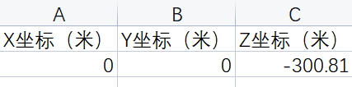

图 **7 result.xlsx**

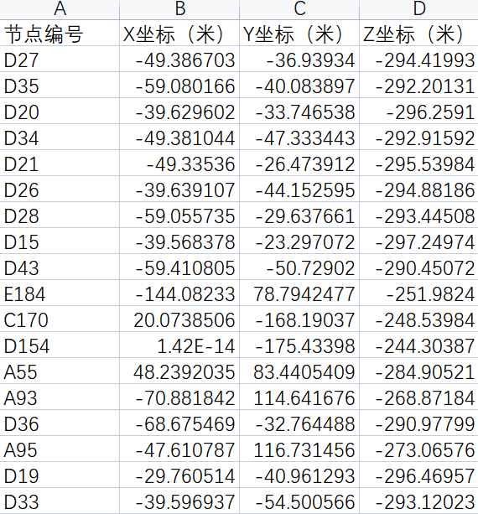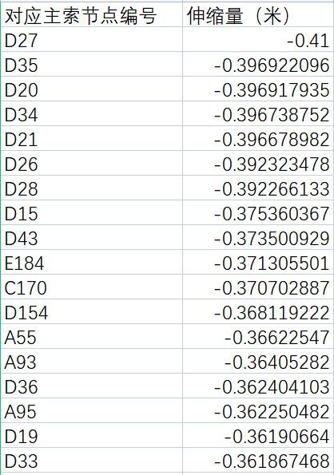

* 1. **result.xlsx (b) result.xlsx**

图 **8**

# 附录 C 问题 1——各抛物面相关参数与评分表

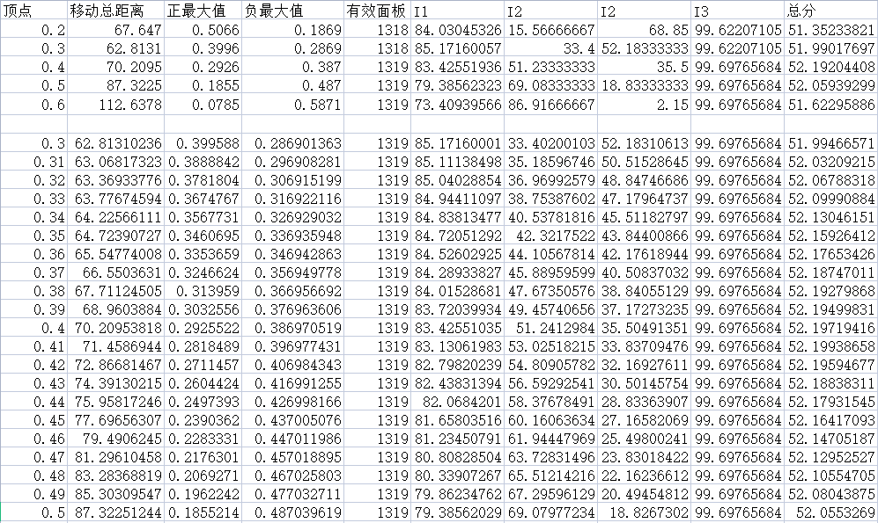

## 图 9 问题 1 各抛物面相关参数与评分表

附录 **D** 问题 **2**——各抛物面相关参数与评分表

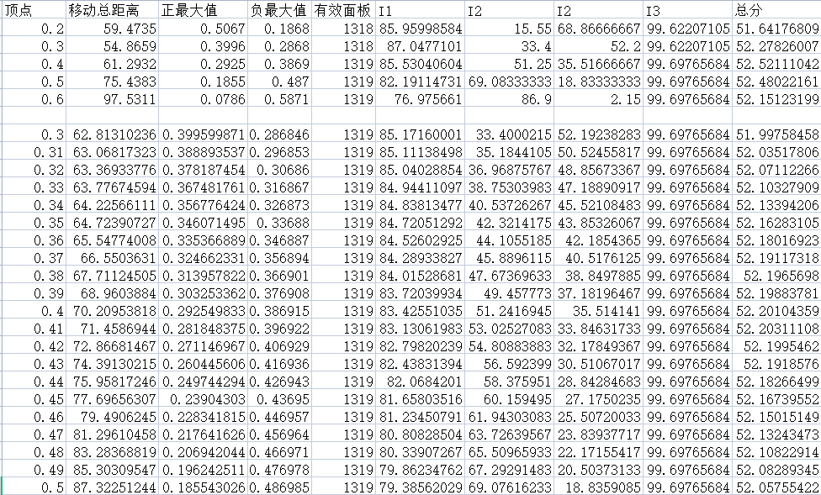

图 **10** 问题 **2** 各抛物面相关参数与评分表