**CS498 AMO Homework 2**

Team :

Minyuan Gu ([minyuan3@illinois.edu](mailto:minyuan3@illinois.edu), netid minyuan3)

Yanislav Shterev ([shterev2@illinois.edu](mailto:shterev2@illinois.edu), netid shterev2)

**Page 1 (15 points)**





**Page 2 (20 points)**

A plot of the validation accuracy every 30 steps, for each value of the regularization constant.

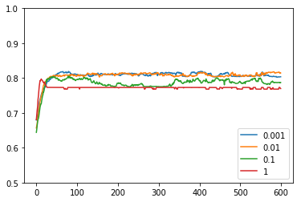

**Page 3 (20 points)**

A plot of the magnitude of the coefficient vector every 30 steps, for each value of the regularization constant.

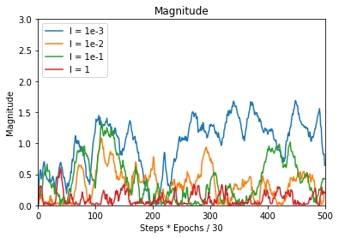

**Page 4 (25 points)**

The best value of the regularization rate was while lambda is 0.01 achieving 81.84% accuracy on the testing data. The corresponding m and n parameters being part of the learning rate formula were 1 and 300. Which produced a smooth training without huge fluctuations during the different epochs and steps. In that case the stochastic gradient descent was smoothly updating matrix A and the scalar value b. By increasing lambda, the penalization factor increases and features contribution to the learning was decreasing which caused model underfitting. Respectively having low value of lambda was causing overfitting of the model not being able to penalize enough.

**Page 5 (20 points)**

* SVM training with (stochastic) gradient descent updating
* Label prediction
* Calculation of the accuracies

**Page 6+**

All code should be attached at the end of the pdf.  There is no limit to the number of pages required for full code printout.