**CS498 AMO Homework 7**

Team :

Minyuan Gu ([minyuan3@illinois.edu](mailto:minyuan3@illinois.edu), netid minyuan3)

Yanislav Shterev ([shterev2@illinois.edu](mailto:shterev2@illinois.edu), netid shterev2)

#### Page 1 Distribution graph (5 points)

Show the distribution graph of words counts vs word rank.

#### 

#### 

#### Page 2 Identify the stop words (5 points)

The frequency thresholds we choose are: max_df=0.42, min_df=3. This means two things:

1. If a word appears more than 42% of the documents will be considered as a stop word. This setting will produced the following stop words (It will be explained later):

{'you', 'was', 'is', 'for', 'have', 'of', 'to', 'this', 'we', 'so', 'are', 'had', 'me', 'they', 'in', 'the', 'on', 'be', 'that', 'it', 'were', 'at', 'but', 'my', 'with', 'place', 'and'}

2. If a word appears at a frequency strictly lower than the given threshold, it will be ignored (cutoff). Here we examined min_df of either 2 or 3, which means if a word only occurs in just one or two documents (reviews in this case) it will be ignored and it is likely to be either a rarely used word, typo or junk characters that isn’t useful for our prediction (similar to an outlier). Between 2 and 3, we observed min_df = 3 substantially reduced dimension (around 2000 less) of feature vectors but with slightly better accuracy. So we choose 3.

**The reason we choose the stop words in point #1 above is:**

From the scatter plot on page 1, we observed a few words have high counts more than 10000 times, but we just have 2000 samples. This indicates we should list out those most frequently occurring words. We tried different max_df settings (e.g. max_df=0.5 means if a word occurs in more than 50% of the documents/samples it is considered as a stop word). We have

max_df=0.42, stop words are:

'but', 'it', 'my', 'with', 'the', 'on', 'was', 'is', 'for', 'have', 'they', 'that', 'of', 'to', 'in', 'and', 'this'

max_df=0.3, on top of those shown above, stop words contain extra words as below:

'so', 'at', 'are', 'had', 'you', 'place', 'me', 'be', 'not', 'were', 'we'

max_df=0.2, on top of those shown above, stop words contain extra words as below:

'food', 'them', 'back', 'go', 'would', 'out', 'will', 'just', 'time', 'as', 'all', 'no', 'what', 'an', 'service', 'can', 'very', 'if', 'one', 'about', 'like', 'their', 'up', 'from', 'great', 'there', 'get', 'good', 'when', 'or', 'here'

From above, from max_df=0.3 we start to see word with some negative meaning (e.g. ‘not’), at max_df=0.2 we see more and more words are included as stop words but expressing either positive or negative opinions, e.g. ‘great’, ‘good’, ‘like’, ‘no’ (and ‘not’). So we think we should stop at max_df=0.3 but with ‘not’ excluded from the stop list (‘not’ usually represents negative meaning so keep it away from stop word list).

In order to achieve that, using sklearn we choose max_df=0.42 and supply the stop word list as below:

{'you', 'was', 'is', 'for', 'have', 'of', 'to', 'this', 'we', 'so', 'are', 'had', 'me', 'they', 'in', 'the', 'on', 'be', 'that', 'it', 'were', 'at', 'but', 'my', 'with', 'place', 'and'}

Using the combination of max_df=0.42, min_df=3 and the stop_word list above, we have input vectors with length of 4606 (words/features).

#### Page 3 Distribution graph again (5 points)

After choosing the stop words, show the distribution graph of words counts vs word rank.

#### 

#### The outstanding point shown above 1500 is the word ‘not’ that we excluded (usually represents negative meaning). Except that, all other words have their counts lower than 1000.

#### 

#### Page 4 Code snippets (15 points)

Show the snippet of your code that you convert all the reviews into bag-of-words formulation using your chosen stop words and your code for nearest-neighbors with cos-distance.

def takeSecond(elem): #used to sort the words by its count  
 return elem[1]  
  
def vectorize_bagOfWd(X, stop_word_lst, maxDf=0.42, minDf=3):  
 plt.figure()  
 vectorizer = CountVectorizer()  
 bagOfWord = vectorizer.fit_transform(X)  
 voc_list = vectorizer.vocabulary_.keys()  
 wordRank = [[index, item] for index, item in enumerate(bagOfWord.sum(axis=0).tolist()[0])]  
 wordRank.sort(key=takeSecond, reverse=True)  
 plt.scatter(range(len(wordRank)), np.array(wordRank)[:, 1])  
 plt.xlabel(**'Word Rank'**)  
 plt.ylabel(**'Word Count'**)  
 plt.grid()  
 plt.show()  
  
 vectorizer_cutoff = CountVectorizer(max_df=maxDf, min_df=minDf, stop_words=stop_word_lst)  
 bagOfWord_swRemoved = vectorizer_cutoff.fit_transform(X)  
 voc_list_swRemoved = vectorizer_cutoff.vocabulary_.keys()  
 excluded_word = set(voc_list)-set(voc_list_swRemoved)  
 print(**"Excluded word list size: "**, len(excluded_word), **"**\n **Excluded word list:**\n**"**, **','**.join(excluded_word))  
 wordRank_swRemoved = [[index, item] for index, item in enumerate(bagOfWord_swRemoved.sum(axis=0).tolist()[0])]  
 wordRank_swRemoved.sort(key=takeSecond, reverse=True)  
 plt.figure()  
 plt.scatter(range(len(wordRank_swRemoved)), np.array(wordRank_swRemoved)[:, 1])  
 plt.xlabel(**'Word Rank'**)  
 plt.ylabel(**'Word Count'**)  
 plt.grid()  
 plt.show()  
 return bagOfWord_swRemoved, vectorizer_cutoff, excluded_word

def text_retrieval(vectorizer, query, Y, query_star=**'1'**, top=5, cos_dist_threshold=0.0):  
 neigh = NearestNeighbors(metric=**"cosine"**)  
 neigh.fit(bagOfWord_vectors.toarray(),Y)  
 print(**"Your query is: "**, query)  
 query = query.lower()  
 query_vector = vectorizer.transform([query])  
 query_distance, query_results = neigh.kneighbors(query_vector.toarray(), top)  
 filtered_index = []  
 print(top, **" closest results: "**)  
 for idx, item in enumerate(query_results[0]):  
 if query_distance[0,idx]<=(1-cos_dist_threshold):  
 print(**"review #"**,idx+1, **", cosine distance: "**, **'%.4f'**%(1-query_distance[0,idx]), **" : "**, X[query_results[0,idx]][0:199])  
 filtered_index.append(query_results[0,idx])  
 if len(filtered_index)>0:  
 accuracy = sum(Y[filtered_index]==query_star)/len(filtered_index)  
 else:  
 accuracy = None  
 print(**"Accuracy is"**, accuracy, **", "**, sum(Y[filtered_index]==query_star), **"out of total matched"**, len(filtered_index), **"are correct"**)  
 return accuracy, len(filtered_index)

stop_words = [**'you'**, **'was'**, **'is'**, **'for'**, **'have'**, **'of'**, **'to'**, **'this'**, **'we'**, **'so'**, **'are'**, **'had'**, **'me'**, **'they'**, **'in'**, **'the'**, **'on'**, **'be'**, **'that'**, **'it'**, **'were'**, **'at'**, **'but'**, **'my'**, **'with'**, **'place'**, **'and'**]  
bagOfWord_vectors, vectorizer, excluded_word = vectorize_bagOfWd(X, stop_words, 0.42, 3)

text_retrieval(vectorizer, **"Horrible customer service"**, Y, query_star=**'1'**, top=5)

#### Page 5 Reviews with score (10 points)

Show the original reviews with the distance scores

Your query is: Horrible customer service

5 closest results:

**review # 1 , cosine distance: 0.6299 :**

rogers ...

1) is over priced

2) have horrible customer service

3) faulty and incorrect billing

4) poor customer service

5) not enough options

6) never arrive for an appointment

**review # 2 , cosine distance: 0.4576 :**

horrible service, horrible customer service, and horrible quality of service! do not waste your time or money using this company for your pool needs. dan (602)363-8267 broke my pool filtration syst

**review # 3 , cosine distance: 0.4444 :**

service was horrible came with a major attitude. payed 30 for lasagna and was no where worth it. won't ever be going back and will never recommend this place. was treated absolutely horrible. horribl

**review # 4 , cosine distance: 0.3849 :**

customer service was super bad. the pizza was cold by the time they delivered it to me.

**review # 5 , cosine distance: 0.3790 :**

went to marca today to get a haircut and was given a great service both by front desk - customer service and by georgia, girl who did my hair. i guess i got lucky with her as she has years of experie

Accuracy is 0.8, 4 out of total matched 5 are correct

#### Page 6 Query results (10 points) Show your document results and explain the reasons that you choose them.

First of all, among the top 5 matches, first 4 of them are good matches. They have cosine distances: 0.6299, 0.4576, 0.4444 and 0.3849 and their ‘star score=1’, which matches the query ‘Horrible customer service’.

And then we look at all the distances scores retrieved, and plot their accuracy & number of matches against the cosine distance thresholds (the k-nearest returned results must have a cosine distance larger than the threshold in order to be considered as a match).

The left plot we set K=2000 which means we include all the samples. The right plot we zoom in to just nearest 50 samples (K=50). From those plots, we can see, if we raise the threshold the accuracy will increase (tighten the selection) while the number of matches will decrease.

#### 

70% accuracy (0.7 in the plot) is achieved at the cosine distance threshold of >=0.33. At cosine distance threshold of 0.33, 11 documents were returned and among them 9 documents are correct matches. They are shown below (wrong one are highlighted in red):

**review # 1** , cosine distance: 0.6299 : rogers ...

1) is over priced

2) have horrible customer service

3) faulty and incorrect billing

4) poor customer service

5) not enough options

6) never arrive for an appointment

**review # 2** , cosine distance: 0.4576 : horrible service, horrible customer service, and horrible quality of service! do not waste your time or money using this company for your pool needs. dan (602)363-8267 broke my pool filtration syst

**review # 3** , cosine distance: 0.4444 : service was horrible came with a major attitude. payed 30 for lasagna and was no where worth it. won't ever be going back and will never recommend this place. was treated absolutely horrible. horribl

**review # 4** , cosine distance: 0.3849 : customer service was super bad. the pizza was cold by the time they delivered it to me.

**review # 5** , cosine distance: 0.3790 : went to marca today to get a haircut and was given a great service both by front desk - customer service and by georgia, girl who did my hair. i guess i got lucky with her as she has years of experie

**review # 6** , cosine distance: 0.3612 : the service is horrible. it's not bad inside, but really one of the most annoying clubs in vegas. i'm all for vegas clubs, but service here sucks.

**review # 7** , cosine distance: 0.3522 : i come here now for all my car service needs. in my experiences, the work is always performed in an efficient, effective manner and in good humor. i appreciate the consistent attention paid to prov

**review # 8** , cosine distance: 0.3482 : horrible customer service! been with them over 2 years, and after staying with them during my last move they raised my bill almost double for the same services! sent two emails since i don't have t

**review # 9** , cosine distance: 0.3482 : horrible service....what a mess upon ordering and paying. where is the manager on duty to fix this!

**review # 10** , cosine distance: 0.3333 : they shut down. makes sense, they had terrible service and subpar food..should have listened to your customer base.

**review # 11** , cosine distance: 0.3333 : worse customer service . trying to ask for help .... no one volunteer to help. this is ridiculous

Accuracy is 0.8181818181818182 , 9 out of total matched 11 are correct

#### Page 7 Accuracy with threshold 0.5 (10 points)

Show your code for creating classifier. Report the accuracy on train and test dataset with threshold 0.5.

 def logistic_regression(X_train, X_test, y_train, y_test):  
 clf = LogisticRegression(solver=**'liblinear'**, max_iter=100)  
 clf.fit(X_train, y_train)  
 predicted_accurary = clf.score(X_test, y_test)  
 train_accuracy = clf.score(X_train, y_train)  
 print(**"Test accuracy is: "**, predicted_accurary, **" Train accuracy is: "**, train_accuracy)  
 return clf

#### Test accuracy is: 0.96. Train accuracy is: 0.9994444444444445

#### Page 8 Predicted scores (10 points)

Show your code for plotting predicted scores and show the figure.

 def plot_histogram(logistic_clf, X_train, y_train):  
 predicted_proba = logistic_clf.predict_proba(X_train)  
 plt.hist([predicted_proba[y_train==**'1'**][:,1],predicted_proba[y_train==**'5'**][:,1]], bins=100, histtype=**'stepfilled'**)  
 plt.xlabel(**"Predicted Score"**)  
 plt.ylabel(**"Count of predictions in bucket"**)  
 false_positive = predicted_proba[y_train==**'1'**][predicted_proba[y_train==**'1'**][:,1]>=0.5]  
 false_negative = predicted_proba[y_train==**'5'**][predicted_proba[y_train==**'5'**][:,1]<=0.5]

#### 

#### Page 9 Accuracy again and curve (20 points) Report the accuracy on train and test dataset with a different threshold. Explain why you choose that threshold.

From the above plots, the 2 different classes are actually separated pretty well, and nearly no overlap across 0.5 (the default threshold). In order to further troubleshooting, we list out the top 5 lowest predicted scores for positive samples and top 5 highest predicted scores for negative ones. See below:

Top 5 largest predicted probability for negative reviews:

0.23707403725589477

0.24493811118253017

0.2613864005027665

0.2732259999116515

0.6006987072381691

Top 5 smallest predicted probability for positive reviews:

0.5882788918196694

0.7301469942797999

0.739769888043451

0.7434682520954394

0.7458043285593453

It can be easily seen there is only one outlier in negative reviews which have a score of 0.6007 and force it to be predicted as a positive review. And let’s find it out before we talk about the threshold:

X[304]: 'i have friends who love this place, and the food can be good. but my personal interactions with them have been not so great :('

Y[304]: ‘1’

Now we know why it was classified as positive review while it is actually a one star review. Many positive key words like ‘love’, ‘good’ and ‘great’ are included, even there is a ‘not’ in front of ‘so great’ but since our model doesn’t not consider the word sequence, it is beyond our model’s capability and tweaking threshold is not actually meaningful.

However, for the sake of trying a different threshold, let’s ignore this outlier and try to shift the threshold to the mid-point between largest negative review score and smallest positive review score to allow better room for prediction. So we shift our new threshold to this mid-point (0.4307524458656604), we achieved the following accuracy on training and testing data:

Training accuracy with threshold changed: 99.94444444444444 %

Test accuracy with threshold changed: 94.0 %

It performs very close to the default threshold value 0.5 used (slightly worse than the 0.96 from the default threshold on page 7), and it doesn’t suggest it as a better value than the default threshold.

Plot the ROC curve.

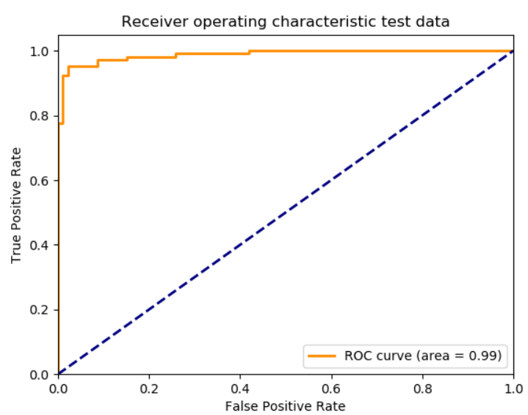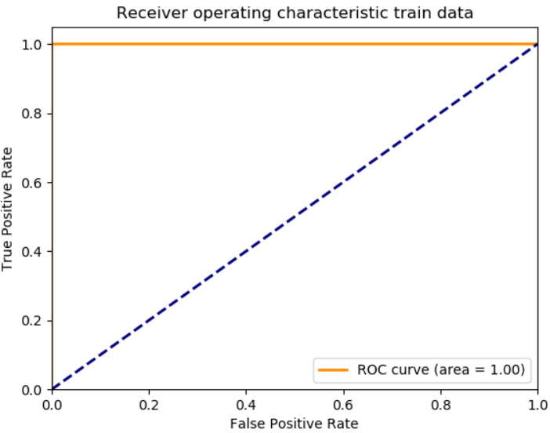

#### Page 10 Best threshold (10 points) Choose the threshold that minimizes false positives while maximizing true positives. Explain your reason.

From the above ROC plot (we choose test data for the discussion purpose, since we explained above train data only misclassified one outlier which is beyond the model capability), we can choose a point on the curve tangent at a line parallel to the diagonal to minimize the false positive while maximizing the true positive. At the point of false positive rate of 0.02150538, we could achieve a true positive rate of 0.95327103 and the associated threshold is 0.544162755. This is very close to the default 0.5.

See the below fpr (false positive rate), tpr (true positive rate) and thresholds.

fpr

array([0. , 0. , 0. , 0.01075269, 0.01075269,

0.02150538, 0.02150538, 0.08602151, 0.08602151, 0.15053763,

0.15053763, 0.25806452, 0.25806452, 0.41935484, 0.41935484,

1. ])

tpr

array([0. , 0.00934579, 0.77570093, 0.77570093, 0.92523364,

0.92523364, 0.95327103, 0.95327103, 0.97196262, 0.97196262,

0.98130841, 0.98130841, 0.99065421, 0.99065421, 1. ,

1. ])

thresholds

array([1.99999999e+00, 9.99999990e-01, 8.97555987e-01, 8.88431005e-01,

6.59130072e-01, 6.45812214e-01, 5.44162755e-01, 4.38586484e-01,

4.29333589e-01, 1.52490327e-01, 1.47008822e-01, 4.00848079e-02,

3.82366796e-02, 1.21272114e-02, 1.15356012e-02, 1.38818025e-14])

With this new threshold, so we have an accuracy similar to the default threshold (0.5):

Test accuracy with threshold changed: 96.0 %

**Libraries used & Reference:**

**David Forsyth’s book** - Applied Machine Learning

**Trevor Walker’s lecture and sample code** – CS-498 Lecture videos

**csv** – for reading data from csv format: <https://docs.python.org/3/library/csv.html>

**Yelp’s reviews dataset** - <http://courses.engr.illinois.edu/cs498aml/sp2019/homeworks/yelp_2k.csv>

**Numpy** - <http://www.numpy.org/>

**matplotlib** - to plot the sum-squared error, mean images and distances plots: <https://matplotlib.org/>

**scikit-learn framework:** [https://scikit-learn.org](https://scikit-learn.org/)