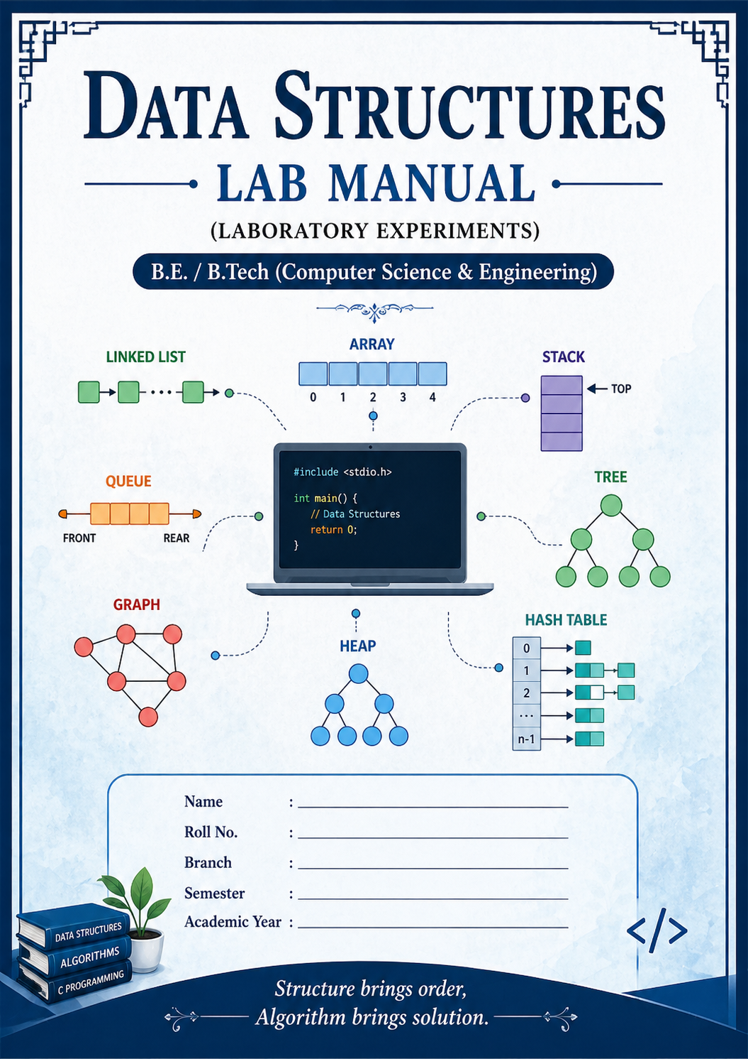

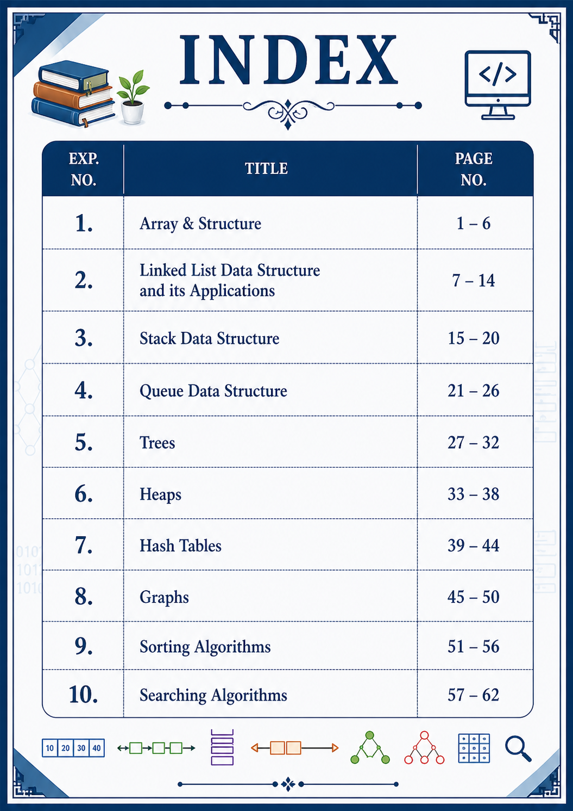

EXPERIMENT – 1
Title: Array & Structure

Aim
To apply the concepts of arrays and structures, and perform operations like insertion, deletion, recursion, and matrix operations.

Theory
- An array is a collection of elements stored in contiguous memory locations.
- A structure is a user-defined data type used to group different types of variables.
- Arrays can be:
  - 1D (linear)
  - 2D (matrix)
- Recursion is a method where a function calls itself.

Code:-
# Sum using recursion
def sum_array(arr, n):
if n == 0:
return 0
return arr[n-1] + sum_array(arr, n-1)

arr = list(map(int, input("Enter elements: ").split()))
print("Sum =", sum_array(arr, len(arr)))

# Linear Search
key = int(input("Enter element to search: "))
if key in arr:
print("Element found")
else:
print("Not found")

Output:-
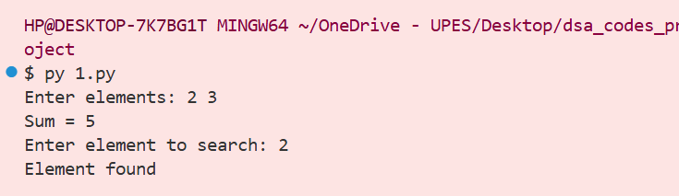

EXPERIMENT – 2
Title: Linked List Data Structure and its Applications
Aim
To implement a singly linked list and its operations.
Theory
- Linked list stores elements using nodes.
- Each node contains data + pointer to next node.

Code:-
class Node:
def __init__(self, data):
self.data = data
self.next = None

class LinkedList:
def __init__(self):
self.head = None

def insert(self, data):
new = Node(data)
new.next = self.head
self.head = new

def display(self):
temp = self.head
while temp:
print(temp.data, end=" -> ")
temp = temp.next

ll = LinkedList()
ll.insert(10)
ll.insert(20)
ll.insert(30)
ll.display()

Output:-
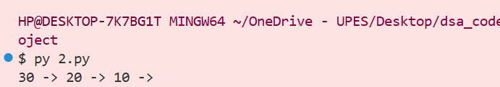

EXPERIMENT – 3
Title: Stack Data Structure
Aim
To implement stack using list.
Theory
- Stack follows LIFO (Last In First Out).

Code:-
stack = []

stack.append(10)
stack.append(20)
stack.append(30)

print("Stack:", stack)

stack.pop()
print("After pop:", stack)

Output:-
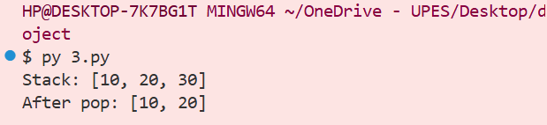

EXPERIMENT – 4
Title: Queue Data Structure
Aim
To implement queue operations.
Theory
- Queue follows FIFO (First In First Out).

Code:-
from collections import deque

q = deque()

q.append(10)
q.append(20)
q.append(30)

print("Queue:", list(q))

q.popleft()
print("After dequeue:", list(q))

Output:-
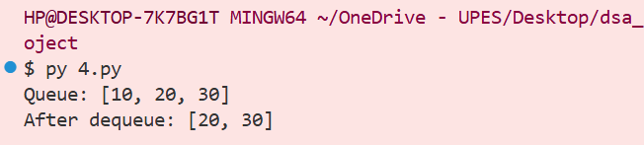

EXPERIMENT – 5
Title: Trees
Aim
To perform tree traversal.
Theory
- Binary tree has max 2 children.
- Traversals:
  - Inorder
  - Preorder
  - Postorder

Code:-
class Node:
def __init__(self, val):
self.left = None
self.right = None
self.val = val

def inorder(root):
if root:
inorder(root.left)
print(root.val, end=" ")
inorder(root.right)

root = Node(1)
root.left = Node(2)
root.right = Node(3)

inorder(root)

Output:-
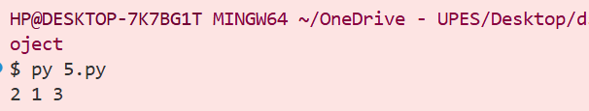

EXPERIMENT – 6
Title: Heaps
Aim
To implement heap operations.
Theory
- Heap is a complete binary tree.
- Python uses heapq.

Code:-
import heapq

heap = []

heapq.heappush(heap, 10)
heapq.heappush(heap, 5)
heapq.heappush(heap, 20)

print("Heap:", heap)

heapq.heappop(heap)
print("After pop:", heap)

Output:-
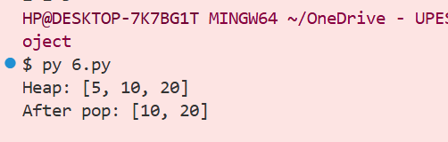

EXPERIMENT – 7
Title: Hash Table
Aim
To implement hashing.
Theory
- Hash table stores key-value pairs.
- Python uses dictionaries.

Code:-
hash_table = {}

hash_table[101] = "Alice"
hash_table[102] = "Bob"

print(hash_table)

print("Search:", hash_table.get(101))

Output:-
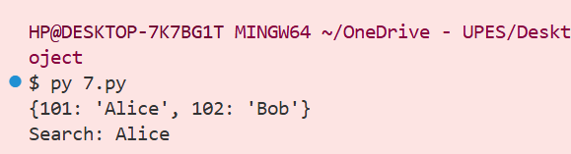

EXPERIMENT – 8
Title: Graphs
Aim
To represent graph using adjacency matrix.
Theory
- Graph = vertices + edges
- Matrix representation used

Code:-
graph = [
[0,1,1],
[1,0,1],
[1,1,0]
]

for row in graph:
print(row)

Output:-
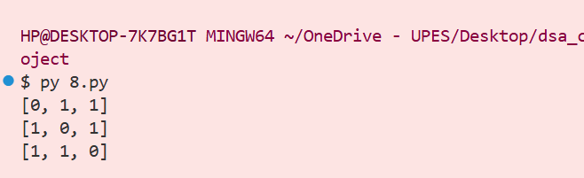

EXPERIMENT – 9
Title: Sorting Algorithm
Aim
To implement sorting algorithms.
Theory
- Sorting arranges data in order.

Code (Selection Sort):-
arr = [64, 25, 12, 22, 11]

for i in range(len(arr)):
min_idx = i
for j in range(i+1, len(arr)):
if arr[j] < arr[min_idx]:
min_idx = j
arr[i], arr[min_idx] = arr[min_idx], arr[i]

print("Sorted:", arr)

Output:-
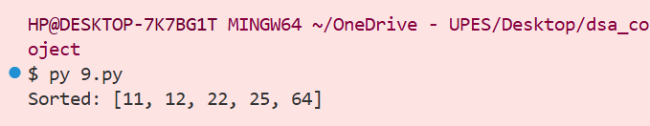

EXPERIMENT – 10
Title: Searching Algorithm
Aim
To implement linear and binary search.
Theory
- Linear search → sequential
- Binary search → requires sorted array

Code:-
arr = [10, 20, 30, 40, 50]

# Linear Search
key = 30
print("Found" if key in arr else "Not Found")

# Binary Search
low, high = 0, len(arr)-1
found = False

while low <= high:
mid = (low + high)//2
if arr[mid] == key:
found = True
break
elif arr[mid] < key:
low = mid + 1
else:
high = mid - 1

print("Binary Search:", "Found" if found else "Not Found")

Output:-
