
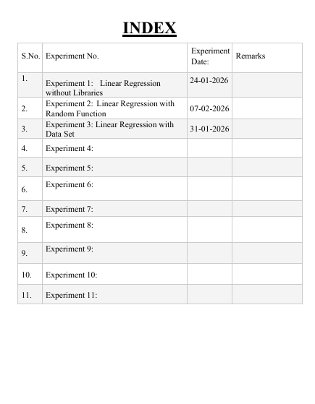
EXPERIMENT-01
Implementing Linear Regression Model without Libraries
Aim :-
To understand and implement Linear Regression using the slope and intercept method for predicting continuous values. The experiment aims to determine the best-fit straight line for a given dataset by calculating the slope (theta_1) and intercept (theta_0) of the regression equation. This helps in analyzing the relationship between the independent variable and the dependent variable, and in using the derived linear model to make predictions.
Code :-
print("Swayam Bhuyan,24/01/26,8:45 AM")

# Regression - Relation between the dependent and independent variable..

# Step 1: Sample data
# x -> feature, y -> target
x = [1, 2, 3, 4, 5]
y = [3, 4, 2, 5, 6]

# Step 2: Calculate mean of x and y
x_mean = sum(x) / len(x)
y_mean = sum(y) / len(y)

# Step 3: Calculate the slope (theta_1)
numerator = sum((xi - x_mean) * (yi - y_mean) for xi, yi in zip(x, y))
denominator = sum((xi - x_mean) ** 2 for xi in x)
theta_1 = numerator / denominator

# Step 4: Calculate the intercept (theta_0)
theta_0 = y_mean - theta_1 * x_mean

print(f"Slope (theta_1): {theta_1}")
print(f"Intercept (theta_0): {theta_0}")

# Step 5: Define the prediction function
def predict(X_values):
return [theta_0 + theta_1 * xi for xi in X_values]

# Step 6: Test the model
x_test = [6, 7, 8]
y_pred = predict(x_test)
print(f"Predictions for {x_test}: {y_pred}")

print("Swayam Bhuyan,31/01/26,8:30 AM")

# Step 7: Visualize the results
import matplotlib.pyplot as plt

# Plot Original data
plt.scatter(x, y, label='Original Data', color='blue')

# Plot regression line
x_line = range(min(x), max(x) + 1)
y_line = predict(x_line)
plt.plot(x_line, y_line, label='Regression Line', color='red')

plt.xlabel('X')
plt.ylabel('Y')
plt.legend()
plt.show()

OUTPUT:-
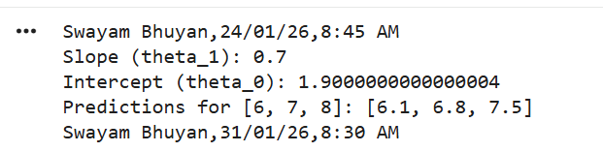
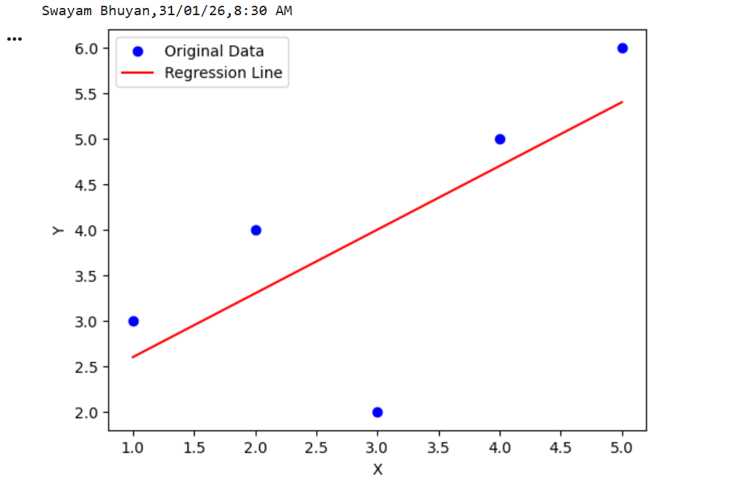
EXPERIMENT-02
Linear Regression with Random Function
Aim :-
To understand and implement Linear Regression using a random function by generating a
random dataset, fitting a best-fit straight line using the slope and intercept method, and
analysing the relationship between the independent and dependent variables.
Code :-
import random
import matplotlib.pyplot as plt

# Generate random data for x and y
random.seed(42)
x = [random.randint(1, 50) for _ in range(100)]
y = [3 * xi + random.randint(-10, 10) for xi in x]

# Calculate means
x_mean = sum(x) / len(x)
y_mean = sum(y) / len(y)

# Calculate slope (theta_1) and intercept (theta_0)
num = sum((xi - x_mean) * (yi - y_mean) for xi, yi in zip(x, y))
deno = sum((xi - x_mean) ** 2 for xi in x)

theta_1 = num / deno
theta_0 = y_mean - theta_1 * x_mean

print(f"Slope (theta_1): {theta_1}")
print(f"Intercept (theta_0): {theta_0}")

# Define prediction function
def predict(x_values):
return [theta_0 + theta_1 * xi for xi in x_values]

# Calculate predictions for original x values
y_pred = predict(x)

# Plot Original data
plt.scatter(x, y, label='Original Data', color='blue')

# Plot regression line
x_line = range(min(x), max(x) + 1)
y_line = predict(x_line)

plt.plot(x_line, y_line, label='Regression Line', color='red')

print("Swayam Bhuyan,590022823,31/01/2026,9:30AM")

# Add labels and legend
plt.xlabel('x')
plt.ylabel('y')
plt.legend()
plt.show()

OUTPUT:-
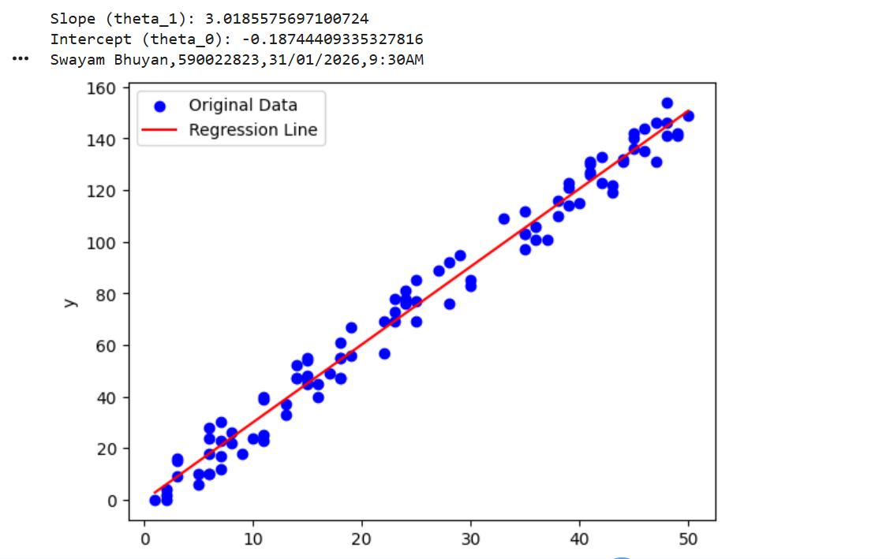
EXPERIMENT-03
Linear Regression with Data Set
Aim :-
To implement Simple Linear Regression using the slope and intercept (mathematical) method
in order to study the relationship between Mid Semester Marks (independent variable) and
End Semester Marks (dependent variable). The experiment involves calculating the slope (θ₁)
and intercept (θ₀) of the best-fit line using statistical formulas, visualizing the regression line
along with the original data points, and using the model to predict continuous outcomes.

Code :-
# Step 1: Upload Excel file
from google.colab import files
uploaded = files.upload()

# Step 2: Read Excel file
import pandas as pd
df = pd.read_excel("Data.xlsx")

print(df.head())
print(df.tail())
print(list(df.columns))

# Step 3: Convert columns to numeric (IMPORTANT)
x = pd.to_numeric(df['MID SEM MARKS'], errors='coerce')
y = pd.to_numeric(df['END SEM MARKS'], errors='coerce')

# Remove NaN values
mask = x.notna() & y.notna()
x = x[mask]
y = y[mask]

# Step 4: Calculate mean
x_mean = sum(x) / len(x)
y_mean = sum(y) / len(y)

# Step 5: Calculate slope (theta_1)
numerator = sum((xi - x_mean) * (yi - y_mean) for xi, yi in zip(x, y))
denominator = sum((xi - x_mean) ** 2 for xi in x)
theta_1 = numerator / denominator

# Step 6: Calculate intercept (theta_0)
theta_0 = y_mean - theta_1 * x_mean

print(f"Slope (theta_1): {theta_1}")
print(f"Intercept (theta_0): {theta_0}")

print("Swayam Bhuyan,590021784,31/01/2026,9:30AM")

# Step 7: Prediction function
def predict(X_values):
return [theta_0 + theta_1 * xi for xi in X_values]

# Step 8: Plot graph
import matplotlib.pyplot as plt

plt.scatter(x, y, label='Original Data', color='blue')

x_line = range(int(min(x)), int(max(x)) + 1)
y_line = predict(x_line)

plt.plot(x_line, y_line, label='Regression Line', color='red')

plt.xlabel('Mid Sem Marks')
plt.ylabel('End Sem Marks')
plt.legend()
plt.show()

OUTPUT:-
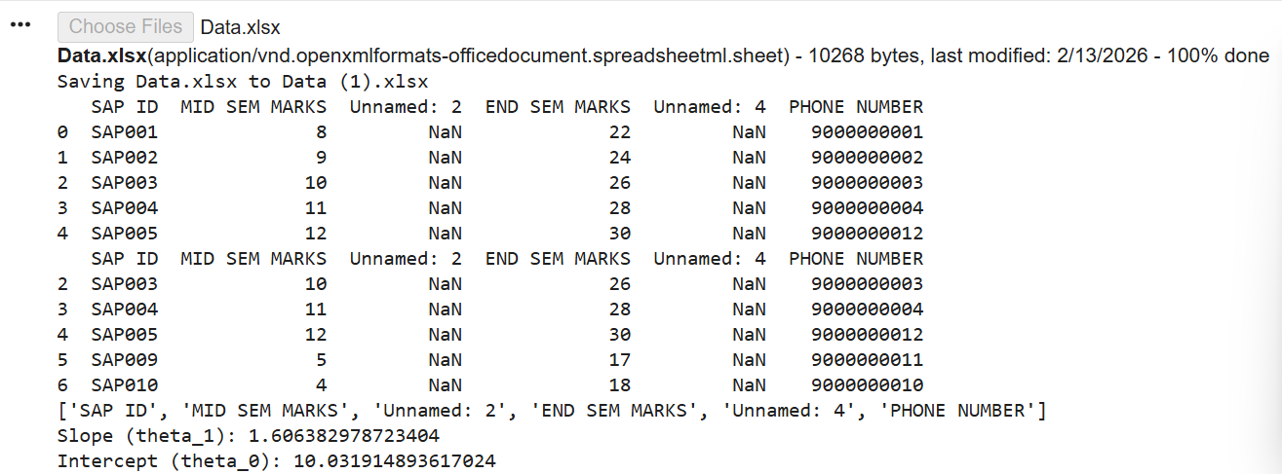
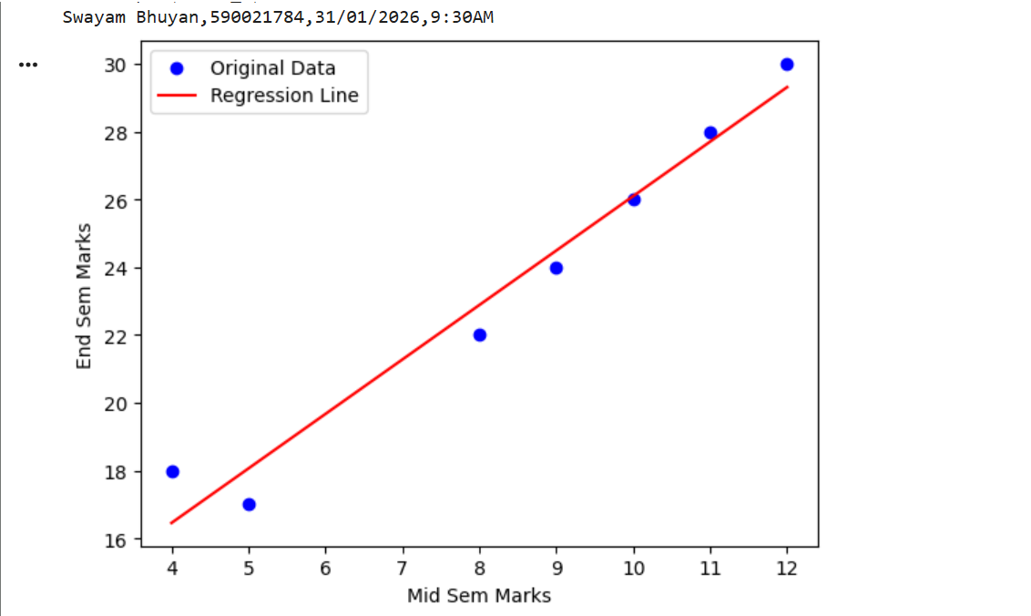

EXPERIMENT-04

Linear Regression using Gradient Descent
Aim :-
To implement Linear Regression using the Gradient Descent algorithm in Python in order to predict the DiabetesPedigreeFunction based on the Glucose values from the given dataset.
Code :-
from google.colab import files
uploaded = files.upload()
import pandas as pd
import numpy as np
import matplotlib.pyplot as plt
# Load dataset
df = pd.read_csv('diabetes.csv')
# Extract required columns
x = np.array(df ['Glucose'] )
y = np.array(df ['DiabetesPedigreeFunction'] )

# Initialize parameters
Theta_1 = 0.0 # slope
Theta_0 = 0.0 # intercept
learning_rate = 0.00001
iterations = 1000

# Cost Function (Mean Squared Error)
def compute_cost(x, y, Theta_1, Theta_0):
m = len(y)
prediction = Theta_1 * x + Theta_0
cost = (1 / (2 * m)) * np.sum((prediction - y) ** 2)
return cost

# Gradient Descent Function
def gradient_descent(x, y, Theta_1, Theta_0, learning_rate):
m = len(y)
prediction = Theta_1 * x + Theta_0

d_1 = (1 / m) * np.sum((prediction - y) * x)
d_0 = (1 / m) * np.sum(prediction - y)
Theta_1 = Theta_1 - learning_rate * d_1
Theta_0 = Theta_0 - learning_rate * d_0
return Theta_1, Theta_0

# Training loop
for i in range(iterations):
Theta_1, Theta_0 = gradient_descent(x, y, Theta_1, Theta_0, learning_rate)
if i % 100 == 0:
cost = compute_cost(x, y, Theta_1, Theta_0)
print(f"Iteration {i}, Cost: {cost:.6f}, Theta_1: {Theta_1:.6f}, Theta_0: {Theta_0:.6f}")
# Final Parameters
print("\nFinal Model Parameters:")
print(f"Theta_1 (Slope): {Theta_1:.6f}")
print(f"Theta_0 (Intercept): {Theta_0:.6f}")

# Predictions
y_pred = Theta_1 * x + Theta_0
print("Swayam Uddeepta bhuyan,590021784,14/02/2026,10:00 AM")

# Plotting
plt.scatter(x, y, label="Actual Data")
plt.plot(x, y_pred, label="Fitted Line", color="red")
plt.xlabel("Glucose")
plt.ylabel("DiabetesPedigreeFunction")
plt.title("Linear Regression using Gradient Descent")
plt.legend()
plt.show()

OUTPUT:-
