Lab 11

Prolog programming & Functions
Aim: Study of Prolog programming and its function.

Theory:
Prolog (PROgramming in LOGic) is a declarative programming language based on first-order logic (predicate logic). It is widely used in artificial intelligence (AI), natural language processing (NLP), expert systems, and symbolic reasoning.
Instead of executing step-by-step instructions like procedural languages (C, Java, Python), Prolog defines relationships and rules, and the Prolog interpreter searches for solutions based on queries.
- Based on Predicate Logic – Prolog is built on first-order predicate logic, meaning it works with facts, rules, and queries.
- Declarative Approach – You define relationships between objects instead of writing step-by-step instructions.
- Backtracking Mechanism – Prolog searches for solutions using a depth-first search and backtracks when needed.
- Pattern Matching (Unification) – Prolog uses unification to match terms and derive conclusions.
- Recursion Instead of Loops – Since Prolog lacks traditional loops (for, while), recursion is used.

Application | Use Case
Artificial Intelligence (AI) | Expert systems, chatbots
Natural Language Processing (NLP) | Grammar processing, language translation
Knowledge Representation | Semantic web, ontology modeling
Automated Theorem Proving extensively. | Mathematical reasoning
Database Querying | Logic-based data retrieval
Game Development | AI-based decision-making

Structure:
A Prolog program consists of three main elements:
- Facts – Defining knowledge in the form of statements
A fact is a basic assertion that represents known information. Facts must always end with a period (.).
- Rules – Logical relationships derived from facts
A rule defines a relationship between facts using logical conditions. Syntax:

head :- body.
  - head is the conclusion (what we want to infer).
  - body is a condition that must be true for the rule to hold.

- Queries – Questions asked to infer new information
Queries allow us to retrieve information from facts and rules.
  - If Prolog finds a solution, it returns true (Yes).
  - If no solution exists, it returns false (No).
  - If multiple solutions exist, Prolog asks: ; for more results.

Examples:
(1) Food and Meal

Facts | Rules | Query
food(burger).  food(sandwich). food(pizza).  lunch(sandwich). dinner(pizza). | meal(X):-food(X). | Food(pizza) Meal(X), food(X)

Output:
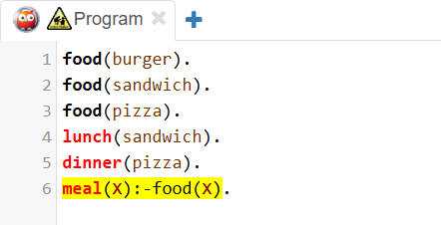
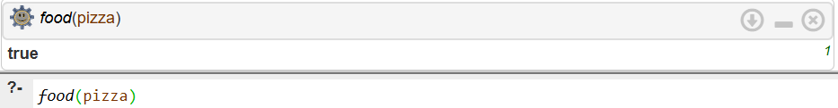
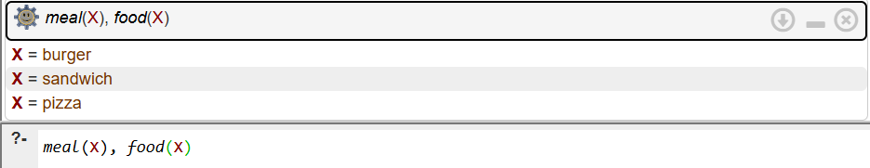

Explanation:
? food(pizza): is pizza is food?
- We define the relation with the help of proposition logic that pizza is a food (food(pizza))
- So, it returns true
? meal(X), food(X): is X is meal and food?
We define that every x is meal if it is food using proposition logic(meal(X):-food(X))

So it gives all food name that is define as food().
(2) Rotes and path

Facts | Rules | query
path(a, b).  path(b, c).  path(c, d).  path(d, e). | route(X, Y, [X,Y]) :- path(X, Y).  route(X, Y, [X|Path]) :- path(X, Z), route(Z, Y, Path). | route(a,e, Path);  route(b,c, Path);  route(a, d, Path); route(d,c, Path)

Output:
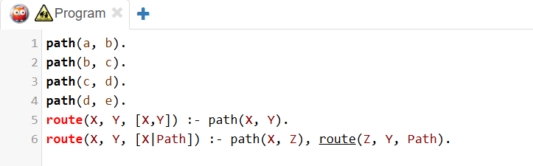
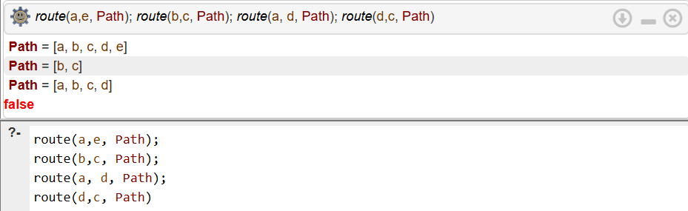

Explanation:
? route(a, e, Path): is a to e route exists?
- Here is all existing path is defined using path(node1, node2). And in rule it is also defined that indirect paths are also consider. Like there is a path between node 1 and node 2 exist and route between node 2 and node 3 is defined then node 1 and node 3 route is also existed.
- So, a to e path is defined that why it gives true.
- Path provides the direct or indirect route if exists
? route(b, c): is b to c route exists?
- Direct path is existed between b and c so it returns true.
- Path provides the direct or indirect route if exists
? route(d, c): is d to c route exists?
- We defined directed path.
- So here no direct or indirect path exist between d and c, so returns false.
- Path provides the direct or indirect route if exists

