**Assignment-1**

* **Process For Create Repository in GitHub and Add Folder:**
* **Step - 1:** Goto GitHub site and login. And then Select New Repositories.

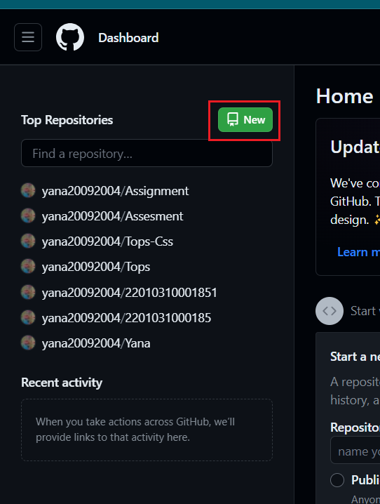

* 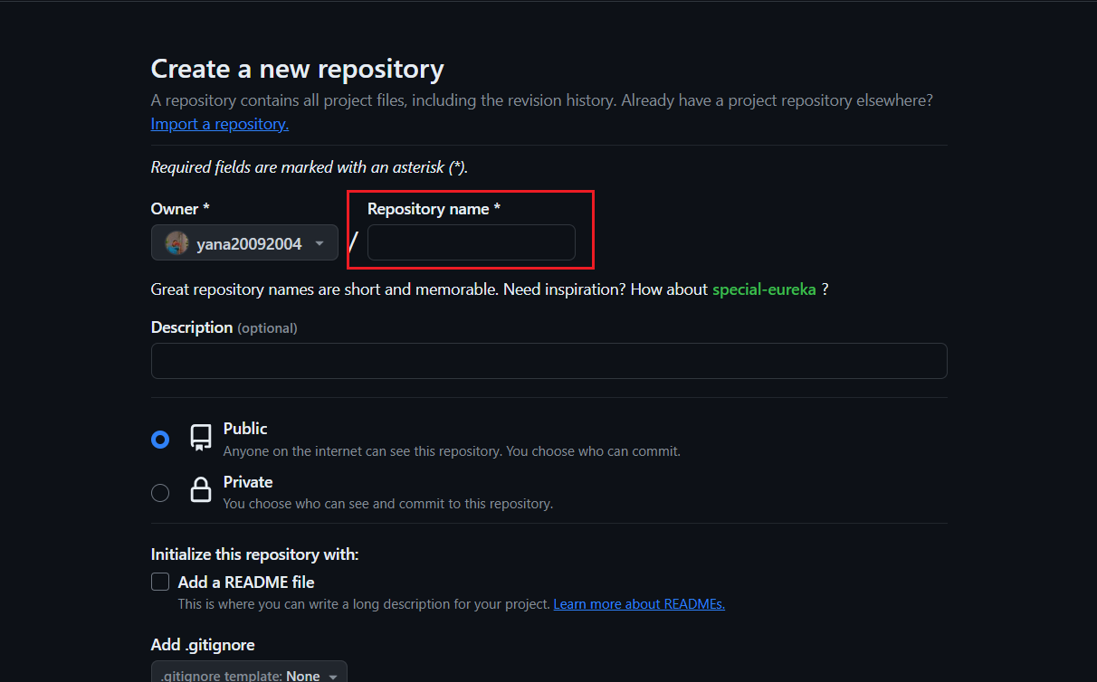**Step - 2:** Then Give Your Repo Name whatever you want and select public. Then you can add README File if you want to add.
* **Step - 3:** End last select Create repository.

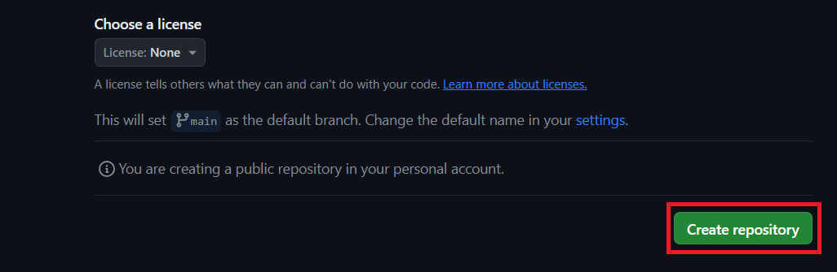

* 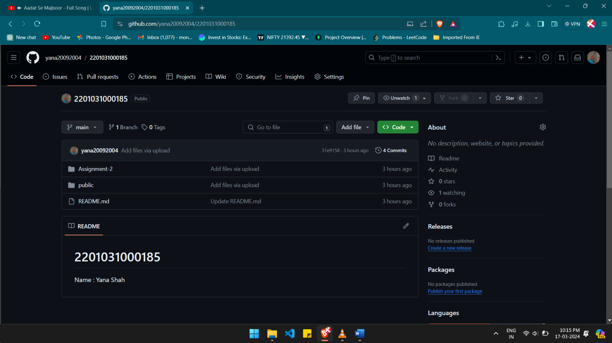**Step - 4:** Your Repository Will be look like this.
* **Step - 5:** Here, You can upload File From your Desktop.

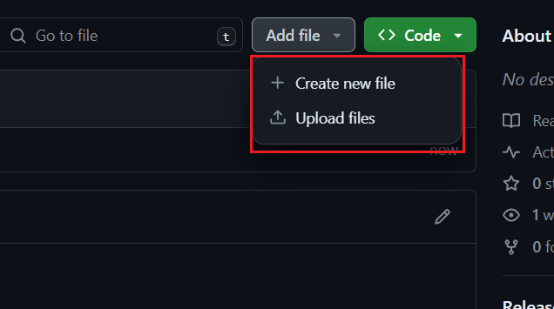

* **Step – 6:** And also you can clone this repository to your pc. For Clone, you need to select HTTPS url display below in picture.

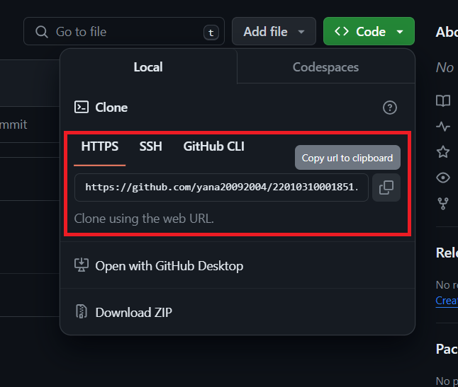

* **Step – 7:** Then go to your Folder which folder you want to create Clone. And then select Git Bash for clone.

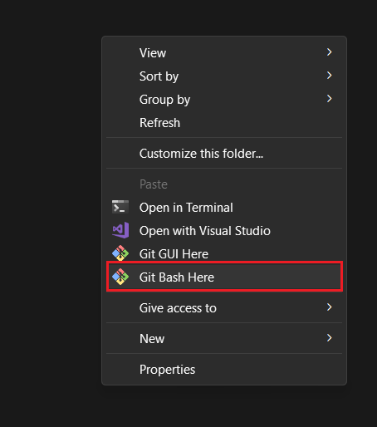

* **Step – 8:** After this you add HTTPS url for clone. (git clone url).
* **Step – 9:** If your url true and you enter correct statement then no error will be display and task will be done.
* **Step – 10:** After Create New Folder on your Repository Folder.

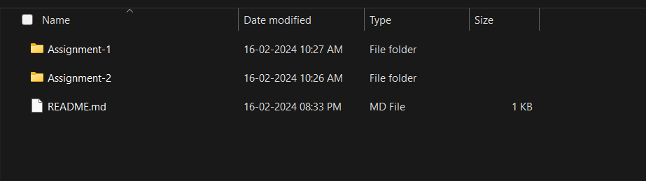

* **Step – 11:** At last Upload Your Folder and File on GitHub using Upload File

