Smart Home Automation IoT System

for Disabled and Elderly

|  |  |  |  |
| --- | --- | --- | --- |
| Anushka Gupta  *ECE(AI) Department* *Indira Gandhi Delhi Technical University For Women* Delhi , India anushka.2210@gmail.com | Yana Parashar  *MAE Department* *Indira Gandhi Delhi Technical University For Women* Delhi , India parasharyana2003@gmail.com | Meghna  *ECE(AI) Department*  *Indira Gandhi Delhi Technical University for Women* Delhi, India nonitasharma@igdtuw.ac.in | Ekta Roy *ECE(AI) Department*  *Indira Gandhi Delhi Technical University for Women* Delhi, India royekta2002@gmail.com |

**

*Abstract*— Smart appliances are a new rise to technology for helping elderly people. Smart homes were considered a luxury before but nowadays it is has become a necessity. Automation of gadgets made it easier for wireless handling of various devices form curtains in homes to moving chair. Elderly people or people with disabilities find it difficult to perform everyday chores, hence it helps them and it customizes our everyday chores and manages energy consumption. Smart Automated home appliances has made regulation of humidity, temperature, and consumption easier it has also led to monitoring of environmental conditions easier. Elderly and disables are benefitted from this a lot as now they do not have to be dependent and feel more self-assured and valued. Zig-bee and z-wave are two most common protocols for smart home appliances used nowadays, both these use, mesh network analysis, and these protocols is governed by IoT technologies which make communication between remote and devices easier and feasible.

Keywords—Smart home, gadgets, regulations, monitoring, zig-bee z-way, mesh network analysis, IoT.

# Introduction

Planet earth comprises on 7728 crores human population approximately, out of which 703 million people are aged above 65 years. People above 65 are elderly people who often face hardships to even do daily chores with ease, hence smart home automation devices become their extra hands and legs. Out of 7 billion population 15 percent people suffer from one or other kind of disability, and the combined ratio of elders and persons with disabilities is expected to increase in coming years, therefore it becomes a necessity to think about them so that they do not dive into dark hole of depression. Smart home automated appliances will regulate and monitor all these daily life activities from maintaining temperature of room to helping in outdoor activities. [1]

IOT has made it easier to give this vision a shape. In this system connected devices are controlled, and data is read and sent to the cloud in real-time. This system will help patients to maintain desired temperature of their wards at their fingertips. It will involve automation of mechanical devices and machines and hence will turn everything a minute work. [2]

# Literature review

IoT is a web which connects mechanical devices, objects and things. IoT provides various applications amongst which home automation has gained popularity due to its growing demand.

The Internet of Things system consists of embedded systems, microprocessors, systems and communication hardware which all together collects, assembles and work on date to produce desired outputs. [3]

It can also be considered that one part of automation tends to make our society is lazy, people become habitual to using everything at a click which makes them less patient, but everything has its pros and cons. [4]

# Hardware design

IoT is a system in which things and people are given unique identities and the capacity to move data via a network without needing two-way human-to-human interaction at the destination or with the computer. IoT is a very promising advancement that will improve living by utilising Internet-connected intelligent sensors and smart gadgets. [5]

Arduino: The primary controller utilised in the project is the Arduino MKR1000, as depicted in Figure 1. The simple network connectivity and cross-platform benefit of this Arduino are its key advantages. The Arduino is open-source and has flexible software support across many cloud infrastructures. It has a low-power ARM microprocessor that would be ideal for a project like this with a lengthy lifespan. The device has 12 PWM pins and 8 I/O pins, and it operates at a 3.3V working voltage. This will be ideal for connecting sufficient appliances and enabling operation of a fan relay in the suggested study. The board that has been selected is the Arduino MKR1000 Wi-Fi because it was created specifically for the Internet of Things. [6]

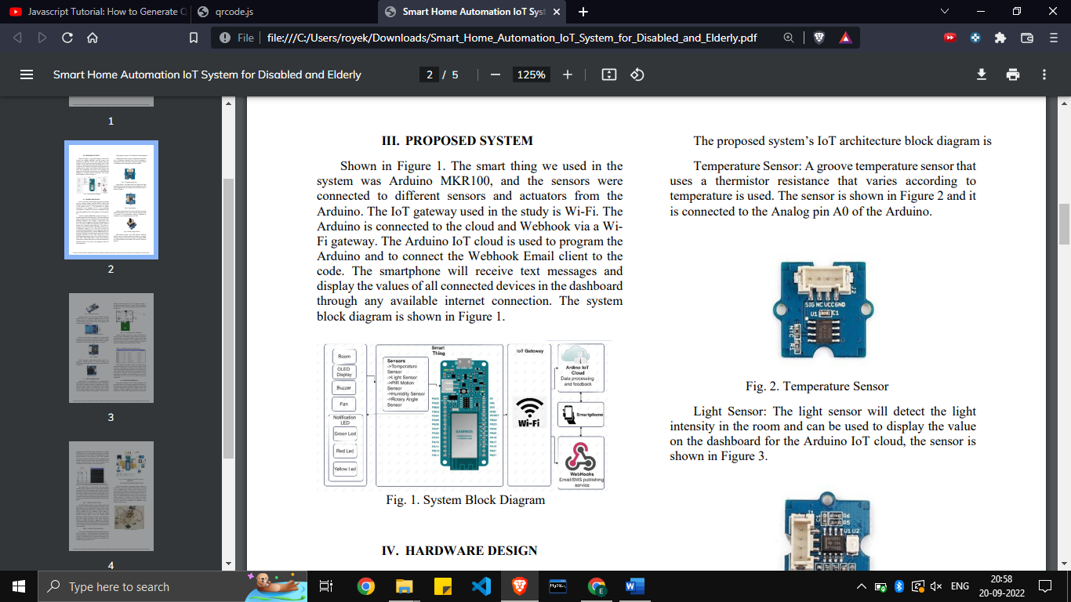

Fig. 1. Temperature Sensor

Temperature Sensor: A temperature sensor with a groove that utilises a variable-resistance thermistor There is a temperature. Figure 1 depicts the sensor, and it is attached to the Arduino's Analog pin A0. [7]

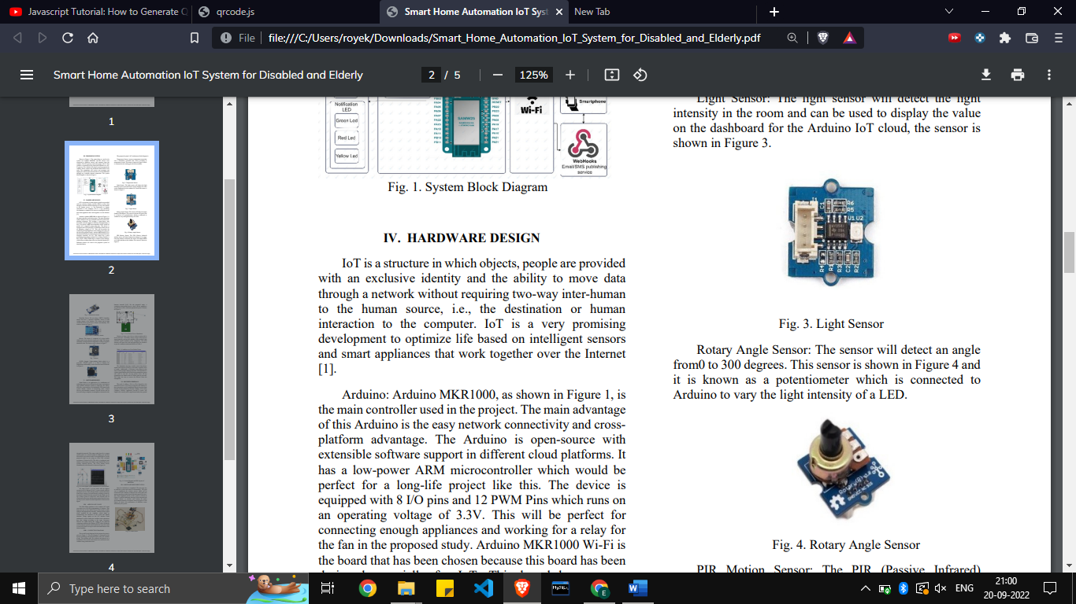

Fig. 2. Light Sensor

Light Sensor: The light sensor, which is seen in Figure 2, will determine the amount of light present in the space and may be used to display the value on the Arduino IoT cloud dashboard. [8]



Fig. 3. Rotatory Angle Sensor

Sensor for Rotating Angles: The sensor can detect angles ranging from 0 to 300 degrees. This sensor, referred to as a potentiometer, is depicted in Figure 3 and is connected to an Arduino to change the LED's light output. [9]

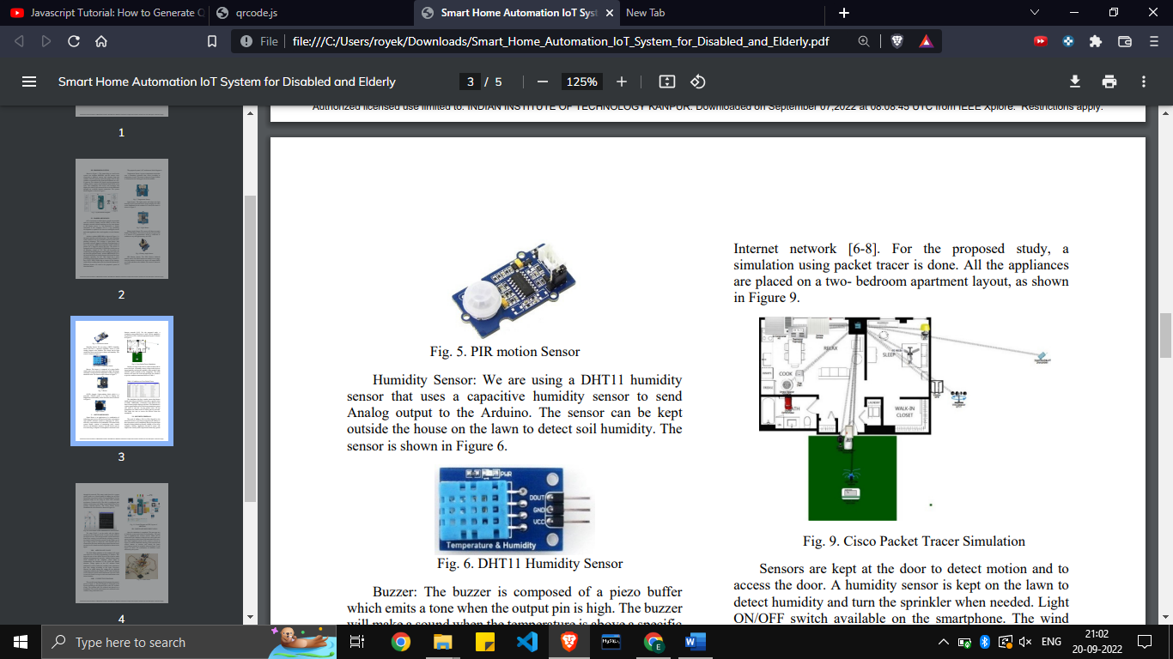

Fig. 4. PIR Motion Sensor

PIR Motion Sensor: PIR (Passive Infrared) A motion sensor detects human movement within its range. The sensor outputs HIGH as soon as motion is detected and will send it to the Arduino. [10]

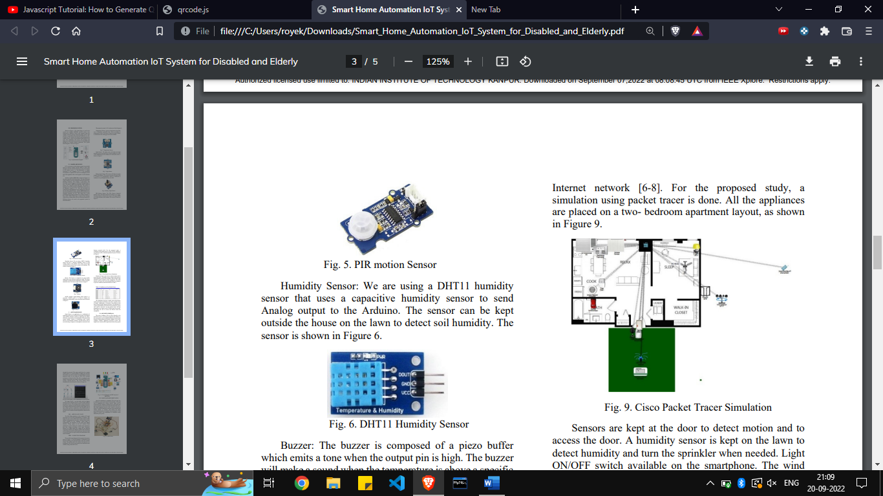

Fig. 5. DHT11 humidity sensor

We are using a DHT11 humidity sensor, which sends analogue output to the Arduino using a capacitive humidity sensor. To measure soil humidity, the sensor can be left on the lawn outside the home. Figure 5 depicts the sensor. [11]

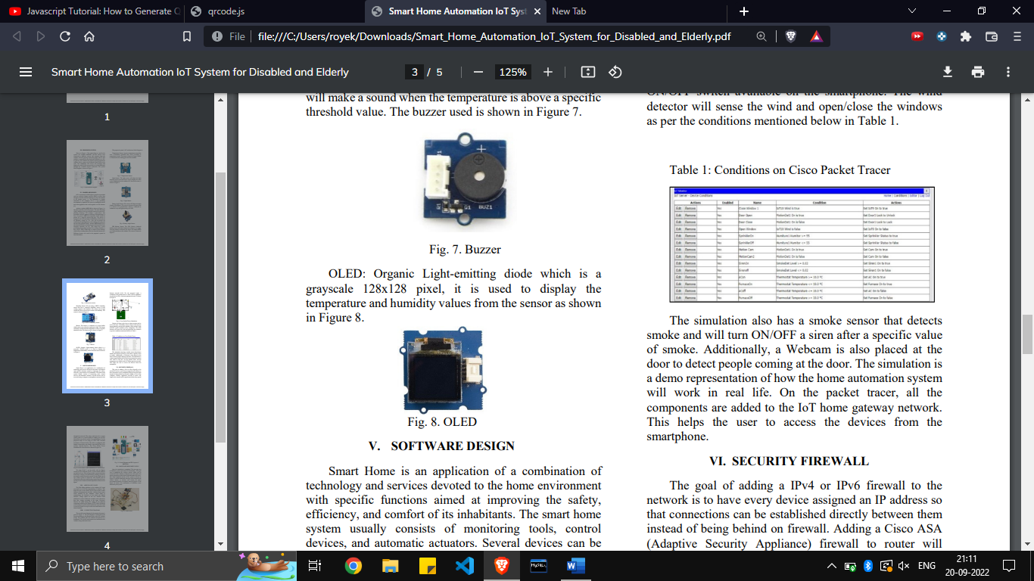

Fig. 6. Buzzer

Buzzer: A piezo buffer makes up the buzzer, and when the output pin is high, it generates a tone. When the temperature rises above a particular threshold, the buzzer will sound. The used buzzer is depicted in Figure 6. [12]



Fig. 7. OLED

The temperature and humidity readings from the sensor are shown using an OLED, which is a grayscale 128x128 pixel device, as seen in Figure 7. [13]

# Software design

Smart home is a combination of application of technology and services devoted to the home environment with specific functions aimed at improving the safety, efficiency and comfort of its inhabitants. In other words, smart home system is a system that connects with the home appliances to automate specific tasks and is remotely controlled. Smart home system can be used to regulate the room temperature, turn on fan, adjust the brightness and other applications. The temperature sensor will sense the temperature and after a certain limit the buzzer will go ON. The humidity sensor is used to sense the humidity and if it will detect the level below a certain limit it will turn ON the fan, which can be used as a lawn sprinkler. Sensors at the door help to detect the motion and access the door. Moreover, a WEBCAM at the door helps to detect the people coming at the door. The system aslo has a smoke detector which turns ON/OFF the siren after a certain level of smoke. All the components are added to the IoT home gateway network. Several devices can be accessed using a computer or smartphone connected to the internet. [14]

# Security firewall

One way to increase smart home  security is by segregating smart devices from laptops and mobile  phones on home network. Cloud-connected devices are  the most likely things to get compromised by hackers on our network and could  give baddies access to your private data  or see inside your house. Once a hacker  is inside your network on one device, it’s far easier for them to jump to other  smart devices, hacking each one in their path. What we want to do is separate these devices  into a trusted and untrusted network. [15]

On the trusted network side, we connect  all the devices that generally contain personal information or that you use day to day to cloud storage accounts. These are the devices and  accounts that we want to protect from hackers and cloud storage accounts. These are the devices and  accounts that we want to protect from hackers. [16]

# Arduino IoT cloud

In this project as we are building up a system in which the connected sensors are controlled by using the ARDUINO MKR 100 for the collection and reading of the data. The data being read and sent to the cloud in real-time, various sensors like temperature sensor, light sensor, rotary angle sensor, motion sensor and humidity sensor that are kept in different parts of the room will read and send data into the Arduino, which is set up and programmed using the ARDUINO IoT CLOUD. The ARDUINO IoT CLOUD used these values from sensors to process and take action accordingly. ARDUINO IoT cloud helps to connect multiple devices to each other and help in exchange of real-time data. It can also be monitored remotely using a simple user interface. The ARDUINO Web Editor platform can even be used to monitor and change the program remotely.

# Connection Diagram

The complete circuit for the system proposed above is given in the figure below. The connections are done according to the code of the program. The Arduino pins are soldered and placed on a breadboard. The sensors and actuators are connected to the ARDUINO using connecting wires.

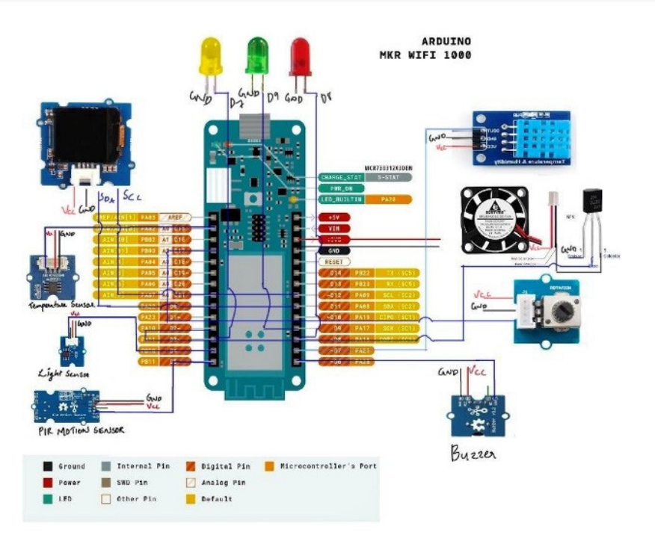 Fig. 8. Connection Diagram

# Hardware implementation

After the finalization of the proposed system, its software and hardware design and ensuring the setup of Security Firewall. The next step was the simulation and then the implementation of the system. The objective was to build a system so that the sensors kept anywhere in the room are connected to the Arduino using the Arduino IoT Cloud. The system was to be designed such that it’s user can remotely control the complete system easily. The sensors can be placed anywhere in the room with minimum or no wires. The system also sends text notification to the owner on his device. The final completed circuit of the system is shown in the figure given below.

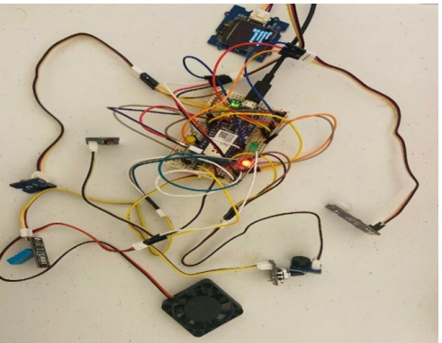

Fig. 9. Final Circuit Diagram

# Conclusion

The simulation and implementation of an automated home to assist the elderly are shown in this research utilising a user-friendly, low-powered home automation system. The various remote access for users allows them to control equipment, read sensor readings, and look for intruders using their mobile devices. Thus, the motion sensor will pick up. The home automation system is finished once all required connections are made. [17]

With the help of the rapidly developing Internet of Things, home automation is now feasible in an easy and economical manner. [18]

# References

[1] Weyrich, Michael & Ebert, Christof. (2016). Reference Architectures for the Internet of Things. IEEE Software. 33. 112-116. 10.1109/MS.2016.20. [2] Madakam, Somayya & Ramaswamy, R & Tripathi, Siddharth. (2015). Internet of Things (IoT): A Literature Review. Journal of Computer and Communications. 3. 164-173. 10.4236/jcc.2015.35021.

[3] Madakam, S., Ramaswamy, R. and Tripathi, S. (2015) Internet of Things (IoT): A Literature Review. Journal of Computer and Communications, 3, 164-173. doi: 10.4236/jcc.2015.35021.

[4] H. Chegini, R. K. Naha, A. Mahanti, and P. Thulasiraman, “Process Automation in an IoT–Fog–Cloud Ecosystem: A Survey and Taxonomy,” IoT, vol. 2, no. 1, pp. 92–118, Feb. 2021, doi: 10.3390/iot2010006.

[5] Bainbridge, L., 2003. Ironies of automation. Automatica. Available at: https://www.sciencedirect.com/science/article/pii/0005109883900468 [Accessed September 21, 2022].